Contents

Course 1: AWS Cloud Technical Essentials 2

Week 1: Getting Started with AWS Cloud 2

Reading 1.2: What is AWS? 3

Reading 1.3: AWS Global Infrastructure 5

Reading 1.4: Interacting with AWS 8

Reading 1.5: Security and the AWS Shared Responsibility Model 10

Reading 1.6: Protect the AWS Root User 12

Reading 1.7: Introduction to AWS Identity and Access Management 15

Reading 1.8: Role Based Access in AWS 18

DEMO AWS IAM 22

Hosting the employee directory application on aws 26

Default Amazon Machine Image (AMI) for Amazon EC2 28

Week 2: AWS Compute & Networking 29

Reading 2.1: Compute as a Service on AWS 29

Reading 2.2: Introduction to Amazon Elastic Compute Cloud 31

Reading 2.25: Amazon EC2 Instance Lifecycle 35

Reading 2.3: Container Services on AWS 39

Reading 2.4: Serverless and AWS Lambda 46

Reading 2.5: Networking on AWS 51

Reading 2.6: Introduction to Amazon VPC 53

Reading 2.7: Amazon VPC Routing and Security 57

Secure Your EC2 Instances with Security Groups 59

Week 3: Storage & Databases on AWS 62

Reading 3.2: Amazon EC2 Instance Storage and Amazon Elastic Block Store 62

Reading 3.3: Object Storage with Amazon S3 64

Reading 3.4: Choose the Right Storage Service 70

Reading 3.5: Explore Databases on AWS 72

Reading 3.6: Amazon Relational Database Service 76

Reading 3.8: Introduction to Amazon DynamoDB 81

Reading 3.9: Choose the Right AWS Database Service 82

Week 4: Monitoring, Optimizing, and Going Serverless on AWS 83

Reading 4.1: Monitoring on AWS 83

Reading 4.2: Introduction to Amazon CloudWatch 85

Course 2: Architecting Solutions on AWS 89

Course 3: Introduction to Designing Data Lake on AWS 89

Course 4: Exam Prep: AWS Certified Solutions Architect – Associate 89

# Course 1: AWS Cloud Technical Essentials

AWS Cloud Technical Essentials is a fundamental-level course. It’s designed to build your competence, confidence, and credibility with practical cloud skills that can help you innovate and advance your professional future. Here’s a quick overview of the skills that you will learn in each week of this first course.

## Week 1: Getting Started with AWS Cloud

In this week, you will learn the definition of cloud computing and how to describe the cloud value proposition. You will learn how to differentiate between workloads that run on premises compared to workloads that run in the cloud, and how to create an AWS account. You will also get an overview of AWS, including how to differentiate between AWS Regions and Availability Zones, and the different ways that you can interact with AWS. Finally, you will learn best practices for using AWS Identity and Access Management (IAM).

This is a basic CRUD app or create read, update, delete.

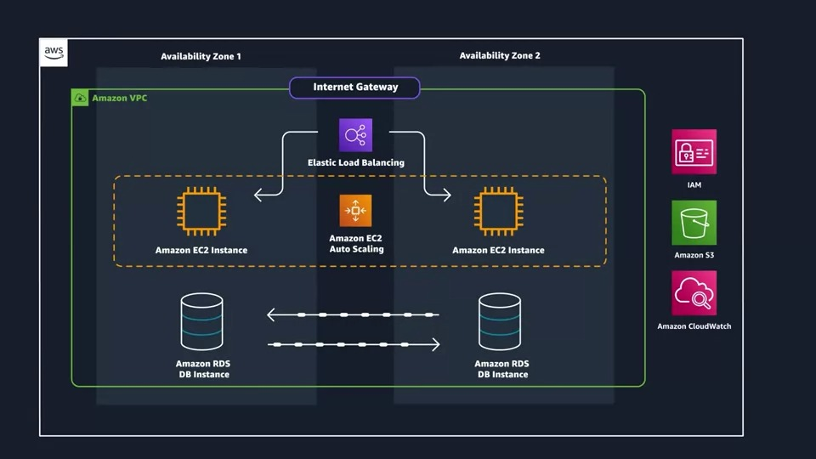

### Reading 1.2: What is AWS?

#### What is the Cloud?

In the past, companies and organizations hosted and maintained hardware such as compute, storage, and networking equipment in their own data centers. They needed to allocate entire infrastructure departments to take care of them, resulting in a costly operation that made some workloads and experimentation impossible.

As internet usage became more widespread, the demand for compute, storage, and networking equipment increased. For some companies and organizations, the cost of maintaining a large physical presence was unsustainable. To solve this problem, cloud computing was created.

Cloud computing is the on-demand delivery of IT resources over the internet with pay-as-you-go pricing. You no longer have to manage and maintain your own hardware in your own data centers. Companies like AWS own and maintain these data centers and provide virtualized data center technologies and services to users over the internet.

To help differentiate between running workloads on-premises versus in the cloud, consider the scenario where your developers need to deploy a new feature on your application. Before they deploy, the team wants to test the feature in a separate quality assurance (QA) environment that has the exact same configurations as production.

If you run your application on-premises, creating this additional environment requires you to buy and install hardware, connect the necessary cabling, provision power, install operating systems, and more. All of these tasks can be time-consuming and take days to perform. Meanwhile, the new product feature’s time-to-market is increasing and your developers are waiting for this environment.

If you ran your application in the cloud, you can replicate the entire environment as often as needed in a matter of minutes or even seconds. Instead of physically installing hardware and connecting cabling, you can logically manage your physical infrastructure over the internet.

Using cloud computing not only saves you time from the set-up perspective, but it also removes the *undifferentiated heavy lifting*. If you look at any application, you’ll see that some of the aspects of it are very important to your business, like the code. However, there are other aspects that are no different than any other application you might make: for instance the compute the code runs on. By removing repetitive common tasks that don’t differentiate your business, like installing virtual machines, or storing backups, you can focus on what is strategically unique to your business and let AWS handle the tasks that are time consuming and don’t separate you from your competitors.

So where does AWS fit into all of this? Well AWS simply just provides cloud computing services. Those IT resources mentioned in the cloud computing definition are AWS services in this case. We’ll need to use these AWS services to architect a scalable, highly available, and cost effective infrastructure to host our corporate directory application. This way we can get our corporate directory app out into the world quickly, without having to manage any heavy-duty physical hardware. There are the six main advantages to running your workloads on AWS.

#### The Six Benefits of Cloud Computing

**Pay as you go.** Instead of investing in data centers and hardware before you know how you are going to use them, you pay only when you use computing resources, and pay only for how much you use.

**Benefit from massive economies of scale.** By using cloud computing, you can achieve a lower cost than you can get on your own. Because usage from hundreds of thousands of customers is aggregated in the cloud, AWS can achieve higher economies of scale, which translates into lower pay as-you-go prices.

**Stop guessing capacity**. Eliminate guessing on your infrastructure capacity needs. When you make a capacity decision prior to deploying an application, you often end up either sitting on expensive idle resources or dealing with limited capacity. With cloud computing, these problems go away. You can access as much or as little capacity as you need, and scale up and down as required with only a few minutes notice.

**Increase speed and agility.** IT resources are only a click away, which means that you reduce the time to make those resources available to your developers from weeks to just minutes. This results in a dramatic increase in agility for the organization since the cost and time it takes to experiment and develop is significantly lower.

**Stop spending money running and maintaining data centers.** Focus on projects that differentiate your business, not the infrastructure. Cloud computing lets you focus on your customers, rather than on the heavy lifting of racking, stacking, and powering physical infrastructure. This is often referred to as undifferentiated heavy lifting.

**Go global in minutes.** Easily deploy your application in multiple Regions around the world with just a few clicks. This means you can provide lower latency and a better experience for your customers at a minimal cost.

**Resources**:

* [*External Site:* AWS: What is cloud computing?](https://aws.amazon.com/what-is-cloud-computing/)
* [*External Site:* AWS: Types of Cloud Computing](http://docs.aws.amazon.com/whitepapers/latest/aws-overview/types-of-cloud-computing.html)
* [*External Site:* AWS: Cloud computing with AWS](https://aws.amazon.com/what-is-aws/)

This cluster of data centers is called an availability zone or AZ. A cluster of AZs is simply called a region. there are four aspects you need to consider when deciding which AWS region to use, compliance, latency, price, and service availability.

When you cache content at an Edge location, a copy is hosted across the Edge locations around the world. That way, when a user goes to retrieve that information, it will come from the closest Edge location, which will greatly reduce the latency for that user. You can use services like Amazon CloudFront to cache content using the Edge locations.

### Reading 1.3: AWS Global Infrastructure

Infrastructure, like data centers and networking connectivity, still exists as the foundation of every cloud application. In AWS, this physical infrastructure makes up the AWS Global Infrastructure, in the form of Availability Zones and Regions.

#### REGIONS

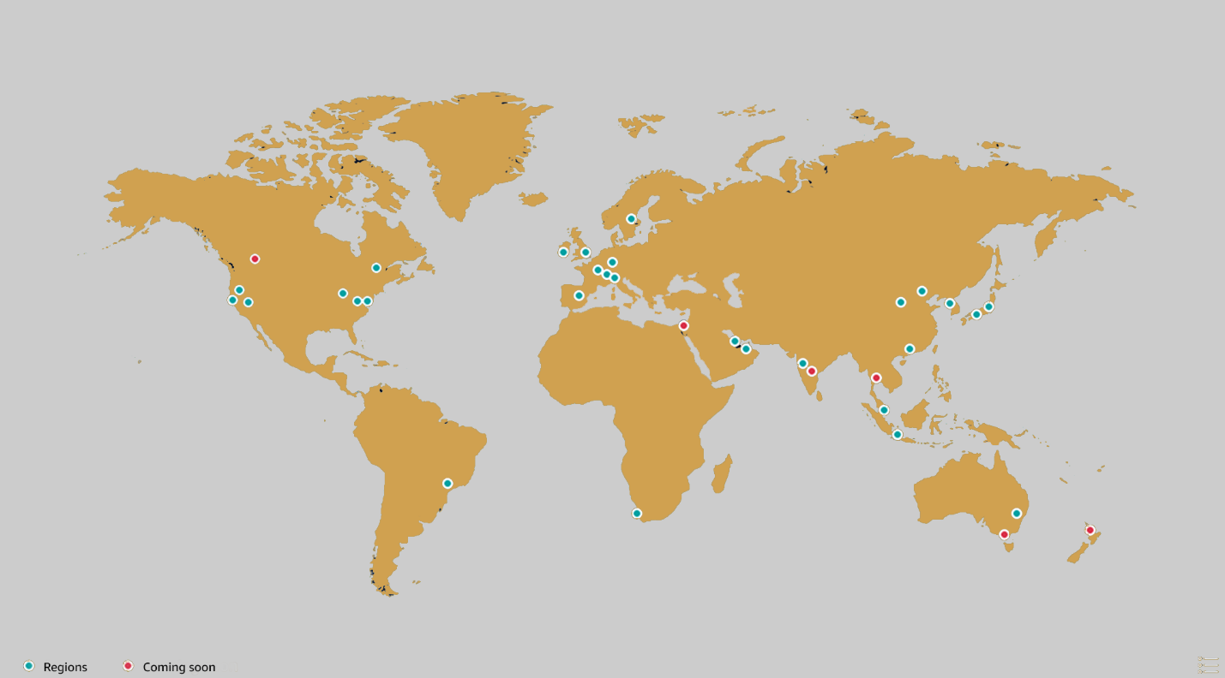

Regions are geographic locations worldwide where AWS hosts its data centers. AWS Regions are named after the location where they reside. For example, in the United States, there is a Region in Northern Virginia called the Northern Virginia Region and a Region in Oregon called the Oregon Region. There are Regions in Asia Pacific, Canada, Europe, the Middle East, and South America, and AWS continues to expand to meet the needs of its customers.Each AWS Region is associated with a geographical name and a Region code.

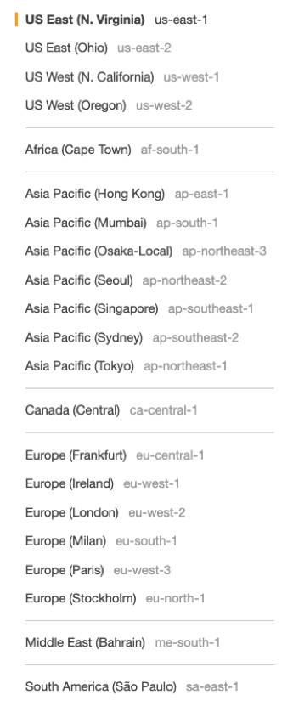

Here are a few examples of Region codes:

* us-east-1: This is the first Region created in the east of the US. The geographical name for this Region is N. Virginia.
* ap-northeast-1: The first Region created in the northeast of Asia Pacific. The geographical name for this Region is Tokyo.

AWS Regions are independent from one another. This means that your data is not replicated from one Region to another, without your explicit consent and authorization.

#### CHOOSE THE RIGHT AWS REGION

Consider four main aspects when deciding which AWS Region to host your applications and workloads: latency, price, service availability, and compliance.

**Latency.** If your application is sensitive to latency, choose a Region that is close to your user base. This helps prevent long wait times for your customers. Synchronous applications such as gaming, telephony, WebSockets, and IoT are significantly affected by higher latency, but even asynchronous workloads, such as ecommerce applications, can suffer from an impact on user connectivity.

**Price.** Due to the local economy and the physical nature of operating data centers, prices may vary from one Region to another. The pricing in a Region can be impacted by internet connectivity, prices of imported pieces of equipment, customs, real estate, and more. Instead of charging a flat rate worldwide, AWS charges based on the financial factors specific to the location.

**Service availability.** Some services may not be available in some Regions. The AWS documentation provides a table containing the Regions and the available services within each one.

**Data compliance.** Enterprise companies often need to comply with regulations that require customer data to be stored in a specific geographic territory. If applicable, you should choose a Region that meets your compliance requirements.

#### AVAILABILITY ZONES

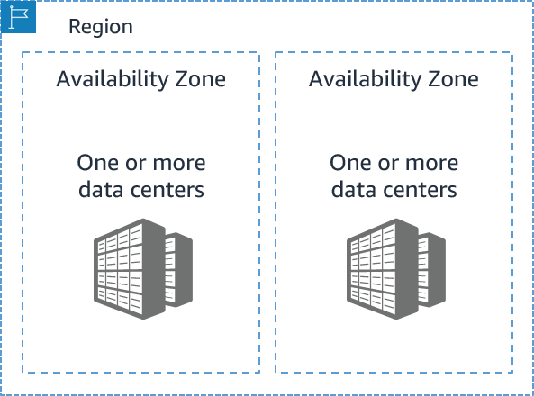

Inside every Region is a cluster of Availability Zones (AZ). An AZ consists of one or more data centers with redundant power, networking, and connectivity. These data centers operate in discrete facilities with undisclosed locations. They are connected using redundant high-speed and low-latency links.AZs also have a code name. Since they’re located inside Regions, they can be addressed by appending a letter to the end of the Region code name. For example:

* us-east-1a: an AZ in us-east-1 (Northern Virginia Region)
* sa-east-1b: an AZ in sa-east-1 (São Paulo Region in South America)

If you see that a resource exists in us-east-1c, you know this resource is located in AZ c of the us-east-1 Region.

#### SCOPE AWS SERVICES

Depending on the AWS Service you use, your resources are either deployed at the AZ, Region, or Global level. Each service is different, so you need to understand how the scope of a service may affect your application architecture.When you operate a Region-scoped service, you only need to select the Region you want to use. If you are not asked to specify an individual AZ to deploy the service in, this is an indicator that the service operates on a Region-scope level. For region-scoped services, AWS automatically performs actions to increase data durability and availability.On the other hand, some services ask you to specify an AZ. With these services, you are often responsible for increasing the data durability and high availability of these resources.

#### MAINTAIN RESILIENCY

To keep your application available, you need to maintain high availability and resiliency. A well-known best practice for cloud architecture is to use Region-scoped, managed services. These services come with availability and resiliency built in.When that is not possible, make sure the workload is replicated across multiple AZs. At a minimum, you should use two AZs. If one entire AZ fails, your application will have infrastructure up and running in at least a second AZ to take over the traffic.

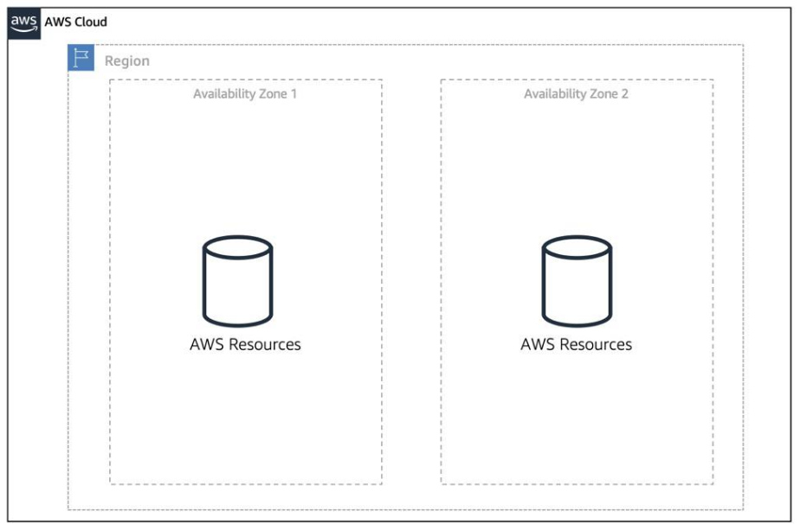

**Resources**:

* [External Site: AWS: Global Infrastructure](https://aws.amazon.com/about-aws/global-infrastructure/)
* [External Site: AWS: AWS Global Infrastructure Documentation](https://docs.aws.amazon.com/whitepapers/latest/aws-overview/global-infrastructure.html)
* [External Site: AWS: AWS Regions and Availability Zones](https://aws.amazon.com/about-aws/global-infrastructure/regions_az/)
* [External Site: AWS: AWS service endpoints](https://docs.aws.amazon.com/general/latest/gr/rande.html)
* [External Site: AWS: AWS Regional Services](https://aws.amazon.com/about-aws/global-infrastructure/regional-product-services/)

now I logically manage it through the AWS Application Program Interface or API.

API calls:

1. the AWS Management Console

a web-based method that you log into from your browser

1. the AWS Command Line Interface
2. the AWS Software Development Kits or SDKs

### Reading 1.4: Interacting with AWS

Every action you make in AWS is an API call that is authenticated and authorized. In AWS, you can make API calls to services and resources through the AWS Management Console, the AWS Command Line Interface (CLI), or the AWS Software Development Kits (SDKs).

#### THE AWS MANAGEMENT CONSOLE

One way to manage cloud resources is through the web-based console, where you log in and click on the desired service. This can be the easiest way to create and manage resources when you’re first begin working with the cloud. Below is a screenshot that shows the landing page when you first log into the AWS Management Console.

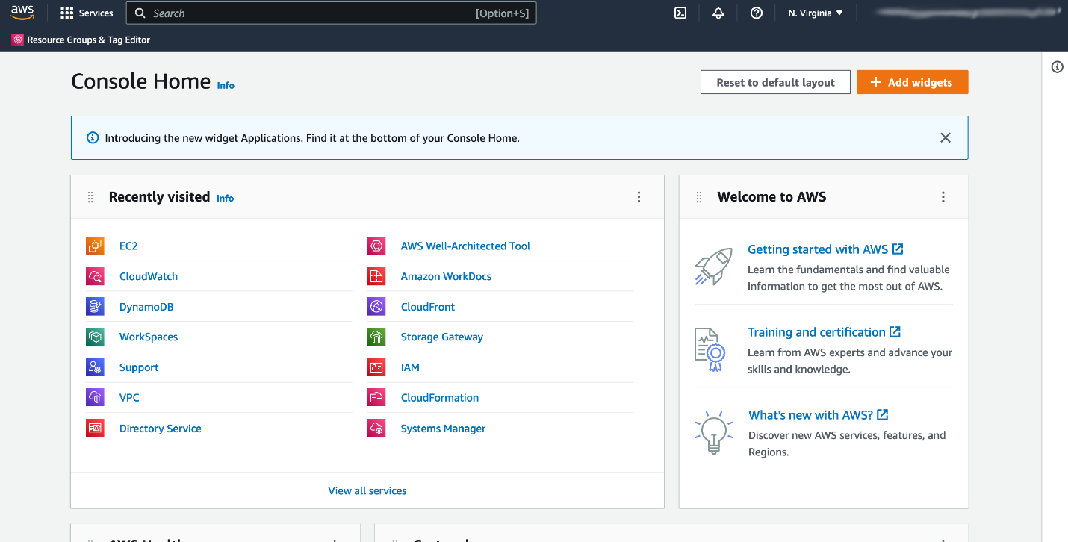

The services are placed in categories, such as compute, database, storage and security, identity and compliance.On the upper right corner is the Region selector. If you click it and change the Region, you will make requests to the services in the chosen Region. The URL changes, too. Changing the Region directs the browser to make requests to a whole different AWS Region, represented by a different subdomain.

#### THE AWS COMMAND LINE INTERFACE (CLI)

Consider the scenario where you run tens of servers on AWS for your application’s frontend. You want to run a report to collect data from all of these servers. You need to do this programmatically every day because the server details may change. Instead of manually logging into the AWS Management Console and copying/pasting information, you can schedule an AWS Command Line Interface (CLI) script with an API call to pull this data for you.The AWS CLI is a unified tool to manage AWS services. With just one tool to download and configure, you control multiple AWS services from the command line and automate them with scripts. The AWS CLI is open-source, and there are installers available for Windows, Linux, and Mac OS.Here is an example of running an API call against a service using the AWS CLI:

You get this response:

{

"Reservations": [

{"Groups": [],

"Instances": [

{"AmiLaunchIndex": 0,

and so on.

#### AWS SOFTWARE DEVELOPMENT KITS (SDKS)

API calls to AWS can also be performed by executing code with programming languages. You can do this by using AWS Software Development Kits (SDKs). SDKs are open-source and maintained by AWS for the most popular programming languages, such as C++, Go, Java, JavaScript, .NET, Node.js, PHP, Python, and Ruby.Developers commonly use AWS SDKs to integrate their application source code with AWS services. Let’s say the frontend of the application runs in Python and every time it receives a cat photo, it uploads that photo to a storage service. This action can be achieved from within the source code by using the AWS SDK for Python.

Here is an example of code you can implement to work with AWS resources using the Python AWS SDK.

import boto3

ec2 = boto3.client('ec2')

response = ec2.describe_instances()

print(response)

#### **Resources**:

* [External Site: AWS: Working with the AWS Management Console](https://docs.aws.amazon.com/awsconsolehelpdocs/latest/gsg/getting-started.html)
* [External Site: AWS: AWS Command Line Interface](https://aws.amazon.com/cli/)
* [External Site: AWS: Tools to Build on AWS](https://aws.amazon.com/tools/)

### Reading 1.5: Security and the AWS Shared Responsibility Model

When you begin working with the AWS Cloud, managing security and compliance is a shared responsibility between AWS and you. To depict this shared responsibility, AWS created the shared responsibility model. This distinction of responsibility is commonly referred to as security of the cloud, versus security in the cloud.

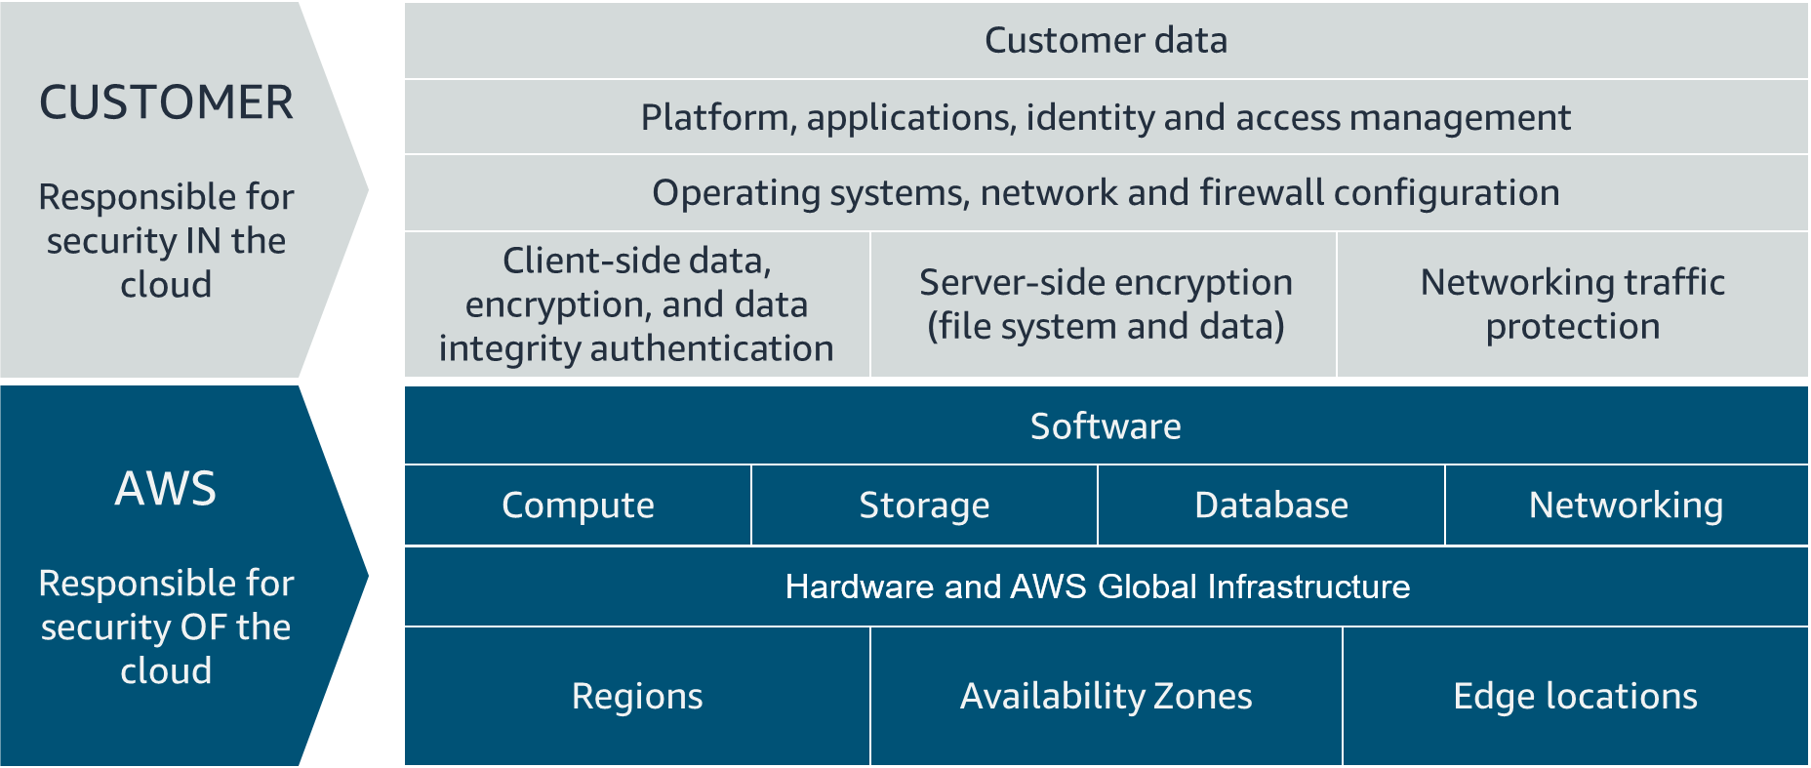

#### WHAT IS AWS RESPONSIBLE FOR?

AWS is responsible for security of the cloud. This means AWS is required to protect and secure the infrastructure that runs all the services offered in the AWS Cloud. AWS is responsible for:

* Protecting and securing AWS Regions, Availability Zones, and data centers, down to the physical security of the buildings
* Managing the hardware, software, and networking components that run AWS services, such as the physical server, host operating systems, virtualization layers, and AWS networking components

The level of responsibility AWS has depends on the service. AWS classifies services into three different categories. The following table provides information about each, as well as the AWS responsibility.

| Category | Examples of AWS Services in the Category | AWS Responsibility |
| --- | --- | --- |
| Infrastructure services | Compute services, such as Amazon Elastic Compute Cloud (Amazon EC2) | AWS manages the underlying infrastructure and foundation services. |
| Container services | Services that require less management from the customer, such as Amazon Relational Database Service (Amazon RDS) | AWS manages the underlying infrastructure and foundation services, operating system, and application platform. |
| Abstracted services | Services that require very little management from the customer, such as Amazon Simple Storage Service (Amazon S3) | AWS operates the infrastructure layer, operating system, and platforms, as well as server-side encryption and data protection. |

#### Note

Container services refer to AWS abstracting application containers behind the scenes, not Docker container services. This enables AWS to move the responsibility of managing that platform away from customers.

#### WHAT IS THE CUSTOMER RESPONSIBLE FOR?

You’re responsible for security in the cloud. When using any AWS service, you’re responsible for properly configuring the service and your applications, as well as ensuring your data is secure.The level of responsibility you have depends on the AWS service. Some services require you to perform all the necessary security configuration and management tasks, while other more abstracted services require you to only manage the data and control access to your resources. Using the three categories of AWS services, you can determine your level of responsibility for each AWS service you use.

| Category | AWS Responsibility | Customer Responsibility |
| --- | --- | --- |
| Infrastructure services | AWS manages the infrastructure and foundation services. | You control the operating system and application platform, as well as encrypting, protecting, and managing customer data. |
| Container services | AWS manages the infrastructure and foundation services, operating system, and application platform. | You are responsible for customer data, encrypting that data, and protecting it through network firewalls and backups. |
| Abstracted services | AWS operates the infrastructure layer, operating system, and platforms, as well as server-side encryption and data protection. | You are responsible for managing customer data and protecting it through client-side encryption. |

Due to the varying level of effort, it’s important to consider which AWS service you use and review the level of responsibility required to secure the service. It’s also important to review how the shared security model aligns with the security standards in your IT environment, as well as any applicable laws and regulations.It’s important to note that you maintain complete control of your data and are responsible for managing the security related to your content. Here are some examples of your responsibilities in context.

* Choosing a Region for AWS resources in accordance with data sovereignty regulations
* Implementing data protection mechanisms, such as encryption and managing backups
* Using access control to limit who has access to your data and AWS resources

#### RESOURCES

* [External Site: AWS: Shared Responsibility Model](https://aws.amazon.com/compliance/shared-responsibility-model/)

### Reading 1.6: Protect the AWS Root User

#### What’s the Big Deal About Auth?

When you’re configuring access to any account, two terms come up frequently: **authentication and authorization**. Though these terms may seem basic, you need to understand them to properly configure access management on AWS. It’s important to keep this mind as you progress in this course. Let’s define both terms.

#### Understand Authentication

When you create your AWS account, you use a combination of an email address and a password to verify your identity. If the user types in the correct email and password, the system assumes the user is allowed to enter and grants them access. This is the process of *authentication*.Authentication ensures that the user is who they say they are. Usernames and passwords are the most common types of authentication, but you may also work with other forms, such as token-based authentication or biometric data like a fingerprint. Authentication simply answers the question, “Are you who you say you are?”

#### Understand Authorization

Once you’re inside your AWS account, you might be curious about what actions you can take. This is where *authorization* comes in. Authorization is the process of giving users permission to access AWS resources and services. Authorization determines whether the user can perform an action—whether it be to read, edit, delete, or create resources. Authorization answers the question, “What actions can you perform?”

#### What Is the AWS Root User?

When you first create an AWS account, you begin with a single sign-in identity that has complete access to all AWS services and resources in the account. This identity is called the AWS root user and is accessed by signing in with the email address and password that you used to create the account.

#### Understand the AWS Root User Credentials

The AWS root user has two sets of credentials associated with it. One set of credentials is the email address and password used to create the account. This allows you to access the AWS Management Console. The second set of credentials is called access keys, which allow you to make programmatic requests from the [AWS Command Line Interface (AWS CLI) or AWS API](https://trailhead.salesforce.com/content/learn/modules/aws-cloud-technical-professionals). Access keys consist of two parts:

* An access key ID, for example, A2lAl5EXAMPLE
* A secret access key, for example, wJalrFE/KbEKxE

Similar to a username and password combination, you need both the access key ID and secret access key to authenticate your requests via the AWS CLI or AWS API. Access keys should be managed with the same security as an email address and password.

#### Follow Best Practices When Working with the AWS Root User

Keep in mind that the root user has complete access to all AWS services and resources in your account, as well as your billing and personal information. Due to this, securely lock away the credentials associated with the root user and do not use the root user for everyday tasks. To ensure the safety of the root user:

* Choose a strong password for the root user.
* Never share your root user password or access keys with anyone.
* Disable or delete the access keys associated with the root user.
* Do not use the root user for administrative tasks or everyday tasks.

When is it OK to use the AWS root user? There are some tasks where it makes sense to use the AWS root user. Check out the links at the end of this section to read about them.

#### Delete Your Keys to Stay Safe

If you don't already have an access key for your AWS account root user, don't create one unless you absolutely need to. If you do have an access key for your AWS account root user and want to delete the keys:

Go to the [My Security Credentials page](https://console.aws.amazon.com/iam/home?#security_credential) in the AWS Management Console and sign in with the root user’s email address and password.

Open the Access keys section.

Under Actions, click **Delete**.

Click **Yes**.

The Case for Multi-Factor Authentication

When you create an AWS account and first log in to that account, you use single-factor authentication. Single-factor authentication is the simplest and most common form of authentication. It only requires one authentication method. In this case, you use a username and password to authenticate as the AWS root user. Other forms of single-factor authentication include a security pin or a security token.However, sometimes a user’s password is easy to guess.

For example, your coworker Bob’s password, IloveCats222, might be easy for someone who knows Bob personally to guess, because it’s a combination of information that is easy to remember and describes certain things about Bob (1. Bob loves cats, and 2. Bob’s birthday is February 22).

If a bad actor guessed or cracked Bob’s password through social engineering, bots, or scripts, Bob might lose control of his account. Unfortunately, this is a common scenario that users of any website often face.

This is why using MFA has become so important in preventing unwanted account access. MFA requires two or more authentication methods to verify an identity, pulling from three different categories of information.

Something you know, such as a username and password, or pin number

Something you have, such as a one-time passcode from a hardware device or mobile app

Something you are, such as fingerprint or face scanning technology

Using a combination of this information enables systems to provide a layered approach to account access. Even though the first method of authentication, Bob’s password, was cracked by a malicious user, it’s very unlikely that a second method of authentication, such as a fingerprint, would also be cracked. This extra layer of security is needed when protecting your most sacred accounts, which is why it’s important to enable MFA on your AWS root user.

#### Use MFA on AWS

If you enable MFA on your root user, you are required to present a piece of identifying information from both the something you know category and the something you have category. The first piece of identifying information the user enters is an email and password combination. The second piece of information is a temporary numeric code provided by an MFA device.Enabling MFA adds an additional layer of security because it requires users to use a supported MFA mechanism in addition to their regular sign-in credentials. It’s best practice to enable MFA on the root user.

#### Review Supported MFA Devices

|  |  |  |
| --- | --- | --- |
| Device | Description | Supported Devices |
| Virtual MFA | A software app that runs on a phone or other device that provides a one-time passcode. Keep in mind that these applications can run on unsecured mobile devices, and because of that, may not provide the same level of security as hardware or U2F devices. | Authy, Duo Mobile, LastPass Authenticator, Microsoft Authenticator, Google Authenticator |
| Hardware | A hardware device, generally a key fob or display card device that generates a one-time six-digit numeric code | Key fob, display card |
| U2F | A hardware device that you plug into a USB port on your computer | YubiKey |

AWS supports a variety of MFA mechanisms, such as virtual MFA devices, hardware devices, and Universal 2nd Factor (U2F) security keys. For instructions on how to set up each method, check out the Resources section.

#### Resources

* [External Site: AWS: Enabling a Hardware MFA Device (Console)](https://docs.aws.amazon.com/IAM/latest/UserGuide/id_credentials_mfa_enable_physical.html)
* [External Site: AWS: Enabling a U2F Security Key (Console)](https://docs.aws.amazon.com/IAM/latest/UserGuide/id_credentials_mfa_enable_u2f.html)
* [External Site: AWS: Enabling a Virtual Multi-Factor Authentication (MFA) Device (Console)](https://docs.aws.amazon.com/IAM/latest/UserGuide/id_credentials_mfa_enable_virtual.html)
* [External Site: AWS: Table of Supported MFA Devices](https://aws.amazon.com/iam/features/mfa/)
* [External Site: Tasks that require the use of root user credentials](https://docs.aws.amazon.com/general/latest/gr/root-vs-iam.html#aws_tasks-that-require-root)

### Reading 1.7: Introduction to AWS Identity and Access Management

#### WHAT IS IAM?

IAM is a web service that enables you to manage access to your AWS account and resources. It also provides a centralized view of who and what are allowed inside your AWS account (authentication), and who and what have permissions to use and work with your AWS resources (authorization).With IAM, you can share access to an AWS account and resources without having to share your set of access keys or password. You can also provide granular access to those working in your account, so that people and services only have permissions to the resources they need. For example, to provide a user of your AWS account with read-only access to a particular AWS service, you can granularly select which actions and which resources in that service they can access.

#### GET TO KNOW THE IAM FEATURES

To help control access and manage identities within your AWS account, IAM offers many features to ensure security.

* IAM is global and not specific to any one Region. This means you can see and use your IAM configurations from any Region in the AWS Management Console.
* IAM is integrated with many AWS services [by default](https://docs.aws.amazon.com/IAM/latest/UserGuide/reference_aws-services-that-work-with-iam.html).
* You can establish password policies in IAM to specify complexity requirements and mandatory rotation periods for users.
* IAM supports MFA.
* IAM supports identity federation, which allows users who already have passwords elsewhere—for example, in your corporate network or with an internet identity provider—to get temporary access to your AWS account.
* Any AWS customer can use IAM; the service is offered at no additional charge.

#### WHAT IS AN IAM USER?

An IAM user represents a person or service that interacts with AWS. You define the user within your AWS account. And any activity done by that user is billed to your account. Once you create a user, that user can sign in to gain access to the AWS resources inside your account.You can also add more users to your account as needed. For example, for your cat photo application, you could create individual users in your AWS account that correspond to the people who are working on your application. Each person should have their own login credentials. Providing users with their own login credentials prevents sharing of credentials.

#### IAM USER CREDENTIALS

An IAM user consists of a name and a set of credentials. When creating a user, you can choose to provide the user:

* Access to the AWS Management Console
* Programmatic access to the AWS Command Line Interface (AWS CLI) and AWS Application Programming Interface (AWS API)

To access the AWS Management Console, provide the users with a user name and password. For programmatic access, AWS generates a set of access keys that can be used with the AWS CLI and AWS API. IAM user credentials are considered permanent, in that they stay with the user until there’s a forced rotation by admins.When you create an IAM user, you have the option to grant permissions directly at the user level.This can seem like a good idea if you have only one or a few users. However, as the number of users helping you build your solutions on AWS increases, it becomes more complicated to keep up with permissions. For example, if you have 3,000 users in your AWS account, administering access becomes challenging, and it’s impossible to get a top-level view of who can perform what actions on which resources.If only there were a way to group IAM users and attach permissions at the group level instead. Guess what: There is!

#### WHAT IS AN IAM GROUP?

An IAM group is a collection of users. All users in the group inherit the permissions assigned to the group. This makes it easy to give permissions to multiple users at once. It’s a more convenient and scalable way of managing permissions for users in your AWS account. This is why using IAM groups is a best practice.If you have a an application that you’re trying to build and have multiple users in one account working on the application, you might decide to organize these users by job function. You might want IAM groups organized by developers, security, and admins. You would then place all of your IAM users in the respective group for their job function.This provides a better view to see who has what permissions within your organization and an easier way to scale as new people join, leave, and change roles in your organization.Consider the following examples.

* A new developer joins your AWS account to help with your application. You simply create a new user and add them to the developer group, without having to think about which permissions they need.
* A developer changes jobs and becomes a security engineer. Instead of editing the user’s permissions directly, you can instead remove them from the old group and add them to the new group that already has the correct level of access.

Keep in mind the following features of groups.

* Groups can have many users.
* Users can belong to many groups.
* Groups cannot belong to groups.

The root user can perform all actions on all resources inside an AWS account by default. This is in contrast to creating new IAM users, new groups, or new roles. New IAM identities can perform no actions inside your AWS account by default until you explicitly grant them permission.The way you grant permissions in IAM is by using IAM policies.

#### WHAT IS AN IAM POLICY?

To manage access and provide permissions to AWS services and resources, you create IAM policies and attach them to IAM users, groups, and roles. Whenever a user or role makes a request, AWS evaluates the policies associated with them. For example, if you have a developer inside the developers group who makes a request to an AWS service, AWS evaluates any policies attached to the developers group and any policies attached to the developer user to determine if the request should be allowed or denied.

#### IAM POLICY EXAMPLES

Most policies are stored in AWS as JSON documents with several policy elements. Take a look at the following example of what providing admin access through an IAM identity-based policy looks like.

**{**

**"Version": "2012-10-17",**

**"Statement": [{ "Effect": "Allow",**

**"Action": "*",**

**"Resource": "*"**

**}]**

**}**

In this policy, there are four major JSON elements: Version, Effect, Action, and Resource.

* The **Version** element defines the version of the policy language. It specifies the language syntax rules that are needed by AWS to process a policy. To use all the available policy features, include "Version": "2012-10-17" before the "Statement" element in all your policies.
* The **Effect** element specifies whether the statement will allow or deny access. In this policy, the Effect is "Allow", which means you’re providing access to a particular resource.
* The **Action** element describes the type of action that should be allowed or denied. In the above policy, the action is "*". This is called a wildcard, and it is used to symbolize every action inside your AWS account.
* The **Resource** element specifies the object or objects that the policy statement covers. In the policy example above, the resource is also the wildcard "*". This represents all resources inside your AWS console.

Putting all this information together, you have a policy that **allows** you to perform **all actions** on **all resources** inside your AWS account. This is what we refer to as an administrator policy.

Let’s look at another example of a more granular IAM policy.

**{"Version": "2012-10-17",**

**"Statement": [{**

**"Effect": "Allow",**

**"Action": [**

**"iam: ChangePassword",**

**"iam: GetUser"**

**]**

**"Resource":**

**"arn:aws:iam::123456789012:user/${aws:username}"**

**}]**

**}**

After looking at the JSON, you can see that this policy **allows** the IAM user to **change their own IAM password** (iam:ChangePassword) and **get information about their own user** (iam:GetUser). It only permits them to access their own credentials because the resource restricts access with the variable substitution ${aws:username}.

#### UNDERSTAND POLICY STRUCTURE

When creating a policy, it is required to have each of the following elements inside a policy statement.

| **Element** | **Description** | **Required** | **Example** |
| --- | --- | --- | --- |
| Effect | Specifies whether the statement results in an allow or an explicit deny | ✔ | "Effect": "Deny" |
| Action | Describes the specific actions that will be allowed or denied | ✔ | "Action": "iam:CreateUser" |
| Resource | Specifies the object or objects that the statement covers | ✔ | "Resource": "arn:aws:iam::account-ID-without-hyphens:user/Bob" |

#### **Resources:**

* [External Site: What is IAM?](https://docs.amazonaws.cn/en_us/IAM/latest/UserGuide/introduction.html)
* [External Site: AWS IAM Identities](https://docs.amazonaws.cn/en_us/IAM/latest/UserGuide/id.html)
* [External Site: Access Management with AWS IAM](https://docs.amazonaws.cn/en_us/IAM/latest/UserGuide/access.html)

### Reading 1.8: Role Based Access in AWS

Throughout these last few lessons, there have been sprinklings of IAM best practices. It’s helpful to have a brief summary of some of the most important IAM best practices you need to be familiar with before building out solutions on AWS.

#### LOCK DOWN THE AWS ROOT USER

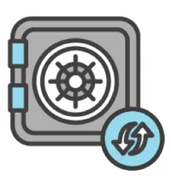

The root user is an all-powerful and all-knowing identity within your AWS account. If a malicious user were to gain control of root-user credentials, they would be able to access every resource within your account, including personal and billing information. To lock down the root user:

* Don’t share the credentials associated with the root user.
* Consider deleting the root user access keys.
* Enable MFA on the root account.

FOLLOW THE PRINCIPLE OF LEAST PRIVILEGE



Least privilege is a standard security principle that advises you to grant only the necessary permissions to do a particular job and nothing more. To implement least privilege for access control, start with the minimum set of permissions in an IAM policy and then grant additional permissions as necessary for a user, group, or role.

#### USE IAM APPROPRIATELY

IAM is used to secure access to your AWS account and resources. It simply provides a way to create and manage users, groups, and roles to access resources within a single AWS account. IAM is **not** used for website authentication and authorization, such as providing users of a website with sign-in and sign-up functionality. IAM also does **not** support security controls for protecting operating systems and networks.

#### USE IAM ROLES WHEN POSSIBLE



Maintaining roles is easier than maintaining users. When you assume a role, IAM dynamically provides temporary credentials that expire after a defined period of time, between 15 minutes and 36 hours. Users, on the other hand, have long-term credentials in the form of user name and password combinations or a set of access keys.User access keys only expire when you or the admin of your account rotates these keys. User login credentials expire if you have applied a password policy to your account that forces users to rotate their passwords.

#### CONSIDER USING AN IDENTITY PROVIDER

If you decide to make your cat photo application into a business and begin to have more than a handful of people working on it, consider managing employee identity information through an identity provider (IdP). Using an IdP, whether it be an AWS service such as AWS IAM Identity Center (Successor to AWS Single Sign-On) or a third-party identity provider, provides you a single source of truth for all identities in your organization.You no longer have to create separate IAM users in AWS. You can instead use IAM roles to provide permissions to identities that are federated from your IdP.For example, you have an employee, Martha, that has access to multiple AWS accounts. Instead of creating and managing multiple IAM users named Martha in each of those AWS accounts, you can manage Martha in your company’s IdP. If Martha moves within the company or leaves the company, Martha can be updated in the IdP, rather than in every AWS account you have.

#### CONSIDER AWS IAM IDENTITY CENTER



If you have an organization that spans many employees and multiple AWS accounts, you may want your employees to sign in with a single credential.AWS IAM Identity Center is an IdP that lets your users sign in to a user portal with a single set of credentials. It then provides them access to all their assigned accounts and applications in one central location.AWS IAM Identity Center is similar to IAM, in that it offers a directory where you can create users, organize them in groups, and set permissions across those groups, and grant access to AWS resources. However, AWS IAM Identity Center has some advantages over IAM. For example, if you’re using a third-party IdP, you can sync your users and groups to AWS IAM Identity Center.This removes the burden of having to re-create users that already exist elsewhere, and it enables you to manage those users from your IdP. More importantly, AWS IAM Identity Center separates the duties between your IdP and AWS, ensuring that your cloud access management is not inside or dependent on your IdP.

#### **Resources**:

* [External Site: AWS: Security Best Practices in IAM](https://docs.aws.amazon.com/IAM/latest/UserGuide/best-practices.html)
* [External Site: How to create and manage users within AWS IAM Identity Center](https://aws.amazon.com/blogs/security/how-to-create-and-manage-users-within-aws-sso/)

All right, so you've learned about IAM users, groups, and policies. Policies can be applied to AWS identities like users and groups to assign permissions. They also, however, can be applied to another AWS identity, IAM roles. An IAM role is an identity that can be assumed by someone or something who needs temporary access to AWS credentials. Let's dive into what I mean when I say AWS credentials. Most AWS API calls that are made must be signed and authenticated, but how does that process work? When you send HTTP request to AWS you must sign the request. This signing process happens programmatically and allows AWS to verify your identity when a request is made and run through various security processes to ensure a request is legit. IAM users have associated credentials like an access key ID and secret access key that are used to sign requests. However, with regards to our architecture, the code running on the EC2 instance needs to sign the request sent to S3. I already told you that I don't intend for you to create an IAM user with credentials to be used by this app, so how will the application gain access to the needed AWS access key ID and AWS secret access key to sign the API call? The answer is IAM roles. IAM roles are identities in AWS that like an IAM user also have associated AWS credentials used to sign requests. However, IAM users have usernames and passwords as well as static credentials whereas IAM roles do not have any login credentials like a username and password and the credentials used to sign requests are programmatically acquired, temporary in nature, and automatically rotated. In our example the EC2 instance will be assigned an IAM role. This role can then be assumed by the application running on the virtual machine to gain access to its temporary credentials to sign the AWS API calls being made. A role can be assumed by many different identities and they have many use cases. The important thing to know about roles is that the credentials they provide expire and roles are assumed programmatically. To get an idea of this, let's create a role using the AWS console. I'm already logged in and will navigate to the IAM service. Now I want to create the role the EC2 instance is going to use for the employee directory application. Now, we will click Roles in the left-hand side and select Create role. We will then select the trusted entity this role is intended to be used for, and in our case this will be EC2, then we will click Next. Now we get to select the permissions assigned to this role. Again, permissions being what actions does this identity have the authority to take? We want this identity to be able to read and write to Amazon S3, so I will search for S3 and you can see there are multiple options here for pre-written policies that I can choose from. I also can write my own custom policy which would also show up here if I created it ahead of time. I'm going to select S3 full access for the policy. In the real world you would choose a more restrictive IAM policy for this but for a proof of concept like this course is intended to provide, we will leave the permissions a bit looser for now. You would come back and change the permissions, attach this role to be more granular if this were ever to make it to a production type environment. Now we also need to add another permission here, and that's for DynamoDB. So I will exit out of the S3 filter and then type in DynamoDB and hit Enter. And then we will select the AmazonDynamoDBFullAccess permission. Then we will click Next. Then we can give this role a name, which is EmployeeWebAppRole. Then we can scroll down and we can click Create role.

We can see that this role has now been created successfully and if we click on the role and scroll down, we can then see that this role has two permissions attached. It's very common for roles to be used for access between AWS services. Just because two resources exist in the same AWS account, it doesn't mean that they can send any API calls to each other. If one AWS service needs to send an API call to another AWS service, it would most likely use role-based access where the AWS service assumes a role, gains access to contemporary credentials and then sends the API call to the other AWS services who then verifies the request. Another identity that can assume an IAM role to gain access to AWS is external identity providers. For example, let's say you have a business that employs 5,000 technical employees that all need access to AWS accounts. You already have an identity provider system in place that allows these employees to log into their laptops and gain access to various corporate resources. Should you also now go create 5,000 IAM users for these employees to access AWS? Well, that doesn't sound very efficient. You instead can leverage IAM roles to grant access to existing identities from your enterprise user directory. These are known as federated users. AWS assigns a role to a federated user when access is requested through an identity provider. We also have AWS services that can make this process easier such as AWS IAM Identity Center. These are a couple of examples of role-based access in AWS and this is just the introduction. Check out the class readings for more information and don't worry if you don't quite grasp this concept yet as we will continue using roles in our demos and examples throughout this course.

### DEMO AWS IAM

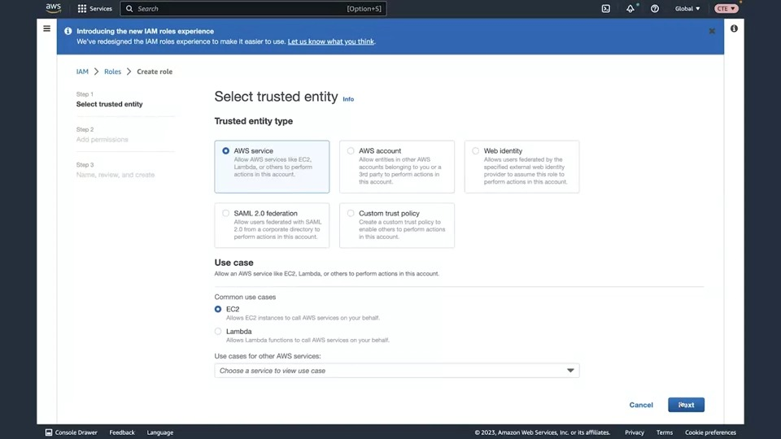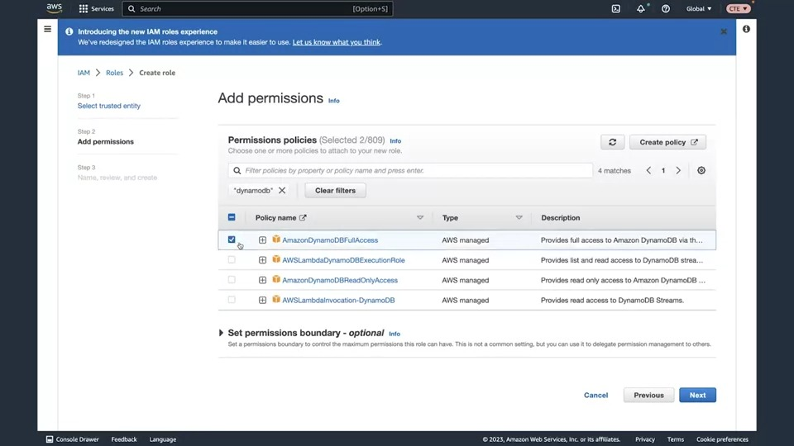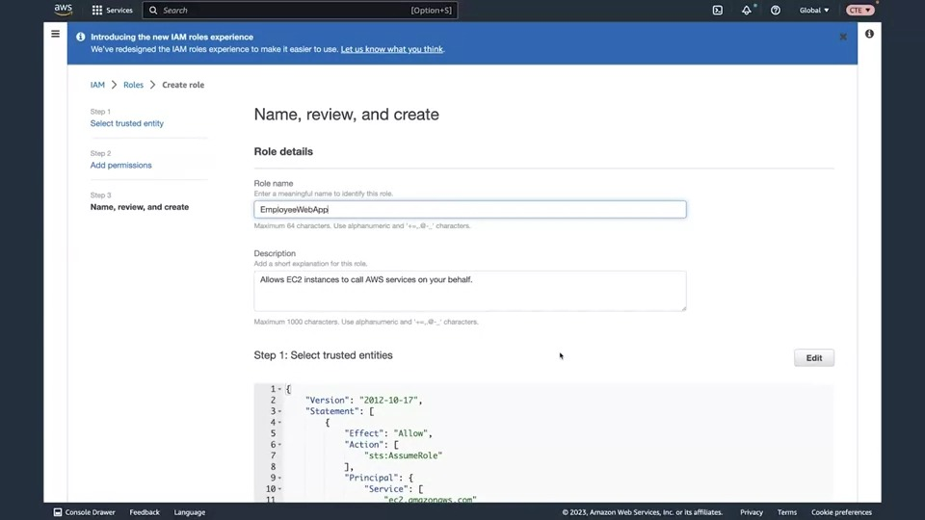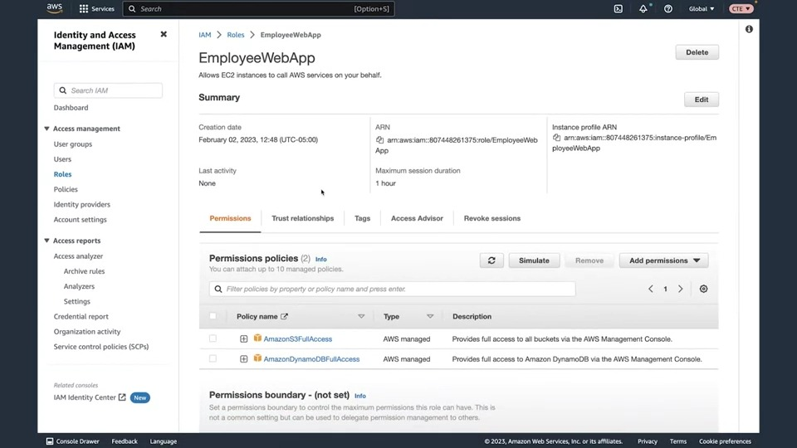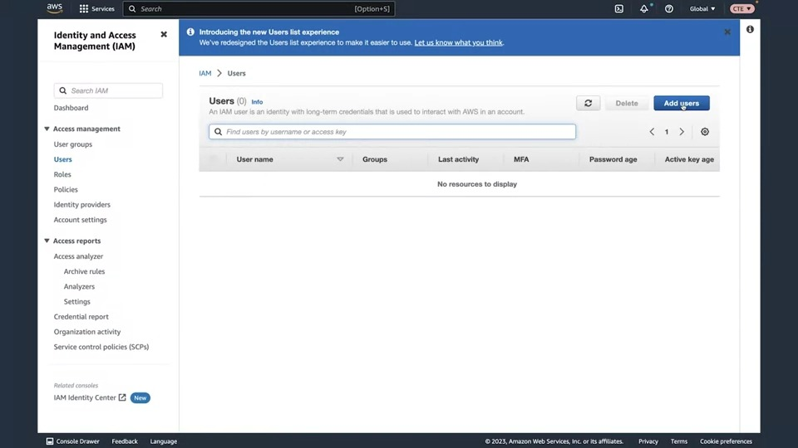**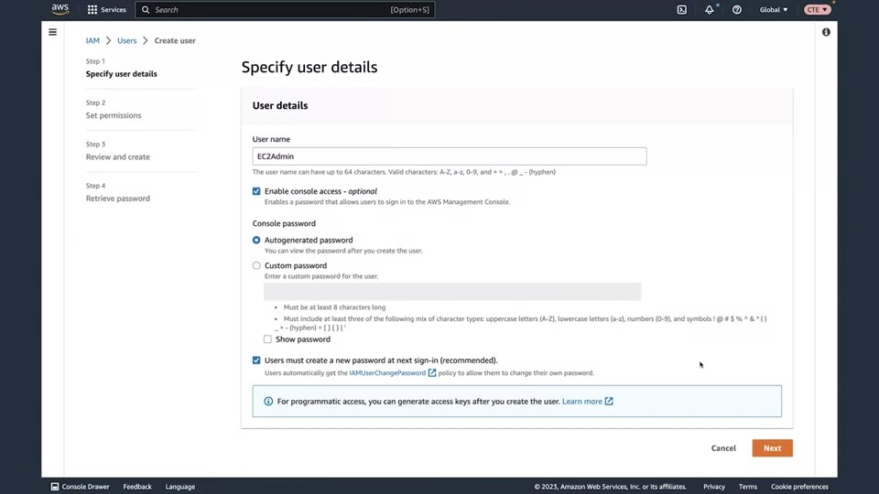[**Instructor] Hello everyone. In this video, we are going to create the IAM role for our employee directory application and we will also look at how to create users, and look at the different AWS access keys, which are used for programmatic access to AWS APIs. So to start off, let's create the role for our application by selecting Roles in the left-hand navigation of the IAM dashboard, and then we will click Create role.

On this page we need to select what the trusted entity type is to assume this role. We know that roles allow you to get access to temporary credentials that are used to make calls to AWS API calls. You wanna make sure that you're restricting who can assume this role. Not anyone can assume this role, right? So under the Trusted entity type we have the AWS service. An AWS service, that would be something like an EC2 instance, a Lambda function, other services that are assuming a role to make AWS API calls. You could have an AWS account, this would allow you to allow cross-account access to permissions for resources in your account. You also could select a web identity, which would allow for federated users to assume a role. You have a SAML 2.0 federation, so if you have a corporate directory that is on premises that would be using SAML, you could use this as your trusted entity type or you could create a Custom Trusts policy. We are going to select AWS service for this and then we are going to select EC2, since our employee directory application will be running on EC2. Next, we can select the Next button and then we're brought to the page to Add permissions. This lists out the different permissions policies that are in IAM, and right now it's pulling back the AWS managed policies that exist in this account by default. And what a managed policy is, is it is a policy that is created and managed by AWS, and so what I mean by that is, let's go ahead and look at the a policy for S3. so if I type in S3 in the search bar and then hit Enter, I'm going to expand this Amazon S3 full access policy and we can see the JSON, which is the permissions for this policy. We can see we have the effect is Allow, that's either gonna be Allow or Deny. There's no other option besides Allow or Deny, and then there's the action, which is going to define what AWS API calls are allowed to be made. So we can see that we have S3:* and S3-object-lambda:*. That's a wild card to determine all API calls are allowed against this service,

and then we also have the resource here, which is also set to *. So this would be all S3 resources. This is a very permissive policy. In the real world, you would likely want to change this to allow just the API calls that your application needs, nothing more, and just the resources that you intend to have this policy be related to. So to do that, you would have to create a custom policy. So if I scroll up, you could click on this Custom policy button, which would take you to a new page where you could then create your custom policy. For now, we're going to use the AWSs managed policies and I'm gonna select the checkbox for AmazonS3FullAccess. And then I'm also going to type in DynamoDB, and exit out of the S3 filter, and then select the AmazonDynamoDBFullAccess policy here as well. Because later in the course, we are going to be using DynamoDB as the database for this application. So to prepare the role, I've selected both the S3FullAccess and DynamoDBFullAccess.

Now we'll click Next. Then we can give this a name. I'm gonna name this EmployeeWebApp, and then I'm going to scroll down. We can view the trusted entities here, so this is our trust policy. We're allowing the API call STS AssumeRole, and who's allowed to assume this role? ec2.amazonaws.com. So an EC2 instance is going to be allowed to assume this role only. All right, so now I can scroll down and then click Create role.

Once your role is created, you can then click on the role, which will bring you to the page where you can see the information about this role, such as the ARN, the Amazon Resource Name, and you can also scroll down, you can view the permissions attached, you could add new permissions if you want to. You can simulate the permissions, you can view the trust relationships, you can also view any tags associated with this, which are key value pairs. So, this is where you can get all of the information about your role and then where you can manage your role. So, next what I wanna do is create a user. So I'm gonna click on users in the left-hand navigation, then I'm going to click Add users, and let's give this user a name. Let's say it's EC2Admin,

and then I want to click the checkbox for Enabling console access. So what that means is I want to allow this user to be able to sign in to the AWS management console. So note, by default, this was unchecked, meaning that just because you create a user doesn't mean they have access to the console. I'm gonna go ahead and check this, and then I'm gonna allow an auto-generated password to be created, and then I want to leave the checkbox checked for users to create a password at the next sign-in. So this will allow them to change their password once they log in for the first time. Now we'll click Next, and next what I want to do, is I'm going to add the users to a group. We currently don't have any groups, so I'm gonna go ahead and click Create group, and then what I wanna do is add a group name. Let's say this is EC2Admins,

and then I want to attach a policy to this group, because we know that it's a best practice to attach policies to groups, not to users directly. So I'm gonna select the AmazonEC2FullAccess policy, and then I'm gonna scroll down and click Create user group, and now I can select this user group to add this user into, and then I can click next, and then we can scroll down. We can see the permissions that this one user currently has. It will be inheriting the permissions from the EC2Admins group, and then it also has directly attached to it the IAMUserChangePassword permission, which will allow these user to change their password. So now we can click Create user,

and now we can go ahead and click Return to users list. We didn't download the password for this, that's fine. I don't intend to actually use this user. It's just for demonstration purposes, so we'll click Continue, and now if I click on this user, what I wanna do next is click on the Security Credentials tab, and if we scroll down, you can see that we have this panel here called Access keys. Access keys are going to allow your users to make programmatic calls to AWS using things like the AWS command line, the AWS software development kits, where maybe they're developing locally on their laptop, and they need their code to be able to reach out to AWS, so I'm gonna go ahead and create an access key here, and then I wanna use this for the command line, and then I'm gonna go ahead and click the checkbox for "I understand the above recommendation." What this is saying is it's saying, "Hey, there's another service in the browser that you could use to use the AWS CLI called AWS CloudShell." We're gonna go ahead and create the access keys anyways. I'm gonna select this checkbox and then click Next, and then I'm gonna click Next again, and click the Create access key. All right, so here you can see, we have our access key here, and then we have our secret access key, which is not being shown currently on this page, but you could click show and then copy it, and you would use this access key and secret access key to be able to configure your command line locally. Now I'll click Done and then click Continue. So now for a little bit of cleanup, I'm gonna select Actions and then I'm gonna click Deactivate and then Deactivate, and then I will click Actions and then Delete, and then we can copy and paste the access key ID here, and then click Delete. All right, that's it for this video. Hopefully you know a little bit more about roles and users.

### Hosting the employee directory application on aws

All right. You've learned some AWS vocabulary, some of the concepts behind cloud computing as well as some of the specifics around cloud identity and access management. As a refresher, let's take a look at the architecture diagram we'll be building out. You'll remember that it's fairly complicated at a glance. There are many different services working together to host this solution and to get this entire thing built out this way will take some time and understanding. You'll get the opportunity to see how each piece is built throughout the upcoming lessons. What I want to do now is show you how we are going to host our employee directory application using a service called Amazon EC2 which has been mentioned in previous videos. I find that the best way for me to explain to you how these services work is to show you how they work. So what we are going to do is we are going to call Seth in here to launch an Amazon EC2 instance and host the employee directory application using the defaults provided by AWS. AWS provides you with something called a default VPC which is a private network for your AWS resources. Every EC2 instance you launch using AWS must live inside of a network. So in order to complete this demo with the limited amount of information that we have shown you about AWS services, we will be using the default network provided by AWS and we will accept most of the default values for launching an EC2 instance. Let's bring Seth in for some help with this one. Hey Seth. - Hey, Morgan. Is it time to launch our first EC2 instance? - It is. We'll be using the default VPC to launch this first instance, and we will configure the bare minimum to get our application up and running. Sound good? - Yep. I got it. Let's get started.

I'm already in the EC2 management console and I will navigate to the service Amazon EC2. As Morgan already mentioned, Amazon EC2 is a compute service that allows you to host virtual machines. You'll learn a lot about this topic coming up soon but for now we are going to simply create an EC2 instance to try and help you wrap your mind around using AWS services on demand. From here, we'll launch a new EC2 instance. An instance is just what we call one single virtual machine. Now we have to select the configurations for this EC2 instance. You will go over these configurations in detail later. We can give this instance a name, I'll call it employee-web-app and then we will select the free tier eligible options using a Linux AMI or Amazon Machine Image. And then scrolling down to the next section we will select the free tier eligible t2.micro for the instance type.

Next, we normally need to select a key pair. This would be used to SSH into the instance but we won't need to do this, so I'm going to select proceed without a key pair and continue scrolling to the network settings.

Here we will select the network. So looking at network settings, we will click Edit.

Then we can select the VPC and subnet for this instance. And as we discussed earlier, we will use the default VPC and leave the subnet at No preference.

The default VPC has configurations in place that make this experimentation process a lot easier when you're first getting started with AWS. Again, we will define all of these things later. Continuing on with network settings, we will create a new security group which is an instance level firewall that will allow HTTP and HTTPS traffic in to reach the instance. So we will add inbound rules for both of those.

Now we will scroll down and expand advanced details. We will accept most of the defaults here except the IAM instance proefs and user data which we will provide a value for. For the IAM instance profile we will use the IAM role that will be used by the application, though this won't come into play until later when we have our S3 bucket created. But for now, let's click the dropdown and select that IAM role.

Now, scrolling down to the user data, this is a script that is going to run when the instance boots up. Let's go ahead and paste in our user data script. This script will download the source code for the app, start the web server, and kick off the application code so it's ready to start handling requests while you could have launched the instance then connected to it via SSH, configured and started your application manually. We have decided to use a script to automate this process on launch. Alright, now we can click Launch instance. It can take a few minutes for the instance to boot up so let's wait for that.

And now it's up and running. To access the instance, copy the IP address from the details listed below, paste it into a new browser tab, and there you go. It's up and ready to go.

Morgan, what do you think? - That looked great. It's exactly what I would expect at this point because there is no data being served from a database so I expect to see just a homepage with no info. So that's great. Thank you Seth for walking us through that. In upcoming lessons, we will discuss the specifics of not only EC2, but also networking on AWS. And you'll understand how everything we just kind of glossed over actually works, so stay tuned.

### Default Amazon Machine Image (AMI) for Amazon EC2

Hello learners!

As of March 15, 2023 the default Amazon Machine Image (AMI) for Amazon EC2 has been updated to use the Amazon Linux 2023 AMI. In the demonstrations for this course, we use the Amazon Linux 2 AMI. If you are following along with the videos please be aware that if you use the new Amazon Linux 2023 AMI with the user data the way it appears in the videos the script will not run properly and the application will not launch. We are in the process of updating the course to reflect this change.

In the meantime, there are a few ways to work around this issue. You can either use the Amazon Linux 2 AMI with the user data as shown in the demonstrations and this will resolve the issue, or you can use an updated version of the user data script which I will include in this message.

To recap, we have a new default AMI for EC2 instances called the Amazon Linux 2023 AMI. The videos show us using Amazon Linux 2. Because of changes between these two AMIs the user data script shown in the videos will not run properly on Amazon Linux 2023 based instances. You can either choose Amazon Linux 2 as the AMI when launching the instance, and use the original user data script or you can use the Amazon Linux 2023 AMI and use the updated user data script.

Amazon Linux 2 user data script:

#!/bin/bash -ex

wget https://aws-tc-largeobjects.s3-us-west-2.amazonaws.com/DEV-AWS-MO-GCNv2/FlaskApp.zip

unzip FlaskApp.zip

cd FlaskApp/

yum -y install python3 mysql

pip3 install -r requirements.txt

amazon-linux-extras install epel

yum -y install stress

export PHOTOS_BUCKET=${SUB_PHOTOS_BUCKET}

export AWS_DEFAULT_REGION=<INSERT REGION HERE>

export DYNAMO_MODE=on

FLASK_APP=application.py /usr/local/bin/flask run --host=0.0.0.0 --port=80

Amazon Linux 2023 user data script:

#!/bin/bash -ex

wget https://aws-tc-largeobjects.s3-us-west-2.amazonaws.com/DEV-AWS-MO-GCNv2/FlaskApp.zip

unzip FlaskApp.zip

cd FlaskApp/

yum -y install python3-pip

pip install -r requirements.txt

yum -y install stress

export PHOTOS_BUCKET=${SUB_PHOTOS_BUCKET}

export AWS_DEFAULT_REGION=<INSERT REGION HERE>

export DYNAMO_MODE=on

FLASK_APP=application.py /usr/local/bin/flask run --host=0.0.0.0 --port=80

When using the user data scripts, remember to replace the <INSERT REGION HERE> with whatever AWS region you are operating in, and ensure you remove both brackets as well.

## Week 2: AWS Compute & Networking

Week 2 is where you will learn how AWS compute services differ from other AWS services. The content for this week covers the basic components of Amazon Elastic Compute Cloud (Amazon EC2) architecture, and how to differentiate between a container and a virtual machine. You will also learn about the features and advantages of using serverless technologies, in addition to basic networking concepts and the features of Amazon Virtual Private Cloud (Amazon VPC).

### Reading 2.1: Compute as a Service on AWS

#### Understanding Servers

The first building block you need to host an application is a server. Servers often times can handle Hypertext Transfer Protocol (HTTP) requests and send responses to clients following the client-server model, though any API based communication also falls under this model. A client being a person or computer that seconds a request, and a server handling the requests is a computer, or collection of computers, connected to the internet serving websites to internet users.These servers power your application by providing CPU, memory, and networking capacity to process users’ requests and transform them into responses. For context, common HTTP servers include:

* Windows options, such as Internet Information Services (IIS).
* Linux options, such as Apache HTTP Web Server, Nginx, and Apache Tomcat.

To run an HTTP server on AWS, you need to find a service that provides compute power in the AWS Management Console. You can log into the console and view the complete list of AWS compute services.

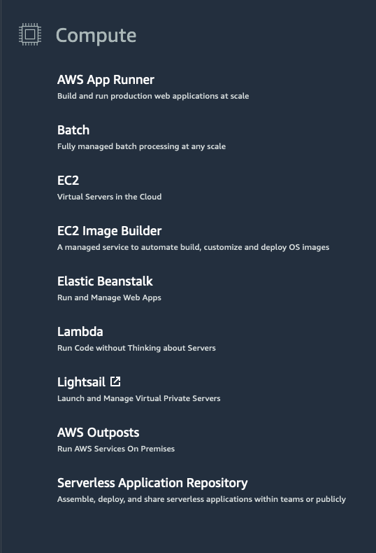

#### Choose the Right Compute Option

If you’re responsible for setting up servers on AWS to run your infrastructure, you have many compute options. You need to know which service to use for which use case. At a fundamental level, there are three types of compute options: virtual machines, container services, and serverless. If you’re coming to AWS with prior infrastructure knowledge, a virtual machine can often be the easiest compute option in AWS to understand. This is because a virtual machine emulates a physical server and allows you to install an HTTP server to run your applications. To run these virtual machines, you install a hypervisor on a host machine. This hypervisor provisions the resources to create and run your virtual machines.In AWS, these virtual machines are called Amazon Elastic Compute Cloud or Amazon EC2. Behind the scenes, AWS operates and manages the host machines and the hypervisor layer. AWS also installs the virtual machine operating system, called the guest operating system.Some AWS compute services use Amazon EC2 or use virtualization concepts under the hood, therefore it is best to understand this service first before moving on to container services and serverless compute.

#### **Resources**:

* [External Site: AWS: Compute Services Whitepaper](https://docs.aws.amazon.com/whitepapers/latest/aws-overview/compute-services.html)
* [External Site: AWS: Compute on AWS](https://aws.amazon.com/products/compute/)
* [External Site: AWS: AWS Compute Blog](https://aws.amazon.com/blogs/compute/)

### Reading 2.2: Introduction to Amazon Elastic Compute Cloud

#### What Is Amazon EC2?



Amazon EC2 is a web service that provides secure, resizable compute capacity in the cloud. It allows you to provision virtual servers called EC2 instances. Although AWS uses the phrase “web service” to describe it, it doesn’t mean that you are limited to running just web servers on your EC2 instances. You can create and manage these instances through the AWS Management Console, the AWS Command Line Interface (CLI), AWS Software Development Kits (SDKs), or through automation tools and infrastructure orchestration services.In order to create an EC2 instance, you need to define:

* Hardware specifications, like CPU, memory, network, and storage.
* Logical configurations, like networking location, firewall rules, authentication, and the operating system of your choice.

When launching an EC2 instance, the first setting you configure is which operating system you want by selecting an Amazon Machine Image (AMI).

#### What Is an AMI?

In the traditional infrastructure world, the process of spinning up a server consists of installing an operating system from installation disks, installation drives, or installation wizards over the network. In the AWS Cloud, this operating system installation is no longer your responsibility, and is instead built into the AMI that you choose.Not only does an AMI let you configure which operating system you want, you can also select storage mappings, the architecture type (such as 32-bit, 64-bit, or 64-bit ARM), and additional software installed.

#### What Is the Relationship Between AMIs and EC2 Instances?

EC2 instances are live instantiations of what is defined in an AMI, much like a cake is a live instantiation of a cake recipe. If you are familiar with software development, you can also see this kind of relationship between a Class and an Object.

A Class is something you model and define, while an object is something you interact with. In this case, the AMI is how you model and define your instance, while the EC2 instance is the entity you interact with, where you can install your web server, and serve your content to users.When you launch a new instance, AWS allocates a virtual machine that runs on a hypervisor. Then the AMI you selected is copied to the root device volume, which contains the image used to boot the volume. In the end, you get a server you can connect to and install packages and any additional software. In this case, you install a web server along with the properly configured source code of your employee directory app.

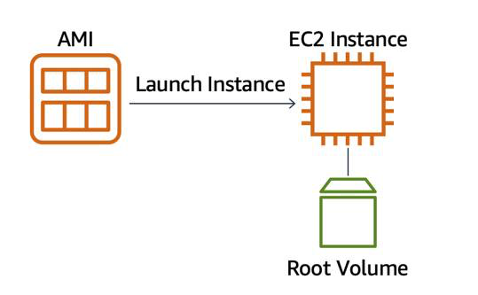

One advantage of using AMIs is that they are reusable.

You might choose a Linux-based AMI and configure the HTTP server, application packages, and any additional software you may need to run your application.

If you wanted to create a second EC2 instance with the same configurations, how can you easily do that? One option is to go through the entire instance creation and configuration process and try to match your settings to the first instance. However, this is time consuming and leaves room for human error.

The second, better option, is to create an AMI from your running instance and use this AMI to start a new instance. This way, your new instance will have all the same configurations as your current instance, because the configurations set in the AMIs are the same.

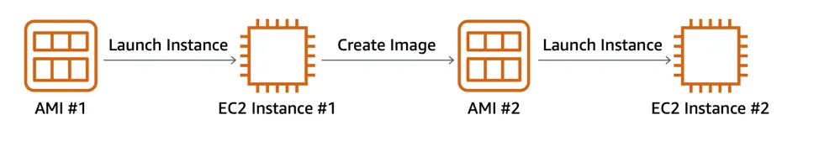

#### Where Can You Find AMIs?

You can select an AMI from the following categories.

* Quick Start AMIs that are premade by AWS and allow you to get started quickly.
* AWS Marketplace AMIs that provide popular open source and commercial software from third-party vendors.
* My AMIs that are created from your EC2 instances.
* Community AMIs that are provided by the AWS user community.
* Build your own custom image with EC2 Image Builder.

Each AMI in the AWS Management Console has an AMI ID, which is prefixed by “ami-”, followed by a random hash of numbers and letters. These IDs are unique to each AWS region.

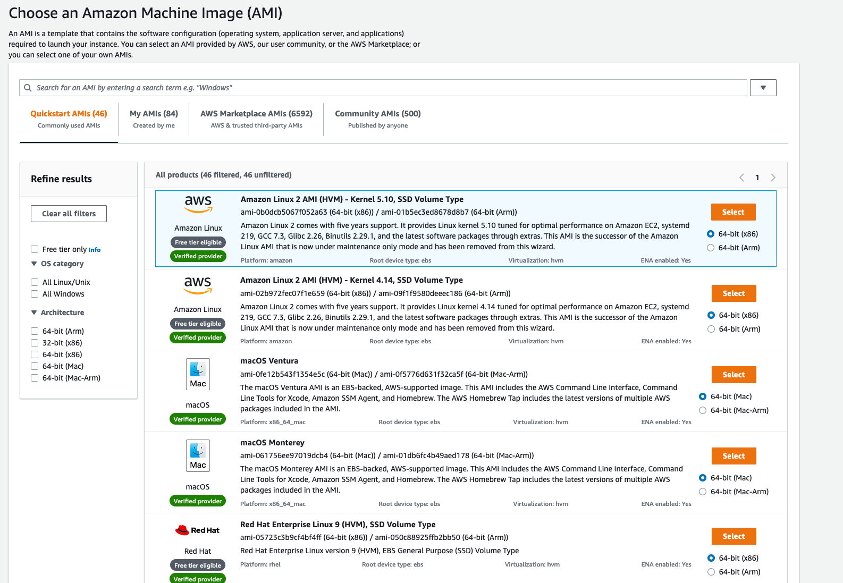

#### **Resources**:

* [External Site: AWS: Amazon EC2](https://aws.amazon.com/ec2/)
* [External Site: AWS: Amazon Machine Images (AMI)](https://docs.aws.amazon.com/AWSEC2/latest/UserGuide/AMIs.html)
* [External Site: AWS: Creating an Amazon EBS-backed Linux AMI](https://docs.aws.amazon.com/AWSEC2/latest/UserGuide/creating-an-ami-ebs.html)
* [External Site: AWS: What Is EC2 Image Builder?](https://docs.aws.amazon.com/imagebuilder/latest/userguide/what-is-image-builder.html)

Building an elastic application means that the resources it needs are added or removed dynamically. 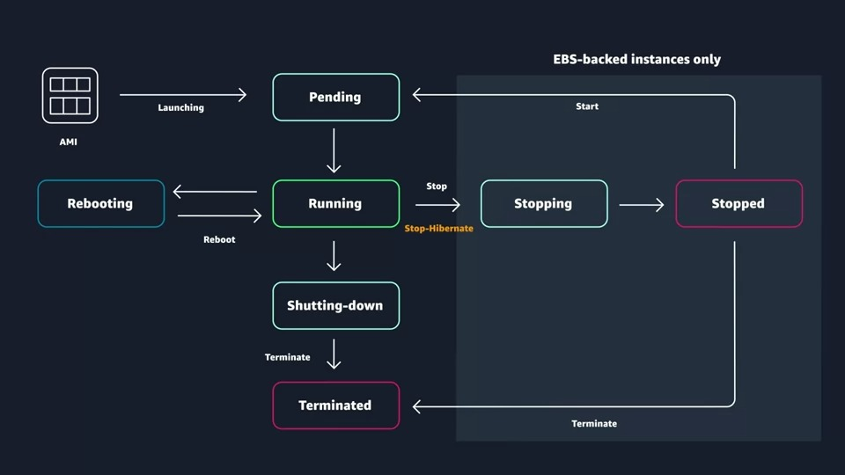

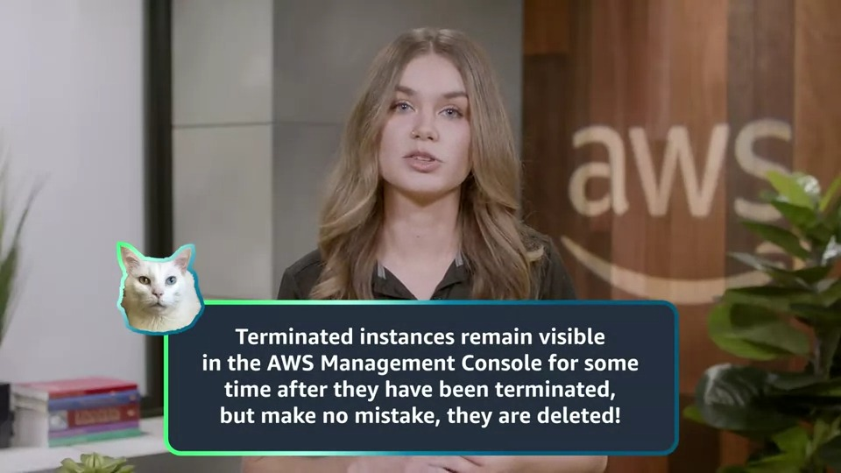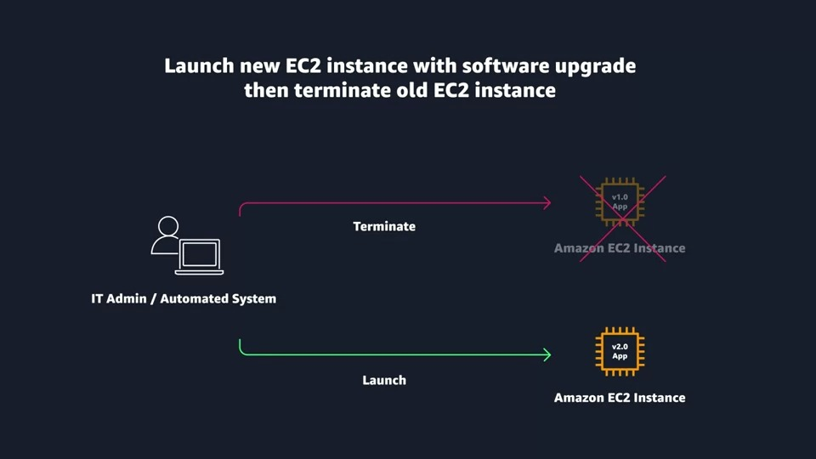

### Reading 2.25: Amazon EC2 Instance Lifecycle

Now that you know how to select an operating system for your EC2 instance, it’s time to choose other configurations to create your EC2 instance, such as the instance type, network, and storage. For an application like the employee directory application, you need instances with enough capacity to run web servers and process incoming customer requests. Your instance sizing will depend on both the demands of your application and the anticipated size of your user base. Forecasting server capacity for an on-premises application requires difficult decisions involving significant up-front capital spending, while changes to the allocation of your cloud-based services can be made with a simple API call. Because of AWS’s pay-as-you-go model, you can match your infrastructure capacity to your application’s demand, instead of the other way around.

#### What Makes Up an EC2 Instance?

EC2 instances are a combination of virtual processors (vCPUs), memory, network, and in some cases, instance storage and graphics processing units (GPUs). When you create an EC2 instance, you need to choose how much you need of each of these components.

AWS offers a variety of instances that differ based on performance. Some instances provide you with more capacity and others provide less. To get an overview of the capacity details for a particular instance, you should look at the instance type. Instance types consist of a prefix identifying the type of workloads they’re optimized for, followed by a size. For example, the instance type c5.large can be broken down into the following elements.

* **c5** determines the instance family and generation number. Here, the instance belongs to the fifth generation of instances in an instance family that’s optimized for generic computation.
* **large**, which determines the amount of instance capacity.

#### What Are Instance Families?

| **Instance Family** | **Description** | **Use Cases** |
| --- | --- | --- |
| General purpose | Provides a balance of compute, memory, and networking resources, and can be used for a variety of workloads. | Scale-out workloads such as web servers, containerized microservices, caching fleets, distributed data stores, and development environments. |
| Compute optimized | Ideal for compute-bound applications that benefit from high-performance processors. | High-performance web servers, scientific modeling, batch processing, distributed analytics, high-performance computing (HPC), machine/deep learning, ad serving, highly scalable multiplayer gaming. |
| Memory optimized | Designed to deliver fast performance for workloads that process large data sets in memory. | Memory-intensive applications such as high-performance databases, distributed web-scale in-memory caches, mid-size in-memory databases, real-time big-data analytics, and other enterprise applications. |
| Accelerated computing | Use hardware accelerators or co-processors to perform functions such as floating-point number calculations, graphics processing, or data pattern matching more efficiently than is possible with conventional CPUs. | 3D visualizations, graphics-intensive remote workstations, 3D rendering, application streaming, video encoding, and other server-side graphics workloads. |
| Storage optimized | Designed for workloads that require high, sequential read and write access to large data sets on local storage. They are optimized to deliver tens of thousands of low-latency random I/O operations per second (IOPS) to applications that replicate their data across different instances. | NoSQL databases, such as Cassandra, MongoDB, and Redis, in-memory databases, scale-out transactional databases, data warehousing, Elasticsearch, and analytics. |

#### Where Does Your EC2 Instance Live?

By default, your EC2 instances are placed in a network called the default Amazon Virtual Private Cloud (VPC). This network was created so that you can easily get started with Amazon EC2 without having to learn how to create and configure a VPC. Any resource you put inside the default VPC will be public and accessible by the internet, so you shouldn’t place any customer data or private information inside of it. Once you get more comfortable with networking on AWS, you should change this default setting to choose your own custom VPCs and restrict access with additional routing and connectivity mechanisms.

#### Architect for High Availability

Inside this network, your instance resides in an Availability Zone of your choice. AWS services that are scoped at the Availability Zone level must be architected with high availability in mind. While EC2 instances are typically reliable, two is better than one, and three is better than two. Specifying the instance size gives you an advantage when designing your architecture because you can use more smaller instances instead of a few larger ones. If your frontend only has a single instance and that instance fails, your application goes down. On the other hand, if your workload is distributed across 10 instances and one fails, you lose only 10 percent of your fleet and your application availability is hardly affected. When architecting any application for high availability, consider using at least two EC2 instances in two separate Availability Zones. ­­

#### Explore the EC2 Instance Lifecycle

An EC2 instance transitions between different states from the moment you create it all the way through to its termination.

When you launch an instance, it enters the pending state (1). When the instance is pending, billing has not started. At this stage, the instance is preparing to enter the running state. Pending is where AWS performs all actions needed to set up an instance, such as copying the AMI content to the root device and allocating the necessary networking components. When your instance is running (2), it's ready to use. This is also the stage where billing begins. As soon as an instance is running, you are then able to take other actions on the instance, such as reboot, terminate, stop, and stop-hibernate. When you reboot an instance (3), it’s different than performing a stop action and then a start action. Rebooting an instance is equivalent to rebooting an operating system. The instance remains on the same host computer and maintains its public and private IP address, and any data on its instance store. It typically takes a few minutes for the reboot to complete. When you stop and start an instance (4), your instance may be placed on a new underlying physical server. Therefore, you lose any data on the instance store that were on the previous host computer. When you stop an instance, the instance gets a new public IP address but maintains the same private IP address. When you terminate an instance (5), the instance store are erased, and you lose both the public IP address and private IP address of the machine. Termination of an instance means you can no longer access the machine.

#### What Is the Difference Between Stop and Stop-Hibernate?

When you stop your instance, it enters the stopping state, and then the stopped state. AWS does not charge usage or data transfer fees for your instance after you stop it, but storage for any Amazon EBS volumes is still charged. While your instance is in the stopped state, you can modify some attributes, like the instance type. When you stop your instance, the data stored in memory (RAM) is lost. When you stop-hibernate your instance, AWS signals the operating system to perform hibernation (suspend-to-disk), which saves the contents from the instance memory (RAM) to the Amazon EBS root volume. Consider a scenario where you build a standard three tier application, where you have web servers, application servers and database servers. Turns out, the application you built becomes extremely popular. To relieve some stress on the database that supports your application, you want to implement a custom backend layer that caches database information in memory (RAM). You decide to run this custom backend caching solution on Amazon EC2. In this scenario, the stop-hibernate feature would be instrumental in persisting storage. It would prevent you from having to manually create scripts to save this RAM data before shutting down the server.

#### What Makes Up the Pricing?

To understand EC2 pricing, let’s decouple the instance price from other services attached to it, such as storage and networking costs. In this unit we refer to the instance cost as the cost associated with the instance in terms of specifications and not the total blended cost of running an instance. Once an instance is launched in your AWS account, the billing usually accrues on a per-second basis. For simplicity of calculation, prices are stated per-hour. For example, if you have an instance running for 5 minutes and 38 seconds during a given month, you only pay for 338 seconds of utilization at the end of the month. One exception to this pricing convention may be third-party AMIs purchased from the AWS Marketplace, which may have a minimum billing of 1 hour. For more details, check out the resources section of this unit.

#### What Are the EC2 Pricing Options?

One of the ways to reduce costs with Amazon EC2 is to choose the right pricing option for the way your applications run. There are three main purchasing options for EC2 instances: on-demand, reserved, and spot instances.

#### Pay As You Go with On-Demand Instances

With On-Demand instances, you pay for compute capacity with no long-term commitments. Billing begins whenever the instance is running, and billing stops when the instance is in a stopped or terminated state. The price per second for a running On-Demand instance is fixed. For applications that require servers to be running all the time, you are less likely to benefit from the On-Demand pricing model, simply because there is no situation where you will need to turn servers off. For example, you might want the web server hosting the frontend of your corporate directory application to be running 24/7 so that users can access the website at any time. Even if there are no users connected to your website, you don’t want to shut down the servers supporting the site in case of potential user activity. In the case when servers cannot be stopped, consider using a Reserved Instance to save on costs.

#### Reserve Capacity with Reserved Instances (RIs)

RIs provide you with a significant discount compared to On-Demand instance pricing. RIs provide a discounted hourly rate and an optional capacity reservation for EC2 instances. You can choose between three payment options: All Upfront, Partial Upfront, or No Upfront. You can select either a 1-year or 3-year term for each of these options. Depending on which option you choose, you are discounted differently.

* All Upfront offers a higher discount than Partial Upfront instances.
* Partial Upfront instances offer a higher discount than No Upfront.
* No Upfront offers a higher discount than On-Demand.

On-Demand and No Upfront are similar since both do not require any upfront payment. However, there is a major difference. When you choose an On-Demand instance, you stop paying for the instance when you stop or terminate the instance. When you stop an RI, you still pay for it because you committed to a 1-year or 3-year term. Reserved Instances are associated with an instance type and an Availability Zone depending on how you reserve it. The discount applied by a Reserved Instance purchase is not directly associated with a specific instance ID, but with an instance type.

#### Save on Costs with Spot Instances

Another way of paying for EC2 instances is by using Spot Instances. Amazon EC2 Spot Instances allow you to take advantage of unused EC2 capacity in the AWS Cloud. They are available at up to a 90% discount compared to On-Demand prices. With Spot Instances, you set a limit on how much you would like to pay for the instance hour. This is compared against the current Spot price that AWS determines. If the amount you pay is more than the current Spot price and there is capacity, then you will receive an instance. While they are very promising from the billing perspective, there are some architectural considerations you will need to consider in order to use them effectively. One consideration is that your spot instance may be interrupted. For example, if AWS determines that capacity is no longer available for a particular spot instance or if the Spot price exceeds how much you are willing to pay, AWS will give you a 2-minute warning before it interrupts your instance. That means any application or workload that runs on a Spot instance must be able to be interrupted. Because of this unique consideration, inherently fault-tolerant workloads are typically good candidates to use with Spot instances. These include big data, containerized workloads, continuous integration/continuous delivery (CI/CD), web servers, high-performance computing (HPC), image and media rendering, or other test and development workloads.

#### **Resources**

* [External Site: AWS: Amazon EC2](https://aws.amazon.com/ec2/)
* [External Site: AWS: Default VPC and default subnets](https://docs.aws.amazon.com/vpc/latest/userguide/default-vpc.html)
* [External Site: AWS: AWS Reliability Pillar](https://docs.aws.amazon.com/wellarchitected/latest/reliability-pillar/welcome.html)
* [External Site: AWS: Instance lifecycle](https://docs.aws.amazon.com/AWSEC2/latest/UserGuide/ec2-instance-lifecycle.html)
* [External Site: AWS: Amazon EC2 pricing](https://aws.amazon.com/ec2/pricing/)
* [External Site: AWS: Amazon EC2 On-Demand Pricing](https://aws.amazon.com/ec2/pricing/on-demand/)
* [External Site: AWS: Amazon EC2 Spot Instances Pricing](https://aws.amazon.com/ec2/spot/pricing/)
* [External Site: AWS: Amazon EC2 Reserved Instances Pricing](https://aws.amazon.com/ec2/pricing/reserved-instances/pricing/)

### Reading 2.3: Container Services on AWS

AWS offers a broad spectrum of compute offerings that give you the flexibility to choose the right tool for the right job. The three main categories of compute are virtual machines, containers, and serverless. There is no one-size-fits-all service because it depends on your needs.The key is to understand what each option has to offer in order to build a more appropriate cloud architecture for your use case. In this unit, you learn about containers and how to run them on AWS.Containers can host a variety of different workloads, including web applications, lift and shift migrations, distributed applications, and streamlining of development, test, and production environments.

#### WHAT IS A CONTAINER?

While containers are often referred to as a new technology, the idea started in the 1970s with certain Linux kernels having the ability to separate their processes through isolation. At the time, this was configured manually, making operations complex.With the evolution of the open source software community, containers evolved. Today, containers are used as a solution to problems of traditional compute, including the issue of getting software to run reliably when it moves from one compute environment to another.A container is a standardized unit that packages up your code and all of its dependencies. This package is designed to run reliably on any platform, because the container creates its own independent environment. This makes it easy to carry workloads from one place to another, such as from development to production or from on-premises to the cloud.

#### WHAT IS DOCKER?

When you hear the word container, you may associate it with Docker. Docker is a popular container runtime that simplifies the management of the entire operating system stack needed for container isolation, including networking and storage. Docker makes it easy to create, package, deploy, and run containers.

#### WHAT IS THE DIFFERENCE BETWEEN CONTAINERS AND VMS?

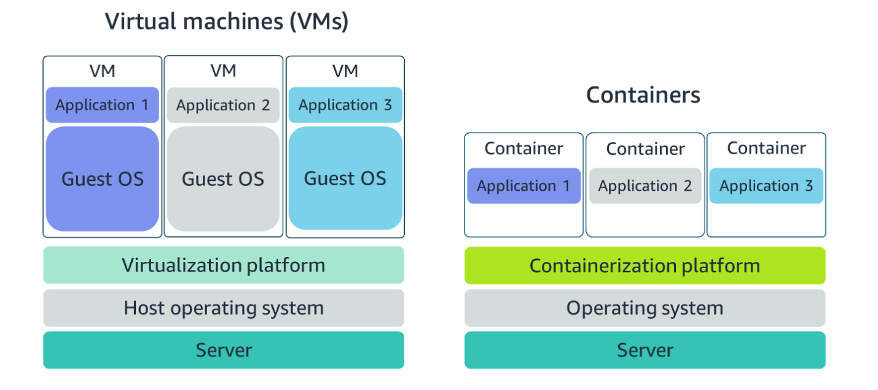

Containers share the same operating system and kernel as the host they exist on, whereas virtual machines contain their operating system. Since each virtual machine has to maintain a copy of an operating system, there’s a degree of wasted space.A container is more lightweight. They spin up quicker, almost instantly. This difference in startup time becomes instrumental when designing applications that need to scale quickly during input/output (I/O) bursts.While containers can provide speed, virtual machines offer you the full strength of an operating system and offer more resources, like package installation, a dedicated kernel, and more.

#### ORCHESTRATE CONTAINERS

In AWS, containers run on EC2 instances. For example, you may have a large instance and run a few containers on that instance.While running one instance is easy to manage, it lacks high availability and scalability. Most companies and organizations run many containers on many EC2 instances across several Availability Zones.If you’re trying to manage your compute at a large scale, you need to know:

* How to place your containers on your instances.
* What happens if your container fails.
* What happens if your instance fails.
* How to monitor deployments of your containers.

This coordination is handled by a container orchestration service. AWS offers two container orchestration services: Amazon Elastic Container Service (ECS) and Amazon Elastic Kubernetes Service (EKS).

#### MANAGE CONTAINERS WITH AMAZON ELASTIC CONTAINER SERVICE (AMAZON ECS)

Amazon ECS is an end-to-end container orchestration service that allows you to quickly spin up new containers and manage them across a cluster of EC2 instances.

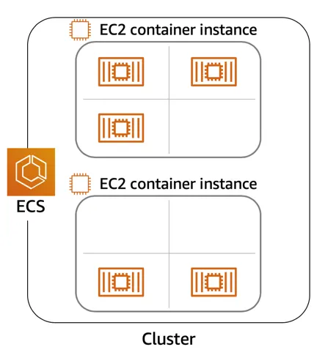

To run and manage your containers, you need to install the Amazon ECS Container Agent on your EC2 instances. This agent is open source and responsible for communicating back to the Amazon ECS service about cluster management details. You can run this agent on both Linux and Windows AMIs. An instance with the container agent installed is often called a container instance.

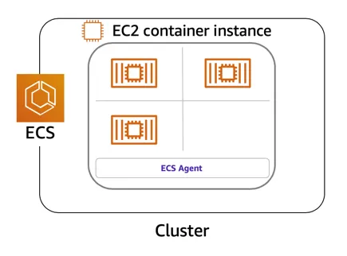

Once the Amazon ECS container instances are up and running, you can perform actions that include, but are not limited to, launching and stopping containers, getting cluster state, scaling in and out, scheduling the placement of containers across your cluster, assigning permissions, and meeting availability requirements.

To prepare your application to run on Amazon ECS, you create a task definition. The task definition is a text file, in JSON format, that describes one or more containers. A task definition is similar to a blueprint that describes the resources you need to run that container, such as CPU, memory, ports, images, storage, and networking information.

Here is a simple task definition that you can use for your corporate director application. In this example, the runs on the Nginx web server.

**{**

**"family": "webserver",**

**"containerDefinitions": [ {**

**"name": "web",**

**"image": "nginx",**

**"memory": "100",**

**"cpu": "99"**

**} ],**

**"requiresCompatibilities": [ "FARGATE" ],**

**"networkMode": "awsvpc",**

**"memory": "512",**

**"cpu": "256"**

**}**

#### USE KUBERNETES WITH AMAZON ELASTIC KUBERNETES SERVICE (AMAZON EKS)

Kubernetes is a portable, extensible, open source platform for managing containerized workloads and services. By bringing software development and operations together by design, Kubernetes created a rapidly growing ecosystem that is very popular and well established in the market.If you already use Kubernetes, you can use Amazon EKS to orchestrate these workloads in the AWS Cloud.Amazon EKS is conceptually similar to Amazon ECS, but there are some differences.

* An EC2 instance with the ECS Agent installed and configured is called a container instance. In Amazon EKS, it is called a worker node.
* An ECS Container is called a task. In the Amazon EKS ecosystem, it is called a pod.
* While Amazon ECS runs on AWS native technology, Amazon EKS runs on top of Kubernetes.

If you have containers running on Kubernetes and want an advanced orchestration solution that can provide simplicity, high availability, and fine-grained control over your infrastructure, Amazon EKS is the tool for you.

#### ****Resources****:

* [External Site: AWS: Containers on AWS](https://aws.amazon.com/containers/services/)
* [External Site: Docker: What Is a Container?](https://www.docker.com/resources/what-container)
* [External Site: AWS: Amazon Elastic Container Service](https://aws.amazon.com/ecs/)
* [External Site: Github: Amazon ECS Agent](https://github.com/aws/amazon-ecs-agent)
* [External Site: AWS: Amazon ECS container instances](https://docs.aws.amazon.com/AmazonECS/latest/developerguide/ECS_instances.html)
* [Coursera Course: Building Containerized Applications on AWS](https://www.coursera.org/learn/containerized-apps-on-aws)

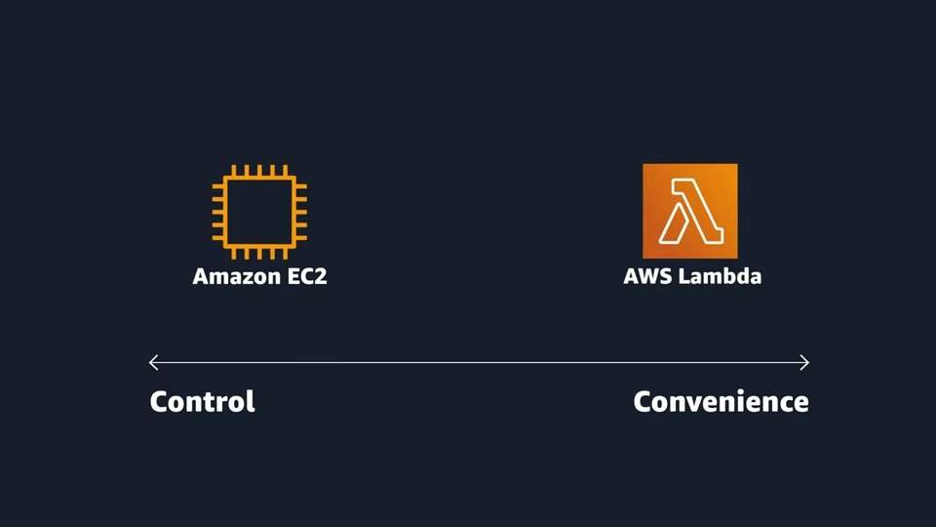 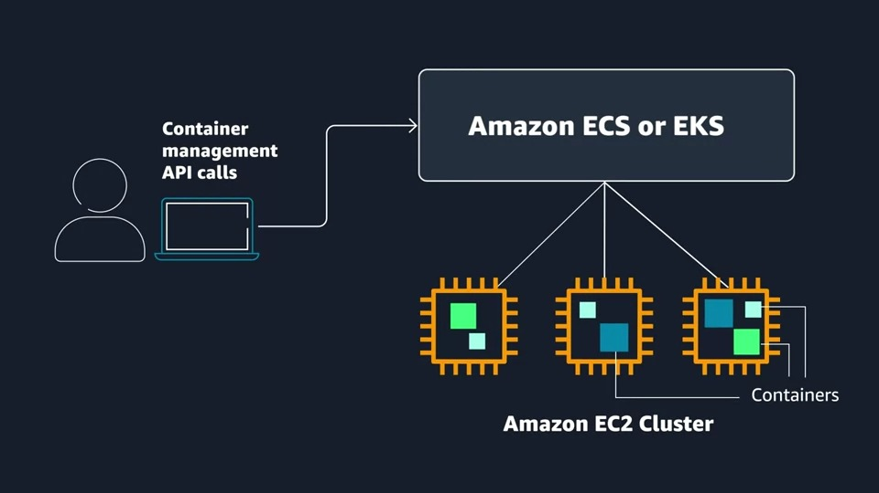 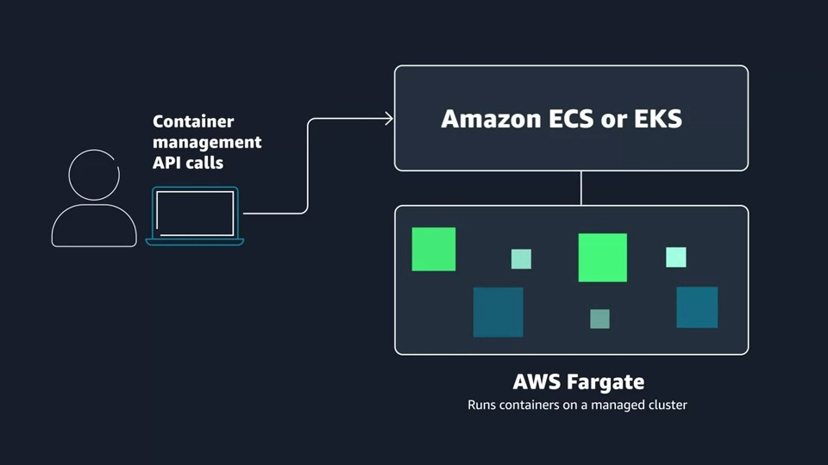 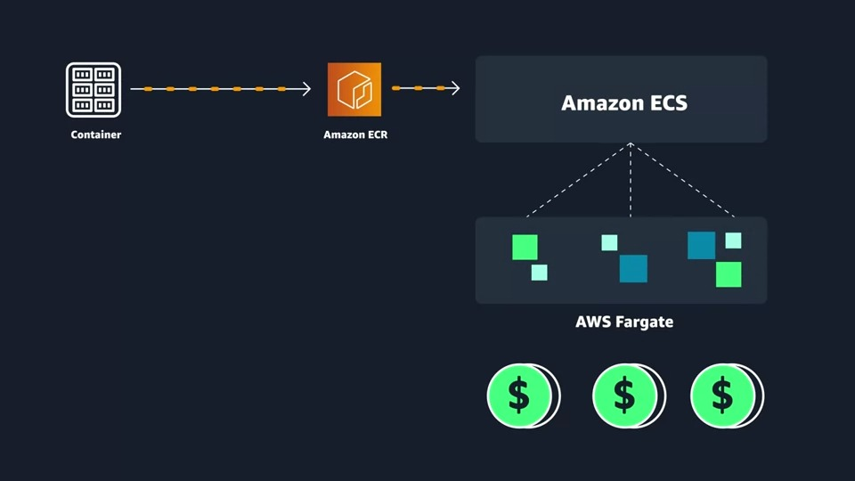

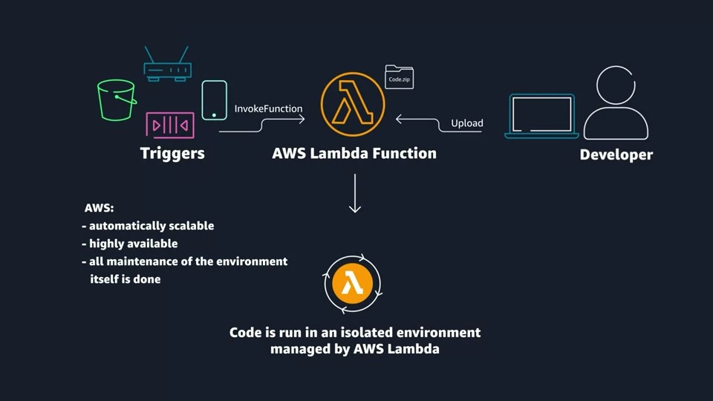 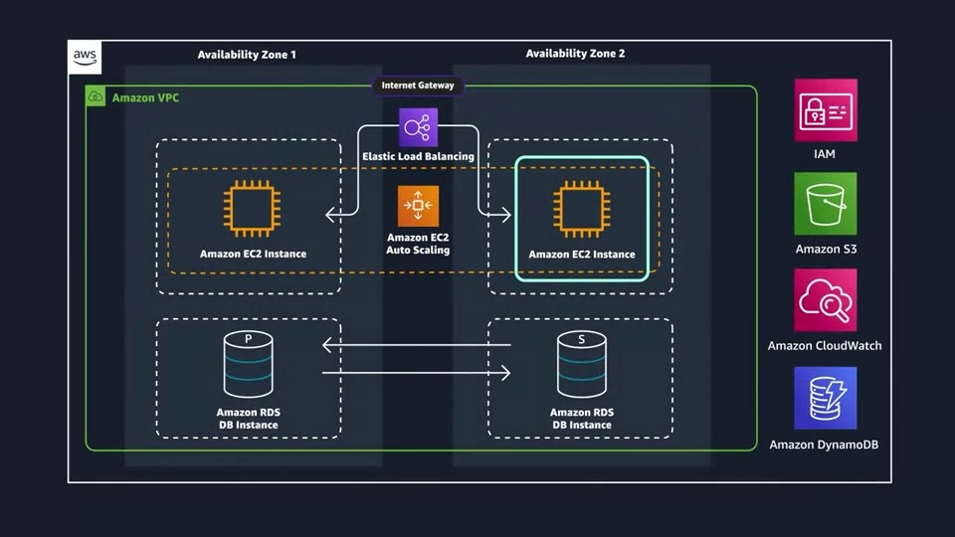

### Reading 2.4: Serverless and AWS Lambda

#### ****REMOVE THE UNDIFFERENTIATED HEAVY LIFTING****

If you run your code on Amazon EC2, AWS is responsible for the physical hardware and you are responsible for the logical controls, such as guest operating system, security and patching, networking, security, and scaling.If you run your code in containers on Amazon ECS and Amazon EKS, AWS is responsible for more of the container management, such as deploying containers across EC2 instances and managing the container cluster. However, when running ECS and EKS on EC2, you are still responsible for maintaining the underlying EC2 instances.If you want to deploy your workloads and applications without having to manage any EC2 instances, you can do that on AWS with serverless compute.

#### ****GO SERVERLESS****

Every definition of serverless mentions four aspects.

No servers to provision or manage.

Scales with usage.

You never pay for idle resources.

Availability and fault tolerance are built-in.

With serverless, spend time on the things that differentiate your application, rather than spending time on ensuring availability, scaling, and managing servers.AWS has several serverless compute options, including AWS Fargate and AWS Lambda.

#### ****EXPLORE SERVERLESS CONTAINERS WITH AWS FARGATE****

Amazon ECS and Amazon EKS enable you to run your containers in two modes.

Amazon EC2 mode

AWS Fargate mode

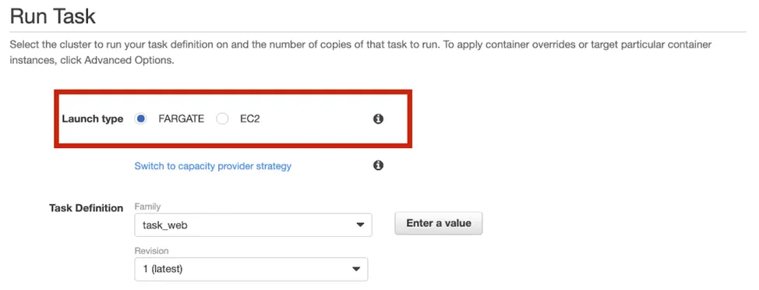

AWS Fargate is a purpose-built serverless compute engine for containers. Fargate scales and manages the infrastructure, allowing developers to work on what they do best: application development.It achieves this by allocating the right amount of compute, eliminating the need to choose and handle EC2 Instances and cluster capacity and scaling. Fargate supports both Amazon ECS and Amazon EKS architecture and provides workload isolation and improved security by design.

AWS Fargate abstracts the EC2 instance so you’re not required to manage it. However, with AWS Fargate, you can use all the same ECS primitives, APIs, and AWS integrations. It natively integrates with AWS Identity and Access Management (IAM) and Amazon Virtual Private Cloud (VPC). Having native integration with Amazon VPC allows you to launch Fargate containers inside your network and control connectivity to your applications.

#### ****RUN YOUR CODE ON AWS LAMBDA****

If you want to deploy your workloads and applications without having to manage any EC2 instances or containers, you can use AWS Lambda.AWS Lambda lets you run code without provisioning or managing servers or containers. You can run code for virtually any type of application or backend service, including data processing, real-time stream processing, machine learning, WebSockets, IoT backends, mobile backends, and web apps, like your corporate directory app!

AWS Lambda requires zero administration from the user. You upload your source code and Lambda takes care of everything required to run and scale your code with high availability. There are no servers to manage, bringing you continuous scaling with subsecond metering and consistent performance.

#### ****HOW LAMBDA WORKS****

There are three primary components of a Lambda function: the trigger, code, and configuration.The code is source code, that describes what the Lambda function should run. This code can be authored in three ways.

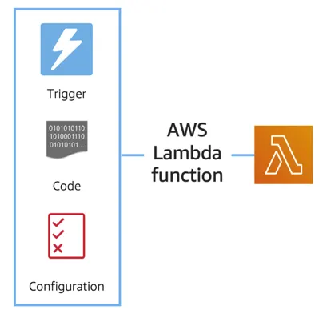

You create the code from scratch.

You use a blueprint that AWS provides.

You use same code from the AWS Serverless Application Repository, a resource that contains sample applications, such as “hello world” code, Amazon Alexa Skill sample code, image resizing code, video encoding, and more.

When you create your Lambda function, you specify the runtime you want your code to run in. There are built-in runtimes such as Python, Node.js, Ruby, Go, Java, .NET Core, or you can implement your Lambda functions to run on a custom runtime.The configuration of a Lambda function consists of information that describes how the function should run. In the configuration, you specify network placement, environment variables, memory, invocation type, permission sets, and other configurations. To dive deeper into these configurations, check out the resources section of this unit.Triggers describe when the Lambda function should run.

A trigger integrates your Lambda function with other AWS services, enabling you to run your Lambda function in response to certain API calls that occur in your AWS account. This makes you quicker to respond to events in your console without having to perform manual actions.All you need is the what, how, and when of a Lambda function to have functional compute capacity that runs only when you need it to.Amazon’s CTO, Werner Vogels, says, “No server is easier to manage than no server.” This quote summarizes the convenience you can have when running serverless solutions, like AWS Fargate and AWS Lambda.

In the next unit, you apply all the information you’ve learned about Amazon EC2, Amazon ECS and Amazon EKS, and AWS Fargate and learn the use cases for each service.

#### ****AWS Lambda function handler****

The AWS Lambda function handler is the method in your function code that processes events. When your function is invoked, Lambda runs the handler method. When the handler exits or returns a response, it becomes available to handle another event.You can use the following general syntax when creating a function handler in Python:

def handler_name(event, context): ... return some_value

#### ****NAMING****

The Lambda function handler name specified at the time you create a Lambda function is derived from the following:the name of the file in which the Lambda handler function is locatedthe name of the Python handler functionA function handler can be any name; however, the default on the Lambda console is lambda_function.lambda_handler. This name reflects the function name as lambda_handler, and the file where the handler code is stored in lambda_function.py.If you choose a different name for your function handler on the Lambda console, you must update the name on the **Runtime settings** pane.

#### ****BILLING GRANULARITY****

AWS Lambda lets you run code without provisioning or managing servers, and you pay only for what you use. You are charged for the number of times your code is triggered (requests) and for the time your code executes, rounded up to the nearest 1ms (duration). AWS rounds up duration to the nearest millisecond with no minimum execution time. With this pricing, it can be very cost effective to run functions whose execution time is very low, such as functions with durations under 100ms or low latency APIs. For more information, see AWS News Blog.

#### **SOURCE CODE**

This video used a small amount of sample code illustrating a pattern for lazily generating assets using AWS Lambda and Amazon S3. If you’re looking to deploy a service to resize images to production, consider using the new release  [Serverless Image Handler](https://aws.amazon.com/answers/web-applications/serverless-image-handler/)which is a robust solution to handle image manipulation and can be deployed via an AWS CloudFormation template.

You can find a tutorial on creating the AWS Lambda function as well as the code used in the AWS Lambda demo here: see [AWS News Blog](https://aws.amazon.com/blogs/compute/resize-images-on-the-fly-with-amazon-s3-aws-lambda-and-amazon-api-gateway/).

#### **Resources**:

[External Site: AWS: Serverless](https://aws.amazon.com/serverless/#:~:text=Serverless%20is%20the%20native%20architecture,services%20without%20thinking%20about%20servers.)

[Coursera Course: Building Modern Python Applications on AWS](https://www.coursera.org/learn/building-modern-python-applications-on-aws)

[External Site: AWS: AWS Serverless resources](https://aws.amazon.com/serverless/resources/?serverless.sort-by=item.additionalFields.createdDate&serverless.sort-order=desc)

[External Site: AWS: Building Applications with Serverless Architectures](https://aws.amazon.com/lambda/serverless-architectures-learn-more/)

[External Site: AWS: Best practices for organizing larger serverless applications](https://aws.amazon.com/blogs/compute/best-practices-for-organizing-larger-serverless-applications/)

[External Site: AWS: Managing AWS Lambda functions](https://docs.aws.amazon.com/lambda/latest/dg/lambda-functions.html)

[External Site: AWS: 10 Things Serverless Architects Should Know](https://aws.amazon.com/blogs/architecture/ten-things-serverless-architects-should-know/)

[External Site: AWS: AWS Alien Attack! A Serverless Adventure](https://alienattack.workshop.aws/)

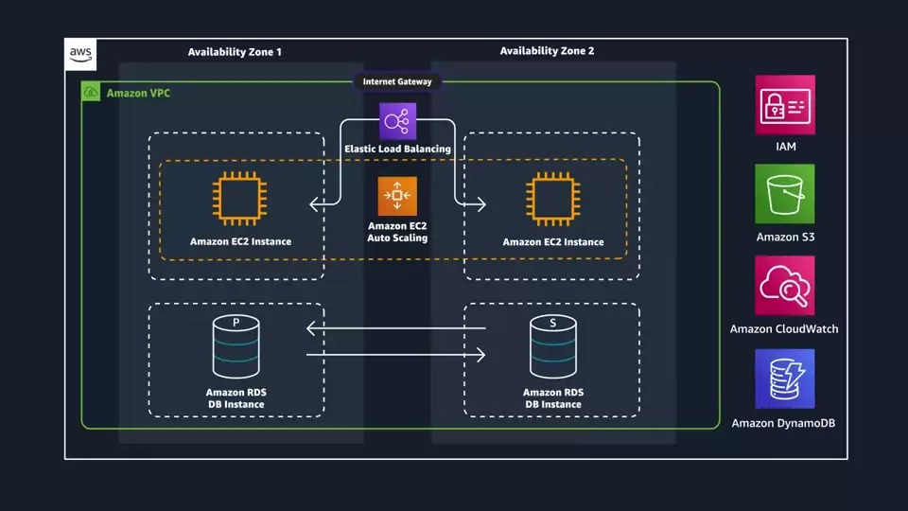

### Reading 2.5: Networking on AWS

#### ****WHAT IS NETWORKING?****

Networking is how you connect computers around the world and allow them to communicate with one another. In this trail, you’ve already seen a few examples of networking. One is the AWS global infrastructure. AWS has created a network of resources using data centers, Availability Zones, and Regions.

#### ****KNOW THE NETWORKING BASICS****

Think about sending a letter. When sending a letter, there are three pieces of information you need.

* The payload or letter inside the envelope.
* The address of the sender in the From section.
* The address of the recipient in the To section.

Let’s go further. Each address must contain information such as:

* Name of sender and recipient
* Street
* City
* State or province
* Zip, area, or postal code
* Country

You need all parts of an address to ensure that your letter gets to its destination. Without the correct address, postal workers are not able to properly deliver the message. In the digital world, computers handle the delivery of messages in a similar way. This is called routing.

#### ****WHAT ARE IP ADDRESSES?****

In order to properly route your messages to a location, you need an address. Just like each home has a mail address, each computer has an IP address. However, instead of using the combination of street, city, state, zip code, and country, the IP address uses a combination of bits, 0s and 1s.

Here is an example of a 32-bit address in binary format:

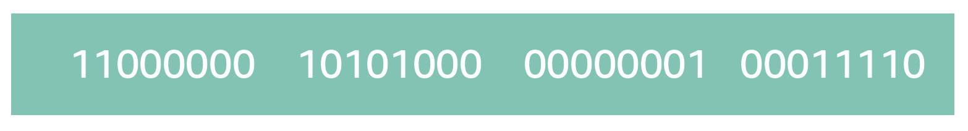

 It’s called 32-bit because you have 32 digits. Feel free to count!

#### ****WHAT IS IPV4 NOTATION?****

Typically, you don’t see an IP address in this binary format. Instead, it’s converted into decimal format and noted as an Ipv4 address.

In the diagram below, the 32 bits are grouped into groups of 8 bits, also called octets. Each of these groups is converted into decimal format separated by a period.

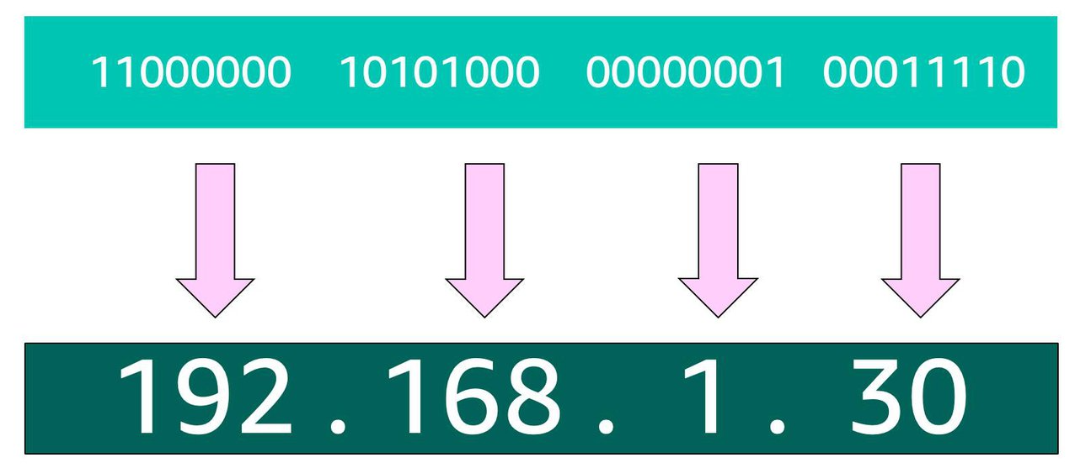

In the end, this is what is called an Ipv4 address. This is important to know when trying to communicate to a single computer. But remember, you’re working with a network. This is where CIDR Notation comes in.

#### ****USE CIDR NOTATION****

192.168.1.30 is a single IP address. If you wanted to express IP addresses between the range of 192.168.1.0 and 192.168.1.255, how can you do that?

One way is by using Classless Inter-Domain Routing (CIDR) notation. CIDR notation is a compressed way of specifying a range of IP addresses. Specifying a range determines how many IP addresses are available to you.

CIDR notation looks like this:



It begins with a starting IP address and is separated by a forward slash (the “/” character) followed by a number. The number at the end specifies how many of the bits of the IP address are fixed. In this example, the first 24 bits of the IP address are fixed. The rest are flexible.

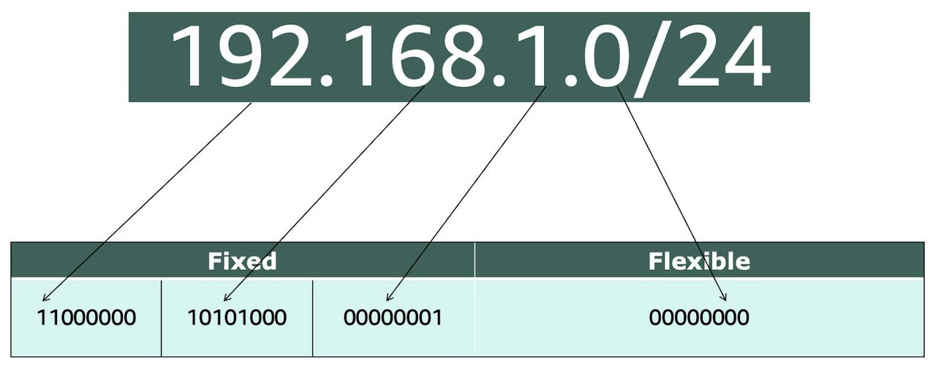

32 total bits subtracted by 24 fixed bits leaves 8 flexible bits. Each of these flexible bits can be either 0 or 1, because they are binary. That means you have two choices for each of the 8 bits, providing 256 IP addresses in that IP range.

The higher the number after the /, the smaller the number of IP addresses in your network. For example, a range of 192.168.1.0/24 is smaller than 192.168.1.0/16.

When working with networks in the AWS Cloud, you choose your network size by using CIDR notation. In AWS, the smallest IP range you can have is /28, which provides you 16 IP addresses. The largest IP range you can have is a /16, which provides you with 65,536 IP addresses.

#### ****Resources****:

* [External Site: Stanford: Introduction to Computer Networking](https://web.stanford.edu/class/cs101/network-1-introduction.html)
* [External Site: Ionos: CIDR: What is classless inter-domain routing?](https://www.ionos.com/digitalguide/server/know-how/cidr-classless-inter-domain-routing/)

### Reading 2.6: Introduction to Amazon VPC

A VPC is an isolated network you create in the AWS cloud, similar to a traditional network in a data center. When you create a VPC, you need to choose three main things.

1. The name of your VPC.
2. A Region for your VPC to live in. Each VPC spans multiple Availability Zones within the Region you choose.
3. A IP range for your VPC in CIDR notation. This determines the size of your network. Each VPC can have up to four /16 IP ranges.

Using this information, AWS will provision a network and IP addresses for that network.

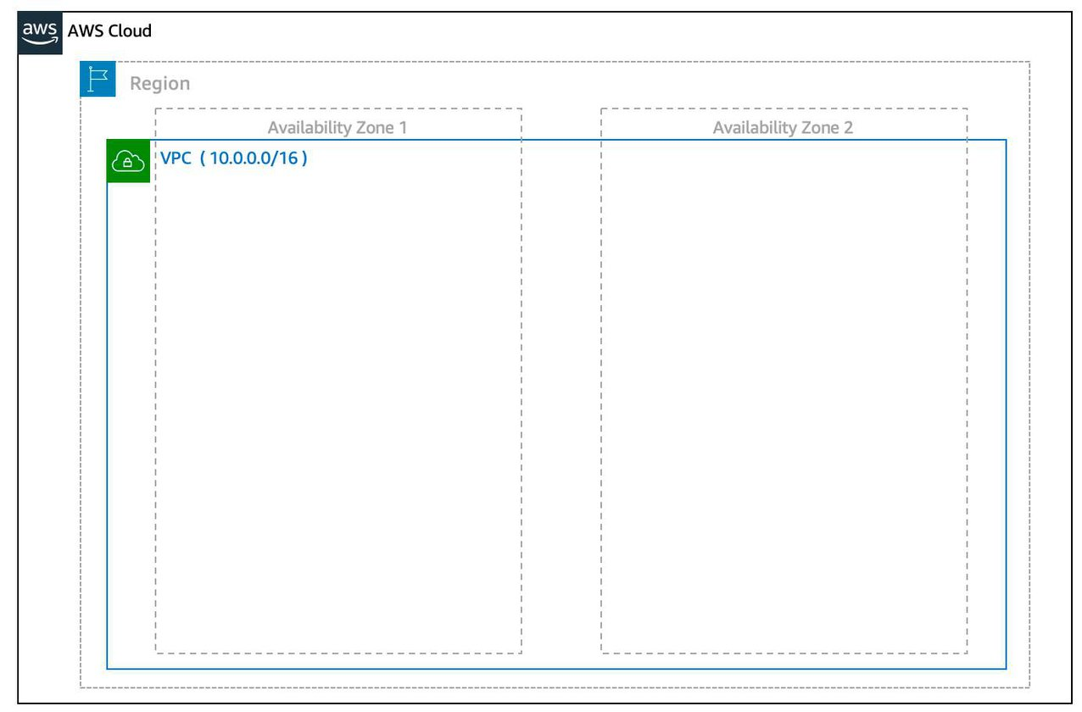

**Create a Subnet** After you create your VPC, you need to create subnets inside of this network. Think of subnets as smaller networks inside your base network—or virtual area networks (VLANs) in a traditional, on-premises network. In an on-premises network, the typical use case for subnets is to isolate or optimize network traffic. In AWS, subnets are used for high availability and providing different connectivity options for your resources. When you create a subnet, you need to choose three settings.

1. The VPC you want your subnet to live in, in this case VPC (10.0.0.0/16).
2. The Availability Zone you want your subnet to live in, in this case AZ1.
3. A CIDR block for your subnet, which must be a subset of the VPC CIDR block, in this case 10.0.0.0/24.

When you launch an EC2 instance, you launch it inside a subnet, which will be located inside the Availability Zone you choose.

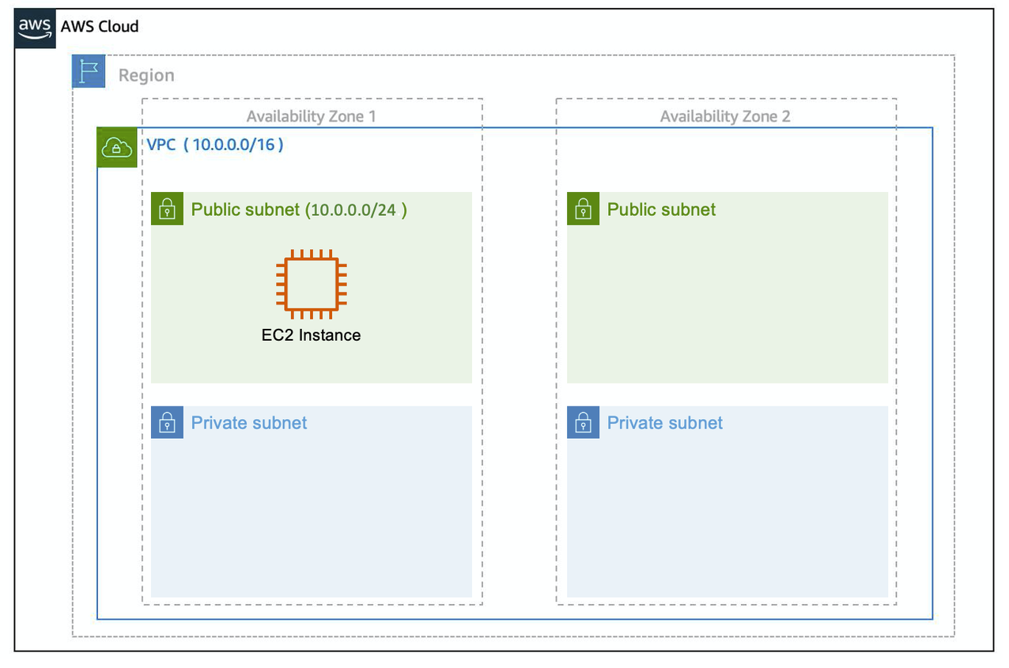

**High Availability with A VPC** When you create your subnets, keep high availability in mind. In order to maintain redundancy and fault tolerance, create at least two subnets configured in two different Availability Zones.

As you learned earlier in the trail, it’s important to consider that “everything fails all the time.” In this case, if one of these AZs fail, you still have your resources in another AZ available as backup.

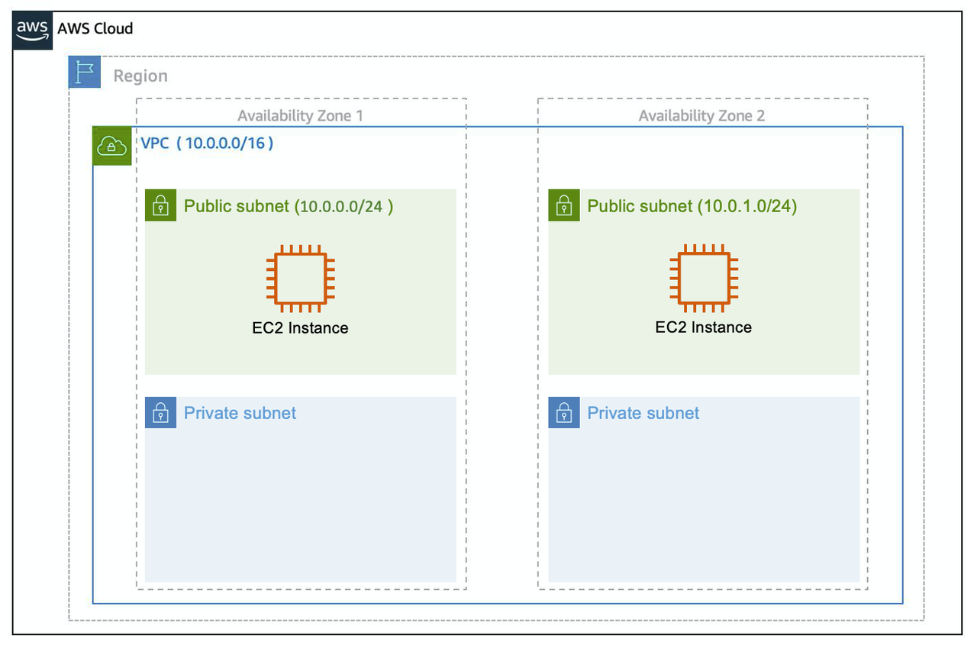

**Reserved IPs** For AWS to configure your VPC appropriately, AWS reserves five IP addresses in each subnet. These IP addresses are used for routing, Domain Name System (DNS), and network management.

For example, consider a VPC with the IP range 10.0.0.0/22. The VPC includes 1,024 total IP addresses. This is divided into four equal-sized subnets, each with a /24 IP range with 256 IP addresses. Out of each of those IP ranges, there are only 251 IP addresses that can be used because AWS reserves five.

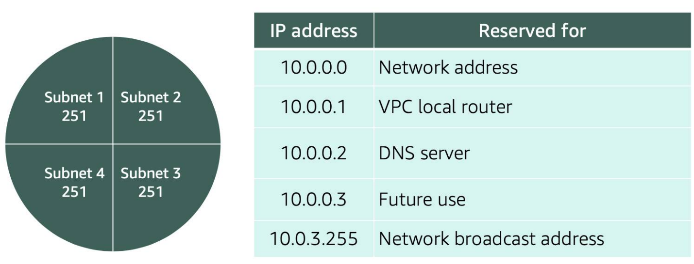

Since AWS reserves these five IP addresses, it can impact how you design your network. A common starting place for those who are new to the cloud is to create a VPC with a IP range of /16 and create subnets with a IP range of /24. This provides a large amount of IP addresses to work with at both the VPC and subnet level.

#### Gateways

##### **Internet Gateway**

To enable internet connectivity for your VPC, you need to create an internet gateway. Think of this gateway as similar to a modem. Just as a modem connects your computer to the internet, the internet gateway connects your VPC to the internet. Unlike your modem at home, which sometimes goes down or offline, an internet gateway is highly available and scalable. After you create an internet gateway, you then need to attach it to your VPC.

##### **Virtual Private Gateway**

A virtual private gateway allows you to connect your AWS VPC to another private network. Once you create and attach a VGW to a VPC, the gateway acts as anchor on the AWS side of the connection. On the other side of the connection, you’ll need to connect a customer gateway to the other private network. A customer gateway device is a physical device or software application on your side of the connection. Once you have both gateways, you can then establish an encrypted VPN connection between the two sides.

#### ****Resources****:

* [External Site: AWS: VPC with public and private subnets (NAT)](https://docs.aws.amazon.com/vpc/latest/userguide/VPC_Scenario2.html)
* [External Site: AWS: custom route tables](https://docs.aws.amazon.com/vpc/latest/userguide/VPC_Route_Tables.html#CustomRouteTables)
* [External Site: Customer Gateway](https://docs.aws.amazon.com/vpn/latest/s2svpn/how_it_works.html#CustomerGateway)
* [External Site: AWS: What Is Amazon VPC?](https://docs.aws.amazon.com/vpc/latest/userguide/what-is-amazon-vpc.html)
* [External Site: AWS: VPCs and subnets](https://docs.aws.amazon.com/vpc/latest/userguide/VPC_Subnets.html)

### Reading 2.7: Amazon VPC Routing and Security

#### The Main Route Table

When you create a VPC, AWS creates a route table called the main route table. A route table contains a set of rules, called routes, that are used to determine where network traffic is directed. AWS assumes that when you create a new VPC with subnets, you want traffic to flow between them. Therefore, the default configuration of the main route table is to allow traffic between all subnets in the local network. Below is an example of a main route table:



There are two main parts to this route table.

* The destination, which is a range of IP addresses where you want your traffic to go. In the example of sending a letter, you need a destination to route the letter to the appropriate place. The same is true for routing traffic. In this case, the destination is the IP range of our VPC network.
* The target, which is the connection through which to send the traffic. In this case, the traffic is routed through the local VPC network.

#### Custom Route Tables

While the main route table controls the routing for your VPC, you may want to be more granular about how you route your traffic for specific subnets. For example, your application may consist of a frontend and a database. You can create separate subnets for these resources and provide different routes for each of them.

If you associate a custom route table with a subnet, the subnet will use it instead of the main route table. By default, each custom route table you create will have the local route already inside it, allowing communication to flow between all resources and subnets inside the VPC.

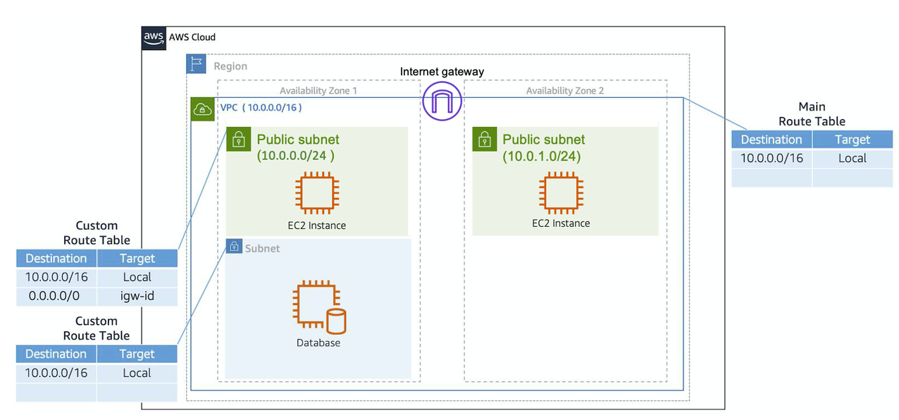

#### ****Secure Your Subnets with Network ACLs****

Think of a network ACL as a firewall at the subnet level. A network ACL enables you to control what kind of traffic is allowed to enter or leave your subnet. You can configure this by setting up rules that define what you want to filter. Here’s an example.

|  |  |  |  |  |  |
| --- | --- | --- | --- | --- | --- |
| **Inbound** |  |  |  |  |  |
| **Rule #** | **Type** | **Protocol** | **Port Range** | **Source** | **Allow/Deny** |
| 100 | All IPv4 traffic | All | All | 0.0.0.0/0 | ALLOW |
| * | All IPv4 traffic | All | All | 0.0.0.0/0 | DENY |
| **Outbound** |  |  |  |  |  |
| **Rule #** | **Type** | **Protocol** | **Port Range** | **Source** | **Allow/Deny** |
| 100 | All IPv4 traffic | All | All | 0.0.0.0/0 | ALLOW |
| * | All IPv4 traffic | All | All | 0.0.0.0/0 | DENY |

The default network ACL, shown in the table above, allows all traffic in and out of your subnet. To allow data to flow freely to your subnet, this is a good starting place. However, you may want to restrict data at the subnet level. For example, if you have a web application, you might restrict your network to allow HTTPS traffic and remote desktop protocol (RDP) traffic to your web servers.

|  |  |  |  |  |  |
| --- | --- | --- | --- | --- | --- |
| **Inbound** |  |  |  |  |  |
| **Rule #** | **Source IP** | **Protocol** | **Port** | **Allow/Deny** | **Comments** |
| 100 | All IPv4 traffic | TCP | 443 | ALLOW | Allows inbound HTTPS traffic from anywhere |
| 130 | 192.0.2.0/24 | TCP | 3389 | ALLOW | Allows inbound RDP traffic to the web servers from your home network’s public IP address range (over the internet gateway) |
| * | All IPv4 traffic | All | All | DENY | Denies all inbound traffic not already handled by a preceding rule (not modifiable) |
| **Outbound** |  |  |  |  |  |
| **Rule #** | **Destination IP** | **Protocol** | **Port** | **Allow/Deny** | **Comments** |
| 120 | 0.0.0.0/0 | TCP | 1025-65535 | ALLOW | Allows outbound responses to clients on the internet (serving people visiting the web servers in the subnet) |
| * | 0.0.0.0/0 | All | All | DENY | Denies all outbound traffic not already handled by a preceding rule (not modifiable) |

Notice that in the network ACL example above, you allow inbound 443 and outbound range 1025-65535. That’s because HTTP uses port 443 to initiate a connection and will respond to an ephemeral port. Network ACL’s are considered stateless, so you need to include both the inbound and outbound ports used for the protocol. If you don’t include the outbound range, your server would respond but the traffic would never leave the subnet.

Since network ACLs are configured by default to allow incoming and outgoing traffic, you don’t need to change their initial settings unless you need additional security layers.

### ****Secure Your EC2 Instances with Security Groups****

The next layer of security is for your EC2 Instances. Here, you can create a firewall called a security group. The default configuration of a security group blocks all inbound traffic and allows all outbound traffic.

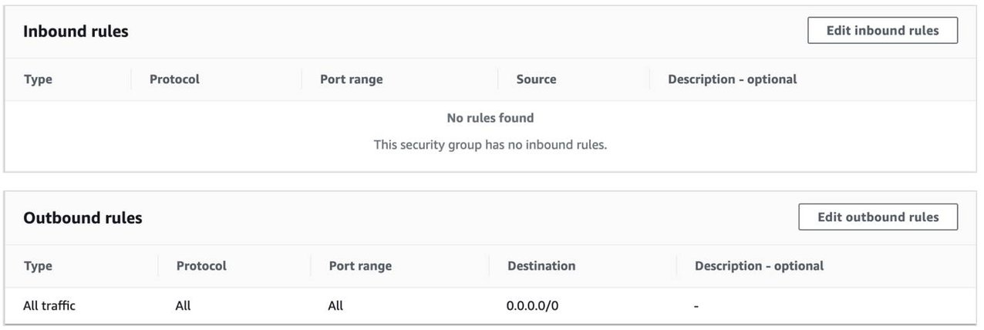

You might be wondering: “Wouldn’t this block all EC2 instances from receiving the response of any customer requests?” Well, security groups are stateful, meaning they will remember if a connection is originally initiated by the EC2 instance or from the outside and temporarily allow traffic to respond without having to modify the inbound rules.

If you want your EC2 instance to accept traffic from the internet, you’ll need to open up inbound ports. If you have a web server, you may need to accept HTTP and HTTPS requests to allow that type of traffic in through your security group. You can create an inbound rule that will allow port 80 (HTTP) and port 443 (HTTPS) as shown below.

|  |  |  |  |
| --- | --- | --- | --- |
| **Inbound rules** |  |  |  |
| **Type** | **Protocol** | **Port Range** | **Source** |
| HTTP (80) | TCP (6) | 80 | 0.0.0.0/0 |
| HTTP (80) | TCP (6) | 80 | ::/0 |
| HTTPS (443) | TCP (6) | 443 | 0.0.0.0/0 |
| HTTPS (443) | TCP (6) | 443 | ::/0 |

You learned in a previous unit that subnets can be used to segregate traffic between computers in your network. Security groups can be used to do the same thing. A common design pattern is organizing your resources into different groups and creating security groups for each to control network communication between them.

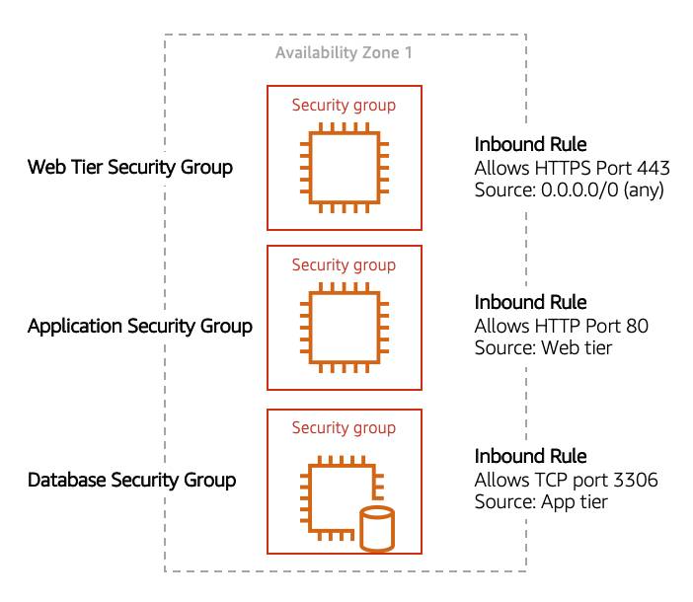

This example allows you to define three tiers and isolate each tier with the security group rules you define. In this case, you only allow internet traffic to the web tier over HTTPS, Web Tier to Application Tier over HTTP, and Application tier to Database tier over MySQL. This is different from traditional on-premises environments, in which you isolate groups of resources via VLAN configuration. In AWS, security groups allow you to achieve the same isolation without tying it to your network.

#### ****Resources****:

* [External Site: AWS: Route tables](https://docs.aws.amazon.com/vpc/latest/userguide/VPC_Route_Tables.html)
* [External Site: AWS: Example routing options](https://docs.aws.amazon.com/vpc/latest/userguide/route-table-options.html)
* [External Site: AWS: Working with routing tables](https://docs.aws.amazon.com/vpc/latest/userguide/WorkWithRouteTables.html)
* [External Site: AWS: Network ACLs](https://docs.aws.amazon.com/vpc/latest/userguide/vpc-network-acls.html)
* [External Site: AWS: Security groups for your VPC](https://docs.aws.amazon.com/vpc/latest/userguide/VPC_SecurityGroups.html)
* [External Site: AWS: I host a website on an EC2 instance. How do I allow my users to connect on HTTP (80) or HTTPS (443)?](https://aws.amazon.com/premiumsupport/knowledge-center/connect-http-https-ec2/)

## Week 3: Storage & Databases on AWS

This week, you will learn important concepts for AWS storage services—such as buckets and objects for Amazon Simple Storage Service (Amazon S3), and how Amazon Elastic Block Store (Amazon EBS) is used on AWS. You will also explore databases on AWS, and the use cases for each AWS storage service.

### Reading 3.2: Amazon EC2 Instance Storage and Amazon Elastic Block Store

#### ****Amazon EC2 Instance Store****

Amazon EC2 Instance Store provides temporary block-level storage for your instance. This storage is located on disks that are physically attached to the host computer. This ties the lifecycle of your data to the lifecycle of your EC2 instance. If you delete your instance, the instance store is deleted as well. Due to this, instance store is considered ephemeral storage. Read more about it in the [AWS documentation](https://docs.aws.amazon.com/AWSEC2/latest/UserGuide/InstanceStorage.html) .

Instance store is ideal if you are hosting applications that replicate data to other EC2 instances, such as Hadoop clusters. For these cluster-based workloads, having the speed of locally attached volumes and the resiliency of replicated data helps you achieve data distribution at high performance. It’s also ideal for temporary storage of information that changes frequently, such as buffers, caches, scratch data, and other temporary content.

**Amazon Elastic Block Storage (Amazon EBS)** As the name implies, Amazon EBS is a block-level storage device that you can attach to an Amazon EC2 instance. These storage devices are called Amazon EBS volumes. EBS volumes are essentially drives of a user-configured size attached to an EC2 instance, similar to how you might attach an external drive to your laptop.

EBS volumes act similarly to external drives in more than one way.

Most Amazon EBS volumes can only be connected with one computer at a time. Most EBS volumes have a one-to-one relationship with EC2 instances, so they cannot be shared by or attached to multiple instances at one time. Note: Recently, AWS announced the Amazon EBS multi-attach feature that enables volumes to be attached to multiple EC2 instances at one time. This feature is not available for all instance types and all instances must be in the same Availability Zone. Read more about this scenario in the [EBS documentation](https://docs.aws.amazon.com/AWSEC2/latest/UserGuide/ebs-volumes-multi.html) .

You can detach an EBS volume from one EC2 instance and attach it to another EC2 instance in the same Availability Zone, to access the data on it.

The external drive is separate from the computer. That means, if an accident happens and the computer goes down, you still have your data on your external drive. The same is true for EBS volumes.

You’re limited to the size of the external drive, since it has a fixed limit to how scalable it can be. For example, you may have a 2 TB external drive and that means you can only have 2 TB of content on there. This relates to EBS as well, since volumes also have a max limitation of how much content you can store on the volume.

#### Scale Amazon EBS Volumes

You can scale Amazon EBS volumes in two ways.

1. Increase the volume size, as long as it doesn’t increase above the maximum size limit. For EBS volumes, the maximum amount of storage you can have is 16 TB. That means if you provision a 5 TB EBS volume, you can choose to increase the size of your volume until you get to 16 TB.
2. Attach multiple volumes to a single Amazon EC2 instance. EC2 has a one-to-many relationship with EBS volumes. You can add these additional volumes during or after EC2 instance creation to provide more storage capacity for your hosts.

#### Amazon EBS Use Cases

Amazon EBS is useful when you need to retrieve data quickly and have data persist long-term. Volumes are commonly used in the following scenarios.

* **Operating systems:** Boot/root volumes to store an operating system. The root device for an instance launched from an Amazon Machine Image (AMI) is typically an Amazon EBS volume. These are commonly referred to as EBS-backed AMIs.
* **Databases:** A storage layer for databases running on Amazon EC2 that rely on transactional reads and writes.
* **Enterprise applications:** Amazon EBS provides reliable block storage to run business-critical applications.
* **Throughput-intensive applications:** Applications that perform long, continuous reads and writes.

#### Amazon EBS Volume Types

|  | **EBS Provisioned IOPS SSD** | **EBS General Purpose SSD** | **Throughput Optimized HDD** | **Cold HDD** |
| --- | --- | --- | --- | --- |
| **Description** | Highest performance SSD designed for latency-sensitive transactional workloads | General purpose SSD that balances price and performance for a wide variety of transactional workloads | Low-cost HDD designed for frequently accessed, throughput intensive workloads | Lowest cost HDD designed for less frequently accessed workloads |
| **Use Cases** | I/O-intensive NoSQL and relational databases | Boot volumes, low-latency interactive apps, development, and test | Big data, data warehouses, log processing | Colder data requiring fewer scans per day |
| **Volume Size** | 4 GB-16 TB | 1 GB-16 TB | 500 GB-16 TB | 500 GB-16 TB |
| **Max IOPS/Volume** | 64,000 | 16,000 | 500 | 250 |
| **Max Throughput/Volume** | 1,000 MB/s | 250 MB/s | 500 MB/s | 250 MB/s |

There are two main categories of Amazon EBS volumes: solid-state drives (SSDs) and hard-disk drives (HDDs). SSDs provide strong performance for random input/output (I/O), while HDDs provide strong performance for sequential I/O. AWS offers two types of each. The following chart can help you decide which EBS volume is the right option for your workload.

#### Benefits of Using Amazon EBS

Here are the following benefits of using Amazon EBS (in case you need a quick cheat sheet).

* High availability: When you create an EBS volume, it is automatically replicated within its Availability Zone to prevent data loss from single points of failure.
* Data persistence: The storage persists even when your instance doesn’t.
* Data encryption: All EBS volumes support encryption.
* Flexibility: EBS volumes support on-the-fly changes. You can modify volume type, volume size, and input/output operations per second (IOPS) capacity without stopping your instance.
* Backups: Amazon EBS provides you the ability to create backups of any EBS volume.

#### EBS Snapshots

Errors happen. One of those errors is not backing up data, and then, inevitably losing that data. To prevent this from happening to you, you should back up your data—even in AWS. Since your EBS volumes consist of the data from your Amazon EC2 instance, you’ll want to take backups of these volumes, called snapshots.

EBS snapshots are incremental backups that only save the blocks on the volume that have changed after your most recent snapshot. For example, if you have 10 GB of data on a volume, and only 2 GB of data have been modified since your last snapshot, only the 2 GB that have been changed are written to Amazon Simple Storage Service (Amazon S3).

When you take a snapshot of any of your EBS volumes, these backups are stored redundantly in multiple Availability Zones using Amazon S3. This aspect of storing the backup in Amazon S3 will be handled by AWS, so you won’t need to interact with Amazon S3 to work with your EBS snapshots. You simply manage them in the EBS console (which is part of the EC2 console).

EBS snapshots can be used to create multiple new volumes, whether they’re in the same Availability Zone or a different one. When you create a new volume from a snapshot, it’s an exact copy of the original volume at the time the snapshot was taken.

#### ****Resources****

* [External Site: AWS: Amazon Elastic Block Store (Amazon EBS)](https://docs.aws.amazon.com/AWSEC2/latest/UserGuide/AmazonEBS.html)
* [External Site: AWS: Amazon EBS FAQs](https://aws.amazon.com/ebs/faqs/)

### Reading 3.3: Object Storage with Amazon S3

#### **WHAT IS AMAZON S3?**

Unlike Amazon EBS, Amazon S3 is a standalone storage solution that isn’t tied to compute. It enables you to retrieve your data from anywhere on the web. If you’ve ever used an online storage service to back up the data from your local machine, then you most likely have used a service similar to Amazon S3. The big difference between those online storage services and Amazon S3 is the storage type.

Amazon S3 is an object storage service. Object storage stores data in a flat structure, using unique identifiers to look up objects when requested. An object is simply a file combined with metadata and that you can store as many of these objects as you’d like. All of these characteristics of object storage are also characteristics of Amazon S3.

#### **UNDERSTAND AMAZON S3 CONCEPTS**

In Amazon S3, you have to store your objects in containers called **buckets**. You can’t upload any object, not even a single photo, to S3 without creating a bucket first. When you create a bucket, you choose, at the very minimum, two things: the bucket name and the AWS Region you want the bucket to reside in.

 The first part is choosing the **Region** you want the bucket to reside in. Typically, this will be a Region that you’ve used for other resources, such as your compute. When you choose a Region for your bucket, all objects you put inside that bucket are redundantly stored across multiple devices, across multiple Availability Zones. This level of redundancy is designed to provide Amazon S3 customers with 99.999999999% durability and 99.99% availability for objects over a given year.

The second part is choosing a **bucket name**which must be unique across all AWS accounts. AWS stops you from choosing a bucket name that has already been chosen by someone else in another AWS account. Once you choose a name, that name is yours and cannot be claimed by anyone else unless you delete that bucket, which then releases the name for others to use.

AWS uses this name as part of the object identifier. In S3, each object is identified using a URL, which looks like this:

After the http://, you see the bucket name. In this example, the bucket is named doc. Then, the identifier uses the service name, s3 and specifies the service provider amazonaws. After that, you have an implied folder inside the bucket called 2006-03-01 and the object inside the folder that is named AmazonS3.html. The object name is often referred to as the key name.

Note, you can have folders inside of buckets to help you organize objects. However, remember that there’s no actual file hierarchy that supports this on the back end. It is instead a flat structure where all files and folders live at the same level. Using buckets and folders implies a hierarchy, which makes it easy to understand for the human eye.

#### **S3 USE CASES**

Amazon S3 is one of the most widely used storage services, with far more use cases than could fit on one screen. The following list summarizes some of the most common ways you can use Amazon S3.

* **Backup and storage:** S3 is a natural place to back up files because it is highly redundant. As mentioned in the last unit, AWS stores your EBS snapshots in S3 to take advantage of its high availability.
* **Media hosting:** Because you can store unlimited objects, and each individual object can be up to 5 TBs, S3 is an ideal location to host video, photo, or music uploads.
* **Software delivery:** You can use S3 to host your software applications that customers can download.
* **Data lakes:** S3 is an optimal foundation for a data lake because of its virtually unlimited scalability. You can increase storage from gigabytes to petabytes of content, paying only for what you use.
* **Static websites:** You can configure your bucket to host a static website of HTML, CSS, and client-side scripts.
* **Static content:** Because of the limitless scaling, the support for large files, and the fact that you access any object over the web at any time, S3 is the perfect place to store static content.

#### **CHOOSE THE RIGHT CONNECTIVITY OPTION FOR YOUR RESOURCES**

Everything in Amazon S3 is private by default. This means that all S3 resources, such as buckets, folders, and objects can only be viewed by the user or AWS account that created that resource. Amazon S3 resources are all private and protected to begin with.

If you decide that you want everyone on the internet to see your photos, you can choose to make your buckets, folders, and objects public. Keep in mind that a public resource means that everyone on the internet can see it. Most of the time, you don’t want your permissions to be all or nothing. Typically, you want to be more granular about the way you provide access to your resources.

To be more specific about who can do what with your S3 resources, Amazon S3 provides two main access management features: IAM policies and S3 bucket policies.

#### **UNDERSTAND IAM POLICIES**

Previously, you learned about creating and using IAM policies, and now you get to apply this to Amazon S3. When IAM policies are attached to IAM users, groups, and roles, the policies define which actions they can perform. IAM policies are not tied to any one AWS service and can be used to define access to nearly any AWS action. You should use IAM policies for private buckets when:

You have many buckets with different permission requirements. Instead of defining many different S3 bucket policies, you can use IAM policies instead.

You want all policies to be in a centralized location. Using IAM policies allows you to manage all policy information in one location.

#### **UNDERSTAND S3 BUCKET POLICIES**

S3 bucket policies are similar to IAM policies, in that they are both defined using the same policy language in a JSON format. The difference is IAM policies are attached to users, groups, and roles, whereas S3 bucket policies are only attached to buckets. S3 bucket policies specify what actions are allowed or denied on the bucket.

For example, if you have a bucket called employeebucket, you can attach an S3 bucket policy to it that allows another AWS account to put objects in that bucket.

Or if you wanted to allow anonymous viewers to read the objects in employeebucket, then you can apply a policy to that bucket that allows anyone to read objects in the bucket using "Effect":Allow on the "Action:["s3:GetObject"]".

Here’s an example of what that S3 bucket policy might look like.

{

"Version":"2012-10-17",

"Statement":[

{

"Sid":"PublicRead",

"Effect":"Allow",

"Principal": "*",

"Action":["s3:GetObject"],

"Resource":["arn:aws:s3:::employeebucket/*"]

}

]

}

S3 Bucket policies can only be placed on buckets, and cannot be used for folders or objects. However, the policy that is placed on the bucket applies to every object in that bucket. You should use S3 bucket policies when:

You need a simple way to do cross-account access to S3, without using IAM roles.

Your IAM policies bump up against the defined size limit. S3 bucket policies have a larger size limit.

#### **ENCRYPT S3**

Amazon S3 reinforces encryption in transit (as it travels to and from Amazon S3) and at rest. To protect data at rest, you can use:

* **Server-side encryption:** This allows Amazon S3 to encrypt your object before saving it on disks in its data centers and then decrypt it when you download the objects.
* **Client-side encryption:** Encrypt your data client-side and upload the encrypted data to Amazon S3. In this case, you manage the encryption process, the encryption keys, and all related tools.

To encrypt in transit, you can use client-side encryption or Secure Sockets Layer (SSL).

#### **USE VERSIONING TO PRESERVE OBJECTS**

As you know, Amazon S3 identifies objects in part by using the object name. For example, when you upload an employee photo to S3, you may name the object employee.jpg and store it in a folder called employees. If you don’t use Amazon S3 versioning, anytime you upload an object called employee.jpg to the employees folder, it overwrites the original file. This can be an issue for several reasons.

* employee.jpg is a common name for an employee photo object. You or someone else who has access to that bucket might not have intended to overwrite it, and now that you have, you no longer have access to the original file.
* You may want to preserve different versions of employee.jpg. Without versioning, if you wanted to create a new version of employee.jpg, you would need to upload the object and choose a different name for it. Having several objects all with slight differences in naming variations may cause confusion and clutter in your bucket.

So, what do you do? You use S3 versioning! Versioning enables you to keep multiple versions of a single object in the same bucket. This allows you to preserve old versions of an object without having to use different naming constructs, in case you need to recover from accidental deletions, accidental overwrites, or even application failures. Let’s see how this works.

If you enable versioning for a bucket, Amazon S3 automatically generates a unique version ID for the object being stored. In one bucket, for example, you can have two objects with the same key, but different version IDs, such as employeephoto.gif (version 111111) and employeephoto.gif (version 121212). Versioning-enabled buckets let you recover objects from accidental deletion or overwrite.

* Deleting an object does not remove the object permanently. Instead, Amazon S3 puts a marker on the object that shows you tried to delete it. If you want to restore the object, you can remove this marker and it reinstates the object.
* If you overwrite an object, it results in a new object version in the bucket. You still have access to previous versions of the object.

#### **UNDERSTAND VERSIONING STATES**

Buckets can be in one of three states.

* Unversioned (the default): No new or existing objects in the bucket have a version.
* Versioning-enabled: This enables versioning for all objects in the bucket.
* Versioning-suspended: This suspends versioning for new objects. All new objects in the bucket will not have a version. However, all existing objects keep their object versions.

The versioning state applies to all of the objects in that bucket. Keep in mind that storage costs are incurred for all objects in your bucket and all versions of those objects. To reduce your S3 bill, you may want to delete previous versions of your objects that are no longer in use.

#### **WHAT ARE AMAZON S3 STORAGE CLASSES?**

When you upload an object to Amazon S3 and you don’t specify the storage class, you’re uploading it to the default storage class—often referred to as standard storage. When you learned about Amazon S3 in previous units, you were learning about the standard storage class without even knowing it! S3 storage classes let you change your storage tier as your data characteristics change. For example, if you are now accessing your old photos infrequently, you may want to change the storage class those photos are stored in to save on costs. There are six S3 storage classes.

1. **Amazon S3 Standard:** This is considered general purpose storage for cloud applications, dynamic websites, content distribution, mobile and gaming applications, and big data analytics.
2. **Amazon S3 Intelligent-Tiering:** This tier is useful if your data has unknown or changing access patterns. S3 Intelligent-Tiering stores objects in two tiers, a frequent access tier and an infrequent access tier. Amazon S3 monitors access patterns of your data, and automatically moves your data to the most cost-effective storage tier based on frequency of access.
3. **Amazon S3 Standard-Infrequent Access (S3 Standard-IA):** S3 Standard-IA is for data that is accessed less frequently, but requires rapid access when needed. S3 Standard-IA offers the high durability, high throughput, and low latency of S3 Standard, with a low per-GB storage price and per-GB retrieval fee. This storage tier is ideal if you want to store long-term backups, disaster recovery files, and so on.
4. **Amazon S3 One Zone-Infrequent Access (S3 One Zone-IA):** Unlike other S3 storage classes which store data in a minimum of three Availability Zones (AZs), S3 One Zone-IA stores data in a single AZ and costs 20% less than S3 Standard-IA. S3 One Zone-IA is ideal for customers who want a lower-cost option for infrequently accessed data but do not require the availability and resilience of S3 Standard or S3 Standard-IA. It’s a good choice for storing secondary backup copies of on-premises data or easily re-creatable data.
5. **Amazon S3 Glacier Instant Retrieval:**Amazon S3 Glacier Instant Retrieval is an archive storage class that delivers the lowest-cost storage for long-lived data that is rarely accessed and requires retrieval in milliseconds.
6. **Amazon S3 Glacier Flexible Retrieval:**S3 Glacier Flexible Retrieval delivers low-cost storage, up to 10% lower cost (than S3 Glacier Instant Retrieval), for archive data that is accessed 1—2 times per year and is retrieved asynchronously.
7. **Amazon S3 Glacier Deep Archive:** S3 Glacier Deep Archive is Amazon S3’s lowest-cost storage class and supports long-term retention and digital preservation for data that may be accessed once or twice in a year. It is designed for customers—particularly those in highly regulated industries, such as the Financial Services, Healthcare, and Public Sectors—that retain data sets for 7 to 10 years or longer to meet regulatory compliance requirements.
8. **Amazon S3 Outposts:**Amazon S3 on Outposts delivers object storage to your on-premises AWS Outposts environment.

#### **AUTOMATE TIER TRANSITIONS WITH OBJECT LIFECYCLE MANAGEMENT**

If you keep manually changing your objects, such as your employee photos, from storage tier to storage tier, you may want to look into automating this process using a lifecycle policy. When you define a lifecycle policy configuration for an object or group of objects, you can choose to automate two actions: transition and expiration actions.

* **Transition actions** are used to define when you should transition your objects to another storage class.
* **Expiration actions** define when objects expire and should be permanently deleted.

For example, you might choose to transition objects to S3 Standard-IA storage class 30 days after you created them, or archive objects to the S3 Glacier storage class one year after creating them.

The following use cases are good candidates for lifecycle management.

* **Periodic logs:** If you upload periodic logs to a bucket, your application might need them for a week or a month. After that, you might want to delete them.
* **Data that changes in access frequency:** Some documents are frequently accessed for a limited period of time. After that, they are infrequently accessed. At some point, you might not need real-time access to them, but your organization or regulations might require you to archive them for a specific period. After that, you can delete them.

### Reading 3.4: Choose the Right Storage Service

Here’s a recap of all the storage services mentioned so far. By the end of this reading, you should be able to better answer the question “Which storage service should I use?” for some of the more common scenarios.

#### Amazon EC2 Instance Store

Instance store is ephemeral block storage. This is preconfigured storage that exists on the same physical server that hosts the EC2 instance and cannot be detached from Amazon EC2. You can think of it as a built-in drive for your EC2 instance. Instance store is generally well-suited for temporary storage of information that is constantly changing, such as buffers, caches, and scratch data. It is not meant for data that is persistent or long-lasting. If you need persistent long-term block storage that can be detached from Amazon EC2 and provide you more management flexibility, such as increasing volume size or creating snapshots, then you should use Amazon EBS.

#### Amazon EBS

Amazon EBS is meant for data that changes frequently and needs to persist through instance stops, terminations, or hardware failures. Amazon EBS has two different types of volumes: SSD-backed volumes and HDD-backed volumes.SSD-backed volumes have the following characteristics.

* Performance depends on IOPS (input/output operations per second).
* Ideal for transactional workloads such as databases and boot volumes.

HDD-backed volumes have the following characteristics:

* Performance depends on MB/s.
* Ideal for throughput-intensive workloads, such as big data, data warehouses, log processing, and sequential data I/O.

Here are a few important features of Amazon EBS that you need to know when comparing it to other services.

* It is block storage.
* You pay for what you provision (you have to provision storage in advance).
* EBS volumes are replicated across multiple servers in a single Availability Zone.
* Most EBS volumes can only be attached to a single EC2 instance at a time.

#### Amazon S3

If your data doesn’t change that often, Amazon S3 might be a more cost-effective and scalable storage solution. S3 is ideal for storing static web content and media, backups and archiving, data for analytics, and can even be used to host entire static websites with custom domain names.Here are a few important features of Amazon S3 to know about when comparing it to other services.

* It is object storage.
* You pay for what you use (you don’t have to provision storage in advance).
* Amazon S3 replicates your objects across multiple Availability Zones in a Region.
* Amazon S3 is not storage attached to compute.

#### Amazon Elastic File System (Amazon EFS) and Amazon FSx

In this module, you’ve already learned about Amazon S3 and Amazon EBS. You learned that S3 uses a flat namespace and isn’t meant to serve as a standalone file system. You also learned most EBS volumes can only be attached to one EC2 instance at a time. So, if you need file storage on AWS, which service should you use?For file storage that can mount on to multiple EC2 instances, you can use Amazon Elastic File System (Amazon EFS) or Amazon FSx. Use the following table for more information about each of these services.

|  |  |  |
| --- | --- | --- |
| Service | Characteristic | More Information |
| Amazon Elastic File System (EFS) | Fully managed NFS file system. | [EFS FAQs](https://aws.amazon.com/efs/faq/) |
| Amazon FSx for Windows File Server | Fully managed file server built on Windows Server that supports the SMB protocol. | [FSx for Windows File Server FAQs](https://aws.amazon.com/fsx/windows/faqs/?nc=sn&loc=8) |
| Amazon FSx for Lustre | Fully managed Lustre file system that integrates with S3. | [FSx for Lustre FAQs](https://aws.amazon.com/fsx/lustre/faqs/?nc=sn&loc=5) |

Here are a few important features of Amazon EFS and FSx to know about when comparing them to other services.

* It is file storage.
* You pay for what you use (you don’t have to provision storage in advance).
* Amazon EFS and Amazon FSx can be mounted onto multiple EC2 instances.

#### ****Resources****:

* [External Site: AWS: Storage](https://docs.aws.amazon.com/AWSEC2/latest/UserGuide/Storage.html)
* [External Site: AWS: Cloud Storage on AWS](https://aws.amazon.com/products/storage/)
* [External Site: Amazon EFS How it works](https://docs.aws.amazon.com/efs/latest/ug/how-it-works.html)
* [External Site: Amazon FSx for Windows File Server](https://aws.amazon.com/fsx/windows/)
* [External Site: Amazon FSx for Lustre](https://aws.amazon.com/fsx/lustre/)

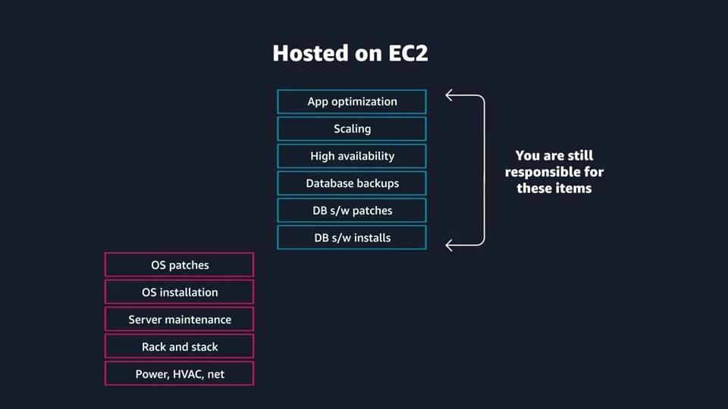

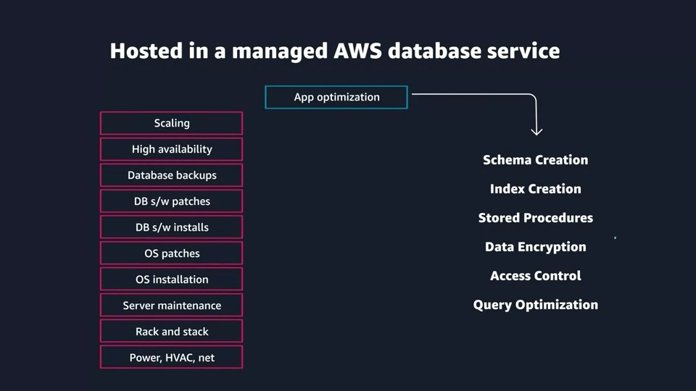

### Reading 3.5: Explore Databases on AWS

#### Explore Databases on AWS

#### UNDERSTANDING THE HISTORY BEHIND ENTERPRISE DATABASES

Choosing a database used to be a straightforward decision. There were only a few options to choose from. In the past, you likely considered a few vendors and then inevitably chose one for all of your applications.

Businesses often selected the database technology they were going to use, even before they fully understood their use case. Since the 1970s, the database most commonly selected by businesses was a **relational database**.

#### WHAT IS A RELATIONAL DATABASE?

A relational database organizes data into tables. Data in one table can be linked to data in other tables to create relationships—hence, the relational part of the name.

A table stores data in rows and columns. A row, often called a record, contains all information about a specific entry. Columns describe attributes of that entry. Here’s an example of three tables in a relational database.

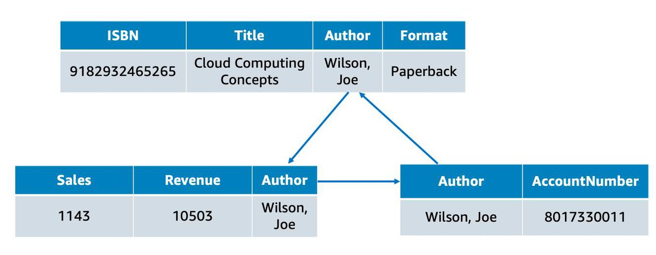

This shows a table for books, a table for sales, and a table for authors. In the books table, each row includes the book ISBN, the title, the author, and the format. Each of these attributes is stored in its own column. The books table has something in common with the other two tables: the author attribute. That common column creates a relationship between the tables.

The tables, rows, columns, and relationships between them is referred to as a **logical schema**. With relational databases, a schema is fixed. Once the database is operational, it becomes difficult to change the schema. This requires most of the data modeling to be done upfront before the database is active.

#### WHAT IS A RELATIONAL DATABASE MANAGEMENT SYSTEM?

A relational database management system (RDBMS) lets you create, update, and administer a relational database. Here are some common examples of relational database management systems:

* MySQL
* PostgresQL
* Oracle
* SQL server
* Amazon Aurora

You communicate with most RDBMS by using Structured Query Language (SQL) queries. Here’s an example: SELECT * FROM table_name.

This query selects all of the data from a particular table. However, the real power of SQL queries is in creating more complex queries that let you pull data from several tables to piece together patterns and answers to business problems. For example, querying the sales table and the book table together to see sales in relation to an author’s books. This is made possible by a join, which we talk about next.

#### THE BENEFITS OF USING A RELATIONAL DATABASE

There are many benefits to using a relational database. A few of them are listed here.

* **Joins:** You can join tables, enabling you to better understand relationships between your data.
* **Reduced redundancy:** You can store data in one table and reference it from other tables instead of saving the same data in different places.
* **Familiarity:** Relational databases have been a popular choice since the 1970s. Due to this popularity, technical professionals often have familiarity and experience with this type of database.
* **Accuracy:** Relational databases ensure that your data is persisted with high integrity and adheres to the ACID (atomicity, consistency, isolation, durability) principle.

#### USE CASES FOR RELATIONAL DATABASES

Much of the world runs on relational databases. In fact, they’re at the core of many mission-critical applications, some of which you may use in your day to day life. Here are some common use cases for relational databases.Applications that have a solid schema that doesn’t change often, such as:

* Lift and shift applications that lifts an app from on-premises and shifts it to the cloud, with little or no modifications.

Applications that need persistent storage that follows the ACID principle, such as:

* Enterprise Resource Planning (ERP) applications
* Customer Relationship Management (CRM) applications
* Commerce and financial applications

#### CHOOSE BETWEEN UNMANAGED AND MANAGED DATABASES

If you want to run a relational database on AWS, you first need to select how you want to run it: the unmanaged way or the managed way.

The paradigm of managed versus unmanaged services is similar to the Shared Responsibility Model. The Shared Responsibility Model distinguishes between AWS’s and the customer’s security responsibility over a service. Similarly, managed versus unmanaged can be understood as a tradeoff between convenience and control.

##### **On-Premises Database**

Let’s say you operate a relational database on-premises (in your own data center). In this scenario, you are responsible for all aspects of operation, including the security and electricity of the data center, the management of the host machine, the management of the database on that host, as well as optimizing queries and managing customer data. You are responsible for absolutely everything, which means you have control over absolutely everything.

##### **Unmanaged Database**

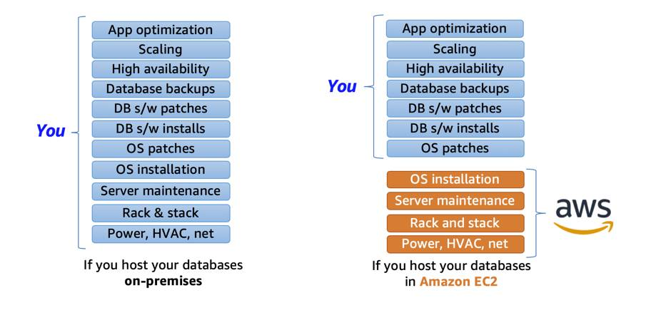

Now, let’s say you want to shift some of this work to AWS by running your relational database on Amazon EC2. If you host a database on Amazon EC2, AWS takes care of implementing and maintaining the physical infrastructure and hardware and installing the operating system of the EC2 instance. However, you’re still responsible for managing the EC2 instance, managing the database on that host, optimizing queries, and managing customer data.

This is what is often referred to as the **unmanaged database** option on AWS. AWS is responsible for and has control over the hardware and underlying infrastructure, and you are responsible and have control over management of the host and database.**Managed Database**

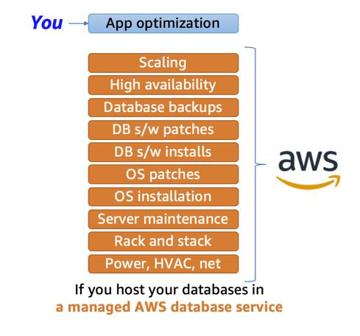

If you want to shift even more of the work to AWS, you can use a **managed database** service. These services provide the setup of both the EC2 instance and the database, and they provide systems for high availability, scalability, patching, and backups. However, you’re still responsible for database tuning, query optimization, and of course, ensuring that your customer data is secure. This provides you ultimate convenience, but you have the least amount of control compared to the two previous options.

#### ****Resources****:

* [External Site: AWS: What Is a Relational Database?](https://aws.amazon.com/relational-database/)
* [External Site: AWS: Databases on AWS](https://aws.amazon.com/products/databases/)

### Reading 3.6: Amazon Relational Database Service

#### What Is Amazon RDS?

Amazon RDS enables you to create and manage relational databases in the cloud without the operational burden of traditional database management. For example, if you sell healthcare equipment and your goal is to be the number-one seller in the Pacific Northwest, building out a database doesn’t directly help you achieve that goal though having a database is necessary to achieve the goal. Amazon RDS helps you offload some of this unrelated work of creating and managing a database. You can focus on the tasks that differentiate your application, instead of infrastructure-related tasks such as provisioning, patching, scaling, and restoring. Amazon RDS supports most of the popular relational database management systems, ranging from commercial options, open source options, and even an AWS-specific option. Here are the supported Amazon RDS engines.

* **Commercial:** Oracle, SQL Server
* **Open Source:** MySQL, PostgreSQL, MariaDB
* **Cloud Native:** Amazon Aurora

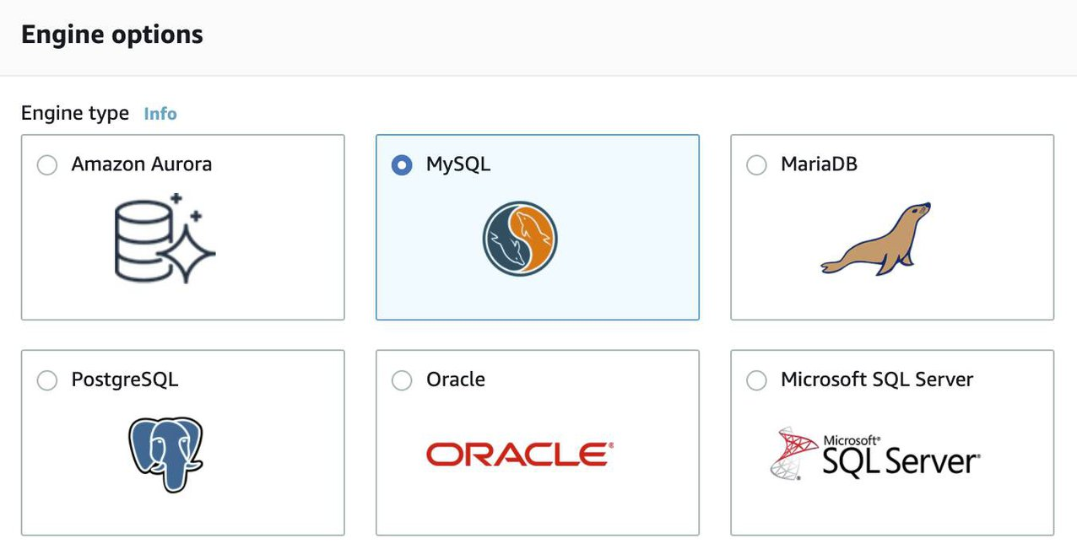

**Note:** The cloud native option, Amazon Aurora, is a MySQL and PostgreSQL-compatible database built for the cloud. It is more durable, more available, and provides faster performance than the Amazon RDS version of MySQL and PostgreSQL. To learn more about Amazon Aurora, view the [Amazon Aurora FAQs](https://aws.amazon.com/rds/aurora/faqs/?nc=sn&loc=6).

#### Understand DB Instances

Just like the databases that you would build and manage yourself, Amazon RDS is built off of compute and storage. The compute portion is called the DB (database) instance, which runs the database engine. Depending on the engine of the DB instance you choose, the engine will have different supported features and configurations. A DB instance can contain multiple databases with the same engine, and each database can contain multiple tables. Underneath the DB instance is an EC2 instance. However, this instance is managed through the Amazon RDS console instead of the Amazon EC2 console. When you create your DB instance, you choose the instance type and size. Amazon RDS supports three instance families.

* **Standard**, which include general-purpose instances
* **Memory Optimized**, which are optimized for memory-intensive applications
* **Burstable Performance**, which provides a baseline performance level, with the ability to burst to full CPU usage.

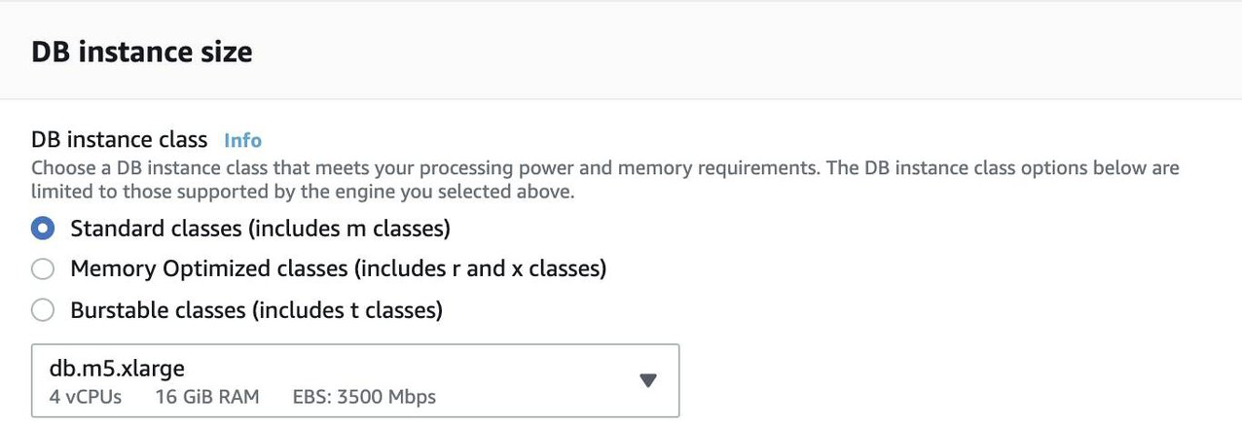

The DB instance you choose affects how much processing power and memory it has. Not all of the options are available to you, depending on the engine that you choose. You can find more information about the DB instance types in the resources section of this unit. Much like a regular EC2 instance, the DB instance uses Amazon Elastic Block Store (EBS) volumes as its storage layer. You can choose between three types of EBS volume storage.

* General purpose (SSD)
* Provisioned IOPS (SSD)
* Magnetic storage (not recommended)

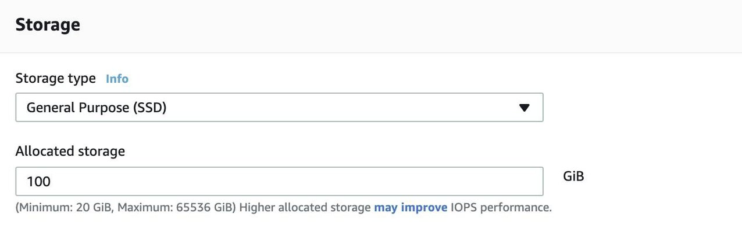

#### Work with Amazon RDS in an Amazon Virtual Private Cloud

When you create a DB instance, you select the Amazon Virtual Private Cloud (VPC) that your databases will live in. Then, you select the subnets that you want the DB instances to be placed in. This is referred to as a **DB subnet group**. To create a DB subnet group, you specify:

* The Availability Zones (AZs) that include the subnets you want to add
* The subnets in that AZ where your DB instance are placed

The subnets you add should be private so they don’t have a route to the internet gateway. This ensures your DB instance, and the cat data inside of it, can only be reached by the app backend. Access to the DB instance can be further restricted by using network access control lists (ACLs) and security groups. With these firewalls, you can control, at a granular level, what type of traffic you want to allow into your database. Using these controls provide layers of security for your infrastructure. It reinforces that only the backend instances have access to the database.

#### Use AWS Identity and Access Management (IAM) Policies to Secure Amazon RDS

Network ACLs and security groups allow you to dictate the flow of traffic. If you want to restrict what actions and resources your employees can access, you can use IAM policies.

#### Back Up Your Data

You don’t want to lose any of that precious cat information. To take regular backups of your RDS instance, you can use:

* Automatic backups
* Manual snapshots

##### **Automatic Backups**

Automated backups are turned on by default. This backs up your entire DB instance (not just individual databases on the instance), and your transaction logs. When you create your DB instance, you set a backup window that is the period of time that automatic backups occur. Typically, you want to set these windows during a time when your database experiences little activity because it can cause increased latency and downtime.

You can retain your automated backups between 0 and 35 days. You might ask yourself, “Why set automated backups for 0 days?” The 0 days setting actually disables automatic backups from happening. Keep in mind that if you set it to 0, it will also delete all existing automated backups. This is not ideal, as the benefit of having automated backups is having the ability to do point-in-time recovery.

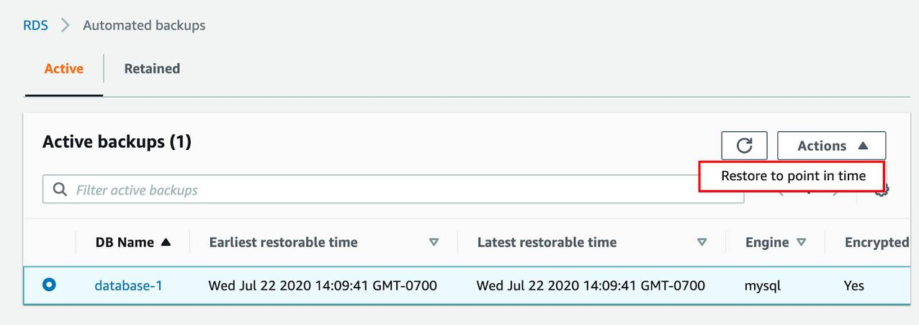

If you restore data from an automated backup, you have the ability to do point-in-time recovery. Point-in-time recovery creates a new DB instance using data restored from a specific point in time. This restoration method provides more granularity by restoring the full backup and rolling back transactions up to the specified time range.

##### **Manual Snapshots**

If you want to keep your automated backups longer than 35 days, use manual snapshots. Manual snapshots are similar to taking EBS snapshots, except you manage them in the RDS console. These are backups that you can initiate at any time, that exist until you delete them.

For example, to meet a compliance requirement that mandates you to keep database backups for a year, you would need to use manual snapshots to ensure those backups are retained for that period of time.

If you restore data from a manual snapshot, it creates a new DB instance using the data from the snapshot.

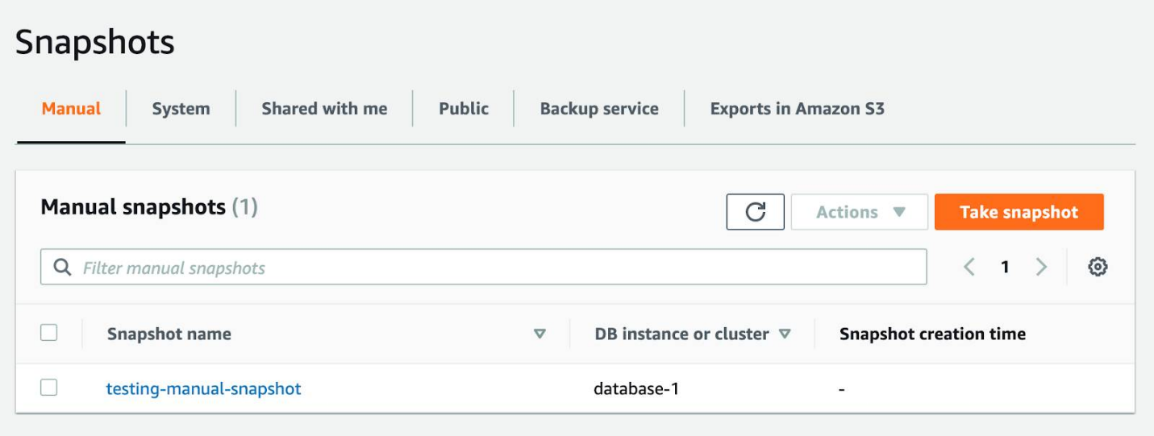

#### Which Backup Option Should I Use?

The answer, almost always, is both. Automated backups are beneficial for the point-in-time recovery. Manual snapshots allow you to retain backups for longer than 35 days.

#### Get Redundancy with Amazon RDS Multi-AZ

When you enable Amazon RDS Multi-AZ, Amazon RDS creates a redundant copy of your database in another AZ. You end up with two copies of your database: a primary copy in a subnet in one AZ and a standby copy in a subnet in a second AZ.

The primary copy of your database provides access to your data so that applications can query and display that information.

The data in the primary copy is synchronously replicated to the standby copy. The standby copy is not considered an active database, and does not get queried by applications.

To improve availability, Amazon RDS Multi-AZ ensures that you have two copies of your database running and that one of them is in the primary role. If there’s an availability issue, such as the primary database losing connectivity, Amazon RDS triggers an automatic failover.

When you create a DB instance, a domain name system (DNS) name is provided. AWS uses that DNS name to failover to the standby database. In an automatic failover, the standby database is promoted to the primary role and queries are redirected to the new primary database.

To ensure that you don’t lose Multi-AZ configuration, a new standby database is created by either:

* Demoting the previous primary to standby if it’s still up and running
* Or standing up a new standby DB instance

The reason you can select multiple subnets for an Amazon RDS database is because of the Multi-AZ configuration. You’ll want to ensure that you have used subnets in different AZs for your primary and standby copies.

#### ****Resources****:

* [External Site: AWS: Working With Backups](https://docs.aws.amazon.com/AmazonRDS/latest/UserGuide/USER_WorkingWithAutomatedBackups.html)
* [External Site: AWS: Amazon RDS Backup and Restore](https://aws.amazon.com/rds/details/backup/)
* [External Site: AWS: Creating and Using an IAM Policy for IAM Database Access](https://docs.aws.amazon.com/AmazonRDS/latest/UserGuide/UsingWithRDS.IAMDBAuth.IAMPolicy.html)
* [External Site: AWS: Amazon Virtual Private Cloud VPCs and Amazon RDS](https://docs.aws.amazon.com/AmazonRDS/latest/UserGuide/USER_VPC.html)

### Reading 3.8: Introduction to Amazon DynamoDB

#### What Is Amazon DynamoDB?

Amazon DynamoDB is a fully managed NoSQL database service that provides fast and predictable performance with seamless scalability. DynamoDB lets you offload the administrative burdens of operating and scaling a distributed database so that you don't have to worry about hardware provisioning, setup and configuration, replication, software patching, or cluster scaling.

With DynamoDB, you can create database tables that can store and retrieve any amount of data and serve any level of request traffic. You can scale up or scale down your tables' throughput capacity without downtime or performance degradation. You can use the AWS Management Console to monitor resource utilization and performance metrics.

DynamoDB automatically spreads the data and traffic for your tables over a sufficient number of servers to handle your throughput and storage requirements, while maintaining consistent and fast performance. All of your data is stored on solid-state disks (SSDs) and is automatically replicated across multiple Availability Zones in an AWS Region, providing built-in high availability and data durability.

#### Core Components of Amazon DynamoDB

In DynamoDB, tables, items, and attributes are the core components that you work with. A table is a collection of items, and each item is a collection of attributes. DynamoDB uses primary keys to uniquely identify each item in a table and secondary indexes to provide more querying flexibility.

The following are the basic DynamoDB components:

**Tables** – Similar to other database systems, DynamoDB stores data in tables. A table is a collection of data. For example, see the example table called People that you could use to store personal contact information about friends, family, or anyone else of interest. You could also have a Cars table to store information about vehicles that people drive.

**Items** – Each table contains zero or more items. An item is a group of attributes that is uniquely identifiable among all of the other items. In a People table, each item represents a person. For a Cars table, each item represents one vehicle. Items in DynamoDB are similar in many ways to rows, records, or tuples in other database systems. In DynamoDB, there is no limit to the number of items you can store in a table.

**Attributes** – Each item is composed of one or more attributes. An attribute is a fundamental data element, something that does not need to be broken down any further. For example, an item in a People table contains attributes called PersonID, LastName, FirstName, and so on. For a Department table, an item might have attributes such as DepartmentID, Name, Manager, and so on. Attributes in DynamoDB are similar in many ways to fields or columns in other database systems.

#### Security with Amazon DynamoDB

DynamoDB also offers encryption at rest, which eliminates the operational burden and complexity involved in protecting sensitive data. For more information, see [DynamoDB Encryption at Rest](https://docs.aws.amazon.com/amazondynamodb/latest/developerguide/EncryptionAtRest.html).

Below you can find additional resources for learning about Amazon DynamoDB:

* [External Resource: Introduction to Amazon DynamoDB](https://docs.aws.amazon.com/amazondynamodb/latest/developerguide/Introduction.html)

### Reading 3.9: Choose the Right AWS Database Service

#### AWS Database Services

AWS has a variety of different database options for different use cases. Use the table below to get a quick look at the AWS database portfolio.

|  |  |  |
| --- | --- | --- |
| Database Type | Use Cases | AWS Service |
| Relational | Traditional applications, ERP, CRM, e-commerce | Amazon RDS, Amazon Aurora, Amazon Redshift |
| Key-value | High-traffic web apps, e-commerce systems, gaming applications | Amazon DynamoDB |
| In-memory | Caching, session management, gaming leaderboards, geospatial applications | Amazon ElastiCache for Memcached, Amazon ElastiCache for Redis |
| Document | Content management, catalogs, user profiles | Amazon DocumentDB (with MongoDB compatibility) |
| Wide column | High-scale industrial apps for equipment maintenance, fleet management, and route optimization | Amazon Keyspaces (for Apache Cassandra) |
| Graph | Fraud detection, social networking, recommendation engines | Amazon Neptune |
| Time series | IoT applications, DevOps, industrial telemetry | Amazon Timestream |
| Ledger | Systems of record, supply chain, registrations, banking transactions | Amazon QLDB |

#### Breaking Up Applications and Databases

As the industry changes, applications and databases change too. Today, with larger applications, you no longer see just one database supporting it. Instead, these applications are being broken into smaller services, each with their own purpose-built database supporting it.

This shift removes the idea of a one-size-fits-all database and replaces it with a complimentary database strategy. You can give each database the appropriate functionality, performance, and scale that the workload requires.

#### ****Resources****:

* [External Site: AWS: Databases on AWS](https://aws.amazon.com/products/databases/)
* [External Site: AWS: AWS Database Blog](https://aws.amazon.com/blogs/database/?nc=sn&loc=4)
* [External Site: AWS: Database Freedom](https://aws.amazon.com/products/databases/freedom/?nc=sn&loc=5)

## Week 4: Monitoring, Optimizing, and Going Serverless on AWS

In Week 4, you will learn about the benefits of monitoring on AWS, and how to optimize solutions on AWS. You will also learn about the function of Elastic Load Balancing (ELB), and how to differentiate between vertical scaling and horizontal scaling.

Now, it’s time to get started!

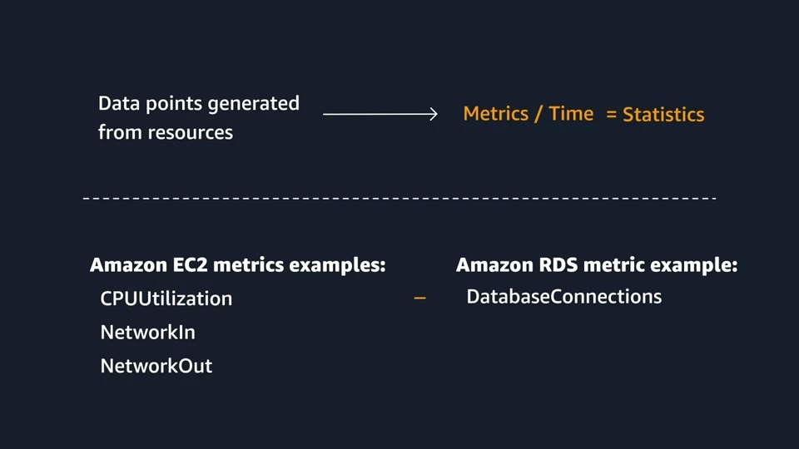

### Reading 4.1: Monitoring on AWS

When operating a website like the Employee Directory Application on AWS you may have questions like:

* How many people are visiting my site day to day?
* How can I track the number of visitors over time?
* How will I know if the website is having performance or availability issues?
* What happens if my Amazon Elastic Compute Cloud (EC2) instance runs out of capacity?
* Will I be alerted if my website goes down?

You need a way to collect and analyze data about the operational health and usage of your resources. The act of collecting, analyzing, and using data to make decisions or answer questions about your IT resources and systems is called monitoring. Monitoring enables you to have a near real-time pulse on your system and answer the questions listed above. You can use the data you collect to watch for operational issues caused by events like over-utilization of resources, application flaws, resource misconfiguration, or security-related events. Think of the data collected through monitoring as outputs of the system, or metrics.

#### Use Metrics to Solve Problems

The resources that host your solutions on AWS all create various forms of data that you might be interested in collecting. You can think of each individual data point that is created by a resource as a metric. Metrics that are collected and analyzed over time become statistics, like the example of average CPU utilization over time below, showing a spike at 1:30. Consider this: One way to evaluate the health of an Amazon EC2 instance is through CPU utilization. Generally speaking, if an EC2 instance has a high CPU utilization, it can mean a flood of requests. Or it can reflect a process that has encountered an error and is consuming too much of the CPU. When analyzing CPU utilization, take a process that exceeds a specific threshold for an unusual length of time. Use that abnormal event as a cue to either manually or automatically resolve the issue through actions like scaling the instance. This is one example of a metric. Other examples of metrics EC2 instances have are network utilization, disk performance, memory utilization, and the logs created by the applications running on top of EC2.

#### Know the Different Types of Metrics

Different resources in AWS create different types of metrics. An Amazon Simple Storage Service (S3) bucket would not have CPU utilization like an EC2 instance does. Instead, S3 creates metrics related to the objects stored in a bucket like the overall size, or the number of objects in a bucket. S3 also has metrics related to the requests made to the bucket such as reading or writing objects. Amazon Relational Database Service (RDS) creates metrics such as database connections, CPU utilization of an instance, or disk space consumption. This is not a complete list for any of the services mentioned, but you can see how different resources create different metrics. You could be interested in a wide variety of metrics depending on the types of resources you are using, the goals you have, or the types of questions you want answered.

#### Understand the Benefits of Monitoring

Monitoring gives you visibility into your resources, but the question now is, "Why is that important?" The following are some of the benefits of monitoring.

**Respond to operational issues proactively before your end users are aware of them.** It’s a bad practice to wait for end users to let you know your application is experiencing an outage. Through monitoring, you can keep tabs on metrics like error response rate or request latency, over time, that help signal that an outage is going to occur. This enables you to automatically or manually perform actions to prevent the outage from happening—fixing the problem before your end users are aware of it.

**Improve the performance and reliability of your resources.** Monitoring the different resources that comprise your application provides you with a full picture of how your solution behaves as a system. Monitoring, if done well, can illuminate bottlenecks and inefficient architectures. This enables you to drive performance and reliability improvement processes.

**Recognize security threats and events.** When you monitor resources, events, and systems over time, you create what is called a baseline. A baseline defines what activity is normal. Using a baseline, you can spot anomalies like unusual traffic spikes or unusual IP addresses accessing your resources. When an anomaly occurs, an alert can be sent out or an action can be taken to investigate the event.

**Make data-driven decisions for your business.** Monitoring is not only to keep an eye on IT operational health. It also helps drive business decisions. For example, let’s say you launched a new feature for your cat photo app, and want to know whether it’s being used. You can collect application-level metrics and view the number of users who use the new feature. With your findings, you decide whether to invest more time into improving the new feature.

**Create more cost-effective solutions.** Through monitoring, you can view resources that are being underutilized and rightsize your resources to your usage. This helps you optimize cost and make sure you aren’t spending more money than necessary.

#### Enable Visibility

AWS resources create data you can monitor through metrics, logs, network traffic, events, and more. This data is coming from components that are distributed in nature, which can lead to difficulty in collecting the data you need if you don’t have a centralized place to review it all. AWS has already done that for you with a service called Amazon CloudWatch.

Amazon CloudWatch is a monitoring and observability service that collects data like those mentioned in this module. CloudWatch provides actionable insights into your applications, and enables you to respond to system-wide performance changes, optimize resource utilization, and get a unified view of operational health. This unified view is important. You can use CloudWatch to:

* Detect anomalous behavior in your environments.
* Set alarms to alert you when something’s not right.
* Visualize logs and metrics with the AWS Management Console.
* Take automated actions like scaling.
* Troubleshoot issues.
* Discover insights to keep your applications healthy.

#### ****Resource****:

* [External Site: AWS: Amazon CloudWatch](https://aws.amazon.com/cloudwatch/)

### Reading 4.2: Introduction to Amazon CloudWatch

#### How CloudWatch Works

The great thing about CloudWatch is that all you need to get started is an AWS account. It is a managed service, which enables you to focus on monitoring, without managing any underlying infrastructure.

The employee directory app is built with various AWS services working together as building blocks. It would be difficult to monitor all of these different services independently, so CloudWatch acts as one centralized place where metrics are gathered and analyzed. You already learned how EC2 instances post CPU utilization as a metric to CloudWatch. Different AWS resources post different metrics that you can monitor. You can view a list of services that send metrics to CloudWatch in the resources section of this unit.

Many AWS services send metrics automatically for free to CloudWatch at a rate of one data point per metric per 5-minute interval, without you needing to do anything to turn on that data collection. This by itself gives you visibility into your systems without you needing to spend any extra money to do so. This is known as **basic monitoring**. For many applications, basic monitoring does the job.

For applications running on EC2 instances, you can get more granularity by posting metrics every minute instead of every 5 minutes using a feature like **detailed monitoring**. Detailed monitoring has an extra fee associated. You can read about pricing on the CloudWatch Pricing Page linked in the resources section of this unit.

#### Break Down Metrics

Each metric in CloudWatch has a timestamp and is organized into containers called **namespaces**. Metrics in different namespaces are isolated from each other—you can think of them as belonging to different categories.

AWS services that send data to CloudWatch attach **dimensions** to each metric. A dimension is a name/value pair that is part of the metric’s identity. You can use dimensions to filter the results that CloudWatch returns. For example, you can get statistics for a specific EC2 instance by specifying the InstanceId dimension when you search.

#### Set Up Custom Metrics

Let’s say for your application you wanted to record the number of page views your website gets. How would you record this metric to CloudWatch? It’s an application-level metric, meaning that it’s not something the EC2 instance would post to CloudWatch by default. This is where **custom metrics** come in. Custom metrics allows you to publish your own metrics to CloudWatch.

If you want to gain more granular visibility, you can use **high-resolution custom metrics**, which enable you to collect custom metrics down to a 1-second resolution. This means you can send one data point per second per custom metric. Other examples of custom metrics are:

* Web page load times
* Request error rates
* Number of processes or threads on your instance
* Amount of work performed by your application

**Note**: You can get started with custom metrics by programmatically sending the metric to CloudWatch using the PutMetricData API.

#### Understand the CloudWatch Dashboards

Once you’ve provisioned your AWS resources and they are sending metrics to CloudWatch, you can then visualize and review that data using the CloudWatch console with dashboards. Dashboards are customizable home pages that you use for data visualization for one or more metrics through the use of widgets, such as a graph or text.

You can build many custom dashboards, each one focusing on a distinct view of your environment. You can even pull data from different Regions into a single dashboard in order to create a global view of your architecture.

CloudWatch aggregates statistics according to the period of time that you specify when creating your graph or requesting your metrics. You can also choose whether your metric widgets display live data. Live data is data published within the last minute that has not been fully aggregated.

You are not bound to using CloudWatch exclusively for all your visualization needs. You can use external or custom tools to ingest and analyze CloudWatch metrics using the GetMetricData API.

As far as security goes, you can control who has access to view or manage your CloudWatch dashboards through AWS Identity and Access Management (IAM) policies that get associated with IAM users, IAM groups, or IAM roles.

#### Get to Know CloudWatch Logs

CloudWatch can also be the centralized place for logs to be stored and analyzed, using CloudWatch Logs. CloudWatch Logs can monitor, store, and access your log files from applications running on Amazon EC2 instances, AWS Lambda functions, and other sources.

CloudWatch Logs allows you to query and filter your log data. For example, let’s say you’re looking into an application logic error for your application, and you know that when this error occurs it will log the stack trace. Since you know it logs the error, you query your logs in CloudWatch Logs to find the stack trace. You also set up **metric filters** on logs, which turn log data into numerical CloudWatch metrics that you graph and use on your dashboards.

Some services are set up to send log data to CloudWatch Logs with minimal effort, like AWS Lambda. With AWS Lambda, all you need to do is give the Lambda function the correct IAM permissions to post logs to CloudWatch Logs. Other services require more configuration. For example, if you want to send your application logs from an EC2 instance into CloudWatch Logs, you need to first install and configure the CloudWatch Logs agent on the EC2 instance.

The CloudWatch Logs agent enables Amazon EC2 instances to automatically send log data to CloudWatch Logs. The agent includes the following components.

* A plug-in to the AWS Command Line Interface (CLI) that pushes log data to CloudWatch Logs.
* A script that initiates the process to push data to CloudWatch Logs.
* A cron job that ensures the daemon is always running.

After the agent is installed and configured, you can then view your application logs in CloudWatch Logs.

#### Learn the CloudWatch Logs Terminology

Log data sent to CloudWatch Logs can come from different sources, so it’s important you understand how they’re organized and the terminology used to describe your logs.

**Log event:** A log event is a record of activity recorded by the application or resource being monitored, and it has a timestamp and an event message.

**Log stream:** Log events are then grouped into log streams, which are sequences of log events that all belong to the same resource being monitored. For example, logs for an EC2 instance are grouped together into a log stream that you can then filter or query for insights.

**Log groups:** Log streams are then organized into log groups. A log group is composed of log streams that all share the same retention and permissions settings. For example, if you have multiple EC2 instances hosting your application and you are sending application log data to CloudWatch Logs, you can group the log streams from each instance into one log group. This helps keep your logs organized.

#### Configure a CloudWatch Alarm

You can create CloudWatch alarms to automatically initiate actions based on sustained state changes of your metrics. You configure when alarms are triggered and the action that is performed.

You first need to decide what metric you want to set up an alarm for, then you define the threshold at which you want the alarm to trigger. Next, you define the specified time period of which the metric should cross the threshold for the alarm to be triggered.

For example, if you wanted to set up an alarm for an EC2 instance to trigger when the CPU utilization goes over a threshold of 80%, you also need to specify the time period the CPU utilization is over the threshold. You don’t want to trigger an alarm based on short temporary spikes in the CPU. You only want to trigger an alarm if the CPU is elevated for a sustained amount of time, for example if it is over 80% for 5 minutes or longer, when there is a potential resource issue.

Keeping all that in mind, to set up an alarm you need to choose the metric, the threshold, and the time period. An alarm has three possible states.

* **OK:** The metric is within the defined threshold. Everything appears to be operating like normal.
* **ALARM:** The metric is outside of the defined threshold. This could be an operational issue.
* **INSUFFICIENT_DATA:** The alarm has just started, the metric is not available, or not enough data is available for the metric to determine the alarm state.

An alarm can be triggered when it transitions from one state to another. Once an alarm is triggered, it can initiate an action. Actions can be an Amazon EC2 action, an Auto Scaling action, or a notification sent to Amazon Simple Notification Service (SNS).

#### Use CloudWatch Alarms to Prevent and Troubleshoot Issues

CloudWatch Logs uses metric filters to turn the log data into metrics that you can graph or set an alarm on. For the employee directory application, let’s say you set up a metric filter for 500-error response codes.

Then, you define an alarm for that metric that will go into the ALARM state if 500-error responses go over a certain amount for a sustained time period. Let’s say if it’s more than five 500-error responses per hour, the alarm should enter the ALARM state. Next, you define an action that you want to take place when the alarm is triggered.

In this case, it makes sense to send an email or text alert to you so you can start troubleshooting the website, hopefully fixing it before it becomes a bigger issue. Once the alarm is set up, you feel comfortable knowing that if the error happens again, you’ll be notified promptly.

You can set up different alarms for different reasons to help you prevent or troubleshoot operational issues. In the scenario just described, the alarm triggered an SNS notification that went to a person who looked into the issue manually. Another option is to have alarms trigger actions that automatically remediate technical issues.

For example, you can set up an alarm to trigger an EC2 instance to reboot, or scale services up or down. You can even set up an alarm to trigger an SNS notification, which then triggers an AWS Lambda function. The Lambda function then calls any AWS API to manage your resources, and troubleshoot operational issues. By using AWS services together like this, you respond to events more quickly.

#### ****Resources****:

* [External Site: AWS: Getting Started with Amazon CloudWatch](https://docs.aws.amazon.com/AmazonCloudWatch/latest/monitoring/GettingStarted.html)
* [External Site: AWS: What Is Amazon CloudWatch Logs?](https://docs.aws.amazon.com/AmazonCloudWatch/latest/logs/WhatIsCloudWatchLogs.html)
* [External Site: AWS Services That Publish CloudWatch Metrics](https://docs.aws.amazon.com/AmazonCloudWatch/latest/monitoring/aws-services-cloudwatch-metrics.html)
* [External Site: AWS: View Available Metrics](https://docs.aws.amazon.com/AmazonCloudWatch/latest/monitoring/viewing_metrics_with_cloudwatch.html)
* [External Site: AWS: Amazon CloudWatch Pricing](https://aws.amazon.com/cloudwatch/pricing/)
* [External Site: AWS: Amazon Simple Notification Service](https://aws.amazon.com/sns/)
* [External Site: AWS: EC2 Auto Scaling Actions](https://aws.amazon.com/ec2/autoscaling/)

### Reading 4.3: Optimizing Solutions on AWS

#### What Is Availability?

The availability of a system is typically expressed as a percentage of uptime in a given year or as a number of nines. Below, you can see a list of the percentages of availability based on the downtime per year, as well as its notation in nines.

|  |  |
| --- | --- |
| Availability (%) | Downtime (per year) |
| 90% ("one nine") | 36.53 days |
| 99% ("two nines") | 3.65 days |
| 99.9% ("three nines") | 8.77 hours |
| 99.95% ("three and a half nines") | 4.38 hours |
| 99.99% ("four nines") | 52.60 minutes |
| 99.995% ("four and a half nines") | 26.30 minutes |
| 99.999% ("five nines") | 5.26 minutes |

To increase availability, you need redundancy. This typically means more infrastructure: more data centers, more servers, more databases, and more replication of data. You can imagine that adding more of this infrastructure means a higher cost. Customers want the application to always be available, but you need to draw a line where adding redundancy is no longer viable in terms of revenue.

#### Improve Application Availability

In the current application, there is only one EC2 instance used to host the application, the photos are served from Amazon Simple Storage Service (S3) and the structured data is stored in Amazon DynamoDB. That single EC2 instance is a single point of failure for the application. Even if the database and S3 are highly available, customers have no way to connect if the single instance becomes unavailable. One way to solve this single point of failure issue is by adding one more server.

#### Use a Second Availability Zone

The physical location of that server is important. On top of having software issues at the operating system or application level, there can be a hardware issue. It could be in the physical server, the rack, the data center or even the Availability Zone hosting the virtual machine. An easy way to fix the physical location issue is by deploying a second EC2 instance in a different Availability Zone. That would also solve issues with the operating system and the application. However, having more than one instance brings new challenges.

#### Manage Replication, Redirection, and High Availability

**Create a Process for Replication**The first challenge is that you need to create a process to replicate the configuration files, software patches, and application itself across instances. The best method is to automate where you can.

**Address Customer Redirection**The second challenge is how to let the clients, the computers sending requests to your server, know about the different servers. There are different tools that can be used here. The most common is using a Domain Name System (DNS) where the client uses one record which points to the IP address of all available servers. However, the time it takes to update that list of IP addresses and for the clients to become aware of such change, sometimes called propagation, is typically the reason why this method isn’t always used.

Another option is to use a load balancer which takes care of health checks and distributing the load across each server. Being between the client and the server, the load balancer avoids propagation time issues. We discuss load balancers later.

**Understand the Types of High Availability**The last challenge to address when having more than one server is the type of availability you need—either be an active-passive or an active-active system.

* Active-Passive: With an active-passive system, only one of the two instances is available at a time. One advantage of this method is that for stateful applications where data about the client’s session is stored on the server, there won’t be any issues as the customers are always sent to the same server where their session is stored.
* Active-Active: A disadvantage of active-passive and where an active-active system shines is scalability. By having both servers available, the second server can take some load for the application, thus allowing the entire system to take more load. However, if the application is stateful, there would be an issue if the customer’s session isn’t available on both servers. Stateless applications work better for active-active systems.

#### ****Resources****

* [External Site: High Availability and Scalability on AWS](https://docs.aws.amazon.com/whitepapers/latest/real-time-communication-on-aws/high-availability-and-scalability-on-aws.html)
* [External Site: AWS: AWS Reliability Pillar: AWS Well-Architected Framework](https://docs.aws.amazon.com/wellarchitected/latest/reliability-pillar/welcome.html)

### Reading 4.4: Route Traffic with Amazon Elastic Load Balancing

#### WHAT’S A LOAD BALANCER?

Load balancing refers to the process of distributing tasks across a set of resources. In the case of the corporate directory application, the resources are EC2 instances that host the application, and the tasks are the different requests being sent. It’s time to distribute the requests across all the servers hosting the application using a load balancer.

To do this, you first need to enable the load balancer to take all of the traffic and redirect it to the backend servers based on an algorithm. The most popular algorithm is round-robin, which sends the traffic to each server one after the other.

A typical request for the application would start from the browser of the client. It’s sent to a load balancer. Then, it’s sent to one of the EC2 instances that hosts the application. The return traffic would go back through the load balancer and back to the client browser. Thus, the load balancer is directly in the path of the traffic.

Although it is possible to install your own software load balancing solution on EC2 instances, AWS provides a service for that called Elastic Load Balancing (ELB).

#### FEATURES OF ELB

The ELB service provides a major advantage over using your own solution to do load balancing, in that you don’t need to manage or operate it. It can distribute incoming application traffic across EC2 instances as well as containers, IP addresses, and AWS Lambda functions.

* The fact that ELB can load balance to IP addresses means that it can work in a hybrid mode as well, where it also load balances to on-premises servers.
* ELB is highly available. The only option you have to ensure is that the load balancer is deployed across multiple Availability Zones.
* In terms of scalability, ELB automatically scales to meet the demand of the incoming traffic. It handles the incoming traffic and sends it to your backend application.

#### HEALTH CHECKS

Taking the time to define an appropriate health check is critical. Only verifying that the port of an application is open doesn’t mean that the application is working. It also doesn’t mean that simply making a call to the home page of an application is the right way either.

For example, the employee directory application depends on a database, and S3. The health check should validate all of those elements. One way to do that would be to create a monitoring webpage like “/monitor” that will make a call to the database to ensure it can connect and get data, and make a call to S3. Then, you point the health check on the load balancer to the “/monitor” page.

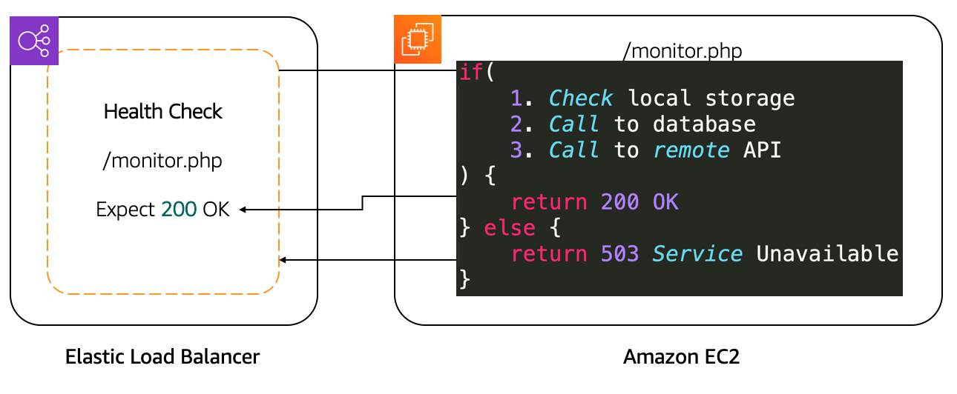

 After determining the availability of a new EC2 instance, the load balancer starts sending traffic to it. If ELB determines that an EC2 instance is no longer working, it stops sending traffic to it and lets EC2 Auto Scaling know. EC2 Auto Scaling’s responsibility is to remove it from the group and replace it with a new EC2 instance. Traffic only sends to the new instance if it passes the health check.

In the case of a scale down action that EC2 Auto Scaling needs to take due to a scaling policy, it lets ELB know that EC2 instances will be terminated. ELB can prevent EC2 Auto Scaling from terminating the EC2 instance until all connections to that instance end, while preventing any new connections. That feature is called **connection draining**.

#### ELB COMPONENTS

The ELB service is made up of three main components.

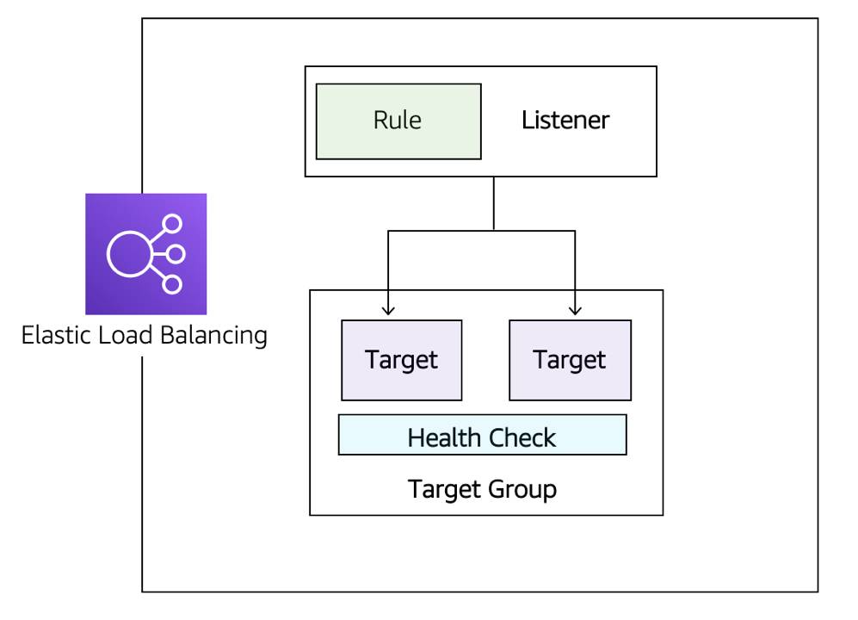

* **Listeners:** The client connects to the listener. This is often referred to as client-side. To define a listener, a port must be provided as well as the protocol, depending on the load balancer type. There can be many listeners for a single load balancer.
* **Target groups:** The backend servers, or server-side, is defined in one or more target groups. This is where you define the type of backend you want to direct traffic to, such as EC2 Instances, AWS Lambda functions, or IP addresses. Also, a health check needs to be defined for each target group.
* **Rules:** To associate a target group to a listener, a rule must be used. Rules are made up of a condition that can be the source IP address of the client and a condition to decide which target group to send the traffic to.

#### APPLICATION LOAD BALANCER

Here are some primary features of Application Load Balancer (ALB).

**ALB routes traffic based on request data.** It makes routing decisions based on the HTTP protocol like the URL path (/upload) and host, HTTP headers and method, as well as the source IP address of the client. This enables granular routing to the target groups.

**Send responses directly to the client.** ALB has the ability to reply directly to the client with a fixed response like a custom HTML page. It also has the ability to send a redirect to the client which is useful when you need to redirect to a specific website or to redirect the request from HTTP to HTTPS, removing that work from your backend servers.

**ALB supports TLS offloading.** Speaking of HTTPS and saving work from backend servers, ALB understands HTTPS traffic. To be able to pass HTTPS traffic through ALB, an SSL certificate is provided by either importing a certificate via Identity and Access Management (IAM) or AWS Certificate Manager (ACM) services, or by creating one for free using ACM. This ensures the traffic between the client and ALB is encrypted.

**Authenticate users.** On the topic of security, ALB has the ability to authenticate the users before they are allowed to pass through the load balancer. ALB uses the OpenID Connect protocol and integrates with other AWS services to support more protocols like SAML, LDAP, Microsoft AD, and more.

**Secure traffic.** To prevent traffic from reaching the load balancer, you configure a security group to specify the supported IP address ranges.

**ALB uses the round-robin routing algorithm.** ALB ensures each server receives the same number of requests in general. This type of routing works for most applications.

**ALB uses the least outstanding request routing algorithm.** If the requests to the backend vary in complexity where one request may need a lot more CPU time than another, then the least outstanding request algorithm is more appropriate. It’s also the right routing algorithm to use if the targets vary in processing capabilities. An outstanding request is when a request is sent to the backend server and a response hasn’t been received yet.

For example, if the EC2 instances in a target group aren’t the same size, one server’s CPU utilization will be higher than the other if the same number of requests are sent to each server using the round-robin routing algorithm. That same server will have more outstanding requests as well. Using the least outstanding request routing algorithm would ensure an equal usage across targets.

**ALB has sticky sessions.** In the case where requests need to be sent to the same backend server because the application is stateful, then use the sticky session feature. This feature uses an HTTP cookie to remember across connections which server to send the traffic to.Finally, ALB is specifically for HTTP and HTTPS traffic. If your application uses a different protocol, then consider the Network Load Balancer (NLB).

#### NETWORK LOAD BALANCER

Here are some primary features of Network Load Balancer (NLB).**Network Load Balancer supports TCP, UDP, and TLS protocols.** HTTPS uses TCP and TLS as protocol. However, NLB operates at the connection layer, so it doesn’t understand what a HTTPS request is. That means all features discussed above that are required to understand the HTTP and HTTPS protocol, like routing rules based on that protocol, authentication, and least outstanding request routing algorithm, are not available with NLB.

**NLB uses a flow hash routing algorithm.** The algorithm is based on:

* The protocol
* The source IP address and source port
* The destination IP address and destination port
* The TCP sequence number

If all of these parameters are the same, then the packets are sent to the exact same target. If any of them are different in the next packets, then the request may be sent to a different target.

**NLB has sticky sessions.** Different from ALB, these sessions are based on the source IP address of the client instead of a cookie.

**NLB supports TLS offloading.** NLB understands the TLS protocol. It can also offload TLS from the backend servers similar to how ALB works.

**NLB handles millions of requests per second.** While ALB can also support this number of requests, it needs to scale to reach that number. This takes time. NLB can instantly handle this amount of requests.

**NLB supports static and elastic IP addresses.** There are some situations where the application client needs to send requests directly to the load balancer IP address instead of using DNS. For example, this is useful if your application can’t use DNS or if the connecting clients require firewall rules based on IP addresses. In this case, NLB is the right type of load balancer to use.

**NLP preserves source IP address.** NLB preserves the source IP address of the client when sending the traffic to the backend. With ALB, if you look at the source IP address of the requests, you will find the IP address of the load balancer. While with NLB, you would see the real IP address of the client, which is required by the backend application in some cases.

#### SELECT BETWEEN ELB TYPES

Selecting between the ELB service types is done by determining which feature is required for your application. Below you can find a list of the major features that you learned in this unit and the previous.

| **Feature** | **Application Load Balancer** | **Network Load Balancer** |
| --- | --- | --- |
| Protocols | HTTP, HTTPS | TCP, UDP, TLS |
| Connection draining (deregistration delay) | ✔ |  |
| IP addresses as targets | ✔ | ✔ |
| Static IP and Elastic IP address |  | ✔ |
| Preserve Source IP address |  | ✔ |
| Routing based on Source IP address, path, host, HTTP headers, HTTP method, and query string | ✔ |  |
| Redirects | ✔ |  |
| Fixed response | ✔ |  |
| User authentication | ✔ |  |

**Resources**:

* [External Site: AWS: Elastic Load Balancer product comparison](https://aws.amazon.com/elasticloadbalancing/features/#Product_comparisons)
* [External Site: AWS: AWS Certificate Manager](https://aws.amazon.com/certificate-manager/)
* [External Site: AWS: Authenticate users using an Application Load Balancer](https://docs.aws.amazon.com/elasticloadbalancing/latest/application/listener-authenticate-users.html)
* [External Site: AWS: How AWS WAF works](https://docs.aws.amazon.com/waf/latest/developerguide/how-aws-waf-works.html)

### Reading 4.5: Amazon EC2 Auto Scaling

Availability and reachability is improved by adding one more server. However, the entire system can again become unavailable if there is a capacity issue. Let’s look at that load issue with both types of systems we discussed, active-passive and active-active.

#### ****Vertical Scaling****

If there are too many requests sent to a single active-passive system, the active server will become unavailable and hopefully failover to the passive server. But this doesn’t solve anything. With active-passive, you need vertical scaling. This means increasing the size of the server. With EC2 instances, you select either a larger type or a different instance type. This can only be done while the instance is in a stopped state. In this scenario, the following steps occur:

1. Stop the passive instance. This doesn’t impact the application since it’s not taking any traffic.
2. Change the instance size or type, then start the instance again.
3. Shift the traffic to the passive instance, turning it active.
4. The last step is to stop, change the size, and start the previous active instance as both instances should match.

When the amount of requests reduces, the same operation needs to be done. Even though there aren’t that many steps involved, it’s actually a lot of manual work to do. Another disadvantage is that a server can only scale vertically up to a certain limit.

Once that limit is reached, the only option is to create another active-passive system and split the requests and functionalities across them. This could require massive application rewriting.This is where the active-active system can help. When there are too many requests, this system can be scaled horizontally by adding more servers.

#### ****Horizontal Scaling****

As mentioned above, for the application to work in an active-active system, it’s already created as stateless, not storing any client session on the server. This means that having two servers or having four wouldn’t require any application changes. It would only be a matter of creating more instances when required and shutting them down when the traffic decreases.

The Amazon EC2 Auto Scaling service can take care of that task by automatically creating and removing EC2 instances based on metrics from Amazon CloudWatch.

You can see that there are many more advantages to using an active-active system in comparison with an active-passive. Modifying your application to become stateless enables scalability.

#### Integrate ELB with EC2 Auto Scaling

The ELB service integrates seamlessly with EC2 Auto Scaling. As soon as a new EC2 instance is added to or removed from the EC2 Auto Scaling group, ELB is notified. However, before it can send traffic to a new EC2 instance, it needs to validate that the application running on that EC2 instance is available.

This validation is done via the health checks feature of ELB. Monitoring is an important part of load balancers, as it should route traffic to only healthy EC2 instances. That’s why ELB supports two types of health checks.

* Establishing a connection to a backend EC2 instance using TCP, and marking the instance as available if that connection is successful.
* Making an HTTP or HTTPS request to a webpage that you specify, and validating that an HTTP response code is returned.

#### Differentiate Between Traditional Scaling and Auto Scaling

With a traditional approach to scaling, you buy and provision enough servers to handle traffic at its peak. However, this means that at night time, there is more capacity than traffic. This also means you’re wasting money. Turning off those servers at night or at times where the traffic is lower only saves on electricity.

The cloud works differently, with a pay-as-you-go model. It’s important to turn off the unused services, especially EC2 instances that you pay for On-Demand. One could manually add and remove servers at a predicted time. But with unusual spikes in traffic, this solution leads to a waste of resources with over-provisioning or with a loss of customers due to under-provisioning.

The need here is for a tool that automatically adds and removes EC2 instances according to conditions you define—that’s exactly what the EC2 Auto Scaling service does.

#### Use Amazon EC2 Auto Scaling

The EC2 Auto Scaling service works to add or remove capacity to keep a steady and predictable performance at the lowest possible cost. By adjusting the capacity to exactly what your application uses, you only pay for what your application needs. And even with applications that have steady usage, EC2 Auto Scaling can help with fleet management. If there is an issue with an EC2 instance, EC2 Auto Scaling can automatically replace that instance. This means that EC2 Auto Scaling helps both to scale your infrastructure and ensure high availability.

#### Configure EC2 Auto Scaling Components

There are three main components to EC2 Auto Scaling.

* **Launch template or configuration:** What resource should be automatically scaled?
* **EC2 Auto Scaling Group:** Where should the resources be deployed?
* **Scaling policies:** When should the resources be added or removed?

#### Learn About Launch Templates

There are multiple parameters required to create EC2 instances: Amazon Machine Image (AMI) ID, instance type, security group, additional Amazon Elastic Block Store (EBS) volumes, and more. All this information is also required by EC2 Auto Scaling to create the EC2 instance on your behalf when there is a need to scale. This information is stored in a launch template.

You can use a launch template to manually launch an EC2 instance. You can also use it with EC2 Auto Scaling. It also supports versioning, which allows for quickly rolling back if there was an issue or to specify a default version of your launch template. This way, while iterating on a new version, other users can continue launching EC2 instances using the default version until you make the necessary changes.

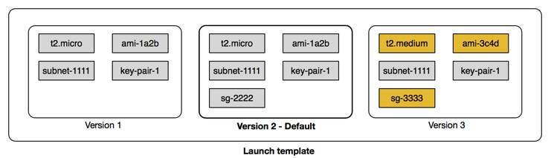

You can create a launch template one of three ways.

* The fastest way to create a template is to use an existing EC2 instance. All the settings are already defined.
* Another option is to create one from an already existing template or a previous version of a launch template.
* The last option is to create a template from scratch. The following options will need to be defined: AMI ID, instance type, key pair, security group, storage, and resource tags.

**Note**: Another way to define what Amazon EC2 Auto Scaling needs to scale is by using a **launch configuration**. It’s similar to the launch template, but it doesn’t allow for versioning using a previously created launch configuration as a template. Nor does it allow for creating one from an already existing EC2 instance. For these reasons and to ensure that you’re getting the latest features from Amazon EC2, use a launch template instead of launch configuration.

#### Get to Know EC2 Auto Scaling Groups

The next component that EC2 Auto Scaling needs is an EC2 Auto Scaling Group (ASG). An ASG enables you to define where EC2 Auto Scaling deploys your resources. This is where you specify the Amazon Virtual Private Cloud (VPC) and subnets the EC2 instance should be launched in.

EC2 Auto Scaling takes care of creating the EC2 instances across the subnets, so it’s important to select at least two subnets that are across different Availability Zones.

ASGs also allow you to specify the type of purchase for the EC2 instances. You can use On-Demand only, Spot only, or a combination of the two, which allows you to take advantage of Spot instances with minimal administrative overhead.To specify how many instances EC2 Auto Scaling should launch, there are three capacity settings to configure for the group size.

* **Minimum:** The minimum number of instances running in your ASG even if the threshold for lowering the amount of instances is reached.
* **Maximum:** The maximum number of instances running in your ASG even if the threshold for adding new instances is reached.
* **Desired capacity:** The amount of instances that should be in your ASG. This number can only be within or equal to the minimum or maximum. EC2 Auto Scaling automatically adds or removes instances to match the desired capacity number.

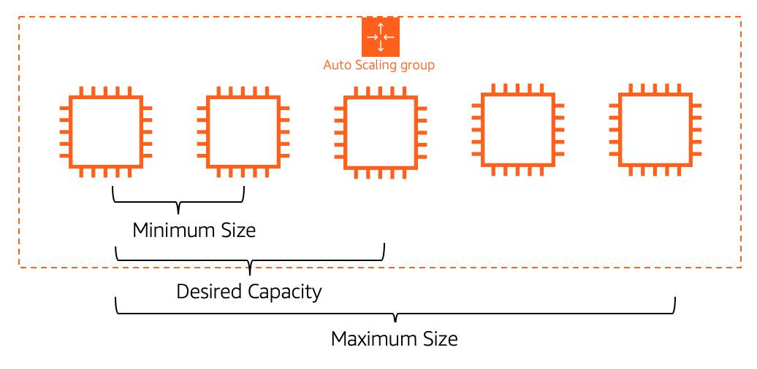

When EC2 Auto Scaling removes EC2 instances because the traffic is minimal, it keeps removing EC2 instances until it reaches a minimum capacity. Depending on your application, using a minimum of two is a good idea to ensure high availability, but you know how many EC2 instances at a bare minimum your application requires at all times. When reaching that limit, even if EC2 Auto Scaling is instructed to remove an instance, it does not, to ensure the minimum is kept.

On the other hand, when the traffic keeps growing, EC2 Auto Scaling keeps adding EC2 instances. This means the cost for your application will also keep growing. That’s why it’s important to set a maximum amount to make sure it doesn’t go above your budget.

The desired capacity is the amount of EC2 instances that EC2 Auto Scaling creates at the time the group is created. If that number decreases, then EC2 Auto Scaling removes the oldest instance by default. If that number increases, then EC2 Auto Scaling creates new instances using the launch template.

#### Ensure Availability with EC2 Auto Scaling

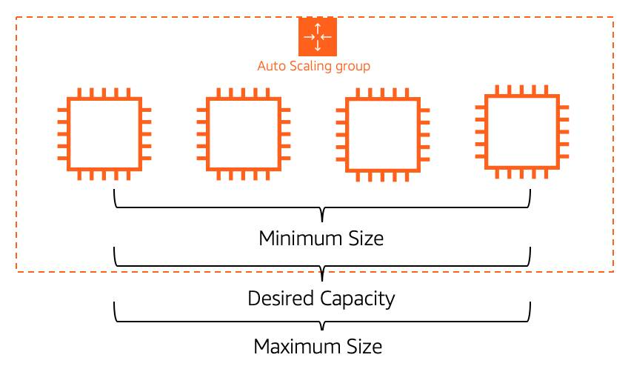

Using different numbers for minimum, maximum, and desired capacity is used for dynamically adjusting the capacity. However, if you prefer to use EC2 Auto Scaling for fleet management, you can configure the three settings to the same number, for example four. EC2 Auto Scaling will ensure that if an EC2 instance becomes unhealthy, it replaces it to always ensure that four EC2 instances are available. This ensures high availability for your applications.

#### Enable Automation with Scaling Policies

By default, an ASG will be kept to its initial desired capacity. Although it’s possible to manually change the desired capacity, you can also use scaling policies.

In the AWS Monitoring module, you learned about Amazon CloudWatch metrics and alarms. You use **metrics** to keep information about different attributes of your EC2 instance like the CPU percentage. You use **alarms** to specify an action when a threshold is reached. Metrics and alarms are what scaling policies use to know when to act. For example, you set up an alarm that says when the CPU utilization is above 70% across the entire fleet of EC2 instances, trigger a scaling policy to add an EC2 instance.

There are three types of scaling policies: simple, step, and target tracking scaling.

#### Simple Scaling Policy

A simple scaling policy allows you to do exactly what’s described above. You use a CloudWatch alarm and specify what to do when it is triggered. This can be a number of EC2 instances to add or remove, or a specific number to set the desired capacity to. You can specify a percentage of the group instead of using an amount of EC2 instances, which makes the group grow or shrink more quickly.

Once this scaling policy is triggered, it waits a cooldown period before taking any other action. This is important as it takes time for the EC2 instances to start and the CloudWatch alarm may still be triggered while the EC2 instance is booting. For example, you could decide to add an EC2 instance if the CPU utilization across all instances is above 65%. You don’t want to add more instances until that new EC2 instance is accepting traffic.

However, what if the CPU utilization was now above 85% across the ASG? Only adding one instance may not be the right move here. Instead, you may want to add another step in your scaling policy. Unfortunately, a simple scaling policy can’t help with that.

#### Step Scaling Policy

This is where a step scaling policy helps. Step scaling policies respond to additional alarms even while a scaling activity or health check replacement is in progress. Similar to the example above, you decide to add two more instances in case the CPU utilization is at 85%, and four more instances when it’s at 95%.

Deciding when to add and remove instances based on CloudWatch alarms may seem like a difficult task. This is why the third type of scaling policy exists: target tracking.

#### Target Tracking Scaling Policy

If your application scales based on average CPU utilization, average network utilization (in or out), or based on request count, then this scaling policy type is the one to use. All you need to provide is the target value to track and it automatically creates the required CloudWatch alarms.

#### ****Resources****

* [External Site: AWS: Amazon EC2 Auto Scaling](https://aws.amazon.com/ec2/autoscaling/)
* [External Site: AWS: Amazon EC2 Auto Scaling FAQs](https://aws.amazon.com/ec2/autoscaling/faqs/)
* [External Site: AWS: Setting capacity limits for your Auto Scaling Group](https://docs.aws.amazon.com/autoscaling/ec2/userguide/asg-capacity-limits.html)
* [External Site: AWS: Step and simple scaling policies for Amazon EC2 Auto Scaling](https://docs.aws.amazon.com/autoscaling/ec2/userguide/as-scaling-simple-step.html)
* [External Site: AWS: Target tracking scaling policies for Amazon EC2 Auto Scaling](https://docs.aws.amazon.com/autoscaling/ec2/userguide/as-scaling-target-tracking.html)
* [External Site: AWS: Creating an Auto Scaling Group using a launch template](https://docs.aws.amazon.com/autoscaling/ec2/userguide/create-asg-launch-template.html)

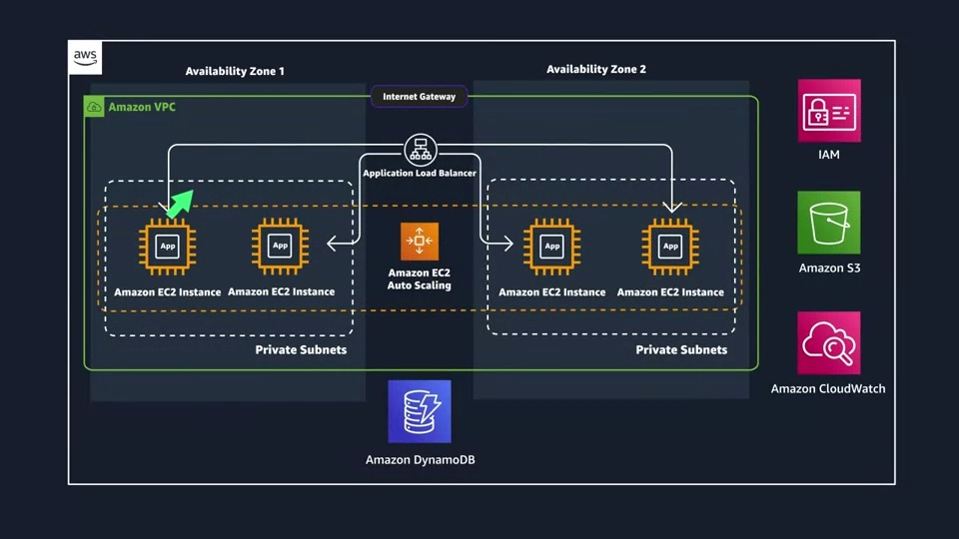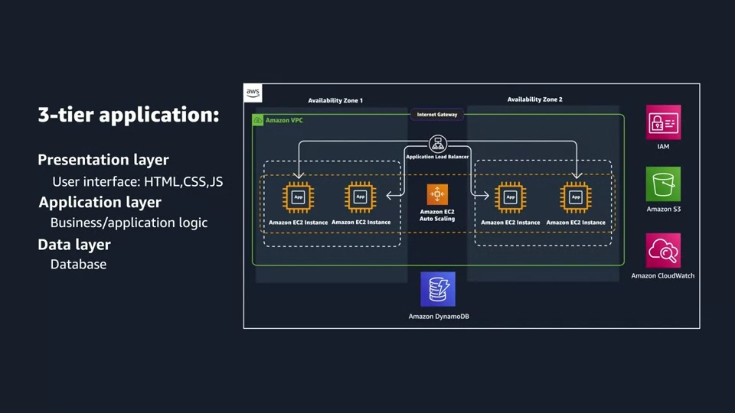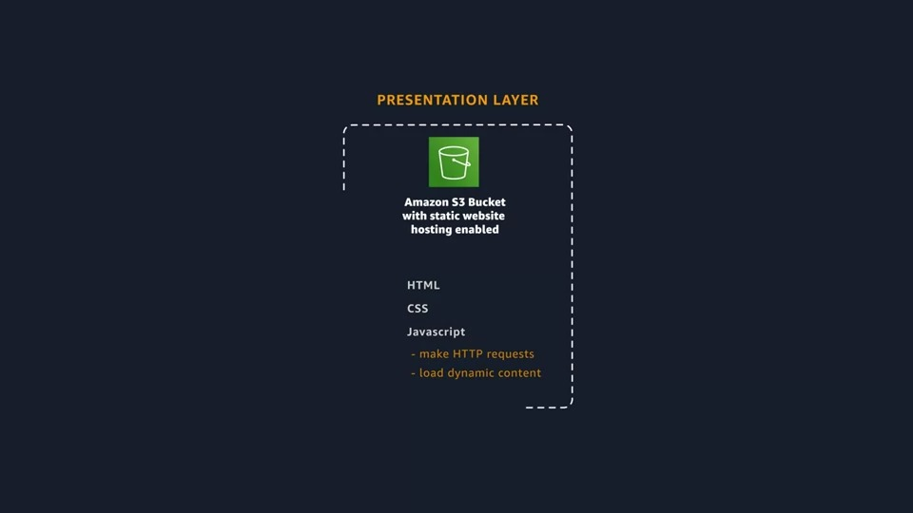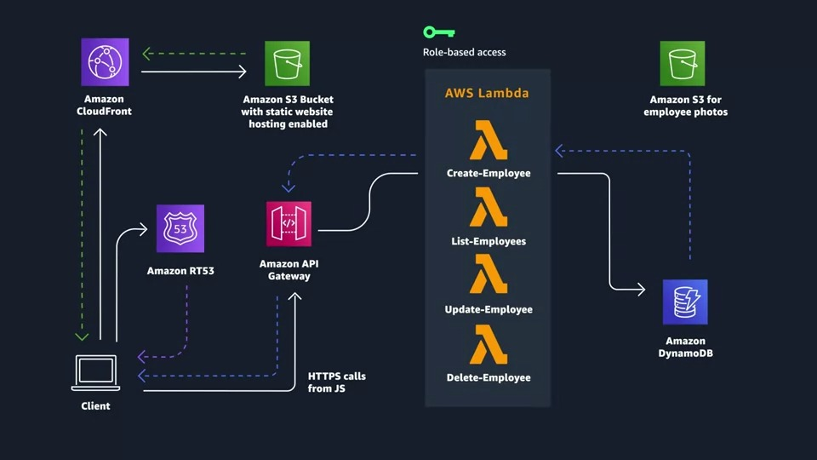

# Course 2: Architecting Solutions on AWS

## Week1: Designing a serverless web backend on AWS

### Welcome to the Course

Welcome to Architecting Solutions on AWS, which is the second of four courses in the AWS Cloud Solutions Architect Professional Certificate. This course will help prepare you to begin your career architecting solutions on AWS. Through a series of use case scenarios and practical learning, you will learn how to identify services and features so that you can build resilient, secure, and highly available IT solutions in the AWS Cloud. Each week, a fictional customer will present a different business need. The instructors will then review the options, choose the best services for the use case, and walk you through the architectural design on a whiteboard. First, you will learn about building event-driven architectures with a focus on performance efficiency and cost. You will also learn about how to architect a solution by using many purpose-built AWS services. With this knowledge, you will gain a deeper understanding of hybrid architectures with a focus on reliability and operational efficiency. Finally, you will wrap up your learning by understanding how to build a multi-account strategy that is centered around security and cost. Each course of the AWS Cloud Solutions Architect Professional Certificate is broken down into weeks. Remember that you can complete courses at your own pace, but the weekly breakdowns are designed to help you finish the program in about 6 months.

**Week 1: Designing a serverless web backend on AWS** The first week in this course follows a customer use case where an ecommerce company needs to migrate a backend web service to AWS. You will first hear from the customer about their requirements and the problems that they are trying to solve with this migration. Then, you will learn how to design the solution for this use case, step by step, by using services such as Amazon API Gateway, AWS Lambda, Amazon Simple Queue Service (Amazon SQS), Amazon Simple Notification Service (Amazon SNS), and Amazon DynamoDB.

**Week 2: Designing a serverless data analytics solution on AWS** The second week in this course follows a customer use case where a software company needs a data analytics solution in AWS so that they can derive insights from clickstream data. You will first hear from the customer about their requirements and the problems that they are trying to solve with this solution. Then, you will learn how to design the solution for this use case, step by step, by using services such as Amazon Simple Storage Service (Amazon S3), Amazon Kinesis Data Firehose, Amazon Athena, Amazon QuickSight, and more.

**Week 3: Designing a hybrid solution for container based workloads on AWS** The third week in this course follows a customer use case where an enterprise insurance company needs to migrate some of their container workloads to AWS by using a hybrid model. You will first hear from the customer about their requirements and the problems that they are trying to solve with this migration. Then, you will learn how to design the solution for this use case, step by step, by using services such as AWS Direct Connect, Amazon Elastic Container Service (Amazon ECS), Amazon ECS Anywhere, Amazon Relational Database Service (Amazon RDS), AWS Systems Manager, and more.

**Week 4: Designing a solution following account governance and management best practices** The fourth week in this course follows a customer use case where a startup company needs guidance about how to set up an account-management strategy that follows best practices for account governance and standards. You will first hear from the customer about their requirements and the problems that they are trying to solve with this strategy. Then, you will learn how to design the solution for this use case, step by step, by using services such as AWS Organizations, AWS IAM Identity Center (successor to AWS Single Sign-On), AWS CloudTrail, and more.

Happy Learning!

Morgan & Raf

### Customer #1 – AnyCompany Online Introduction

Throughout this course, we will include readings like this one that link to resources to help you further your learning with AWS. Depending on your experience level, you might be looking for deeper information or hands-on tutorials on AWS. These readings will help point you to resources where you can explore topics that are relevant to your own learning in more detail.

#### Architecting Solutions on AWS

This course explores architecting solutions on AWS in the context of four unique scenarios. Each week, you will be presented with a customer use case. You will then view videos that design a solution to meet the customer’s needs, step by step. This process will result in an AWS architecture diagram at the end of each week. If you want to follow along and also design the AWS architectures, you can use various tools to build your diagram. To view drawing and diagramming tools, see [AWS Architecture Icons](https://aws.amazon.com/architecture/icons/) and scroll down to the drawing and diagramming tools section. This course doesn’t include videos about building a proof of concept for each design, though it does include instructions on how to build a proof of concept for week 1 and week 2. These instructions can be followed in your own personal AWS account. This course also offers exploratory demos for many of the services that are covered, and some tutorials will be embedded or linked to in the readings.

#### Hands-on exercises and tutorials

Any hands-on tutorials or exercises that are included in this course—or linked to from this course—will require you to have an AWS account. To create an AWS account, follow the instructions in [How do I create and activate an AWS account?](https://aws.amazon.com/premiumsupport/knowledge-center/create-and-activate-aws-account/)

#### AWS Free Tier

With the AWS Free Tier, customers can explore and try out AWS services free of charge, up to specified limits for each service. The AWS Free Tier comprises three different types of offerings: 12 months free, always free, and short-term trials. Customers can use services with a 12-months-free offer to use the product for free—up to specified limits—for 1 year, starting from the date that the account was activated. Customers can use services with an always-free offer to use the product for free up (again, up to specified limits) as long as they are an AWS customer. Services with a short-term trial are free to use for a specified period of time, or up to a one-time limit, depending on the service that’s selected. You can see details about the limits and services that are provided for free on each card on the AWS Free Tier page. If your application use exceeds the AWS Free Tier limits, you pay standard, pay-as-you-go service rates (for full pricing details, see the main webpage for the service). For more information about the AWS Free Tier, see [AWS Free Tier](https://aws.amazon.com/free/?all-free-tier.sort-by=item.additionalFields.SortRank&all-free-tier.sort-order=asc&awsf.Free%20Tier%20Types=*all&awsf.Free%20Tier%20Categories=*all).

#### AWS Architecture Center

The AWS Architecture Center provides reference architecture diagrams, vetted architecture solutions, Well-Architected best practices, patterns, icons, and more. This expert guidance was contributed by cloud architecture experts from AWS (including solutions architects and professional services consultants) and AWS Partners. For examples from the AWS Architecture Center, see [AWS Architecture Center](https://aws.amazon.com/architecture/?cards-all.sort-by=item.additionalFields.sortDate&cards-all.sort-order=desc&awsf.content-type=*all&awsf.methodology=*all&awsf.tech-category=*all&awsf.industries=*all).

#### AWS Well-Architected Framework

In this course, we will optimize a sample architecture at the end of every week. As a solutions architect or cloud consultant, you might be asked to perform an AWS Well-Architected review in the future. For more information about the AWS Well-Architected Framework, see [AWS Well-Architected Framework.](https://docs.aws.amazon.com/wellarchitected/latest/framework/welcome.html)  
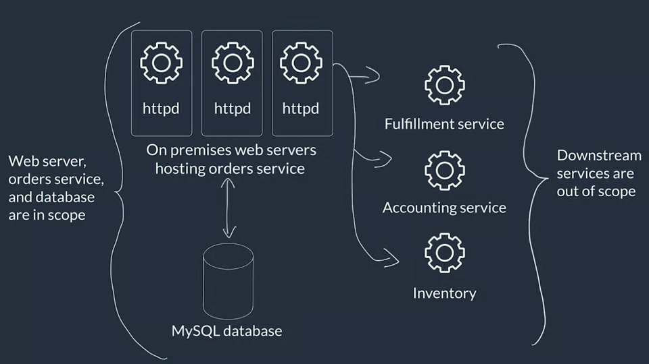

Now, for the requirements that we gathered. First off, managed scaling for compute and database components, when possible, is going to be important. This one makes me immediately think that we will be using serverless services as much as possible. Serverless services scale in and out with demand on their own, without the customer needing to step in. For some services, you can set parameters around how scaling happens, or set limits to scaling, but it's totally managed behind the scenes. So, I'm going to keep serverless top of mind as we go through the different potential components, which, spoiler alert, means I probably won't be looking at EC2 a lot for this solution. Now, for the next requirement, we have decoupling components to maximize resilience. This one is really about eliminating single points of failure for the app. I'm thinking of breaking the order service down into multiple components, and following an event-driven architecture, so we can more loosely couple each piece. What I mean by that, is that the order acceptance, order processing, and then the downstream calls, should all be independent of each other, so that if one has a hiccup or fails, it won't take down everything else. We'll keep talking about this throughout the week. Another requirement from the customer is that they wanted centralized monitoring and logging. They want to be able to see the state of their application all in one place, and have a centralized point to come to for debugging or troubleshooting. This won't be a problem, especially with the serverless services, which all tend to be integrated with Amazon CloudWatch and Amazon CloudWatch Logs. Then finally, there's our last requirement, which is all about optimizing for cost, performance efficiency, and operational overhead. Cost is going to be one of the main drivers for what services I choose, and then, secondarily, performance efficiency and operational overhead. It can be difficult to balance these things. But again, serverless really tends to optimize in the direction of these three things anyways, so I'm not too concerned here. We will build out the architecture first, piece by piece, put it all together, and then circle back and talk about the different choices that we can make to optimize for cost and performance.

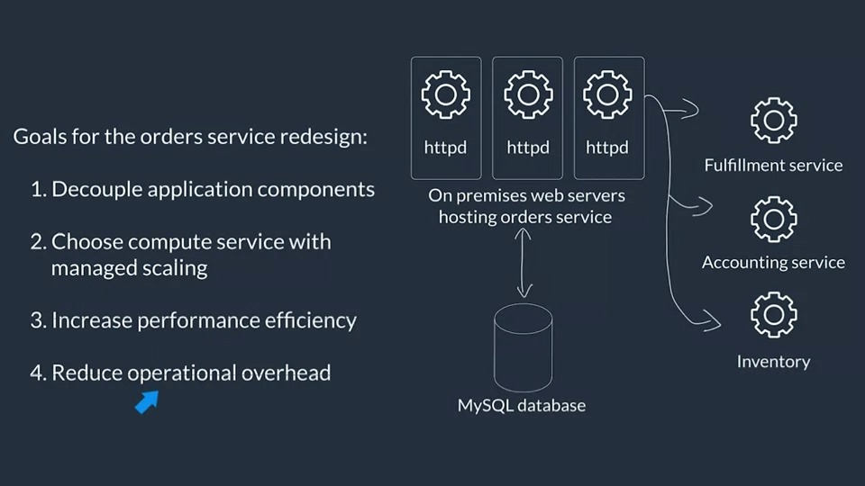

### Compute on AWS

When you consider what compute service to use for a specific use case, you should ensure that you are up to date on any new AWS service or feature releases. To review a high-level overview of the different AWS compute services AWS, see [Compute on AWS - Compute for any workload](https://aws.amazon.com/products/compute/).

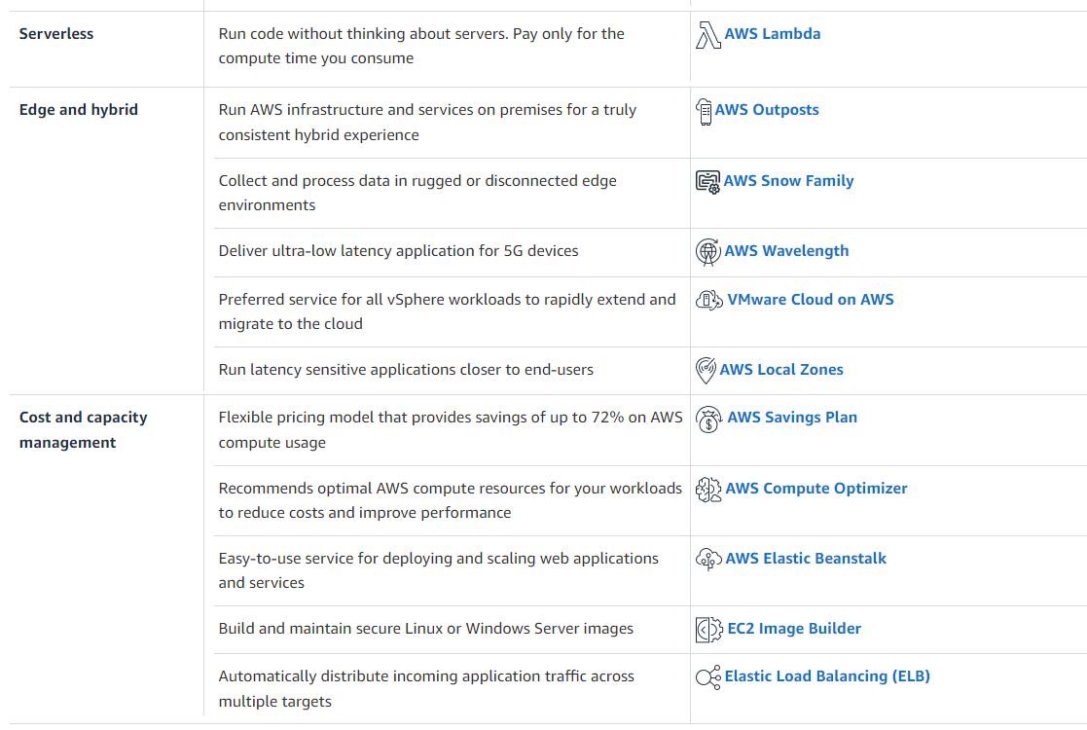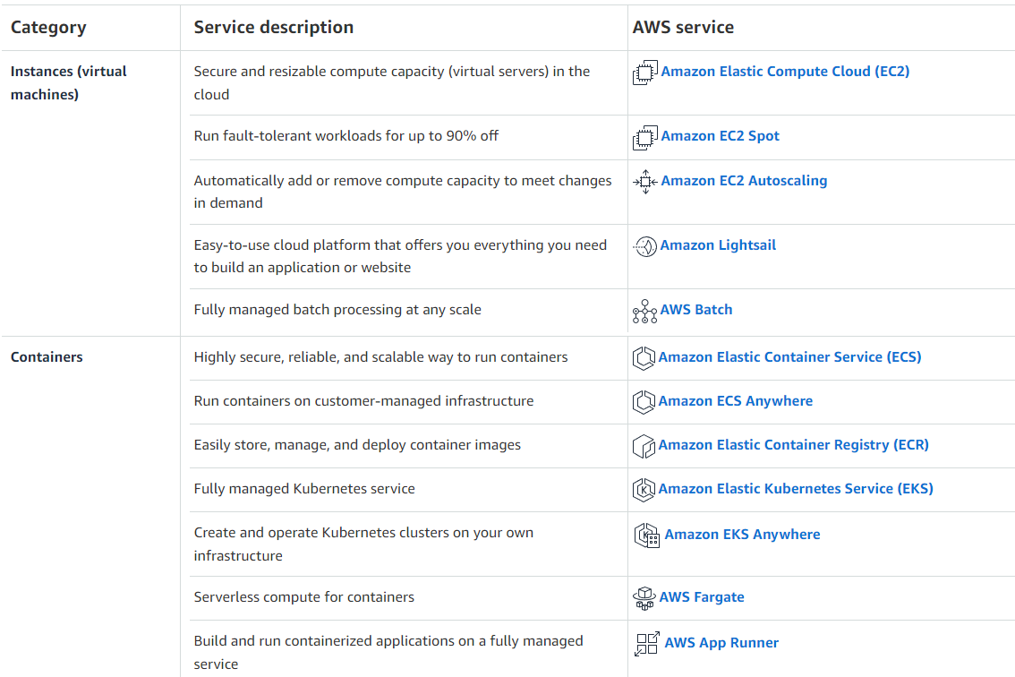

#### AWS Lambda

For this weeks architecture, we have chosen AWS Lambda as the compute service due to it’s serverless nature and ability to support a web backend. Lambda is a compute service that provides serverless compute functions that run in response to events or triggers. When an event or trigger is detected, a Lambda function is spun up in its own secure and isolated runtime environment, which is called an execution environment. Lambda functions can run for up to 15 minutes. Any processes that need longer than 15 minutes to run should use other compute services on AWS for hosting. Each execution environment stays active for a period of time, and then it shuts down on its own.

When you use Lambda, you are responsible only for your code, which can make it easier to optimize for operational efficiency and low operational overhead. Lambda manages the compute fleet, which offers a balance of memory, CPU, network, and other resources to run your code. Because Lambda manages these resources, you can’t log in to compute instances or customize the operating system on the provided runtimes. Lambda performs operational and administrative activities on your behalf, including managing capacity, monitoring, and logging your Lambda functions.If you need to manage your own compute resources, AWS has other compute services that can meet your needs. For example:

* Amazon Elastic Compute Cloud (Amazon EC2) offers a wide range of EC2 instance types to choose from. With Amazon EC2, you can customize operating systems, settings for network and security, and the entire software stack. You are responsible for provisioning capacity, monitoring fleet health and performance, and using Availability Zones for fault tolerance.
* AWS Elastic Beanstalk is a service that you can use to deploy and scale applications on Amazon EC2. You retain ownership and full control over the underlying EC2 instances.

Lambda can be used for virtually any application or backend that requires compute and that runs in under 15 minutes. Common use cases are web backends, Internet of Things (IoT) backends, mobile backends, file or data processing, stream or message processing, and more. Lambda is a good choice for use cases where the requirements include reducing operational overhead, optimizing for cost, or optimizing for performance efficiency. Lambda works well for these use cases because it’s a managed service and you only pay for what you use. There are no idling resources when working with AWS Lambda, which means that each Lambda function is highly performant and cost efficient.

* To gain a deeper understanding of Lambda, see [AWS Lambda FAQs](https://aws.amazon.com/lambda/faqs/).
* To learn more about Lambda, see the [AWS Lambda Developer Guide](https://docs.aws.amazon.com/lambda/latest/dg/welcome.html) or the [AWS Lambda Operator Guide](https://docs.aws.amazon.com/lambda/latest/operatorguide/intro.html).
* To learn more about architecting and best practices for Lambda, see [Architecture and Best Practices](https://docs.aws.amazon.com/lambda/latest/operatorguide/architecture-best-practice.html).
* For a list of technical talks that cover Lambda, see [AWS Lambda - Technical Talks](https://aws.amazon.com/lambda/resources/webinars-and-talks/).
* For a list of technical tutorials that use Lambda, see [AWS Lambda - Workshops & Tutorials](https://aws.amazon.com/lambda/resources/workshops-and-tutorials/).

#### Amazon API Gateway

After Morgan selected Lambda for the compute backend, she needed to find a way to expose the backend Lambda function. Amazon API Gateway integrates with Lambda, thus providing a way to expose the backend service without exposing to the open internet. This week’s customer might decide to add authentication to API Gateway to secure it further.

API Gateway is a fully managed service that makes it easier for developers to create, publish, maintain, monitor, and secure APIs at any scale. APIs act as the front door for applications, so that the applications can access data, business logic, or functionality from your backend services. By using API Gateway, you can create RESTful APIs and WebSocket APIs that enable real-time two-way communication applications. API Gateway supports containerized and serverless workloads, as well as web applications.

API Gateway handles all the tasks involved in accepting and processing up to hundreds of thousands of concurrent API calls, including traffic management, CORS support, authorization and access control, throttling, monitoring, and API version management. API Gateway has no minimum fees or startup costs. You pay for the API calls you receive and the amount of data transferred out and, with the API Gateway tiered pricing model, you can reduce your cost as your API usage scales.

* For more information about Amazon API Gateway, see [Amazon API Gateway](https://aws.amazon.com/api-gateway/) or [Amazon API Gateway FAQs](https://aws.amazon.com/api-gateway/faqs/).

#### Amazon EC2

Amazon EC2 is a service that provides resizable compute capacity in the cloud, which means that it provides virtual machines in the cloud. Amazon EC2 is a flexible service that offers multiple instance types, sizes, and pricing models to meet specific requirements. Because you can choose your operating system and configurations for your instance, you can configure Amazon EC2 to work with virtually any workload.

You can use Amazon EC2 when you want to run applications on AWS, but still want to retain control over the underlying infrastructure. Morgan didn’t choose Amazon EC2 as the compute service for this customer’s use case because of the operational overhead that Amazon EC2 requires. You have a lot of control over Amazon EC2, but that control also means that you will have overhead for managing the service. The customer had a straightforward use case and was willing to rewrite the code to use Lambda. The customer also had a spiky demand for their workload. Thus, choosing a service such as Lambda minimizes idling resources during low volume times, which can be more difficult to achieve with Amazon EC2.

* For a beginner tutorial about Amazon EC2, see [Get started with Amazon EC2 Linux instances](https://docs.aws.amazon.com/AWSEC2/latest/UserGuide/EC2_GetStarted.html).
* To gain a deeper understanding of Amazon EC2, see [What is Amazon EC2?](https://docs.aws.amazon.com/AWSEC2/latest/UserGuide/concepts.html) or [Amazon EC2 FAQs](https://aws.amazon.com/ec2/faqs/).

#### AWS container services

Container management tools can be divided into three categories: registry, orchestration, and compute. AWS offers services that give you a secure place to store and manage your container images, orchestration that manages when and where your containers run, and flexible compute engines to power your containers. AWS can help manage your containers and their deployments for you, so you don't have to worry about the underlying infrastructure. No matter what you're building, AWS makes it easy and efficient to build with containers.

Container services were not chosen for this architecture because the customer did not want to integrate this technology into their stack. So, even though running a container on Amazon ECS using AWS Fargate as the compute platform would technically work it was not chosen because of other customer preferences.

#### Amazon ECS

Amazon Elastic Container Service (Amazon ECS) is a fully managed container orchestration service that you can use to deploy, manage, and scale containerized applications. It integrates with the rest of the AWS Cloud to provide a secure and easy-to-use solution for running container workloads in the cloud or on premises. Key features of Amazon ECS:

* Serverless by default with AWS Fargate: Fargate is built into Amazon ECS, and it reduces the time you need to spend on managing servers, handling capacity planning, or figuring out how to isolate container workloads for security. With Fargate, you define your application’s requirements and select Fargate as your launch type in the console or AWS Command Line Interface (AWS CLI). Then, Fargate takes care of all the scaling and infrastructure management that’s needed to run your containers.
* Security and isolation by design: Amazon ECS natively integrates with the tools you already trust for security, identity, and management and governance. This can help you get to production quickly and successfully. You can assign granular permissions for each of your containers, giving you a high level of isolation when you build your applications. You can launch your containers with the security and compliance levels that you have come to expect from AWS.
* Autonomous control plane operations: Amazon ECS is a fully-managed container orchestration service, with AWS configuration and operational best practices built-in—with no control plane, nodes, or add-ons for you to manage. It natively integrates with both AWS and third-party tools to make it easier for teams to focus on building the applications, not the environment.

#### Amazon EKS

Amazon Elastic Kubernetes Service (Amazon EKS) is a managed service that you can use to run Kubernetes on AWS without needing to install, operate, and maintain your own Kubernetes control plane or nodes. Kubernetes is an open-source system for automating the deployment, scaling, and management of containerized applications. Amazon EKS offers the following features:

* It runs and scales the Kubernetes control plane across multiple AWS Availability Zones to ensure high availability.
* It also automatically scales control plane instances based on load, detects and replaces unhealthy control plane instances, and provides automated version updates and patching for them.
* It is integrated with many AWS services to provide scalability and security for your applications, including the following capabilities:
* Amazon Elastic Container Registry (Amazon ECR for container images).
* Elastic Load Balancing for load distribution.
* AWS Identity and Access Management (IAM) for authentication.
* Amazon Virtual Private Cloud (VPC) for isolation.
* It runs up-to-date versions of Kubernetes, so you can use all of the existing plugins and tooling from the Kubernetes community.

Applications that run on Amazon EKS are fully compatible with applications that run on any standard Kubernetes environment—it doesn’t matter whether they run in on-premises data centers or public clouds. This means that you can migrate any standard Kubernetes application to Amazon EKS with virtually no code modification.

#### AWS Fargate

AWS Fargate is a technology that you can use with Amazon ECS to run containers without managing servers or clusters of EC2 instances. AWS Fargate reduces your need to provision, configure, or scale clusters of virtual machines to run containers. Thus, it also minimizes your need to choose server types, decide when to scale your clusters, or optimize cluster packing.

When you run your tasks and services with the Fargate launch type, you package your application in containers, specify the CPU and memory requirements, define networking and IAM policies, and launch the application. Each Fargate task has its own isolation boundary and doesn’t share the underlying kernel, CPU resources, memory resources, or elastic network interface with another task.

With Amazon ECS on AWS Fargate capacity providers, you can use both Fargate and Fargate Spot capacity with your Amazon ECS tasks. With Fargate Spot, you can run interruption-tolerant Amazon ECS tasks at a discounted rate, compared to the Fargate price. Fargate Spot runs tasks on spare compute capacity. When AWS needs the capacity back, your tasks will be interrupted with a 2-minute warning notice.

* To learn more about Amazon EKS, see the [Amazon EKS User Guide](https://docs.aws.amazon.com/eks/latest/userguide/what-is-eks.html).
* To learn more about AWS container services, see [Containers on AWS.](https://aws.amazon.com/containers/services/)
* To learn more about AWS Fargate, see [Amazon ECS on AWS Fargate.](https://docs.aws.amazon.com/AmazonECS/latest/developerguide/AWS_Fargate.html)
* 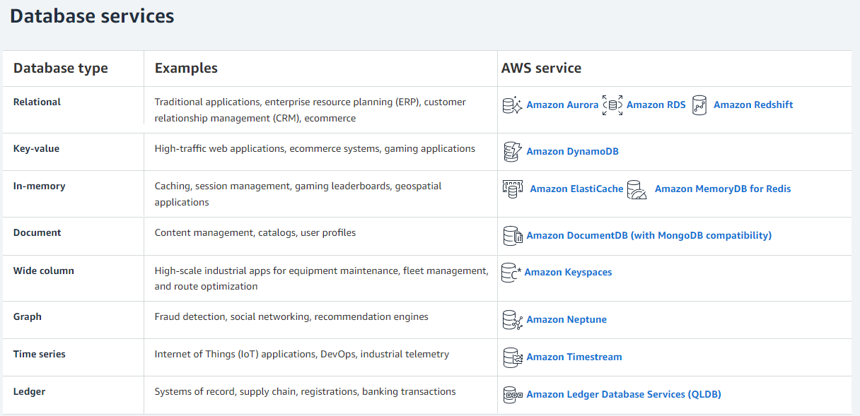For hands-on tutorials using Amazon ECS, see [Amazon ECS Workshop.](https://ecsworkshop.com/)

### Databases on AWS

https://aws.amazon.com/products/databases/

Databases are purpose-built on AWS, which means that each AWS database service is built for a specific use case or set of use cases. Using a database that is a best fit for the use case can save a lot of time in development hours. In the past, it was common to use relational databases for everything because they were the most commonly operated database on premises. With AWS, you can run different types of databases more easily without managing the infrastructure yourself. This can lead to making decisions that are more aligned with the use case and aren’t limited to in-house skill for database administration.

For this weeks customer, Morgan chose Amazon DynamoDB as the database choice because the customer is using it as a simple lookup table, there is no need for complex SQL queries or joins across tables, and the serverless nature of the table makes it easy to operate over time.

For a high-level overview of the AWS database services, see [AWS Cloud Databases.](https://aws.amazon.com/products/databases/)

#### Amazon Aurora

Amazon Aurora is a fully managed relational database engine that's compatible with MySQL and PostgreSQL. You can use the code, tools, and applications for your existing MySQL and PostgreSQL databases with Aurora.

Aurora wasn’t chosen for this architecture because the customer doesn’t need the complex, enterprise-database features that Aurora offers.

As an enterprise-level database, Aurora can—with some workloads—deliver up to five times the throughput of MySQL and up to three times the throughput of PostgreSQL without requiring changes to most of your existing applications.

Aurora includes a high-performance storage subsystem. Its MySQL-compatible and PostgreSQL-compatible database engines are customized to take advantage of that fast, distributed storage. The underlying storage grows automatically as needed. An Aurora cluster volume can grow to a maximum size of 128 tebibytes (TiB). Aurora also automates and standardizes database clustering and replication, which are typically among the most challenging aspects of database configuration and administration.

Aurora is part of the managed database service Amazon Relational Database Service (Amazon RDS). Amazon RDS is a web service that makes it easier to set up, operate, and scale a relational database in the cloud. Aurora Serverless v2is an on-demand, automatic scaling configuration for Aurora.

Aurora Serverless v2 helps automate the processes of monitoring the workload and adjusting the capacity for your databases. Capacity is adjusted automatically based on application demand. You're charged only for the resources that your database clusters consume. Thus, Aurora Serverless v2 can help you to stay within budget and reduce the need to pay for computer resources that you don't use.

This type of automation is especially valuable for multitenant databases, distributed databases, development and test systems, and other environments with highly variable and unpredictable workloads.

* For more information on Amazon Aurora Serverless, see [Using Aurora Serverless v2](https://docs.aws.amazon.com/AmazonRDS/latest/AuroraUserGuide/aurora-serverless-v2.html).
* For links to tutorials for Amazon Aurora, see [Getting started with Amazon Aurora](https://aws.amazon.com/rds/aurora/getting-started/).

#### Amazon RDS Proxy

By using Amazon RDS Proxy, your applications can pool and share database connections to improve their ability to scale. RDS Proxy makes applications more resilient to database failures by automatically connecting to a standby DB instance, while preserving application connections. By using RDS Proxy, you can also enforce AWS Identity and Access Management (IAM) authentication for databases, and securely store credentials in AWS Secrets Manager.

With RDS Proxy, you can handle unpredictable surges in database traffic that otherwise might cause issues because of oversubscribing connections or creating new connections at a fast rate. RDS Proxy establishes a database connection pool and reuses connections in this pool without the memory and CPU overhead of opening a new database connection each time. To protect the database against oversubscription, you can control the number of database connections that are created.

RDS Proxy queues or throttles application connections that can't be served immediately from the pool of connections. Although latencies might increase, your application can continue to scale without abruptly failing or overwhelming the database.

* For more information about Amazon RDS Proxy, see [Using Amazon RDS Proxy.](https://docs.aws.amazon.com/AmazonRDS/latest/AuroraUserGuide/rds-proxy.html)

#### Amazon DynamoDB

Amazon DynamoDB is a fully managed NoSQL database service that provides fast and predictable performance with seamless scalability. By using DynamoDB, you can offload the administrative burdens of operating and scaling a distributed database so that you can reduce your need to handle hardware provisioning, setup and configuration, replication, software patching, or cluster scaling. DynamoDB also offers encryption at rest, which reduces your operational burden and the complexity involved in protecting sensitive data.

With DynamoDB, you can create database tables that can store and retrieve virtually any amount of data and serve virtually any level of request traffic. You can scale up or scale down your tables' throughput capacity with minimal downtime or performance degradation.

If you are an application developer, you might have some experience using a relational database management system (RDBMS) and Structured Query Language (SQL). As you begin working with Amazon DynamoDB, you will encounter many similarities, but also many things that are different.

NoSQL is a term used to describe nonrelational database systems that are highly available, scalable, and optimized for high performance. Instead of the relational model, NoSQL databases (such as DynamoDB) use alternate models for data management, such as key-value pairs or document storage.

In DynamoDB, tables, items, and attributes are the core components that you work with. A table is a collection of items, and each item is a collection of attributes. DynamoDB uses primary keys to uniquely identify each item in a table, and secondary indexes to provide more querying flexibility. You can use DynamoDB Streams to capture data modification events in DynamoDB tables.

* For more information about Amazon DynamoDB, see [What is Amazon DynamoDB?](https://docs.aws.amazon.com/amazondynamodb/latest/developerguide/Introduction.html) or [Amazon DynamoDB FAQs](https://aws.amazon.com/dynamodb/faqs/).
* For more information about Amazon DynamoDB data modeling, see [Example of modeling relational data in DynamoDB](https://docs.aws.amazon.com/amazondynamodb/latest/developerguide/bp-modeling-nosql-B.html).
* For hands-on learning with Amazon DynamoDB, see [Hands-on labs for DynamoDB](https://amazon-dynamodb-labs.com/hands-on-labs.html).

### Event-Driven Architectures on AWS

This week’s customer currently uses a synchronous web application to host the orders service, which is causing various issues—for example, the code is too tightly coupled with downstream API calls. Morgan suggested that they move to an event-driven architecture to solve this problem.

An event-driven architecture uses events to invoke and communicate between decoupled services. It’s a common architecture in modern applications that are built with microservices. An event is a change in state, or an update, such as placing an item in a shopping cart on an ecommerce website. Events can either carry the state (the item purchased, its price, and a delivery address) or events can be identifiers (a notification that an order was shipped).

Event-driven architectures have three key components: event producers, event routers, and event consumers. A producer publishes an event to the router, which filters and pushes the events to consumers. Producer services and consumer services are decoupled, which means that they can be scaled, updated, and deployed independently.

The following diagram shows an example of an event-driven architecture for an ecommerce site. By using this architecture, the site can react to changes from various sources during times of peak demand, without crashing the application or overprovisioning resources.

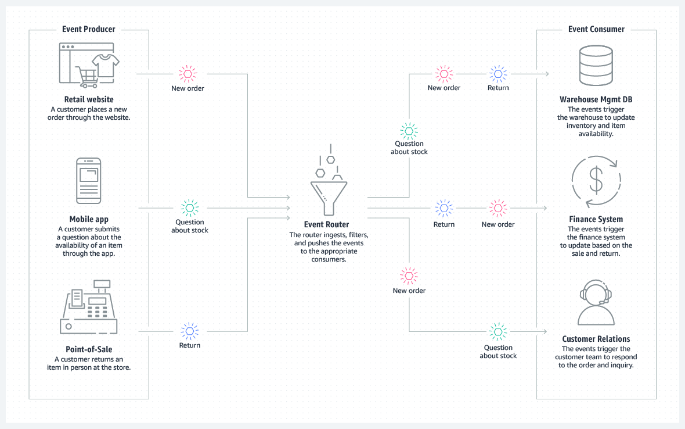

For more information about event-driven architectures, see [What is an Event-Driven Architecture?](https://aws.amazon.com/event-driven-architecture/)

#### Amazon EventBridge compared to Amazon SNS

You can use both Amazon EventBridge and Amazon Simple Notification Service (Amazon SNS) to develop event-driven applications. Your choice will depend on your specific needs.

We recommend EventBridge when you want to build an application that reacts to events from software as a service (SaaS) applications or AWS services. EventBridge is the only event-based service that integrates directly with third-party SaaS AWS Partners. EventBridge also automatically ingests events from over 90 AWS services without requiring developers to create any resources in their account. In addition, EventBridge uses a defined, JSON-based structure for events, and you can also select events to forward to a target by creating rules that are applied across the entire event body. EventBridge currently supports over 15 AWS services as targets, including AWS Lambda, Amazon Simple Queue Service (Amazon SQS), Amazon SNS, Amazon Kinesis Data Streams, and Amazon Kinesis Data Firehose, and more. At launch, EventBridge has limited throughput (see the service limits), which can be increased on request. It also has a typical latency of about half a second.

We recommend Amazon SNS when you want to build an application that reacts to high throughput or low-latency messages that are published by other applications or microservices. Amazon SNS provides nearly unlimited throughput. You can also use it for applications that need very high fan-out (thousands or millions of endpoints). Messages are unstructured and can be in any format. Amazon SNS supports forwarding messages to six different types of targets, including AWS Lambda, Amazon SQS, HTTP/S endpoints, Short Message Service (SMS), mobile push, and email. The typical latency of Amazon SNS typical is under 30 milliseconds. A range of AWS services—more than 30, including Amazon Elastic Compute Cloud (Amazon EC2), Amazon Simple Storage Service (Amazon S3), and Amazon Relational Database Service (Amazon RDS)—send SNS messages by configuring the service to send them.

#### Amazon EventBridge

EventBridge is a serverless event bus service that you can use to connect your applications with data from various sources. EventBridge delivers a stream of real-time data from your applications, software as a service (SaaS) applications, and AWS services to targets such as AWS Lambda functions, HTTP invocation endpoints using API destinations, or event buses in other AWS accounts.

EventBridge receives an event, which is an indicator of a change in environment. EventBridge then applies a rule to route the event to a [target](https://docs.aws.amazon.com/eventbridge/latest/userguide/eb-targets.html). Rules match events to targets based on either the structure of the event (which is called an event pattern), or on a schedule. For example, when an EC2 instance changes from pending to running, you can have a rule that sends the event to a Lambda function. For more information about events, see [Amazon EventBridge events](https://docs.aws.amazon.com/eventbridge/latest/userguide/eb-events.html). For more information about rules, see [Amazon EventBridge rules](https://docs.aws.amazon.com/eventbridge/latest/userguide/eb-rules.html). Finally, for more information about event patterns, see [Amazon EventBridge event patterns](https://docs.aws.amazon.com/eventbridge/latest/userguide/eb-event-patterns.html).

All events that come to EventBridge are associated with an event bus. Rules are tied to a single event bus, so they can only be applied to events on that event bus. Your account has a default event bus, which receives events from AWS services. You can also create custom event buses to send or receive events from a different account or Region. For more information about event buses, see [Amazon EventBridge event buses](https://docs.aws.amazon.com/eventbridge/latest/userguide/eb-event-bus.html).

First is that EventBridge supports a lot more targets for consumers or subscribers than SNS does, including third-party software solutions like software-as-a-service applications, and that also includes the other side of things for the event sources. EventBridge supports a lot of different event sources, as well, like software-as-a-service, or SaaS, applications. It also supports message filtering by using rules, whereas SNS only supports filtering based on message attributes. EventBridge can do much more deeper filtering.

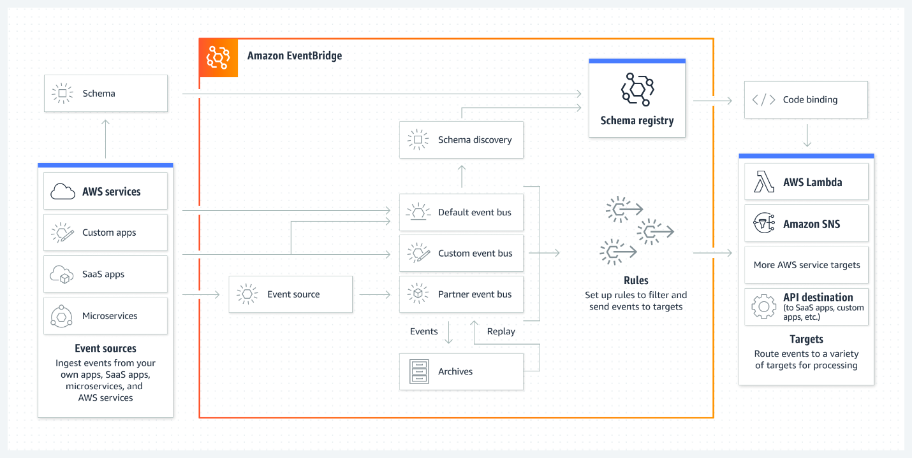

For more information about Amazon EventBridge, see the [Amazon EventBridge FAQs](https://aws.amazon.com/eventbridge/faqs/) or [What is Amazon EventBridge?](https://docs.aws.amazon.com/eventbridge/latest/userguide/eb-what-is.html)

#### Amazon SNS

Amazon SNS is a managed service that provides message delivery from publishers to subscribers (which are also known as producers and consumers). Publishers communicate asynchronously with subscribers by sending messages to a topic, which is a logical access point and communication channel. Clients can subscribe to the SNS topic and receive published messages by using a supported endpoint type, such as Amazon Kinesis Data Firehose, Amazon SQS, AWS Lambda, HTTP, email, mobile push notifications, and mobile text messages through Short Message Service (SMS).

Morgan chose Amazon SNS the customer’s architecture because it’s simple to use and supports a straightforward way to send messages between application components.

**Service Update:** Amazon SNS now supports payload-based message filtering [click here](https://aws.amazon.com/blogs/compute/introducing-payload-based-message-filtering-for-amazon-sns/) for more information.

One to many

SNS wins over EventBridge for cost, and it wins for simplicity.

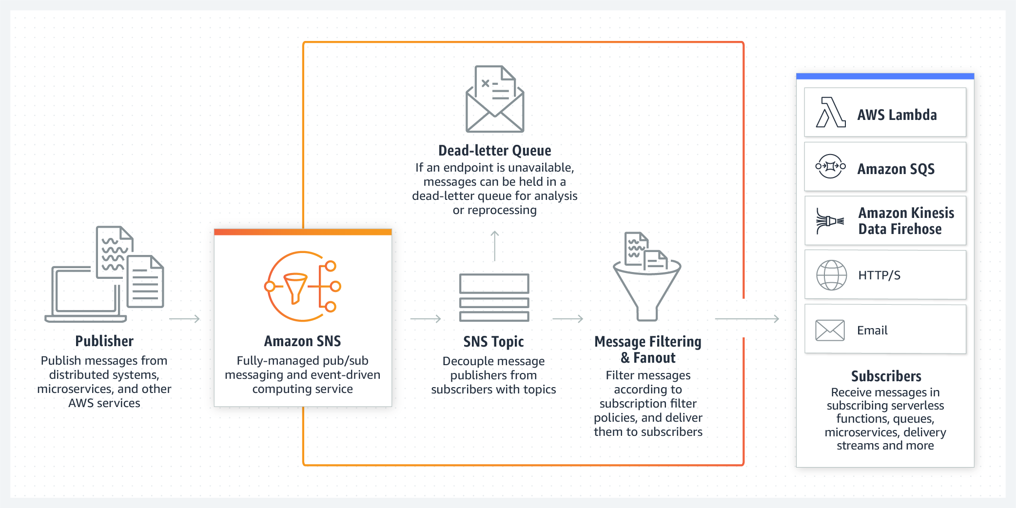

* For more information about Amazon SNS, see the [Amazon SNS FAQs](https://aws.amazon.com/sns/faqs/) or [What is Amazon SNS?](https://docs.aws.amazon.com/sns/latest/dg/welcome.html)
* For a tutorial on how to set up an Amazon SNS topic, see [Getting started with Amazon SNS.](https://docs.aws.amazon.com/sns/latest/dg/sns-getting-started.html#step-create-queue)

#### Amazon DynamoDB Streams

DynamoDB Streams captures a time-ordered sequence of item-level modifications in any DynamoDB table, and stores this information in a log for up to 24 hours. Applications can access this log and view the data items as they appeared, before and after they were modified, in near-real time.Encryption at rest encrypts the data in DynamoDB streams.DynamoDB Streams helps ensure the following:

* Each stream record appears exactly one time in the stream.
* For each item that is modified in a DynamoDB table, the stream records appear in the same sequence as the actual modifications to the item.

DynamoDB Streams writes stream records in near-real time so that you can build applications that consume these streams and take action based on the contents.You can enable a stream on a new table when you create it by using the AWS Command Line Interface (AWS CLI) or one of the AWS SDKs. You can also enable or disable a stream on an existing table, or change the settings of a stream. DynamoDB Streams operates asynchronously, so table performance isn’t affected if you enable a stream.All data in DynamoDB Streams is subject to a 24-hour lifetime. You can retrieve and analyze the last 24 hours of activity for any given table. However, data that is older than 24 hours is susceptible to trimming (removal) at any moment.

* For more information about Amazon DynamoDB Streams, see [Change data capture for DynamoDB Streams.](https://docs.aws.amazon.com/amazondynamodb/latest/developerguide/Streams.html)
* For a tutorial about how to process DynamoDB streams with an AWS Lambda function, see [Tutorial: Process new items with DynamoDB Streams and Lambda](https://docs.aws.amazon.com/amazondynamodb/latest/developerguide/Streams.Lambda.Tutorial.html)

### Decoupling Solutions on AWS

This week’s customer had issues with latency for their end users because they were using a synchronous model for their web backend. Morgan suggested that they migrate to an asynchronous model, where the order is first stored, and then processed shortly after. With this model, end user can receive a response more quickly from the backend. When the backend system receives an order, it can immediately respond and then process the request asynchronously.

A loosely coupled architecture minimizes the bottlenecks that are caused by synchronous communication, latency, and I/O operations. Amazon Simple Queue Service (Amazon SQS) and AWS Lambda are often used to implement asynchronous communication between different services.You should consider using this pattern if you have the following requirements:

* You want to create loosely coupled architecture.
* All operations don’t need to be completed in a single transaction, and some operations can be asynchronous.
* The downstream system can’t handle the incoming transactions per second (TPS) rate. The messages can be written to the queue and processed based on the availability of resources.

A disadvantage of this pattern is that the actions of business transaction are synchronous. Even though the calling system receives a response, some part of the transaction might still continue to be processed by downstream systems.

For more information, see [Patterns for integrating microservices](https://docs.aws.amazon.com/prescriptive-guidance/latest/modernization-integrating-microservices/integrating-patterns.html).

#### Building storage-first applications

Building a storage-first application can help an application be more reliable when working with events. You can read more about this topic in the blog post [Building storage-first serverless applications with HTTP APIs service integrations](https://aws.amazon.com/blogs/compute/building-storage-first-applications-with-http-apis-service-integrations/).

#### Amazon SQS

Amazon SQS is a fully managed, message queuing service that you can use to decouple and scale microservices, distributed systems, and serverless applications. Amazon SQS reduces the complexity and overhead associated with managing and operating message-oriented middleware, which means that developers can focus on differentiating work. By using Amazon SQS, you can send, store, and receive messages between software components at virtually any volume, without losing messages or requiring other services to be available.

When you [create](https://docs.aws.amazon.com/AWSSimpleQueueService/latest/SQSDeveloperGuide/sqs-configure-create-queue.html) or [edit](https://docs.aws.amazon.com/AWSSimpleQueueService/latest/SQSDeveloperGuide/sqs-configure-edit-queue.html) a queue, you can configure the following parameters:

* Visibility timeout: The length of time that a message received from a queue (by one consumer) won't be visible to the other message consumers.
* Message retention period: The amount of time that Amazon SQS retains messages that remain in the queue. By default, the queue retains messages for 4 days. You can configure a queue to retain messages for up to 14 days.
* Delivery delay: The amount of time that Amazon SQS will delay before it delivers a message that is added to the queue. For more information, see [Amazon SQS delay queues](https://docs.aws.amazon.com/AWSSimpleQueueService/latest/SQSDeveloperGuide/sqs-delay-queues.html).
* Maximum message size: The maximum message size for the queue.
* Receive message wait time: The maximum amount of time that Amazon SQS waits for messages to become available after the queue gets a receive request.
* Enable content-based deduplication: Amazon SQS can automatically create deduplication IDs based on the body of the message.
* Enable high throughput FIFO: This feature enables high throughput for messages in the queue. Choosing this option changes the related options (deduplication scope and FIFO throughput limit) to the required settings for enabling high throughput for FIFO queues.
* Redrive allow policy: This policy defines which source queues can use this queue as the dead-letter queue.

#### Short polling compared to long polling

When you consume messages from a queue by using short polling, Amazon SQS samples a subset of its servers (based on a weighted random distribution) and returns messages from only those servers. Thus, a particular ReceiveMessage request might not return all of your messages. However, if you have fewer than 1,000 messages in your queue, a subsequent request will return your messages. If you keep consuming from your queues, Amazon SQS samples all of its servers, and you receive all of your messages.

The following diagram shows the short-polling behavior of messages returned from a standard queue after one of your system components makes a receive request. Amazon SQS samples several of its servers (in gray) and returns messages A, C, D, and B from these servers. Message E isn't returned for this request, but it's returned for a subsequent request.

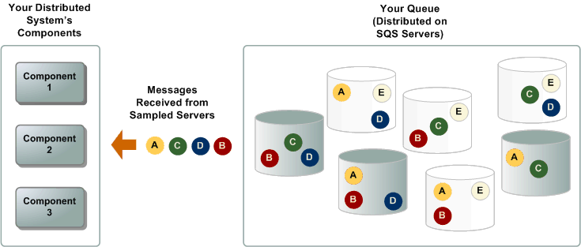

When the wait time for the ReceiveMessage API action is greater than 0, long polling is in effect. The maximum long polling wait time is 20 seconds. Long polling helps reduce the cost of using Amazon SQS by reducing the number of empty responses (when there are no messages available for a ReceiveMessage request) and false empty responses (when messages are available, but aren't included in a response). For information about enabling long polling for a new or existing queue using the Amazon SQS console, see [Configuring queue parameters (console)](https://docs.aws.amazon.com/AWSSimpleQueueService/latest/SQSDeveloperGuide/sqs-configure-queue-parameters.html). For best practices, see [Setting up long polling](https://docs.aws.amazon.com/AWSSimpleQueueService/latest/SQSDeveloperGuide/working-with-messages.html#setting-up-long-polling).

Long polling offers the following benefits:

* Reduces empty responses by letting Amazon SQS wait until a message is available in a queue before it sends a response. Unless the connection times out, the response to the ReceiveMessage request contains at least one of the available messages, up to the maximum number of messages specified in the ReceiveMessage action. In rare cases, you might receive empty responses even when a queue still contains messages, especially if you specify a low value for the ReceiveMessageWaitTimeSeconds parameter.
* Reduces false empty responses by querying all—instead of a subset of—Amazon SQS servers.
* Returns messages as soon as they become available.

#### Resources

* For more information about Amazon SQS, see [What is Amazon Simple Queue Service?](https://docs.aws.amazon.com/AWSSimpleQueueService/latest/SQSDeveloperGuide/welcome.html) or [Amazon SQS FAQs](https://aws.amazon.com/sqs/faqs/).
* For a tutorial about setting up Amazon SQS to invoke Lambda functions, see [Using AWS Lambda with Amazon SQS](https://docs.aws.amazon.com/lambda/latest/dg/with-sqs.html).

### Architecture Optimizations for Week 1

In this reading, you will find further information about the topics that Morgan and Raf talked about in the video where they both played Solutions Architects.

#### Caching for Amazon DynamoDB by using Amazon DynamoDB Accelerator

Raf mentioned that if you need to improve Amazon DynamoDB performance to microsecond latency, to look into using Amazon DynamoDB Accelerator (DAX).

DAX is a fully managed, highly available, in-memory [cache](https://aws.amazon.com/caching/) for DynamoDB that’s designed to deliver up to a 100-times performance improvement—from milliseconds to microseconds—even at millions of requests per second.

DAX does the heavy lifting that’s required to add in-memory acceleration to your DynamoDB tables—and developers don’t need to manage cache invalidation, data population, or cluster management.

A benefit of using DAX is that you don’t need to modify the application logic because DAX is compatible with existing DynamoDB API calls.

DAX is designed to run within an Amazon Virtual Private Cloud (Amazon VPC) environment. Amazon VPC defines a virtual network that closely resembles a traditional data center. With a VPC, you have control over its IP address range, subnets, routing tables, network gateways, and security settings. You can launch a DAX cluster in your virtual network, and control access to the cluster by using Amazon VPC security groups.

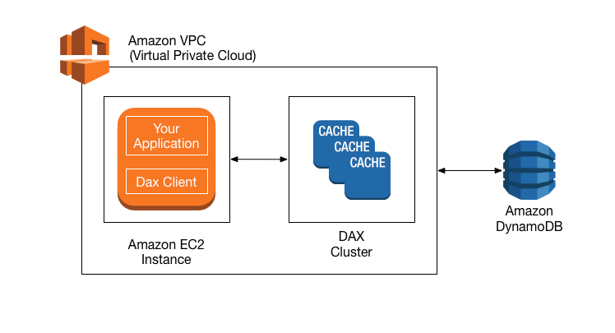

For more information about DAX, see [Amazon DynamoDB Accelerator.](https://aws.amazon.com/dynamodb/dax/)

#### Optimizing AWS Lambda

#### AWS Lambda Power Tuning

Morgan mentioned that you can fine-tune the memory or power configuration for your AWS Lambda functions to potentially increase performance and lower costs.

[AWS Lambda Power Tuning](https://github.com/alexcasalboni/aws-lambda-power-tuning) is an open-source tool that helps you visualize and fine-tune the memory or power configuration of Lambda functions. It runs in your own AWS account, and it supports three optimization strategies: cost, speed, and balanced.

AWS Lambda Power Tuning is a state machine that’s powered by AWS Step Functions. It helps you optimize your Lambda functions for cost or performance in a data-driven way.The state machine is designed to be easy to deploy and fast to execute. Also, it's language agnostic, so you can optimize any Lambda functions in your account.

To work with AWS Lambda Power Turning, you provide a Lambda function Amazon Resource Name (ARN) as input. The state machine then invokes that function with multiple power configurations (from 128 MB to 10 GB—you decide which values). Then, it analyzes all the execution logs and suggests the best power configuration to minimize cost or maximize performance.

Note that the input function will run in your AWS account, which means that it will perform HTTP requests, SDK calls, cold starts, and so on. The state machine also supports cross-Region invocations, and you can enable parallel execution to generate results in a few seconds.

The state machine generates a visualization of average cost and speed for each power configuration.

For example, the following diagram shows results for two CPU-intensive functions, which become both cheaper and faster with more power.

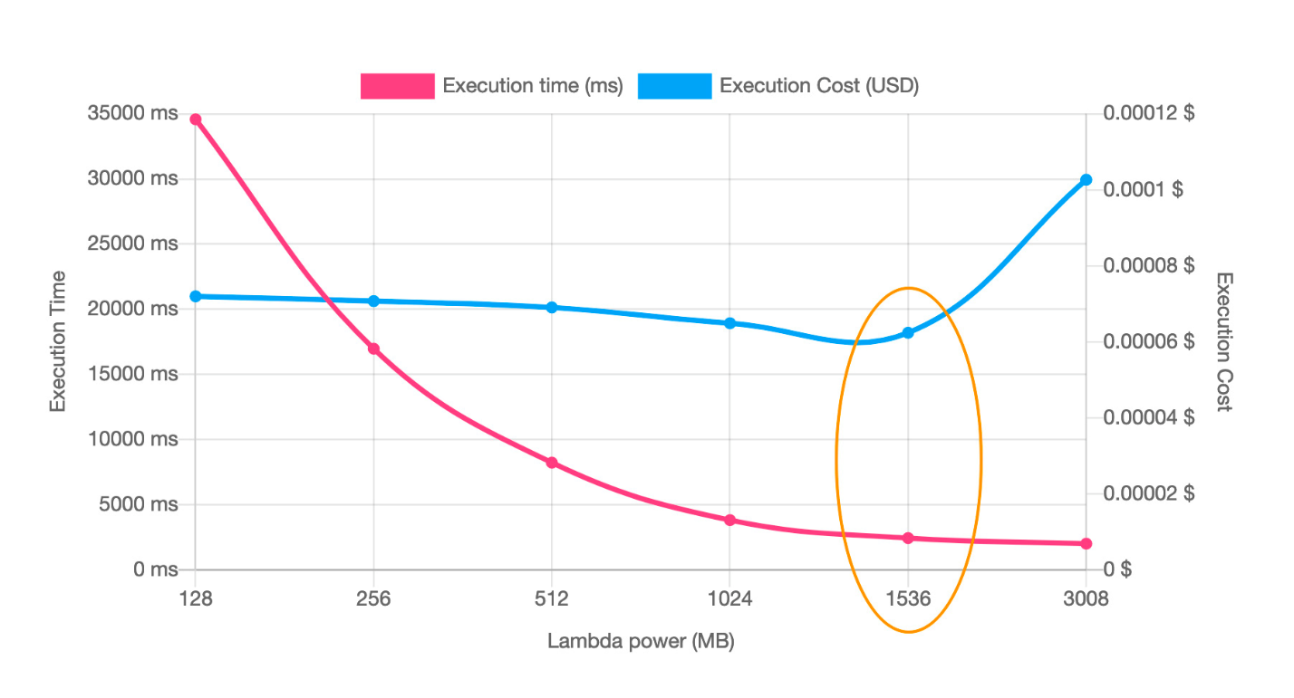

For more information, see [AWS Lambda Power Tuning](https://github.com/alexcasalboni/aws-lambda-power-tuning).

#### AWS Lambda Powertools

Morgan also mentioned that you can use another suite of tools called AWS Lambda Powertools to optimize your Lambda functions and use best practices. AWS Lambda Powertools is a suite of utilities for AWS Lambda functions that is designed to make it easier to adopt best practices such as tracing, structured logging, custom metrics, idempotency, batching, and more.

For more information, see [AWS Lambda Powertools](https://awslabs.github.io/aws-lambda-powertools-python/latest/).

#### AWS Lambda execution environment reuse

Another optimization technique that Morgan mentioned for Lambda is to move certain initialization tasks in your code so they are outside the handler. These tasks can then be reused across invocations (which is also known as execution environment reuse).

You can take advantage of execution environment reuse to improve the performance of your function. To do this, initialize SDK clients and database connections outside of the function handler, and cache static assets locally in the /tmp directory. Subsequent invocations that are processed by the same instance of your function can reuse these resources. This reuse saves cost by reducing function run time.

To avoid potential data leaks across invocations, don’t use the execution environment to store user data, events, or other information with security implications. If your function relies on a mutable state that can’t be stored in memory within the handler, consider creating a separate function or separate versions of a function for each user.

To learn more, see [Best practices for working with AWS Lambda.](https://docs.aws.amazon.com/lambda/latest/dg/best-practices.html)

#### Resources

* For more information about how to optimize serverless applications for cost, see [Building well-architected serverless applications: Optimizing application costs](https://aws.amazon.com/blogs/compute/building-well-architected-serverless-applications-optimizing-application-costs/) in the AWS Compute Blog.
* For more information about well-architected serverless applications, visit [Serverless Applications Lens - AWS Well-Architected Framework](https://docs.aws.amazon.com/wellarchitected/latest/serverless-applications-lens/welcome.html?did=wp_card&trk=wp_card).

### Exercise 1. Architecting Solutions: Building a Proof of Concept for a Serverless Solution

This exercise provides you with instructions for how to build a proof of concept for a serverless solution in the AWS Cloud.

Suppose you have a customer that needs a serverless web backend hosted on AWS. The customer sells cleaning supplies and often sees spikes in demand for their website, which means that they need an architecture that can easily scale in and out as demand changes. The customer also wants to ensure that the application has decoupled application components.

The following architectural diagram shows the flow for the serverless solution that you will build.

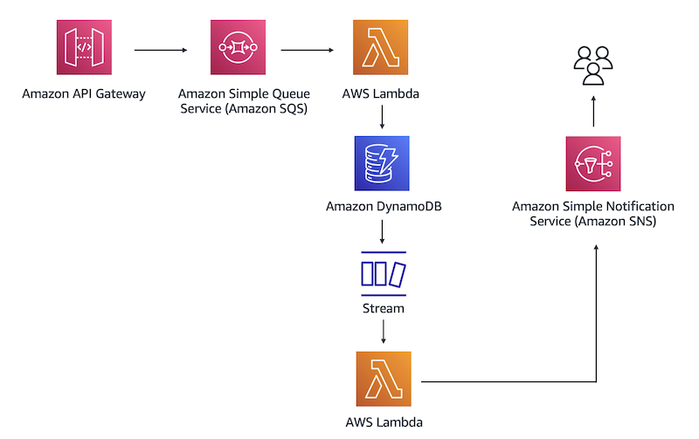Architecture diagram for exercise 1

In this architecture, you will use a REST API to place a database entry in the Amazon SQS queue. Amazon SQS will then invoke the first Lambda function, which inserts the entry into a DynamoDB table. After that, DynamoDB Streams will capture a record of the new entry in a database and invoke a second Lambda function. The function will pass the database entry to Amazon SNS. After Amazon SNS processes the new record, it will send you a notification through a specified email address.

In this exercise, you will learn how to do the following:

Create IAM policies and roles to follow best practices of working in the AWS Cloud.

Create a DynamoDB table to store data.

Create an Amazon SQS queue to receive, store, and send messages between software components.

Create Lambda functions and set up triggers to invoke actions in different AWS services.

Enable DynamoDB Streams to capture modifications in the database table.

Configure Amazon SNS to receive email or text notifications.

Create a REST API to insert data into a database.

**Notes:**

To complete the instructions in this exercise, choose the **US East (N. Virginia) us-east-1** Region in the navigation pane of the AWS Management Console.

The instructions might prompt you to enter your account ID. Your account ID is a 12-digit account number that appears under your account alias in the top-right corner of the AWS Management Console. When you enter your account number (ID), make sure that you remove hyphens (-).

#### Task 1. Setup: Creating IAM policies and roles

When you first create an account on AWS, you become a root user, or an account owner. We don’t recommend that you use the account root user for daily operations and tasks. Instead, you should use an IAM user or IAM roles to access specific services and features. IAM policies, users, and roles are offered at no additional charge.

In this task, you create custom IAM policies and roles to grant limited permissions to specific AWS services.

##### Step 1.1: Creating custom IAM policies

1. Sign in to the AWS Management Console.
2. In the search box, enter **IAM**.
3. From the results list, choose **IAM**.
4. In the navigation pane, choose **Policies**.
5. Choose **Create policy**.

The **Create policy** page appears. You can create and edit a policy in the visual editor or use JSON. In this exercise, we provide JSON scripts to create policies. In total, you must create four policies.

1. In the JSON tab, paste the following code:

{

"Version": "2012-10-17",

"Statement": [

{

"Sid": "VisualEditor0",

"Effect": "Allow",

"Action": [

"dynamodb:PutItem",

"dynamodb:DescribeTable"

],

"Resource": "*"

}

]

}

This JSON script grants permissions to put items into the DynamoDB table. The asterisk (*) indicates that the specified actions can apply to all available resources.

1. Choose **Next: Tags** and then choose **Next: Review**.
2. For the policy name, enter Lambda-Write-DynamoDB.
3. Choose **Create policy**.
4. After you create the Lambda-Write-DynamoDB policy, repeat the previous steps to create the following policies:
   * A policy for Amazon SNS to get, list, and publish topics that are received by Lambda:
     + **Name**: Lambda-SNS-Publish
     + **JSON**:

{

"Version": "2012-10-17",

"Statement": [

{

"Sid": "VisualEditor0",

"Effect": "Allow",

"Action": [

"sns:Publish",

"sns:GetTopicAttributes",

"sns:ListTopics"

],

"Resource": "*"

}

]

}

* + A policy for Lambda to get records from DynamoDB Streams:
    - **Name**: Lambda-DynamoDBStreams-Read
    - **JSON**:

{

"Version": "2012-10-17",

"Statement": [

{

"Sid": "VisualEditor0",

"Effect": "Allow",

"Action": [

"dynamodb:GetShardIterator",

"dynamodb:DescribeStream",

"dynamodb:ListStreams",

"dynamodb:GetRecords"

],

"Resource": "*"

}

]

}

* + A policy for Lambda to read messages that are placed in Amazon SQS:
    - **Name**: Lambda-Read-SQS
    - **JSON**:

{

"Version": "2012-10-17",

"Statement": [

{

"Sid": "VisualEditor0",

"Effect": "Allow",

"Action": [

"sqs:DeleteMessage",

"sqs:ReceiveMessage",

"sqs:GetQueueAttributes",

"sqs:ChangeMessageVisibility"

],

"Resource": "*"

}

]

}

##### Step 1.2: Creating IAM roles and attaching policies to the roles

Because AWS follows the principle of least privilege, we recommend that you provide role-based access to only the AWS resources that are required to perform a task. In this step, you create IAM roles and attach policies to the roles.

1. In the navigation pane of the IAM dashboard, choose **Roles**.
2. Choose **Create role** and in the **Select trusted entity** page, configure the following settings:
   * **Trusted entity type**: AWS service
   * **Common use cases**: Lambda
3. Choose **Next**.
4. On the **Add permissions** page, select **Lambda-Write-DynamoDB** and **Lambda-Read-SQS**.
5. Choose **Next**
6. For **Role name**, enter Lambda-SQS-DynamoDB.
7. Choose **Create role**.
8. Follow the previous steps to create two more IAM roles:
   * An IAM role for AWS Lambda: This role grants permissions to obtain records from the DynamoDB streams and send the records to Amazon SNS. Use the following information to create the role.
     + **IAM role name**: Lambda-DynamoDBStreams-SNS
     + **Trusted entity type**: AWS service
     + **Common use cases**: Lambda
     + **Attach policies**: Lambda-SNS-Publish and Lambda-DynamoDBStreams-Read
   * An IAM role for Amazon API Gateway: This role grants permissions to send data to the SQS queue and push logs to Amazon CloudWatch for troubleshooting. Use the following information to create the role.
     + **IAM role name**: APIGateway-SQS
     + **Trusted entity type**: AWS service
     + **Common use cases**: API Gateway
     + **Attach policies**: AmazonAPIGatewayPushToCloudWatchLogs

#### Task 2: Creating a DynamoDB table

In this task, you create a DynamoDB table that ingests data that’s passed on through API Gateway.

1. In the search box of the AWS Management Console, enter **DynamoDB**.
2. From the list, choose the **DynamoDB** service.
3. On the **Get started** card, choose **Create table** and configure the following settings:
   * **Table**: orders
   * **Partition key**: orderID
   * Data type: Keep **String**
4. Keep the remaining settings at their default values, and choose **Create table**.

#### Task 3: Creating an SQS queue

In this task, you create an SQS queue. In the architecture for this exercise, the Amazon SQS receives data records from API Gateway, stores them, and then sends them to a database.

1. In the AWS Management Console search box, enter SQS and from the list, choose **Simple Queue Service**.
2. On the **Get started** card, choose **Create queue**.

The **Create queue** page appears.

1. Configure the following settings:
   * **Name**: POC-Queue
   * **Access Policy**: Basic
   * **Define who can send messages to the queue**:
     + Select Only the specified AWS accounts, IAM users and roles
     + In the box for this option, paste the Amazon Resource Name (ARN) for the APIGateway-SQS IAM role
     + **Note**: For example, your IAM role might look similar to the following: arn:aws:iam::<account ID>:role/APIGateway-SQS.
   * **Define who can receive messages from the queue**:
     + Select Only the specified AWS accounts, IAM users and roles.
     + In the box for this option, paste the ARN for the Lambda-SQS-DynamoDB IAM role.
     + **Note**: For example, your IAM role might look similar to the following: arn:aws:iam::<account_ID>:role/Lambda-SQS-DynamoDB
2. Choose **Create queue**.

#### Task 4: Creating a Lambda function and setting up triggers

In this task, you create a Lambda function that reads messages from the SQS queue and writes an order record to the DynamoDB table.

##### Step 4.1: Creating a Lambda function for the Lambda-SQS-DynamoDB role

1. In the AWS Management Console search box, enter **Lambda** and from the list, choose **Lambda**.
2. Choose **Create function** and configure the following settings:
   * **Function option**: Author from scratch
   * **Function name**: POC-Lambda-1
   * **Runtime**: Python 3.9
   * **Change default execution role**: Use an existing role
   * **Existing role**: Lambda-SQS-DynamoDB
3. Choose **Create function**.

##### Step 4.2: Setting up Amazon SQS as a trigger to invoke the function

1. If needed, expand the **Function overview** section.
2. Choose **Add trigger**.
3. For **Trigger configuration**, enter SQS and choose the service in the list.
4. For **SQS queue**, choose **POC-Queue**.
5. Add the trigger by choosing **Add**.

##### Step 4.3: Adding and deploying the function code

1. On the **POC-Lambda-1** page, in the **Code** tab, replace the default Lambda function code with the following code:

import boto3, uuid

client = boto3.resource('dynamodb')

table = client.Table("orders")

**def** lambda_handler(event, context):

**for** record **in** event['Records']:

print("test")

payload = record["body"]

print(str(payload))

table.put_item(Item= {'orderID': str(uuid.uuid4()),'order': payload})

1. Choose **Deploy**.

The Lambda code passes arguments to a function call. As a result, when a trigger invokes a function, Lambda runs the code that you specify.

When you use Lambda, you are responsible only for your code. Lambda manages the memory, CPU, network, and other resources to run your code.

##### Step 4.4: Testing the POC-Lambda-1 Lambda function

1. In the **Test** tab, create a new event that has the following settings:
   * **Event name**: POC-Lambda-Test-1
   * **Template-Optional**: SQS

The SQS template appears in the **Event JSON** field.

1. Save your changes and choose **Test**.

After the Lambda function runs successfully, the “Execution result: succeeded” message appears in the notification banner in the **Test** section. This means that the Lambda function sent a test message “Hello from SQS!” from the SQS template to the DynamoDB table.

##### Step 4.5: Verifying that the Lambda function adds the test message to a database

1. In the AWS Management Console search box, enter DynamoDB and from the list, choose **DynamoDB**.
2. In the navigation pane, choose **Explore items**.
3. Select the **orders** database. Under **Items returned**, the **orders** table returns “Hello from SQS!” from the Lambda function test.

#### Task 5: Enabling DynamoDB Streams

In this task, you enable DynamoDB Streams. A DynamoDB stream captures information about every modification to data items in the table.

1. In the DynamoDB console, in the **Tables** section of the navigation pane, choose **Update settings**.
2. In the **Tables** card, make sure that the **orders** table is selected.
3. Choose the **Exports and streams** tab.
4. In the **DynamoDB stream details** section, choose **Enable**.
5. For **View type**, choose **New image**.
6. Choose **Enable stream**.

After the Lambda function reads messages from the SQS queue and writes an order record to the DynamoDB table, DynamoDB Streams captures the primary key attributes from the record.

#### Task 6: Creating an SNS topic and setting up subscriptions

In this task, you create an SNS topic and set up subscriptions. Amazon SNS coordinates and manages delivering or sending messages to subscriber endpoints or clients.

##### Step 6.1: Creating a topic in the notification service

1. In the AWS Management Console, search for SNS and choose **Simple Notification Service**.
2. On the **Create topic** card, enter POC-Topic and choose **Next step**.
3. In the **Details** section, keep the **Standard** topic type selected and choose **Create topic**.
4. On the **POC-Topic** page, copy the ARN of the topic that you just created and save it for your reference.

You will need the ARN for the SNS topic later in this exercise.

##### Step 6.2: Subscribing to email notifications

1. On the **Subscriptions** tab, choose **Create subscription**.
2. For **Topic ARN**, make sure that the box contains the ARN for POC-Topic.
3. To receive notifications, for **Protocol**, choose **Email**.
4. For **Endpoint**, enter your email address.
5. Choose **Create subscription**.

The confirmation message is sent to the email address that you specified.

1. After you receive the confirmation email message, confirm the subscription. If you don’t receive an email message within a few minutes, check the spam folder.

#### Task 7: Creating an AWS Lambda function to publish a message to the SNS topic

In this task, you create a Lambda function for the Lambda-DynamoDBStreams-SNS role. The second Lambda function uses DynamoDB Streams as a trigger to pass the record of a new entry to Amazon SNS.

##### Step 7.1: Creating a POC-Lambda-2 function

1. In the AWS Management Console, search for and open AWS Lambda.
2. Create a new Lambda function by choosing **Create function**, and configure the following settings:
   * **Function option**: Author from scratch
   * **Function name**: POC-Lambda-2
   * **Runtime**: Python 3.9
   * **Change default execution role**: Use an existing role
   * **Existing role**: Lambda-DynamoDBStreams-SNS

This role grants permissions to get records from DynamoDB Streams and send them to Amazon SNS.

1. Choose **Create function**.

##### Step 7.2: Setting up DynamoDB as a trigger to invoke a Lambda function

1. In the **Function overview** section, choose **Add trigger** and configure the following settings:
   * **Trigger configuration**: Enter DynamoDB and from the list, choose **DynamoDB**.
   * **DynamoDB table**: orders
2. Keep the remaining default settings and choose **Add**.
3. In the **Configuration** tab, make sure that you are in the **Triggers** section and that the DynamoDB state is “Enabled.”

##### Step 7.3: Configuring the second Lambda function

1. Choose the **Code** tab and replace the Lambda function code with the following code:

import boto3, json

client = boto3.client('sns')

**def** lambda_handler(event, context):

**for** record **in** event["Records"]:

**if** record['eventName'] == 'INSERT':

new_record = record['dynamodb']['NewImage']

response = client.publish(

TargetArn='<Enter Amazon SNS ARN for the POC-Topic>',

Message=json.dumps({'default': json.dumps(new_record)}),

MessageStructure='json'

)

**Note:** In the function code, replace the **TargetArn** value with the ARN for the Amazon SNS POC-Topic. Make sure that you remove the placeholder angle brackets (<>).

Your ARN might look similar to the following: arn:aws:sns:us-east-1:<account ID>:POC-Topic.

1. Choose **Deploy**.

##### Step 7.4: Testing the POC-Lambda-2 Lambda function

1. On the **Test** tab, create a new event and for **Event name**, enter POC-Lambda-Test-2.
2. For **Template-optional**, enter DynamoDB and from the list, choose **DynamoDB-Update**.

The DynamoDB template appears in the **Event JSON** box.

1. Save your changes and choose **Test**.

After the Lambda function successfully runs, the “Execution result: succeeded” message should appear in the notification banner in the **Test** section.

In a few minutes, an email message should arrive at the email address that you specified in the previous task.

1. Confirm that you received the subscription email message. If needed, check both your inbox and spam folder.

#### Task 8: Creating an API with Amazon API Gateway

In this task, you create a REST API in Amazon API Gateway. The API serves as a communication gateway between your application and the AWS services.

1. In the AWS Management Console, search for and open **API Gateway**.
2. On the **REST API** card with a public authentication, choose **Build** and configure the following settings:
   * **Choose the protocol**: REST
   * **Create new API**: New API
   * **API name**: POC-API
   * **Endpoint Type**: Regional
3. Choose **Create API**.
4. On the **Actions** menu, choose **Create Method**.
5. Open the method menu by choosing the down arrow, and choose **POST**. Save your changes by choosing the check mark.
6. In the **POST - Setup** pane, configure the following settings:
   * **Integration type**: AWS Service
   * **AWS Region**: us-east-1
   * **AWS Service**: Simple Queue Service (SQS)
   * **AWS Subdomain**: Keep empty
   * **HTTP method**: POST
   * **Action Type**: Use path override
   * **Path override**: Enter your account ID followed by a slash (/) and the name of the POC queue
     + **Note**: If POC-Queue is the name of the SQS queue that you created, this entry might look similar to the following: /<account ID>/POC-Queue
   * **Execution role**: Paste the ARN of the APIGateway-SQS role
     + **Note**: For example, the ARN might look like the following: arn:aws:iam::<account ID>:role/APIGateway-SQS
   * **Content Handling**: Passthrough
7. Save your changes.
8. Choose the **Integration Request** card.
9. Scroll to the bottom of the page and expand **HTTP Headers**.
10. Choose **Add header**.
11. For **Name**, enter Content-Type
12. For **Mapped from**, enter 'application/x-www-form-urlencoded'
13. Save your changes to the **HTTP Headers** section by choosing the check mark.
14. Expand **Mapping Templates** and for **Request body passthrough**, choose **Never**.
15. Choose **Add mapping template** and for **Content-Type** , enter application/json
16. Save your changes by choosing the check mark.
17. For **Generate template**, do not choose a default template from the list. Instead, enter the following command: Action=SendMessage&MessageBody=$input.body in a box.
18. Choose **Save**.

#### Task 9: Testing the architecture by using API Gateway

In this task, you use API Gateway to send mock data to Amazon SQS as a proof of concept for the serverless solution.

1. In the API Gateway console, return to the **POST - Method Execution** page and choose **Test**.
2. In the **Request Body** box, enter:

{ "item": "latex gloves",

"customerID":"12345"}

1. Choose **Test**.

If you see the “Successfully completed execution” message with the 200 response in the logs on the right, you will receive an email notification with the new entry. If you don’t receive an email, but the new item appears in the DynamoDB table, troubleshoot the exercise instructions starting from after you set up DynamoDB. Ensure that you deploy all of the resources in the us-east-1 Region.

After API Gateway successfully processes the request that you pasted in the **Request Body** box, it places the request in the SQS queue. Because you set up Amazon SQS as a trigger in the first Lambda function, Amazon SQS invokes the function call. The Lambda function code places the new entry into the DynamoDB table. DynamoDB Streams captures this change to the database and invokes the second AWS Lambda function. This function gets the new record from DynamoDB Streams and sends it to Amazon SNS. Amazon SNS, in turn, sends you an email notification.

#### Task 10: Cleaning up

In this task, you delete the AWS resources that you created for this exercise.

1. Delete the DynamoDB table.
   1. Open the DynamoDB console.
   2. In the navigation pane, choose **Tables**.
   3. Select the **orders** table.
   4. Choose **Delete** and confirm your actions.
2. Delete the Lambda functions.
   1. Open the Lambda console.
   2. Select the Lambda functions that you created in this exercise: **POC-Lambda-1** and **POC-Lambda-2**.
   3. Choose **Actions**, **Delete**.
   4. Confirm your actions and close the dialog box.
3. Delete the SQS queue.
   1. Open the Amazon SQS console.
   2. Select the queue that you created in this exercise.
   3. Choose **Delete** and confirm your actions.
4. Delete the SNS topic and subscriptions.
   1. Open the Amazon SNS console.
   2. In the navigation pane, choose **Topics**.
   3. Select **POC-Topic**.
   4. Choose **Delete** and confirm your actions.
   5. In the navigation pane, choose **Subscriptions**.
   6. Select the subscription that you created in this exercise and choose **Delete**.
   7. Confirm your actions.
5. Delete the API that you created.
   1. Open the API Gateway console.
   2. Select **POC-API**.
   3. Choose **Actions**, **Delete**.
   4. Confirm your actions.
6. Delete the IAM roles and policies.
   1. Open the IAM console.
   2. In the navigation pane, choose **Roles**.
   3. Delete the following roles and confirm your actions:
      * **APIGateway-SQS**
      * **Lambda-SQS-DynamoDB**
      * **Lambda-DynamoDBStreams-SNS**
   4. In the navigation pane, choose **Policies**.
   5. Delete the following custom policies and confirm your actions:
      * **Lambda-DynamoDBStreams-Read**
      * **Lambda-SNS-Publish**
      * **Lambda-Write-DynamoDB**
      * **Lambda-Read-SQS**

## Week2: Designing a serverless data analytics solution on AWS

### A Look into AWS Data Services

In this course, the Morgan and Raf cover some of the AWS data services that can be used for a solution that ingests clickstream data. Clickstream is the term for small events that contain pieces of data that are generated continuously with high speed and volume. Remember, clickstream data is usually data that’s collected by systems (mostly frontends) regarding user interactions with that system. In this week’s scenario, clickstream data will be used to collect information about users’ behaviors when they interact with a restaurant menu. Regardless of whether you are architecting for clickstream data, AWS provides various analytics services that meet your needs for data analytics. Organizations of all sizes and industries can use these services to reinvent their business with data.

#### AWS data services

From data movement, data storage, data lakes, big data analytics, log analytics, streaming analytics, business intelligence, and machine learning (ML) to many things in between, AWS offers purpose-built services that provide price performance, scalability, and low costs. [Data Lakes and Analytics on AWS](https://aws.amazon.com/big-data/datalakes-and-analytics/) lists all the AWS services that can be used for data analytics, and places the services into four distinct categories. This reading summarizes the most popular services in each category.

#### Data lakes and data storage

##### Amazon S3

Amazon Simple Storage Service (Amazon S3) is an object storage service that offers scalability, data availability, security, and performance. Customers of all sizes and industries can store and protect virtually any amount of data for virtually any use case, such as data lakes, cloud-native applications, and mobile apps. With cost-effective storage classes and easy-to-use management features, you can optimize costs, organize data, and configure fine-tuned access controls to meet specific business, organizational, and compliance requirements.

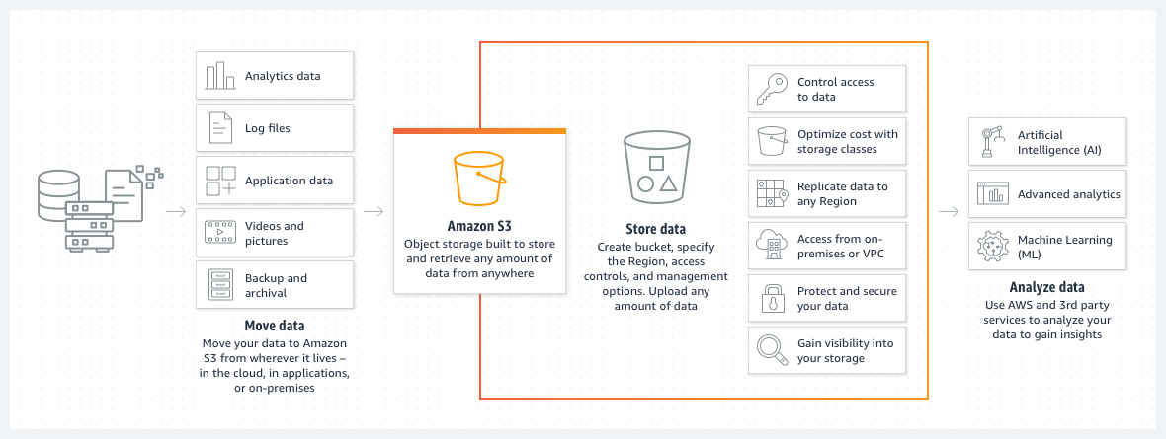

The following list details some use cases for Amazon S3:

* Archive data at the lowest cost: Move data archives to the Amazon Simple Storage Service Glacier (Amazon S3 Glacier storage classes to lower costs, reduce operational complexities, and gain new insights.
* Run cloud-native applications: Build fast, powerful, mobile and web-based cloud-native applications that scale automatically in a highly available configuration, such as static websites that use the client side for coding.
* Build a data lake: Run big data analytics, artificial intelligence (AI), machine learning (ML), and high performance computing (HPC) applications to unlock data insights.
* Back up and restore critical data: Meet Recovery Time Objectives (RTO), Recovery Point Objectives (RPO), and compliance requirements with the robust replication features of Amazon S3.

For more information, see [Amazon S3](https://aws.amazon.com/s3/).

##### Amazon S3 Glacier

**Note:** Amazon S3 storage classes will have their own dedicated reading later in this week.The Amazon S3 Glacier storage classes are purpose-built for data archiving. They are designed to provide you with high performance, retrieval flexibility, and low-cost archive storage in the cloud. All S3 Glacier storage classes provide virtually unlimited scalability and are designed for 99.999999999 percent (11 nines) of data durability. In addition to low-cost storage, the S3 Glacier storage classes also deliver options for fast access to your archival data.

For more information, see [Amazon S3 Glacier storage classes](https://aws.amazon.com/s3/storage-classes/glacier/).

##### AWS Lake Formation

AWS Lake Formation is a service that you can use to set up a secure data lake in days. A data lake is a centralized, curated, and secured repository that stores all your data, both in its original form and prepared for analysis. You can use a data lake to break down data silos and combine different types of analytics to gain insights and guide better business decisions.

For more information, see [AWS Lake Formation](https://aws.amazon.com/lake-formation/?whats-new-cards.sort-by=item.additionalFields.postDateTime&whats-new-cards.sort-order=desc).

#### Data analytics

##### Amazon Athena

Amazon Athena is an interactive query service that you can use to analyze data in Amazon S3 by using standard Structured Query Language (SQL). Athena is serverless, so you don’t need to manage infrastructure, and you pay only for the queries that you run.

Using Athena is straightforward. You point to your data in Amazon S3, define the schema, and start querying by using standard SQL. Most results are delivered within seconds. With Athena, you don’t need complex extract, transform, and load (ETL) jobs to prepare your data for analysis. Anyone with SQL skills can use Athena to quickly analyze large-scale datasets.

For more information, see [Amazon Athena](https://aws.amazon.com/athena/).

##### Amazon EMR

Amazon EMR is a big data solution for petabyte-scale data processing, interactive analytics, and machine learning that use open-source frameworks, such as Apache Spark, Apache Hive, and Presto.

In this course, we didn’t use or explore Amazon EMR for this week’s scenario because the customer was short-staffed, and Amazon EMR requires a learning curve to operate the open-source frameworks that it uses. In fact, Amazon EMR has so many features that we could make an entire 4-week course about it! The following list details some of the use cases for Amazon EMR. (Notice that the third item aligns well with the week’s scenario—Amazon EMR would a good candidate for the task if the customer already had big data knowledge.)

* Run large-scale data processing and what-if analysis by using statistical algorithms and predictive models to uncover hidden patterns, correlations, market trends, and customer preferences.
* Extract data from various sources, process it at scale, and make the data available for applications and users.
* Analyze events from streaming data sources in real time to create long-running, highly available, and fault-tolerant streaming data pipelines.
* Analyze data using open-source ML frameworks, such as Apache Spark MLlib, TensorFlow, and Apache MXNet.
* Connect to Amazon SageMaker Studio for large-scale model training, analysis, and reporting.

For more information, see [Amazon EMR](https://aws.amazon.com/emr/?c=a&sec=srv).

##### Amazon OpenSearch Service

You can use Amazon OpenSearch Service to perform interactive log analytics, real-time application monitoring, website search, and more. OpenSearch is an open source, distributed search and analytics suite that is derived from Elasticsearch. Amazon OpenSearch Service is the successor to Amazon Elasticsearch Service. It offers the latest versions of OpenSearch, support for 19 versions of Elasticsearch, and visualization capabilities that are powered by OpenSearch Dashboards and Kibana. Amazon OpenSearch Service currently has tens of thousands of active customers, with hundreds of thousands of clusters under management, processing hundreds of trillions of requests per month.

For more information, see [Amazon OpenSearch Service](https://aws.amazon.com/opensearch-service/?c=a&sec=srv).

#### Data movement

##### Amazon Kinesis

**Note:** Later this week, Amazon Kinesis will have its own dedicated reading that further explains each of the Kinesis services (such as Amazon Kinesis Data Streams, Amazon Kinesis Data Firehose, and Amazon Kinesis Data Analytics).

With Amazon Kinesis, you can collect, process, and analyze real-time, streaming data so that you can get timely insights and react quickly to new information. Amazon Kinesis offers key capabilities to cost-effectively process streaming data at virtually any scale, along with the flexibility to choose the tools that best suit the requirements of your application. With Amazon Kinesis, you can ingest real-time data such as video, audio, application logs, website clickstreams, and Internet of Things (IoT) telemetry data for machine learning, analytics, and other applications. You can use Amazon Kinesis to process and analyze data as it arrives, which means that you can respond quickly—you don’t need to wait for all your data to be collected before processing can begin.

For more information, see [Amazon Kinesis](https://aws.amazon.com/kinesis/).

##### AWS Glue

AWS Glue is a serverless data integration service that you can use to discover, prepare, and combine data for analytics, machine learning, and application development. AWS Glue provides capabilities that are needed for data integration so that you can start analyzing your data and using your data in minutes instead of months. Data integration is the process of preparing and combining data for analytics, machine learning, and application development. It involves multiple tasks, such as discovering and extracting data from various sources; enriching, cleaning, normalizing, and combining data; and loading and organizing data in databases, data warehouses, and data lakes. These tasks are often handled by different types of users who each use different products.

For more information, see [AWS Glue](https://aws.amazon.com/glue/?whats-new-cards.sort-by=item.additionalFields.postDateTime&whats-new-cards.sort-order=desc).

##### AWS DMS

AWS Database Migration Service (AWS DMS) helps you migrate databases to AWS quickly and securely. The source database remains fully operational during the migration, which minimizes downtime to applications that rely on the database. AWS DMS can migrate your data to and from the most widely used commercial and open-source databases.

For more information, see [AWS Database Migration Service](https://aws.amazon.com/dms/).

#### Predictive analytics and machine learning

You won’t explore this area much in this course, but—as was mentioned earlier in this reading—regardless of the kind of architecture you want to create, AWS offers services that can help. (That is, use the right tool for the job!) Though you might not see the following AWS services typically listed with AWS data services, you can use them to handle or process data for predictive analytics and machine learning (ML).

##### Amazon SageMaker

SageMaker can be used for any generic ML solution. You can use it to build, train, and deploy ML models for virtually any use case with fully managed infrastructure, tools, and workflows. SageMaker requires a learning curve to use, but it’s a managed serverless service that many people can use to innovate with ML through a choice of tools—such as integrated development environments (IDEs) for data scientists and no-code interfaces for business analysts.

For more information, see [Amazon SageMaker](https://aws.amazon.com/sagemaker/).

##### Amazon Rekognition

Amazon Rekognition is one of Raf’s favorite ML services from the entire list of AWS services! It is easy to use, serverless, and abstracted, in the sense that you interact with it by doing API calls. With Amazon Rekognition, you can automate image and video analysis by adding pretrained or customizable computer vision API operations to your applications without building ML models and infrastructure from scratch.

On its own, Amazon Rekognition is not a data analytics service. However, it’s listed here because you can use it as part of a data analytics solution. It is designed to analyze millions of images, streaming, and stored videos within 3 seconds.

Check out some examples:



In this image, Amazon Rekognition is detecting objects (such as packages, pets, or people) in real time from live video streams.



In this image, Amazon Rekognition is detecting faces that appear in images and videos, and recognizing attributes (such as open eyes, glasses, and facial hair) for each face.

For more information, see [Amazon Rekognition](https://aws.amazon.com/rekognition/).

##### Amazon Comprehend

Amazon Comprehend is a natural-language processing (NLP) service that uses ML to uncover valuable insights and connections in text, which is instrumental for a data analytics solution. For example, you could mine business and call center analytics or process financial documents. For medical use cases, you can use Amazon Comprehend Medical, which focuses on extracting information accurately and quickly from unstructured medical text.For more information, see [Amazon Comprehend](https://aws.amazon.com/comprehend/) and [Amazon Comprehend Medical](https://aws.amazon.com/comprehend/medical/).

### Amazon S3 Cross-Region Replication and Object Lifecycle

#### S3 CRR

With S3 Cross-Region Replication (CRR), you can replicate objects—and their respective metadata and object tags—into other AWS Regions for reduced latency, compliance, security, disaster recovery, and other use cases. CRR can be configured from a single, source Amazon Simple Storage Service (Amazon S3) bucket to replicate objects into one or more destination buckets in another AWS Region.

CRR automatically replicates data between buckets across different AWS Regions. With CRR, you can set up replication at a bucket level, a shared prefix level, or an object level (by using Amazon S3 object tags).

You can use CRR to provide lower-latency data access in different geographic regions. CRR can also help if you have a compliance requirement to store copies of data hundreds of miles apart. You can use CRR to change account ownership for the replicated objects to protect data from accidental deletion. For more information about CRR, see [Replicating objects](https://docs.aws.amazon.com/AmazonS3/latest/userguide/replication.html) in the Amazon S3 User Guide.

Example use cases include the following:

* Compliance: Amazon S3 stores your data across multiple geographically distant Availability Zones by default. However, compliance requirements might require you to store data at even greater distances. You can use CRR to replicate data between distant AWS Regions to satisfy these requirements.
* Latency performance: If your customers or end users are distributed across one or more geographic locations, you can minimize latency for data access by maintaining multiple object copies in AWS Regions that are geographically closer to your customers.
* Regional efficiency: If you have compute clusters in two or more AWS Regions that analyze the same set of objects, you might choose to maintain object copies in all of those AWS Regions.

#### S3 Lifecycle

You can add rules in an S3 Lifecycle configuration to tell Amazon S3 to transition objects to another Amazon S3 storage class. For more information about storage classes, see. Some examples of when you might use S3 Lifecycle configurations in this way include the following:

* When you know that objects are infrequently accessed, you might transition them to the S3 Standard-IA storage class.
* You might want to archive objects that you don't need to access in real time to the S3 Glacier Flexible Retrieval storage class.

However, what if you’re not sure about the data access patterns?

#### Amazon S3 Intelligent-Tiering storage class

S3 Intelligent-Tiering is a good storage class for data with unknown, changing, or unpredictable access patterns—independent of object size or retention period. You can use S3 Intelligent-Tiering as the default storage class for virtually any workload, especially data lakes, data analytics, new applications, and user-generated content.

S3 Intelligent-Tiering is the only cloud storage class that’s designed to deliver automatic storage cost savings when data access patterns change, without performance impact or operational overhead. S3 Intelligent-Tiering is designed to optimize storage costs by automatically moving data to the most cost-effective access tier when access patterns change. For a small monthly object monitoring and automation charge, S3 Intelligent-Tiering monitors access patterns and automatically moves objects that haven’t been accessed to lower-cost access tiers.

There are no retrieval charges in S3 Intelligent-Tiering. S3 Intelligent-Tiering has no minimum eligible object size, but objects smaller than 128 KB are not eligible for automatic tiering. These smaller objects can be stored, but they will always be charged at the Frequent Access tier rates and don’t incur the monitoring and automation charge.

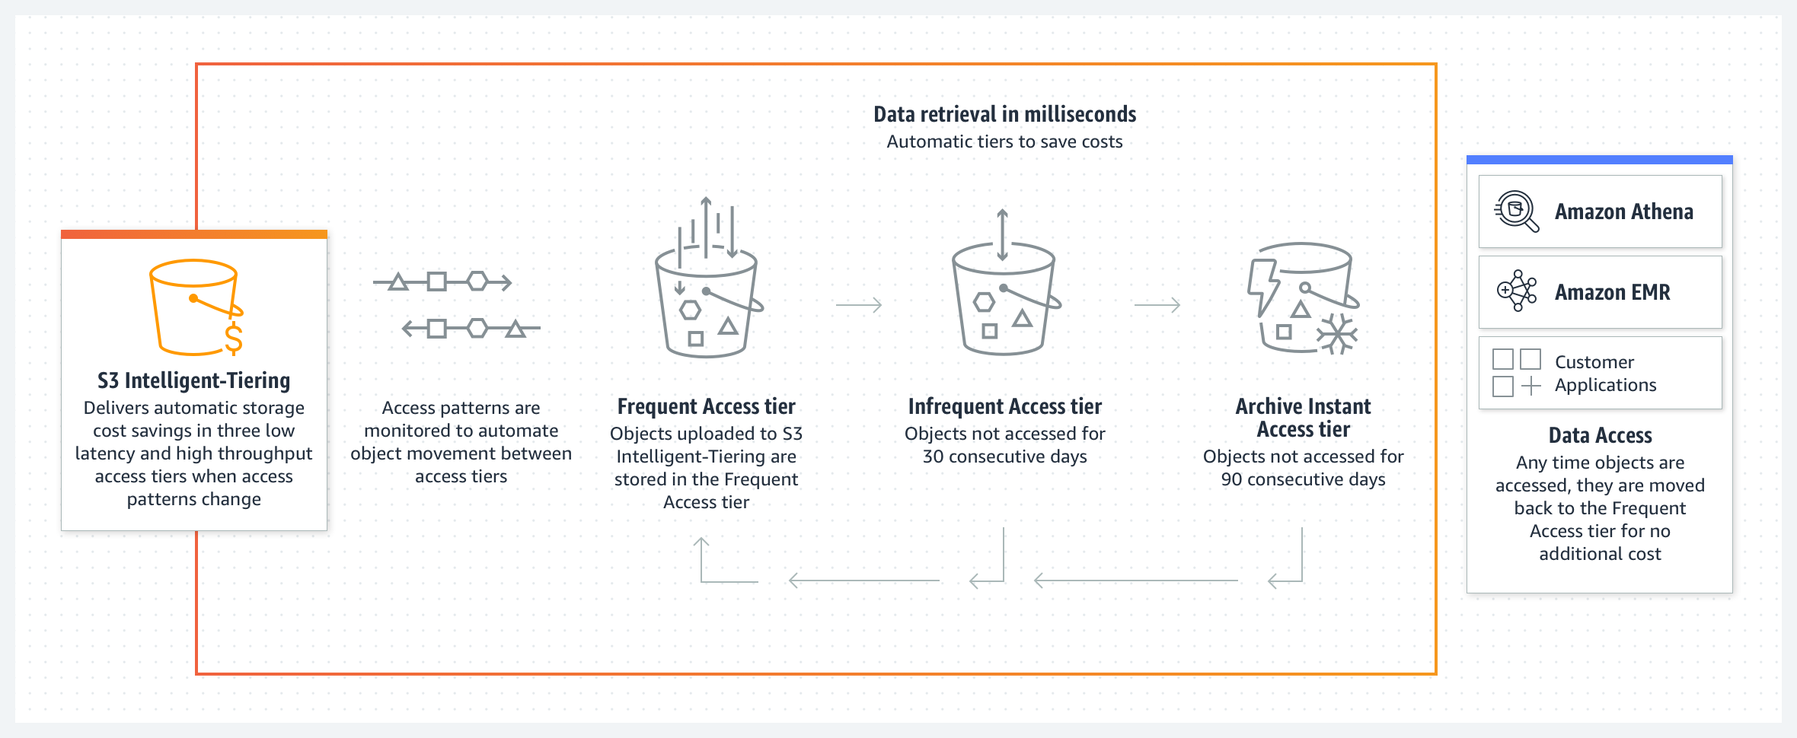

For more information, see [Amazon S3 Intelligent-Tiering storage class](https://aws.amazon.com/s3/storage-classes/intelligent-tiering/).

#### Amazon S3 Glacier storage classes

You can use Amazon S3 Lifecycle policies to transition objects from one storage class to another. These storage classes include Amazon Simple Storage Service Glacier (Amazon S3 Glacier) storage classes, which are purpose-built for data archiving. S3 Glacier storage classes provide you with low-cost archive storage in the cloud. All S3 Glacier storage classes provide virtually unlimited scalability and are designed for 99.999999999 percent (11 nines) of data durability. The S3 Glacier storage classes deliver options for fast access to your archive data and low-cost archive storage in the cloud.

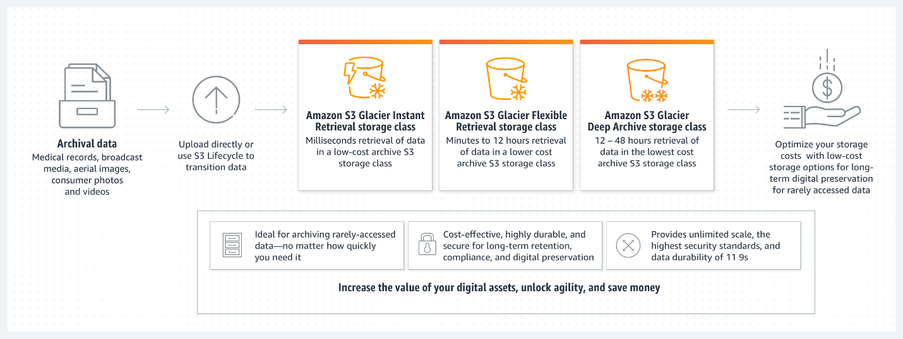

For more information, see [Amazon S3 Glacier storage classes](https://aws.amazon.com/s3/storage-classes/glacier/).

### Differences Between Amazon Kinesis Services

**Amazon Kinesis Family** The Amazon Kinesis Family makes it easier to collect, process, and analyze real-time, streaming data so that you can get timely insights and react quickly to new information. Amazon Kinesis offers key capabilities to cost-effectively process streaming data at virtually any scale, along with the flexibility to choose the tools that best suit the requirements of your application. With Amazon Kinesis, you can ingest real-time data such as video, audio, application logs, website clickstreams, and Internet of Things (IoT) telemetry data for machine learning, analytics, and other applications. You can use Amazon Kinesis to process and analyze data as it arrives, which means that you can respond quickly instead of waiting until all your data is collected before it’s processed. For more information, see [Amazon Kinesis](https://aws.amazon.com/kinesis/).

**Amazon Kinesis Data Streams** Amazon Kinesis Data Streams is a massively scalable and durable real-time data streaming service. Kinesis Data Streams is designed to continuously capture gigabytes of data per second from hundreds of thousands of sources, such as website clickstreams, database event streams, financial transactions, social media feeds, IT logs, and location-tracking events. The data that’s collected is typically available in milliseconds, which means that you can use Kinesis Data Streams with use cases for real-time analytics, such as real-time dashboards, real-time anomaly detection, dynamic pricing, and more. For more information, see [Amazon Kinesis Data Streams](https://aws.amazon.com/kinesis/data-streams/).

**Amazon Kinesis Data Firehose** Amazon Kinesis Data Firehose is designed to reliably load streaming data into data lakes, data stores, and analytics services. It can capture, transform, and deliver streaming data to Amazon Simple Storage Service (Amazon S3), Amazon Redshift, Amazon Elasticsearch Service, generic HTTP endpoints, and service providers like Datadog, New Relic, MongoDB, and Splunk. It is a fully managed service that automatically scales to match the throughput of your data and requires virtually no ongoing administration. It can also batch, compress, transform, and encrypt your data streams before loading, which minimizes the amount of storage that you use and increases security. Although it’s easier to operate when compared with Amazon Kinesis Data Streams, Kinesis Data Firehose delivery streams have a higher latency from the moment that data is ingested. For example, you can set the batch interval to 60 seconds if you want to receive new data within 60 seconds of sending it to your delivery stream. However, you could have latencies that are lower than 1 second when you use Amazon Kinesis Data Streams. For more information, see [Amazon Kinesis Data Firehose](https://aws.amazon.com/kinesis/data-firehose/?kinesis-blogs.sort-by=item.additionalFields.createdDate&kinesis-blogs.sort-order=desc).

**Amazon Kinesis Data Analytics** Amazon Kinesis Data Analytics is designed to transform and analyze streaming data in real time with Apache Flink. Apache Flink is an open-source framework and engine for processing data streams. Amazon Kinesis Data Analytics reduces the complexity of building, managing, and integrating Apache Flink applications with other AWS services. Amazon Kinesis Data Analytics is designed to take care of everything that’s required to run streaming applications continuously. It also scales automatically to match the volume and throughput of your incoming data. With Amazon Kinesis Data Analytics, there are no servers to manage, no minimum fee or setup cost, and you only pay for the resources that your streaming applications consume. For more information, see [Amazon Kinesis Data Analytics](https://aws.amazon.com/kinesis/data-analytics/).

**Amazon Kinesis Video Streams** Amazon Kinesis Video Streams is designed to securely stream video from connected devices to AWS for analytics, machine learning (ML), playback, and other forms of processing. Kinesis Video Streams automatically provisions and elastically scales the infrastructure that’s needed to ingest streaming video data from millions of devices. It’s designed to durably store, encrypt, and index video data in your streams, and you can access your data through the Kinesis Video Streams APIs. You can use Kinesis Video Streams to play back video for live and on-demand viewing. You can also use it to quickly build applications that take advantage of computer vision and video analytics through integration with Amazon Rekognition Video and libraries for ML frameworks (such as Apache MXNet, TensorFlow, and OpenCV). Kinesis Video Streams also supports WebRTC, an open-source project that uses APIs to facilitate real-time media streaming and interaction between web browsers, mobile applications, and connected devices. Typical uses for WebRTC include video chat and peer-to-peer media streaming. For more information, see [Amazon Kinesis Video Streams](https://aws.amazon.com/kinesis/video-streams/).

### Amazon QuickSight Features

With Amazon QuickSight, everyone in your organization can better understand your data by asking questions in natural language and exploring interactive dashboards. QuickSight can also automatically look for patterns and outliers (a feature that’s powered by machine learning).

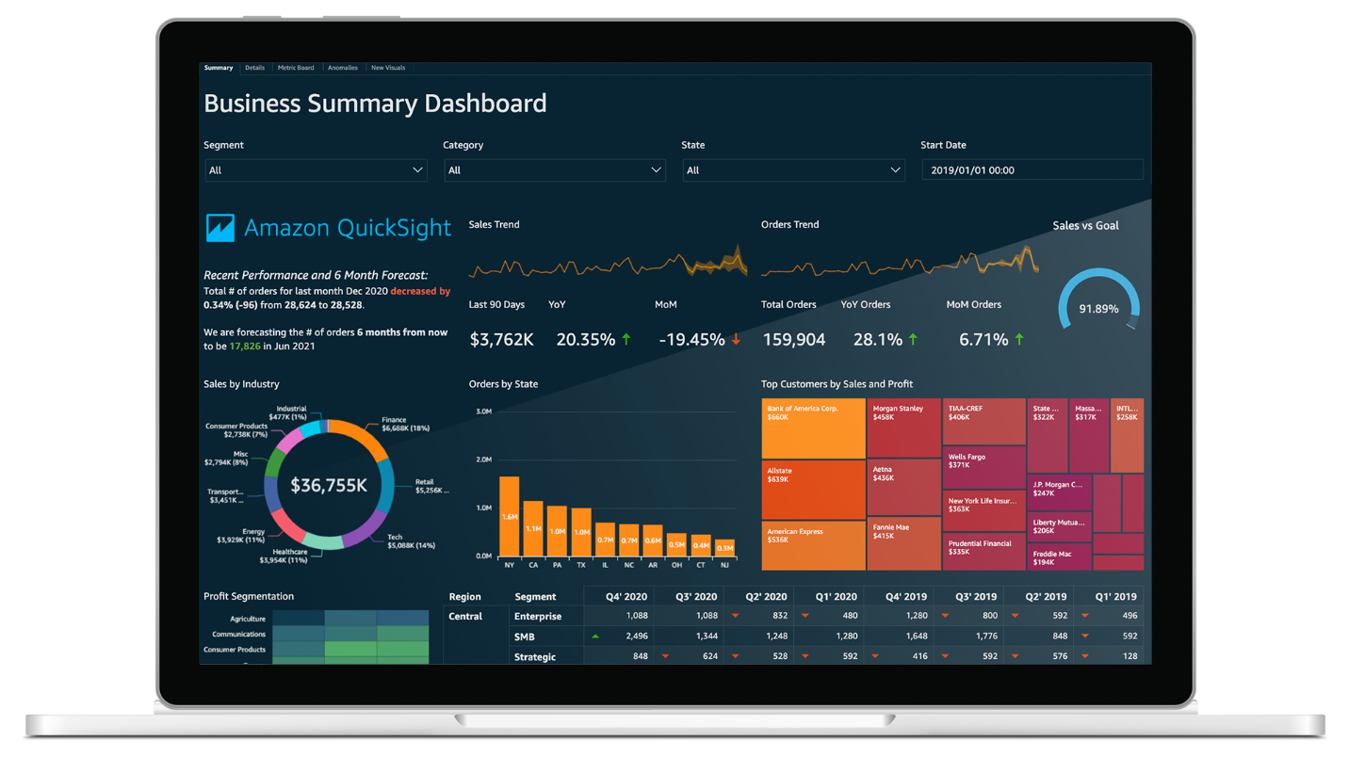

QuickSight powers millions of dashboard views weekly for customers, which means that their end users can make better, data-driven decisions. Here are some key features and benefits of QuickSight:

* Connect and scale all your data
  + Connect to all your data in AWS, in third-party cloud service providers, or on premises
  + Use SPICE in-memory storage to scale data exploration to thousands of users
  + Combine data from multiple sources and create complex data models for governed data sharing
* Build customizable dashboards
  + Use dashboard design to create customized, use-case-specific dashboards
  + Deliver personalized email reports and alerts to end users
  + Access information from virtually anywhere by using QuickSight access for iOS, Android, or mobile web applications
* Use machine learning (ML) integrations for insights
  + Use Anomaly Detection to continuously analyze all your data for anomalies and variations
  + Forecast business metrics and perform interactive what-if analyses
  + Customize Auto-Narratives and weave them into dashboards to provide deeper context for users
* Enable self-service business intelligence (BI) for everyone
  + Dive deep into data through simple questions, without BI training
  + Create visual analyses of data by using a web-based authoring interface
  + Embed QuickSight capabilities in applications for data-driven user experiences
* Use native integration with AWS
  + Use private virtual private cloud (VPC) connectivity for secure AWS access to Amazon Redshift, Snowflake, Exasol, Amazon Relational Database Service (Amazon RDS), and more
  + Use native AWS Identity and Access Management (IAM) permissions for Amazon Simple Storage Service (Amazon S3) and Amazon Athena, with fine-grained access control for serverless data exploration
  + Use Amazon SageMaker integration to incorporate sophisticated ML models without complex data pipelines
* Take advantage of no servers to manage, and paying by usage
  + Automatically scale serverless architecture to hundreds of thousands of users with high availability, with no need to overprovision for peak usage
  + Provide consistent, fast response times for end users and analysts through the auto-scaling capabilities of the SPICE in-memory engine, with no need to scale databases for high workloads
  + Optimize costs through the pay-per-session model by paying only for actual usage, with no need to buy thousands of end-user licenses for large-scale BI or embedded analytics
* Take advantage of built-in security, governance, and compliance
  + Use end-to-end data encryption for data, and use encryption at rest for data in SPICE
  + Use row-level and column-level security with API support for control at the user or group level.
  + Take advantage of rapid deployment for regulated workloads with compliance support for the Health Insurance Portability and Accountability Act (HIPAA), HITRUST CSF, General Data Protection Regulation (GDPR), System and Organizational Controls (SOC), Payment Card Industry (PCI), International Organization for Standardization (ISO) 27001, Federal Risk and Authorization Management Program (FedRAMP) High, and more

### Architecture Optimizations for Week 2

In this reading, you will find further information about the topics that Morgan and Raf talked in the video where they both played solutions architects.

#### Serverless on AWS

Morgan commented about changing the system that generates QR codes into something serverless, or a container. AWS offers technologies for running code, managing data, and integrating applications—all without managing servers. Serverless technologies feature automatic scaling, built-in high availability, and a pay-for-use billing model to increase agility and optimize costs. These technologies also reduce infrastructure management tasks, such as capacity provisioning and patching, so that you can focus on writing code that serves your customers. Serverless applications start with AWS Lambda, an event-driven compute service that natively integrates with over 200 AWS services and software as a service (SaaS) applications.

For more information, see [Serverless on AWS](https://aws.amazon.com/serverless/).

#### Amazon CloudFront

Then, Raf commented that Amazon CloudFront could be used with the Amazon Simple Storage Service (Amazon S3) bucket that is used to display the restaurant menus. Amazon CloudFront is a web service that speeds up the distribution of your static and dynamic web content (such as .html, .css, .js, and image files) to your users. CloudFront delivers your content through a worldwide network of data centers that are called edge locations. When a user requests content that you're serving with CloudFront, the request is routed to the edge location that provides the lowest latency (time delay), so that content is delivered with the best possible performance. In addition, Amazon CloudFront allows custom SSL certificates (issued by AWS Certificate Manager, or ACM), custom domain names, and further distributed denial of service (DDoS) protection that is powered by AWS WAF and AWS Shield.

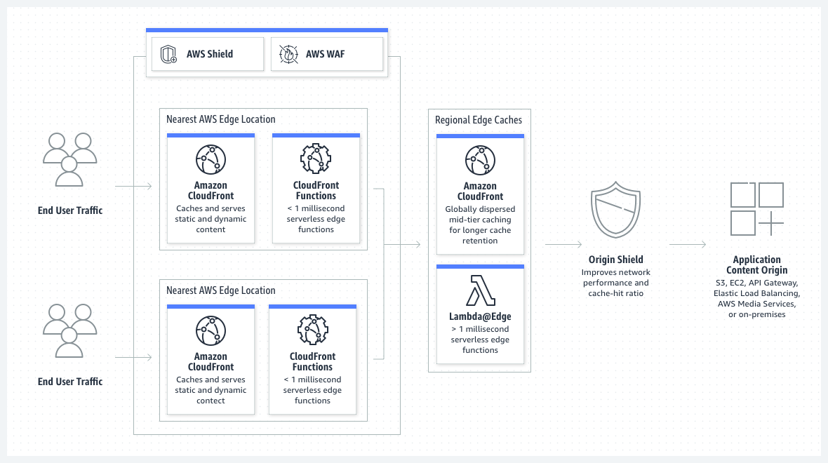

For more information, see [Amazon CloudFront](https://aws.amazon.com/cloudfront/).

#### Amazon Cognito

Morgan commented about using Amazon Cognito instead of Amazon API Gateway to send data to Amazon Kinesis. This solution would require refactoring code in the JavaScript library that sends the clickstream data. However, it would also bypass API Gateway, and therefore reduce cost. You can use Amazon Cognito to add user sign-up, sign-in, and access control to your web applications and mobile apps. Amazon Cognito scales to millions of users and supports sign-in with social identity providers, such as Apple, Facebook, Google, and Amazon, and enterprise identity providers through SAML 2.0 and OpenID Connect. For more information, see [Amazon Cognito](https://aws.amazon.com/cognito/). With Amazon Cognito, you can have a mobile JavaScript library that assumes a role with a web identity. That role must have a strict policy associated with it—for example, the policy could allow only the PutRecord API operation on a specific Kinesis data stream. For more information, see [AssumeRoleWithWebIdentity](https://docs.aws.amazon.com/STS/latest/APIReference/API_AssumeRoleWithWebIdentity.html) in the AWS Security Token Service API Reference.

#### Amazon CloudFormation and IaC

Later in the conversation, Raf talked about transforming the entire environment into a template that could be further replicated for each of the customer’s clients. This can be achieved by treating infrastructure as code (IaC) with a managed AWS service called AWS CloudFormation. CloudFormation helps you model and set up your AWS resources so that you can spend less time managing those resources, and more time focusing on your applications that run in AWS. You create a template that describes all the AWS resources that you want—for example, Amazon Elastic Compute Cloud (Amazon EC2) instances or Amazon Relational Database Service (Amazon RDS) DB instances—and CloudFormation provisions and configures those resources for you. You don't need to individually create and configure AWS resources and figure out which resource is dependent on another resource. For example, this YAML template snippet creates an S3 bucket with the following configurations:

* Static website hosting that uses index.html as the index document and error.html as the error document
* Bucket policy that allows everyone to GET objects (otherwise, the bucket is private)
* Deletion policy that asks CloudFormation to retain the bucket if the CloudFormation stack is deleted (this is a good practice when you use data services, such as buckets and databases)

The snippet also outputs the https:// URL that’s used by static website hosting, which you can send to someone else, or copy and paste into a web browser after the bucket is created.

AWSTemplateFormatVersion: 2010-09-09

Resources:

  S3Bucket:

    Type: 'AWS::S3::Bucket'

    Properties:

      AccessControl: PublicRead

      WebsiteConfiguration:

        IndexDocument: index.html

        ErrorDocument: error.html

    DeletionPolicy: Retain

  BucketPolicy:

    Type: 'AWS::S3::BucketPolicy'

    Properties:

      PolicyDocument:

        Id: MyPolicy

        Version: 2012-10-17

        Statement:

          - Sid: PublicReadForGetBucketObjects

            Effect: Allow

            Principal: '*'

            Action: 's3:GetObject'

            Resource: !Join

              - ''

              - - 'arn:aws:s3:::'

                - !Ref S3Bucket

                - /*

      Bucket: !Ref S3Bucket

Outputs:

  WebsiteURL:

    Value: !GetAtt

      - S3Bucket

      - WebsiteURL

    Description: URL for website hosted on S3

  S3BucketSecureURL:

    Value: !Join

      - ''

      - - 'https://'

        - !GetAtt

          - S3Bucket

          - DomainName





For more examples of how to use CloudFormation templates, see [Template snippets](https://docs.aws.amazon.com/AWSCloudFormation/latest/UserGuide/CHAP_TemplateQuickRef.html) in the AWS CloudFormation User Guide. Creating infrastructure templates is important because you can replicate customer workloads across multiple AWS accounts or Regions. You will learn more about how relevant and important this is in week 4 of this course. For more information, see [AWS CloudFormation](https://aws.amazon.com/cloudformation/).

#### Error retries and exponential backoff in AWS

Morgan also talked about error retries and exponential backoffs. Although this topic seems complicated, here are some best practices and observations about error retries and exponential backoffs. Numerous components on a network—such as DNS servers, switches, load balancers, and others—can generate errors anywhere in the life of a given request. The usual technique for dealing with these error responses in a networked environment is to implement retries in the client application. This technique increases the reliability of the application and reduces operational costs for the developer. If you are using one of the AWS SDKs, they already practice exponential backoffs by default. This default behavior would be one benefit of using Amazon Cognito on the client side to send data to Kinesis, instead of using a custom routine that sends data to API Gateway. You should implement a maximum delay interval and a maximum number of retries. The maximum delay interval and maximum number of retries are not necessarily fixed values. These values should be set based on the operation that’s being performed and other local factors, such as network latency. For more information, see [Error retries and exponential backoff in AWS](https://docs.aws.amazon.com/general/latest/gr/api-retries.html) in the AWS General Reference.

#### Data optimizations for Amazon Athena

Last, but not least—in the conversation, Raf talked about data optimization for Amazon Athena. This topic is broad, and it even has dedicated AWS Blog posts about the [Top 10 Performance Tuning Tips for Amazon Athena](https://aws.amazon.com/blogs/big-data/top-10-performance-tuning-tips-for-amazon-athena/). The top three data best practices for Athena are compressing, partitioning, and converting your data into columnar formats. In brief, Athena is a service that charges per amount of data scanned. By data scanned, AWS means the amount of data that Athena fetches to perform a query. As you know, data compression can reduce file sizes, which means that Athena scans less data per query. Because Athena scans less data, the queries also run faster. You can save from 30 percent to 90 percent on your per-query costs, and get better performance by applying data best practices. Data partitioning is another technique to restrict the amount of data that’s scanned by each query. You can partition your data by any key. A common practice is to partition the data based on time, which often leads to a multi-level partitioning scheme. For example, a customer who has data coming in every hour might decide to partition by year, month, date, and hour. Say that you have a 5-TB file containing monthly information in it, and this file pertains to a whole year. If you constantly query things by adding statements such as **WHERE Month = "February"**, the system will scan the entire 5-TB file for each query. The system will probably ignore data that doesn’t belong to the month of February. This process is slower and more expensive than partitioning the data so that you have files that belong to each individual month. If you partitioned the data by month, a query that contains a clause like **WHERE Month = "February"** would only scan data that pertains to the month of February, thus making the query faster and cheaper. For more information, see [Partitioning data in Athena](https://docs.aws.amazon.com/athena/latest/ug/partitions.html). Another strategy is to use an AWS service to convert bucket data into columnar data formats. Apache Parquet and ORC are columnar storage formats that are optimized for the fast retrieval of data and they are also used in AWS analytical applications. Columnar storage formats have the following characteristics that make them suitable for use with Athena:

* Compression by column, with the compression algorithm selected for the column data type to save storage space in Amazon S3, and reduce disk space and I/O during query processing.
* Predicate pushdown in Parquet and ORC enables Athena queries to fetch only the blocks that it needs, thus improving query performance. When an Athena query obtains specific column values from your data, it uses statistics from data block predicates, such as max or min values, to determine whether to read or skip the block.
* Splitting data in Parquet and ORC enables Athena to split the reading of data to multiple readers and increase parallelism when it processes queries.

For more information, see [Converting to columnar formats](https://docs.aws.amazon.com/athena/latest/ug/convert-to-columnar.html).

## Week3: Designing a hybrid solution for container based workloads on AWS

### Hybrid Networking and Connectivity

This week, the customer has a hybrid deployment, and they require a consistent connection between their data center and AWS. You should consider multiple architecture choices for this solution. However, Morgan ultimately chose AWS Direct Connect because the customer needed consistent, dedicated throughput for the high volume of data that flows between the data center and AWS.

For more information about common networking setups with AWS, see [Network-to-Amazon VPC connectivity options](https://docs.aws.amazon.com/whitepapers/latest/aws-vpc-connectivity-options/network-to-amazon-vpc-connectivity-options.html).

#### AWS Direct Connect

The AWS Direct Connect cloud service is the shortest path to your AWS resources. While your network traffic is in transit, it remains on the AWS global network and never touches the public internet. This isolation reduces the chance of encountering bottlenecks or unexpected increases in latency.

When you create a new connection, you can choose a hosted connection that’s provided by an AWS Direct Connect Delivery Partner, or choose a dedicated connection from AWS—and deploy at over 100 AWS Direct Connect locations around the globe. With AWS Direct Connect SiteLink, you can send data between AWS Direct Connect locations to create private network connections between the offices and data centers in your global network.

Each dedicated AWS Direct Connect connection consists of a single dedicated connection between ports on your router and an AWS Direct Connect device. We recommend establishing a second connection for redundancy.

When you request multiple ports at the same AWS Direct Connect location, they will be provisioned on redundant AWS equipment.

If you have configured a backup Internet Protocol security (IPsec) virtual private network (VPN) connection instead, all virtual private cloud (VPC) traffic will fail over to the VPN connection automatically. Traffic to or from public resources, such as Amazon Simple Storage Service (Amazon S3), will be routed over the internet. If you don’t have a backup AWS Direct Connect link or an IPsec VPN link, then Amazon VPC traffic will be dropped if a failure occurs. Traffic to or from public resources will be routed over the internet.

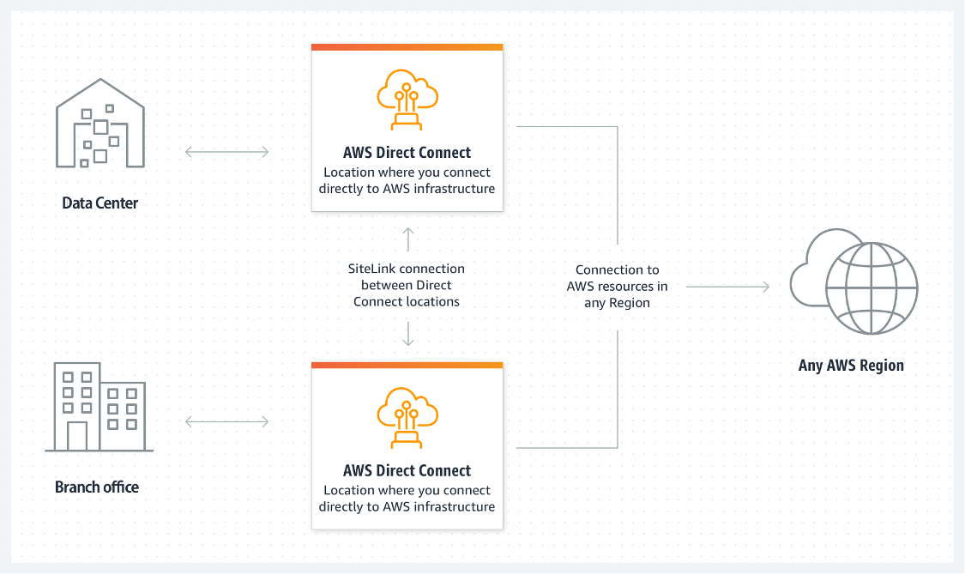

For more general information about AWS Direct Connect, see [What is AWS Direct Connect?](https://docs.aws.amazon.com/directconnect/latest/UserGuide/Welcome.html) and [AWS Direct Connect FAQs.](https://aws.amazon.com/directconnect/faqs/?nc=sn&loc=6)

#### AWS Managed VPN

##### AWS Site-to-Site VPN

By default, instances that you launch into a VPC can't communicate with your own (remote) network. You can enable access to your remote network from your VPC by creating an AWS Site-to-Site VPN connection, and configuring routing to pass traffic through the connection.VPN connection is a general term, but in AWS, a VPN connection refers to the connection between your VPC and your own on-premises network. Site-to-Site VPN supports IPsec VPN connections.

##### Virtual private gateway

A virtual private gateway is the VPN concentrator on the Amazon side of the Site-to-Site VPN connection. You create a virtual private gateway and attach it to the VPC where you want to create the Site-to-Site VPN connection.

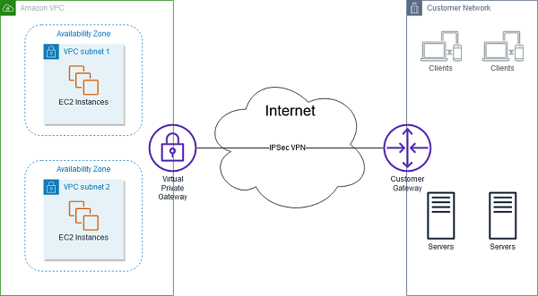

Consider taking this approach when you want to take advantage of an AWS managed VPN endpoint that includes automated redundancy and failover built into the AWS side of the VPN connection.

The virtual private gateway also supports and encourages multiple user gateway connections so that you can implement redundancy and failover on your side of the VPN connection, as shown in the following figure.

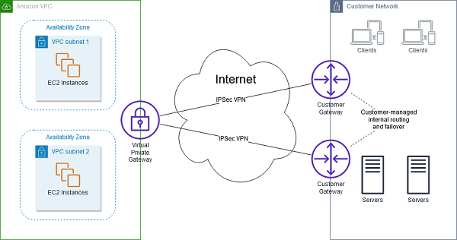

The previous diagram also shows a customer gateway on the customer-network side. A customer gateway device is a physical or software appliance that you own or manage in your on-premises network (that is, on your side of a Site-to-Site VPN connection). You or your network administrator must configure the device to work with the Site-to-Site VPN connection.

#### AWS Client VPN

AWS Client VPN is a fully managed, remote-access VPN solution that your remote workforce can use to securely access resources within both AWS and your on-premises network. It’s fully elastic, so it automatically scales up or down, based on demand. When you migrate applications to AWS, your users access the applications in the same way before, during, and after the move. AWS Client VPN, including the software client, supports the OpenVPN protocol.The following scenarios are examples of how you could use AWS Client VPN.

##### Scenario 1

The configuration for this scenario includes a single target VPC. We recommend this configuration if you need to give clients access to the resources inside only a single VPC.

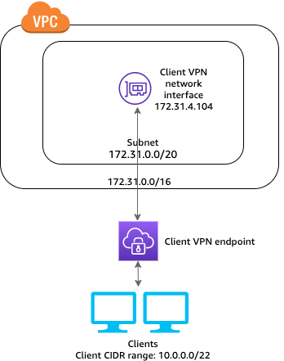

##### Scenario 2

The configuration for this scenario includes access to only an on-premises network. We recommend this configuration if you need to give clients access to the resources inside only an on-premises network.

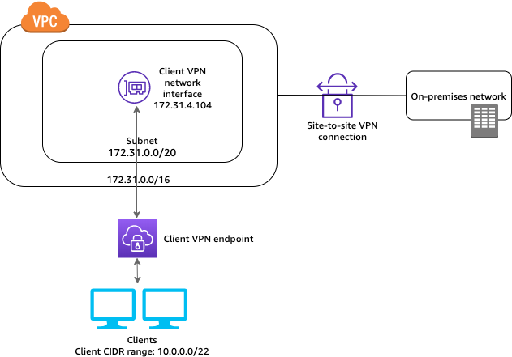

##### Scenario 3

In the configuration for the scenario shown in the following diagram, clients can access a single VPC, and clients can also route traffic to each other. We recommend this configuration if the clients that connect to the same client VPN endpoint also need to communicate with each other. Clients can communicate with each other by using the unique IP address that's assigned to them from the client Classless Inter-Domain Routing (CIDR) range when they connect to the client VPN endpoint.

* For more information about AWS Site-to-Site VPN, see [What is Amazon Site-to-Site VPN?](https://docs.aws.amazon.com/vpn/latest/s2svpn/VPC_VPN.html)

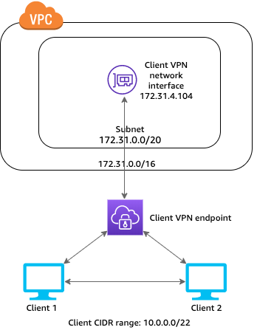

For more resources about AWS VPN services, see the following:

* For more information about AWS Client VPN, see [What is AWS Client VPN?](https://docs.aws.amazon.com/vpn/latest/clientvpn-admin/what-is.html)

#### AWS Transit Gateway

Morgan mentioned that if multiple Regions or AWS accounts were all connected to a remote data center by using AWS Direct Connect, then she might recommend using AWS Transit Gateway.

AWS Transit Gateway connects your VPCs and on-premises networks through a central hub. This arrangement simplifies your network and minimizes complex peering relationships. Transit Gateway acts as a cloud router—each new connection is made only once.

As you expand globally, inter-Region peering connects transit gateways together through the AWS global network. Your data is automatically encrypted and never travels over the public internet.

#### Without AWS Transit Gateway

The following diagram shows what a network solution might look like without the use of AWS Transit Gateway. Notice that there are many different connection points between the different components. This network configuration is complex, and it can be difficult to manage.

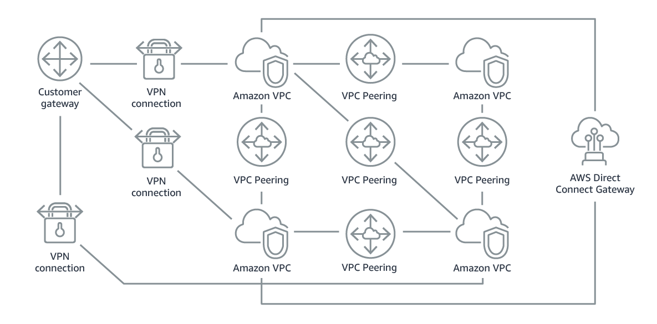

#### With AWS Transit Gateway

In contrast, the following diagram shows what a network solution might look like with the use of AWS Transit Gateway. Transit Gateway is the hub for the connections between the different networks. Using a transit gateway can make the network easier to manage. You can apply route tables so that the transit gateway can connect networks to each other in a more centralized manner.

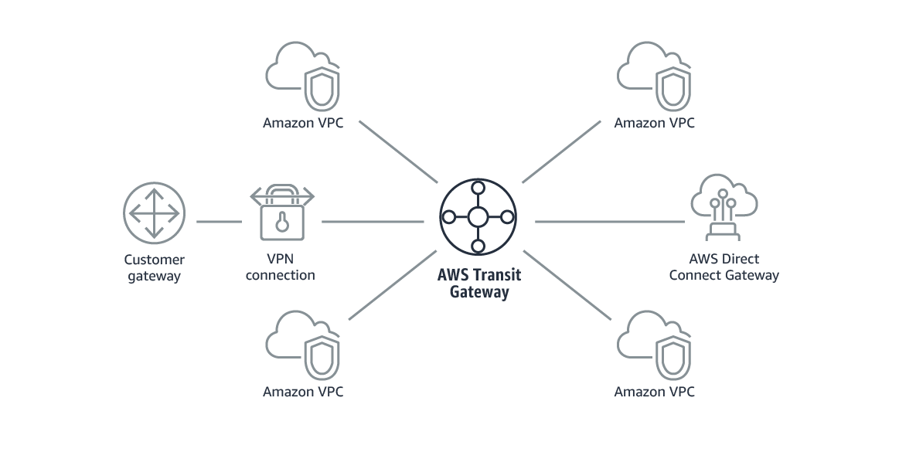

The following example shows what using AWS Transit Gateway with AWS Direct Connect could look like for a solution that has a remote network and three AWS Regions. Each Region has multiple VPCs.

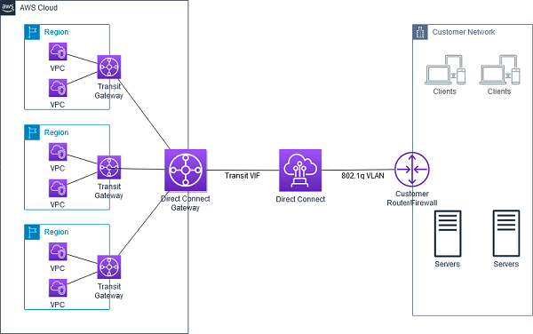

For more information about AWS Transit Gateway, see [What is a transit gateway?](https://docs.aws.amazon.com/vpc/latest/tgw/what-is-transit-gateway.html)

### Running Containers on AWS and NAT Gateways

This week’s customer needed a solution to host containers on AWS. These containers will be running internal applications that don’t require inbound communication from the internet. However, the applications might require outbound communication to the internet so they can do tasks such as download updates from internet sources. The customer must use their own custom Amazon Machine Image (AMI) for the cluster that hosts the containers, and they must also have SSH access to underlying instances. For these reasons, Morgan chose Amazon Elastic Container Service (Amazon ECS) as the container orchestration tool and Amazon Elastic Compute Clear (Amazon EC2) as the launch type. Morgan also chose to include a NAT gateway in the architecture so that private instances could download information from the internet.

#### Amazon ECS launch types

After you choose which container orchestration tool you want to use—either Amazon ECS or Amazon Elastic Kubernetes Services (Amazon EKS)—there are two launch types to pick from:

* EC2: Deploy and manage your own cluster of EC2 instances for running the containers
* AWS Fargate: Run containers directly, without any EC2 instances

Both launch types are good compute options for hosting your containers in a scalable and reliable way. Which launch type you choose will depend on which factors you want to optimize for.

In the video, Morgan chose the EC2 launch type for containers that were being run by Amazon ECS. She chose the EC2 launch type because the customer wants to use a custom AMI. The customer also wants to maintain SSH access to underlying instances so they could try to have similar management operations across workloads. AWS Fargate doesn’t support either of these options. Therefore, EC2 was the correct choice for this use case.

#### EC2 launch type

You can use the EC2 launch type to run your containerized applications on EC2 instances, which you register to your Amazon ECS cluster and manage yourself.

The following diagram shows the general architecture.

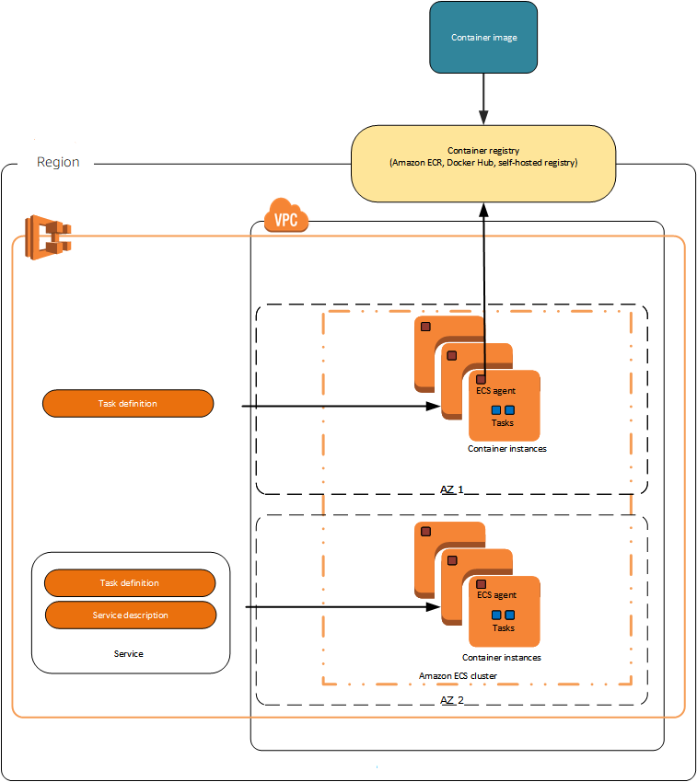

The diagram shows that the ECS agent is installed on each EC2 instance in the cluster. The ECS agent enables the orchestration tool that Amazon ECS uses to manage nodes.

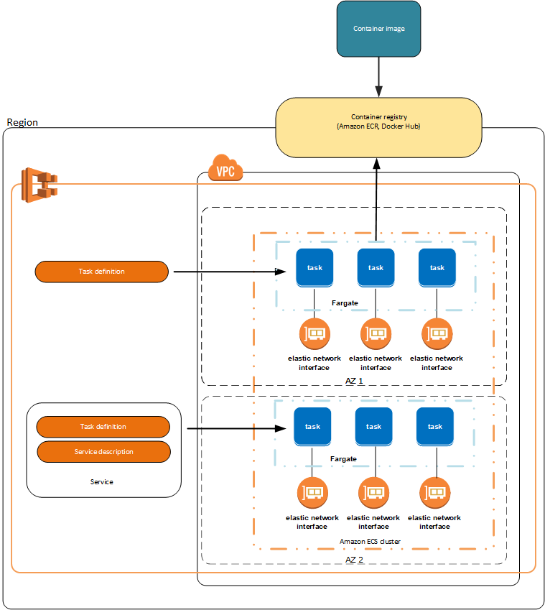

#### Fargate launch type

You can use the Fargate launch type to run your containerized applications without the need to provision and manage the underlying infrastructure. AWS Fargate is the serverless way to host your Amazon ECS workloads.

The following diagram shows the general architecture.



For more resources about containers on AWS, see the following:

* For general information about AWS container services, see [Containers at AWS](https://aws.amazon.com/containers/) or the [Customers FAQs](https://aws.amazon.com/containers/faqs/) on the AWS Containers site.
* For more information about ECS launch types, see [Amazon ECS launch types](https://docs.aws.amazon.com/AmazonECS/latest/developerguide/launch_types.html).

#### NAT devices

You can use a NAT device to allow resources in private subnets to connect to the internet, other VPCs, or on-premises networks. These instances can communicate with services outside the VPC, but they can’t receive unsolicited connection requests.

The NAT device replaces the source IPv4 address of the instances with the address of the NAT device. When the NAT device sends response traffic to the instances, the device translates the addresses back to the original source IPv4 addresses.

You can use a managed NAT device that’s offered by AWS, which is called a NAT gateway. You can also create your own NAT device on an EC2 instance, which is called a NAT instance. We recommend that you use NAT gateways because they provide better availability and bandwidth, and administering NAT gateways requires less effort on your part. You can manage how the traffic flows from the private resources to the NAT device by using route tables.

#### NAT instances

You can create your own AMI that provides network address translation, and use your AMI to launch an EC2 instance as a NAT instance. You can launch a NAT instance in a public subnet so that instances in a private subnet can initiate outbound IPv4 traffic to the internet or other AWS services without receiving inbound traffic that was initiated on the internet.

#### NAT gateways

A NAT gateway is a NAT service. You can use a NAT gateway so that instances in a private subnet can connect to services that are outside your VPC, but external services can’t initiate a connection with those instances.

When you create a NAT gateway, you specify one of the following connectivity types:

* Public (default): Instances in private subnets can connect to the internet through a public NAT gateway, but can’t receive unsolicited inbound connections from the internet. You create a public NAT gateway in a public subnet, and you must associate an elastic IP address with the NAT gateway at creation. You route traffic from the NAT gateway to the internet gateway for the VPC. Alternatively, you can use a public NAT gateway to connect to other VPCs or your on-premises network. In this case, you route traffic from the NAT gateway through a transit gateway or a virtual private gateway.
* Private: Instances in private subnets can connect to other VPCs or your on-premises network through a private NAT gateway. You can route traffic from the NAT gateway through a transit gateway or a virtual private gateway. You can’t associate an elastic IP address with a private NAT gateway. You can attach an internet gateway to a VPC with a private NAT gateway, but if you route traffic from the private NAT gateway to the internet gateway, the internet gateway drops the traffic.

The NAT gateway replaces the source IP address of the instances with the IP address of the NAT gateway. For a public NAT gateway, this is the elastic IP address of the NAT gateway. For a private NAT gateway, this is the private IP address of the NAT gateway. When the NAT device sends response traffic to the instances, it translates the addresses back to the original source IP address.For more resources about NAT devices, see the following:

* For more information, see [Connect to the internet or other networks using NAT devices](https://docs.aws.amazon.com/vpc/latest/userguide/vpc-nat.html).
* For information comparing NAT devices, see [Compare NAT gateways and NAT instances](https://docs.aws.amazon.com/vpc/latest/userguide/vpc-nat-comparison.html).

### Amazon RDS

#### Multi-AZ deployments

For this week’s customer, Morgan recommends that they migrate their on-premises database to Amazon Relational Database Service (Amazon RDS), and to use a Multi-AZ deployment for high availability.

In a Multi-AZ deployment, Amazon RDS automatically creates a primary database (DB) instance and synchronously replicates the data to an instance in a different Availability Zone. When it detects a failure, Amazon RDS automatically fails over to a standby instance without manual intervention. This failover mechanism meets the customer’s need to have a highly available database.

The following diagram shows a Multi-AZ deployment with one standby DB instance, and how it works.

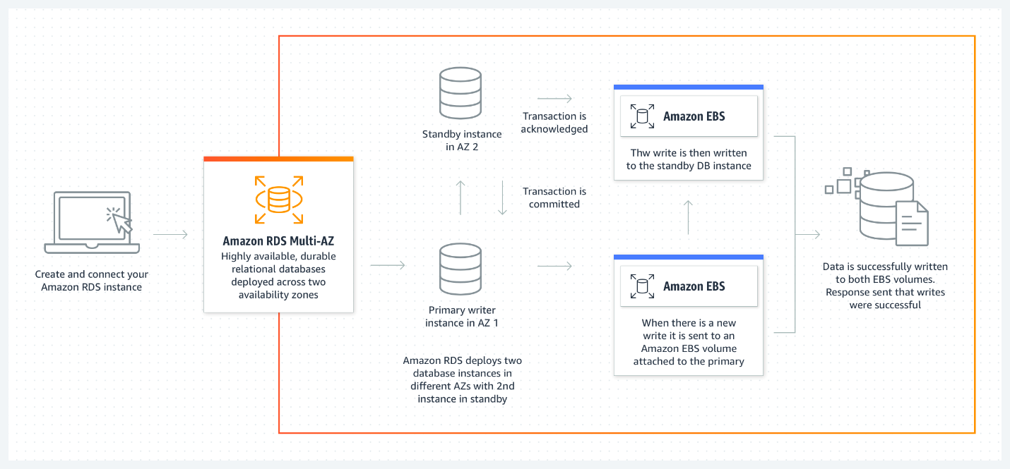

For even higher availability, the customer could explore deploying two standby DB instances, and use three Availability Zones instead of two.

Say that you deploy MySQL or PostgreSQL databases in three Availability Zones by using Amazon RDS Multi-AZ with two readable standbys. With this configuration, you can see automatic failovers typically happen in under 35 seconds, and with a transaction-commit latency that can be up to two times faster when compared to an Amazon RDS Multi-AZ deployment with one standby. You can also gain additional read capacity, and a choice of AWS Graviton2–based or Intel–based instances for compute.

The following diagram shows a Multi-AZ deployment with two standby DB instances, and how it works.

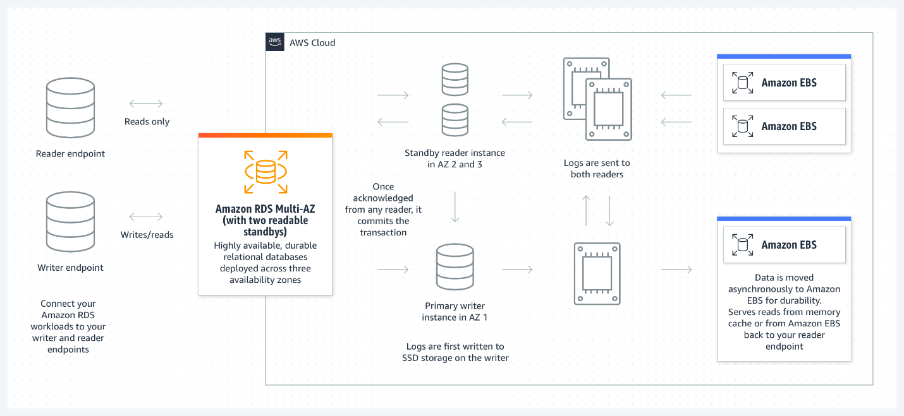

#### Read replicas

Customers can also make RDS more highly available by using read replicas.

Amazon RDS read replicas provide enhanced performance and durability for Amazon RDS DB instances. For read-heavy database workloads, read replicas make it easier to elastically scale out beyond the capacity constraints of a single DB instance.

You can create one or more replicas of a given source DB instance and serve high-volume application read traffic from multiple copies of your data, which increases aggregate read throughput. Read replicas can also be promoted to become standalone DB instances, when needed.

Read replicas are available in Amazon RDS for MySQL, MariaDB, PostgreSQL, Oracle, Microsoft SQL Server, and Amazon Aurora.

For the MySQL, MariaDB, PostgreSQL, Oracle, and SQL Server database engines, Amazon RDS creates a second DB instance by using a snapshot of the source DB instance. Amazon RDS then uses the engine’s native asynchronous replication to update the read replica when there’s a change to the source DB instance.

The read replica operates as a DB instance that allows only read-only connections. Applications can connect to a read replica like they would connect to any DB instance. Amazon RDS replicates all databases in the source DB instance.

Here’s an example of when to use a read replica. Say that you’re running reports on your database, which is causing performance issues with CPU-intensive reads. You can use a read replica and direct all the reporting queries to that replica instead of to the primary instance. Offloading some of the intense queries to the replica should result in enhanced performance on the primary instance.

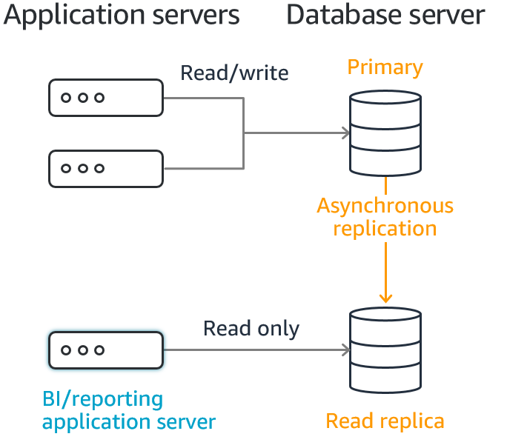

#### Scaling Amazon RDS instances

##### Scale your instance up vertically

When you create an RDS DB instance, you choose a database instance type and size.

Amazon RDS provides a selection of instance types that are optimized to fit different use cases for relational databases. Instance types comprise varying combinations of CPU, memory, storage, and networking capacity. You have the flexibility to choose the appropriate mix of resources for your database. Each instance type includes several instance sizes, which means that you can scale your database to your target workload’s requirements.

Not every instance type is supported for every database engine, version, edition or Region.

When you want to scale your DB instance, you can vertically scale the instance and choose a larger instance size. This might be the route you choose to take when you need more CPU and storage ability for an instance.

##### Use read replicas

If you need more CPU capabilities but don’t need more storage, you might choose to create read replicas to offload some of the workload to a secondary instance.

#### Enable RDS Storage Auto Scaling

If you need more storage, but don’t need more CPU, then you could scale the storage horizontally. You can scale storage horizontally by allocating more storage volumes for your instance manually, or by enabling RDS Storage Auto Scaling. RDS Storage Auto Scaling automatically scales storage capacity in response to growing database workloads, with virtually zero downtime.

Previously, you needed to manually provision storage capacity based on anticipated application demands. Underprovisioning could result in application downtime, and overprovisioning could result in underutilized resources and higher costs. With RDS Storage Auto Scaling, you set your desired maximum storage limit and Auto Scaling takes care of the rest.

RDS Storage Auto Scaling continuously monitors actual storage consumption, and scales capacity up automatically when actual utilization approaches provisioned storage capacity.

Auto Scaling works with new and existing database instances. You can enable Auto Scaling with a few clicks in the AWS Management Console.

#### Change the storage type for increased performance

Finally, here’s one last thing to consider. If you’re looking for better performance, consider using a different storage type. For example, using Provisioned IOPS instead of General Purpose could give you some of the performance enhancements that you want.

The following list briefly describes the three storage types:

* General Purpose SSD: General Purpose SSD volumes offer cost-effective storage that works well for a broad range of workloads. These volumes deliver single-digit millisecond latencies and the ability to burst to 3,000 IOPS for extended periods of time. Baseline performance for these volumes is determined by the volume's size.
* Provisioned IOPS: Provisioned IOPS storage is designed to meet the needs of I/O-intensive workloads—particularly database workloads—that require low I/O latency and consistent I/O throughput.
* Magnetic: Amazon RDS also supports magnetic storage for backward compatibility. We recommend that you use General Purpose SSD or Provisioned IOPS for any new storage needs. The maximum amount of storage that’s allowed for DB instances on magnetic storage is less than that of the other storage types.

For more resources about Amazon RDS, see the following:

* For more information about Amazon RDS Multi-AZ Deployments, see [Amazon RDS Multi-AZ](https://aws.amazon.com/rds/features/multi-az/).
* For more information about Amazon RDS read replicas, see [Amazon RDS Read Replicas](https://aws.amazon.com/rds/features/read-replicas/).
* For more information about Amazon RDS DB instances, see [Amazon RDS DB instances](https://docs.aws.amazon.com/AmazonRDS/latest/UserGuide/Overview.DBInstance.html).

#### AWS DMS

Morgan suggested that this week’s customer use AWS Database Migration Service (Amazon DMS) to migrate data from their on-premises database to Amazon RDS.

AWS DMS helps you migrate databases to AWS quickly and securely. The source database remains fully operational during the migration, which minimizes the downtime to applications that rely on the database. The AWS DMS can migrate your data to and from widely used commercial and open-source databases.

At a basic level, AWS DMS is a server in the AWS Cloud that runs replication software. You create a source and target connection to tell AWS DMS where to extract from and load to. Then, you schedule a task that runs on this server to move your data. AWS DMS creates the tables and associated primary keys if they don't exist on the target. You can precreate the target tables yourself, if you prefer. You can also use AWS Schema Conversion Tool (AWS SCT) to create some or all of the target tables, indexes, views, triggers, and so on.

The following diagram shows the AWS DMS replication process.

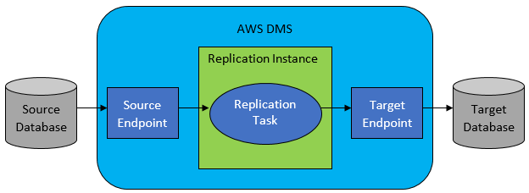

This week’s customer would use AWS DMS to perform a homogenous database migration.

In homogeneous database migrations, the source and target database engines are the same, or are compatible—such as Oracle to Amazon RDS for Oracle, MySQL to Amazon Aurora, MySQL to Amazon RDS for MySQL, or Microsoft SQL Server to Amazon RDS for SQL Server. Because the schema structure, data types, and database code are compatible between the source and target databases, this kind of migration is typically a one-step process. You create a migration task with connections to the source and target databases, and then start the migration. AWS DMS takes care of the rest. The source database can be located in your own premises outside of AWS, on an Amazon Elastic Compute Cloud (Amazon EC2) instance, or in an Amazon RDS DB instance. The target can be a database in Amazon EC2 or Amazon RDS.

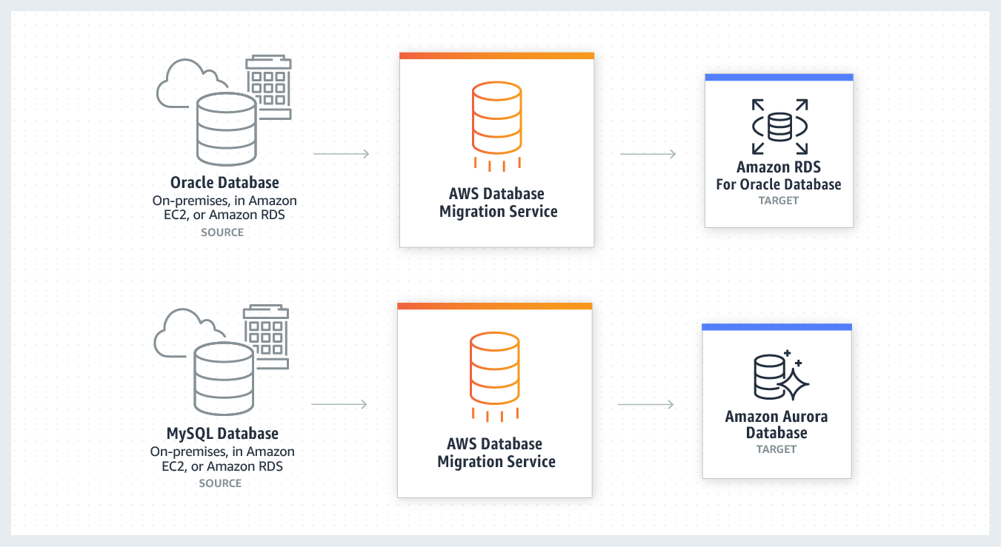

For more general information about AWS DMS, see [What is AWS Database Migration Service?](https://docs.aws.amazon.com/dms/latest/userguide/Welcome.html)

### AWS Storage Services

When you consider which storage service to choose for a specific use case, it’s important to be familiar with the different storage services that AWS has to offer. For this week’s customer, Morgan chose AWS Storage Gateway and Amazon Simple Storage Service (Amazon S3) as the services to support the solution. Morgan chose these services because the customer requires the Network File System (NFS) protocol to remain in place for all on-premises applications. However, the customer also wants to store the files (that they will access) in AWS. Storage Gateway supports this use case.

#### AWS Storage Gateway

AWS Storage Gateway connects an on-premises software appliance with cloud-based storage to provide near-seamless integration with data security features between your on-premises IT environment and the AWS storage infrastructure. You can use the service to store data in the AWS Cloud for scalable and cost-effective storage that helps maintain data security. AWS Storage Gateway offers file-based, volume-based, and tape-based storage solutions.

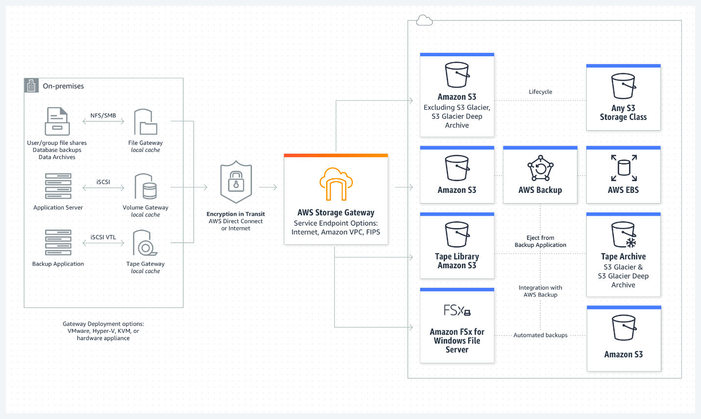

Morgan recommended Amazon S3 File Gateway for the customer’s solution.

#### Amazon S3 File Gateway

Amazon S3 File Gateway supports a file interface into Amazon S3, and it combines a service and a virtual software appliance. By using this combination, you can store and retrieve objects in Amazon S3 by using industry-standard file protocols, such as NFS and Server Message Block (SMB). The software appliance (or gateway) is deployed into your on-premises environment as a virtual machine (VM) that runs on VMware ESXi, Microsoft Hyper-V, or Linux Kernel-based Virtual Machine (KVM) hypervisor. The gateway provides access to objects in Amazon S3 as files or file-share mount points. With S3 File Gateway, you can do the following:

* Store and retrieve files directly by using NFS version 3 or version 4.1.
* Store and retrieve files directly by using SMB file system version 2 or version 3.
* Access data directly in Amazon S3 from any AWS Cloud application or service.
* Manage your Amazon S3 data by using lifecycle policies, S3 Cross-Region Replication (CRR), and versioning. You can think of a S3 File Gateway as a file system mount on Amazon S3.

Amazon S3 File Gateway is designed to simplify file storage in Amazon S3. It integrates to existing applications through industry-standard file system protocols, and it provides a cost-effective alternative to on-premises storage. Amazon S3 File Gateway also provides low-latency access to data through transparent local caching. It manages data transfer to and from AWS, and it optimizes and streams data in parallel. Amazon S3 File Gateway also buffers applications from network congestion, and manages bandwidth consumption.For more resources about Amazon S3 File Gateway, see the following:

* For more information about Amazon S3 File Gateway, see [What is Amazon S3 File Gateway?](https://docs.aws.amazon.com/filegateway/latest/files3/what-is-file-s3.html)
* For more information about AWS Storage Gateway, see [AWS Storage Gateway Features](https://aws.amazon.com/storagegateway/features/).

#### Amazon EBS

An Amazon Elastic Block Store (Amazon EBS) volume is a durable, block-level storage device that you can attach to your Amazon Elastic Compute Cloud (Amazon EC2) instances. After you attach a volume to an instance, you can use it as you would use a physical hard drive. EBS volumes are flexible. For current-generation volumes attached to current-generation instance types, you can dynamically increase size, modify the provisioned IOPS capacity, and change volume type on live production volumes.

It’s important that you know about the different types of EBS volume types and sizes, and how IOPS are correlated with volume size and type.

Amazon EBS provides the following volume types, which differ in performance characteristics and price, so that you can tailor your storage performance and cost to the needs of your applications.

* Solid-state drives (SSD): Optimized for transactional workloads involving frequent read/write operations with small I/O size, where the dominant performance attribute is IOPS. SSD-backed volume types include General Purpose SSD volumes and Provisioned IOPS SSD volumes
* Hard disk drives (HDD): Optimized for large, streaming workloads where the dominant performance attribute is throughput. HDD-backed volume types include Throughput Optimized HDD and Cold HDD volumes.
* Previous generation: Hard disk drives that you can use for workloads with small datasets, where data is accessed infrequently and performance is not a priority. We recommend that you consider a current-generation volume type instead.

Note that the number of available IOPs increases with the size of the volume. Thus, if you need more IOPs, you must vertically scale the volume.For more information, see [Amazon EBS volume types](https://docs.aws.amazon.com/AWSEC2/latest/UserGuide/ebs-volume-types.html).

#### Amazon EFS

Amazon Elastic File System (Amazon EFS) provides a simple, serverless elastic file system that you can use with AWS Cloud services and on-premises resources. It is built to scale on demand to petabytes without disrupting applications. Amazon EFS can grow and shrink automatically as you add and remove files, so it minimizes the need to provision and manage capacity to accommodate growth. Amazon EFS has a web services interface that you can use to create and configure file systems quickly and easily. The service manages all the file storage infrastructure for you, meaning that you can reduce the complexity of deploying, patching, and maintaining complex file system configurations.

Amazon EFS supports NFS version 4 (NFSv4.1 and NFSv4.0), so the applications and tools that you use today work with Amazon EFS. Multiple compute instances—including Amazon EC2, Amazon Elastic Container Service (Amazon ECS), and AWS Lambda—can access an Amazon EFS file system at the same time. Amazon EFS can thus provide a common data source for workloads and applications that run on more than one compute instance or server.

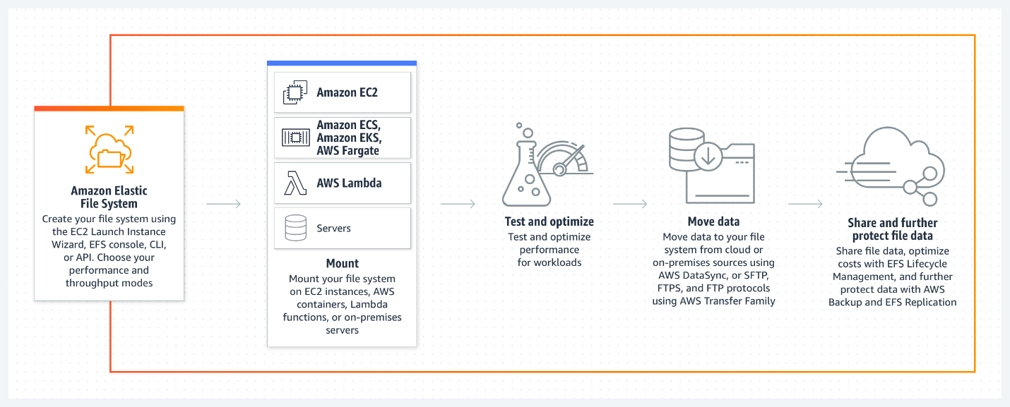

For more information, see [What is Amazon EFS?](https://docs.aws.amazon.com/efs/latest/ug/whatisefs.html)

#### Amazon S3

Amazon S3 is an object storage service that stores data as objects within buckets. An object is a file and any metadata that describes the file. A bucket is a container for objects.

To store your data in Amazon S3, you first create a bucket and specify a bucket name and AWS Region. Then, you upload your data to that bucket as objects in Amazon S3. Each object has a key (or key name), which is the unique identifier for the object within the bucket.

S3 provides features that you can configure to support your specific use case. For example, you can use S3 Versioning to keep multiple versions of an object in the same bucket, which means that you can restore objects that are accidentally deleted or overwritten.

#### Storage classes

Amazon S3 offers a range of storage classes that are designed for different use cases. For example, you could store mission-critical production data in S3 Standard for frequent access. You could also save on costs by storing infrequently accessed data in S3 Standard-IA or S3 One Zone-IA. Finally, you could archive data at a low costs in S3 Glacier Instant Retrieval, S3 Glacier Flexible Retrieval, and S3 Glacier Deep Archive.

You can store data with changing or unknown access patterns in S3 Intelligent-Tiering, which optimizes storage costs by automatically moving your data between four access tiers when your access patterns change. These four access tiers include two low-latency access tiers, which are optimized for frequent and infrequent access. The four access tiers also include two opt-in archive access tiers that are designed for asynchronous access to rarely accessed data.

For more resources about Amazon S3, see the following:

* For more information, see [What is Amazon S3?](https://docs.aws.amazon.com/AmazonS3/latest/userguide/Welcome.html)
* For more information, including links out to hands-on tutorials, see [Getting Started with Amazon S3](https://aws.amazon.com/s3/getting-started/?nc=sn&loc=6&dn=1).
* For more information about Amazon S3 storage classes, see [Amazon S3 Storage Classes](https://aws.amazon.com/s3/storage-classes/).

### AWS Services for Hybrid Deployments

This week’s customer explained that they want to use the same management tools in both their data center and AWS when possible. To support this requirement, Morgan suggested that the customer migrate their on-premises containers to use Amazon Elastic Container Service (Amazon ECS) Anywhere so that they can use common tooling for running containers. Morgan also suggested that the customer use the following tools to manage resources across environments: AWS Systems Manager for operational support and tasks, and AWS Backup for managing backups in one centralized place.

#### Amazon ECS Anywhere

Amazon ECS Anywhere is a feature of Amazon ECS that you can use to run and manage container workloads on customer-managed infrastructure.

Amazon ECS Anywhere builds on the ease and simplicity of Amazon ECS to provide a consistent experience across your container-based applications for working with tooling and APIs. Whether on premises or in the cloud, cluster management, workload scheduling, and monitoring will be similar to what you already know from Amazon ECS. You can reduce costs and mitigate complex local container orchestration by taking advantage of the completely managed solution that Amazon ECS Anywhere provides. Amazon ECS Anywhere can help you meet compliance requirements and scale your business while retaining your on-premises investments.

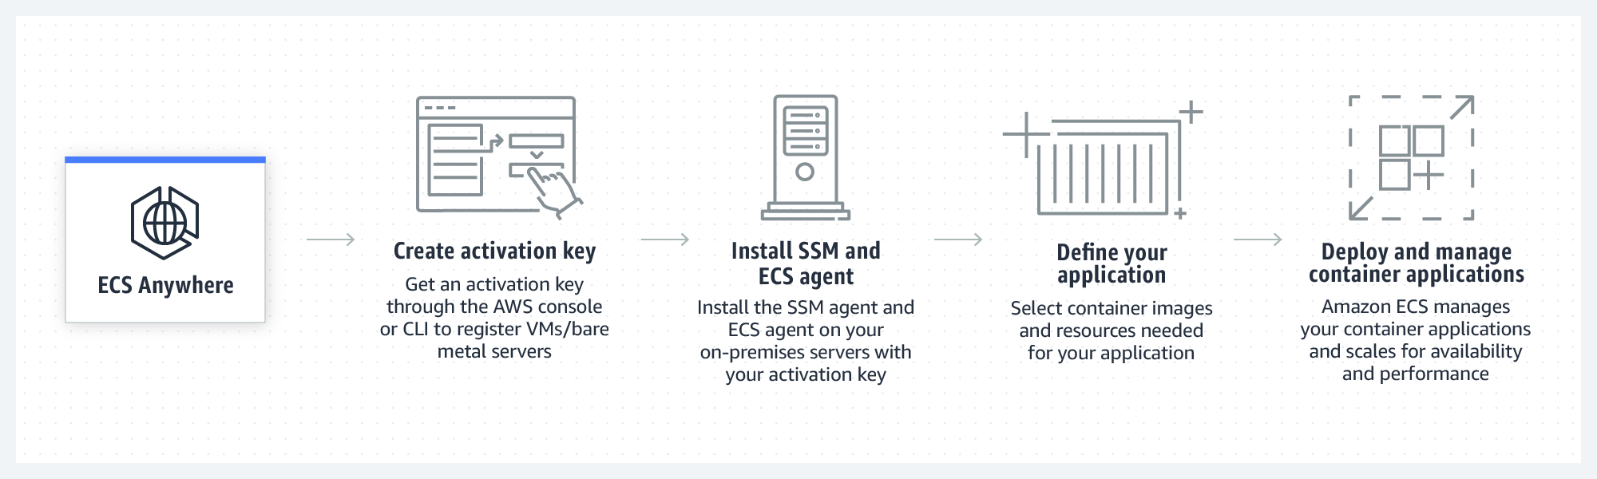

For a hands-on workshop about Amazon ECS Anywhere, see [Amazon ECS Workshop: ECS Anywhere](https://www.ecsworkshop.com/ecsanywhere/).

#### AWS Systems Manager

By using AWS Systems Manager, you have visibility and control of your infrastructure on AWS. Systems Manager provides a unified user interface that you can use to view operational data from multiple AWS services and automate operational tasks across your AWS resources.

With Systems Manager, you can group resources—such as Amazon Elastic Compute Cloud (Amazon EC2) instances, Amazon Simple Storage Service (Amazon S3) buckets, or Amazon Relational Database Service (Amazon RDS) instances—by application. You can also view operational data for monitoring and troubleshooting, and take action on your groups of resources.

Systems Manager is design to simplify resource and application management, reduce the time needed to detect and resolve operational problems, and make it easier to operate and manage your infrastructure securely at scale.

The following diagram shows how some Systems Manager capabilities perform actions on your resources. The diagram doesn't cover all capabilities. Each numbered interaction is described after the diagram.

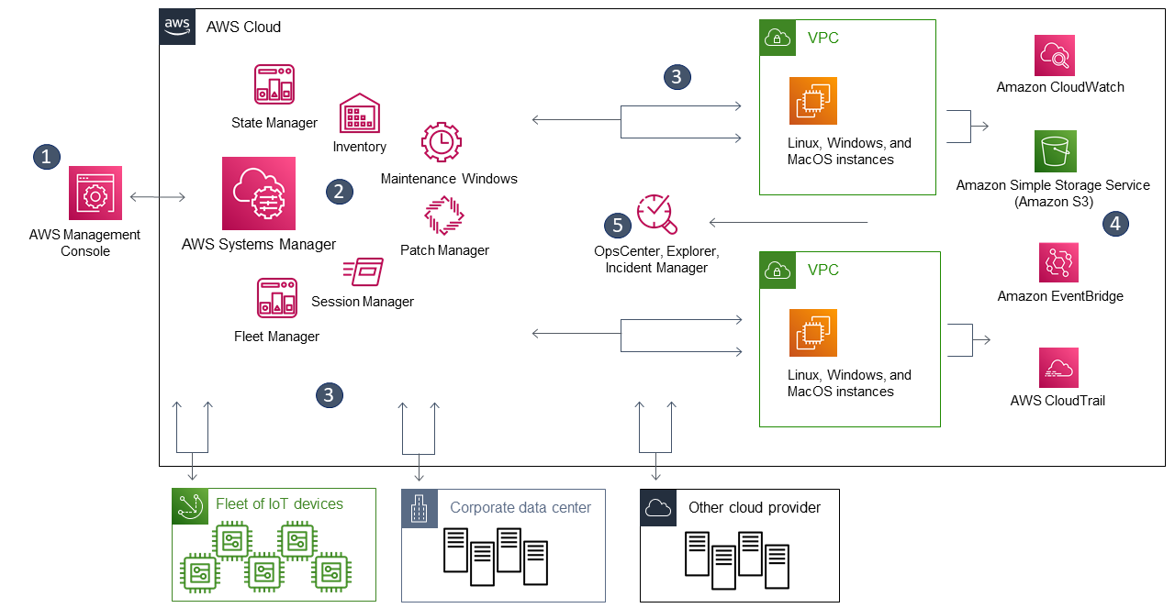

1. Access Systems Manager: Use one of the available options foraccessing Systems Manager, such as the AWS Management Console or the AWS Command Line Interface (AWS CLI).
2. Choose a Systems Manager capability: Determine which capability can help you with the action you want to perform on your resources. The diagram shows only a few of the capabilities that IT administrators and DevOps personnel use to manage their applications and resources.
3. Verification and processing: Systems Manager verifies that your AWS Identity and Access Management (IAM) user, group, or role has the needed permissions to perform the action that you specified. If the target of your action is a managed node, the Systems Manager Agent (SSM Agent) that runs on the node performs the action. For other types of resources, Systems Manager performs the specified action or communicates with other AWS services to perform the action on behalf of Systems Manager.
4. Reporting: Systems Manager, the SSM Agent, and other AWS services that performed an action on behalf of Systems Manager report their status. Systems Manager can send status details to other AWS services, if configured.
5. Systems Manager operations management capabilities: If you enable Systems Manager operations management capabilities—such as Explorer, OpsCenter, and Incident Manager—they can aggregate operations data or create artifacts in response to events or errors with your resources. These artifacts include operational work items (OpsItems) and incidents. The operations management capabilities from Systems Manager provide both operational insight into your applications and resources, and automated remediation solutions to help troubleshoot problems.

For more resources about Systems Manager, see the following:

* For a tutorial about how to use Systems Manager Run Command, see [Remotely Run Commands on an EC2 Instance with AWS Systems Manager](https://aws.amazon.com/getting-started/hands-on/remotely-run-commands-ec2-instance-systems-manager/).
* For a hands-on workshop about using Systems Manager, see [AWS Management and Governance Tools Workshop: AWS Systems Manager.](https://mng.workshop.aws/ssm.html)
* For more general information about Systems Manager, see [What is AWS Systems Manager?](https://docs.aws.amazon.com/systems-manager/latest/userguide/what-is-systems-manager.html)

#### AWS Backup

You can use AWS Backup to centralize and automate data protection across AWS services and hybrid workloads. AWS Backup offers a cost-effective, fully managed, policy-based service that is designed to simplify data protection at scale.

AWS Backup also helps you support your regulatory compliance or business policies for data protection. Together with AWS Organizations, you can use AWS Backup to centrally deploy data protection policies to configure, manage, and govern your backup activity across your company’s AWS accounts and resources. Supported resources include the following:

* EC2 instances
* Applications that are supported by Windows Volume Shadow Copy Service (VSS)—including Windows Server, Microsoft SQL Server, and Microsoft Exchange Server—on Amazon EC2
* Amazon Elastic Block Store (Amazon EBS) volumes
* S3 buckets
* Amazon RDS databases, including Amazon Aurora clusters
* Amazon DynamoDB tables
* Amazon Neptune databases
* Amazon DocumentDB (with MongoDB compatibility) databases
* Amazon Elastic File System (Amazon EFS) file systems
* Amazon FSx for NetApp ONTAP file systems
* Amazon FSx for Lustre file systems
* Amazon FSx for Windows File Server file systems
* Amazon FSx for OpenZFS file systems
* AWS Storage Gateway volumes
* VMware workloads on premises, on Amazon Outposts, and in VMware Cloudon AWS

For more information, see [What is AWS Backup?](https://docs.aws.amazon.com/aws-backup/latest/devguide/whatisbackup.html)

### Architecture Optimizations for Week 3

In this reading, you will find further information about the topics that Morgan and Raf talked in the video where they both played solutions architects.

The following diagram is a more detailed view of the solution that was covered this week.

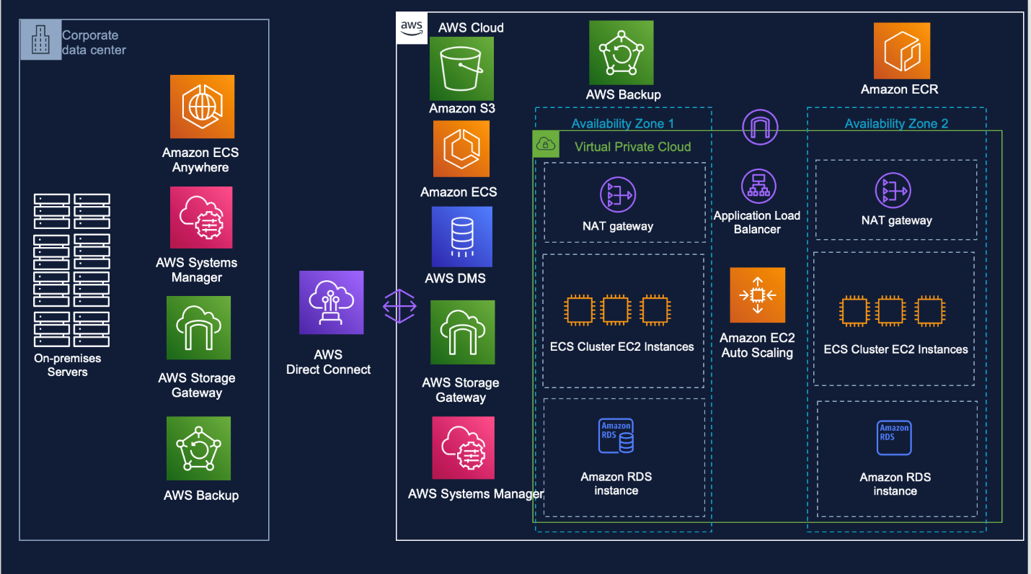

#### Disaster recovery

Morgan mentioned that because this week’s customer is an enterprise company, they could consider designing a disaster recovery (DR) plan for this workload.

The DR strategies that are available to you within AWS can be broadly categorized into four approaches, which range from the low cost and low complexity of making backups to more complex strategies that use multiple active Regions. Active/passive strategies use an active site (such as an AWS Region) to host the workload and serve traffic. The passive site (such as a different AWS Region) is used for recovery. The passive site doesn’t actively serve traffic until a failover event is triggered.

The following diagram outlines the different approaches to disaster recovery on AWS.

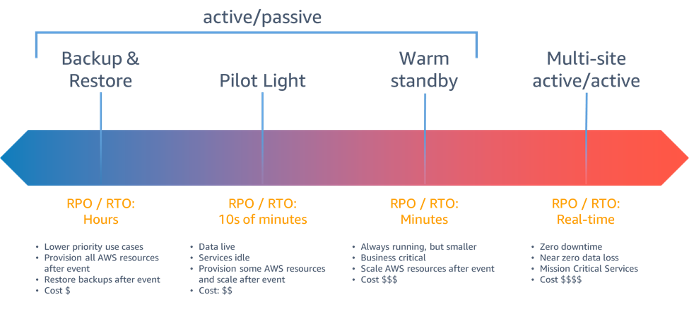

#### Backup and restore

Backup and restore is a suitable approach for mitigating against data loss or corruption. This approach can also be used to mitigate against a regional disaster by replicating data to other AWS Regions, or to mitigate a lack of redundancy for workloads that are deployed to a single Availability Zone. In addition to data, you must redeploy the infrastructure, configuration, and application code in the recovery Region. To enable infrastructure to be redeployed quickly without errors, you should always deploy by using infrastructure as code (IaC), with services such as AWS CloudFormation or the AWS Cloud Development Kit (AWS CDK). Without IaC, it might be complex to restore workloads in the recovery Region, which can lead to increased recovery times and possibly exceed your Recovery Time Objective (RTO). In addition to backing up your user data, back up your code and configurations—including [Amazon Machine Images (AMIs)](https://docs.aws.amazon.com/AWSEC2/latest/UserGuide/AMIs.html) that you use to create Amazon Elastic Compute Cloud (Amazon EC2) instances. You can use [AWS CodePipeline](http://aws.amazon.com/codepipeline) to automate the redeployment of your application code and configurations.

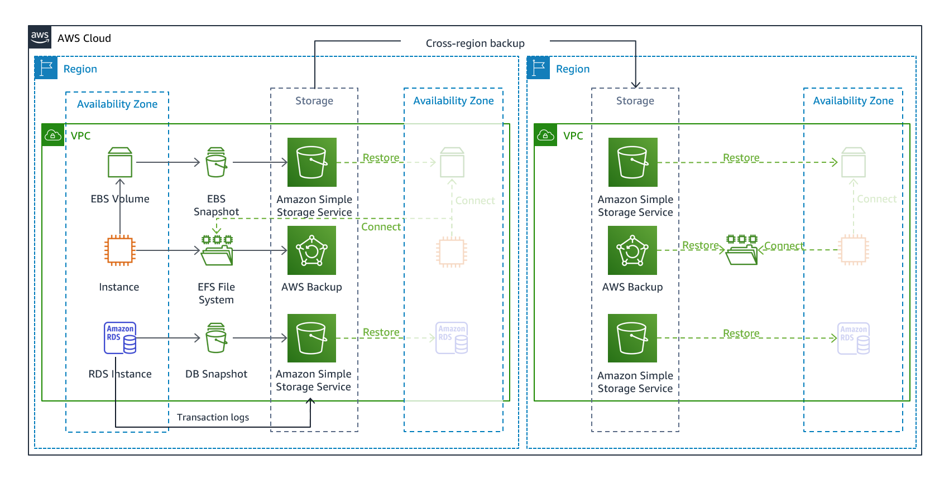

#### Pilot light

With the pilot light approach, you replicate your data from one Region to another, and you provision a copy of your core workload infrastructure. Resources that are needed to support data replication and backup—such as databases and object storage—are always on. Other elements (such as application servers) are loaded with application code and configurations, but are turned off. They are only used during testing or when DR failover is invoked. In the cloud, you have the flexibility to deprovision resources when you don’t need them, and provision them when you do. A best practice for a resource that’s turned off is to not deploy the resource, and then create the configuration and capabilities to deploy it (turn on) when needed. Unlike the backup and restore approach, your core infrastructure is always available. Thus, you always have the option to quickly provision a full scale production environment by turning on and scaling out your application servers.

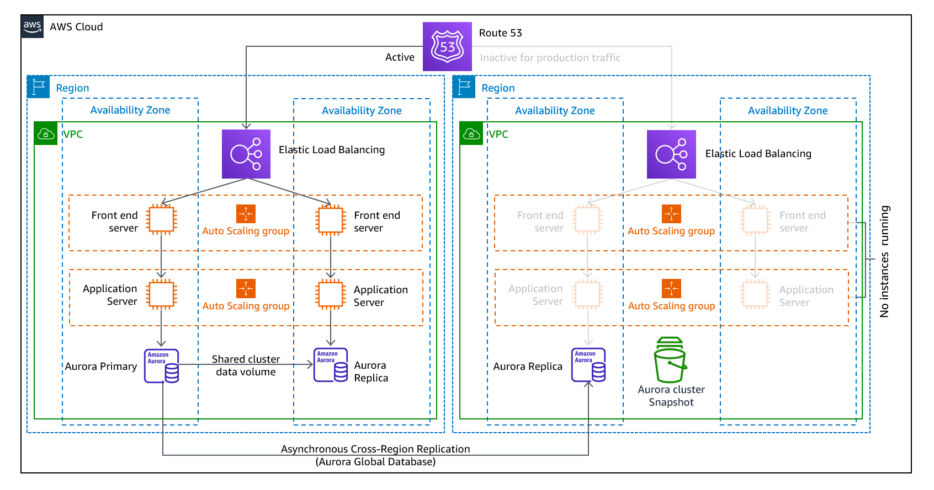

#### Warm standby

The warm standby approach involves provisioning a scaled down—but fully functional—copy of your production environment in another Region. This approach extends the pilot-light concept and decreases the time to recovery because your workload is always-on in another Region. With this approach, you can perform testing or implement continuous testing more easily, which can increase your confidence in your ability to recover from a disaster.

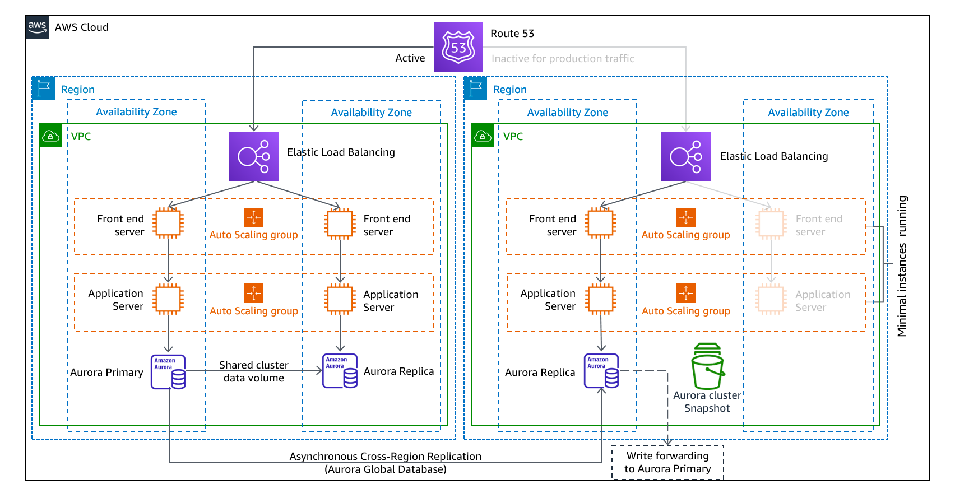

#### Multi-site active/active

You can run your workload simultaneously in multiple Regions as part of either a multi-site active/active strategy or a hot standby active/passive strategy. A multi-site active/active approach serves traffic from all Regions where it’s deployed. In contrast, hot standby approach serves traffic from only a single Region, and the other Regions are used only for DR. With a multi-site active/active approach, users can access your workload in any Regions where it’s deployed. This approach to DR is the most complex and most costly. However, it can reduce your recovery time to near zero for most disasters, with the correct technology choices and implementation. (Note that data corruption might need to rely on backups, which usually results in a non-zero recovery point.) Hot standby uses an active/passive configuration, where users are directed to only a single region and DR Regions don’t take traffic. Most customers find that if they’re going to stand up a full environment in the second Region, it makes sense to use it in an active/active approach. Alternatively, if you don’t want to use both Regions to handle user traffic, then warm standby offers an approach that’s more economical and operationally less complex.

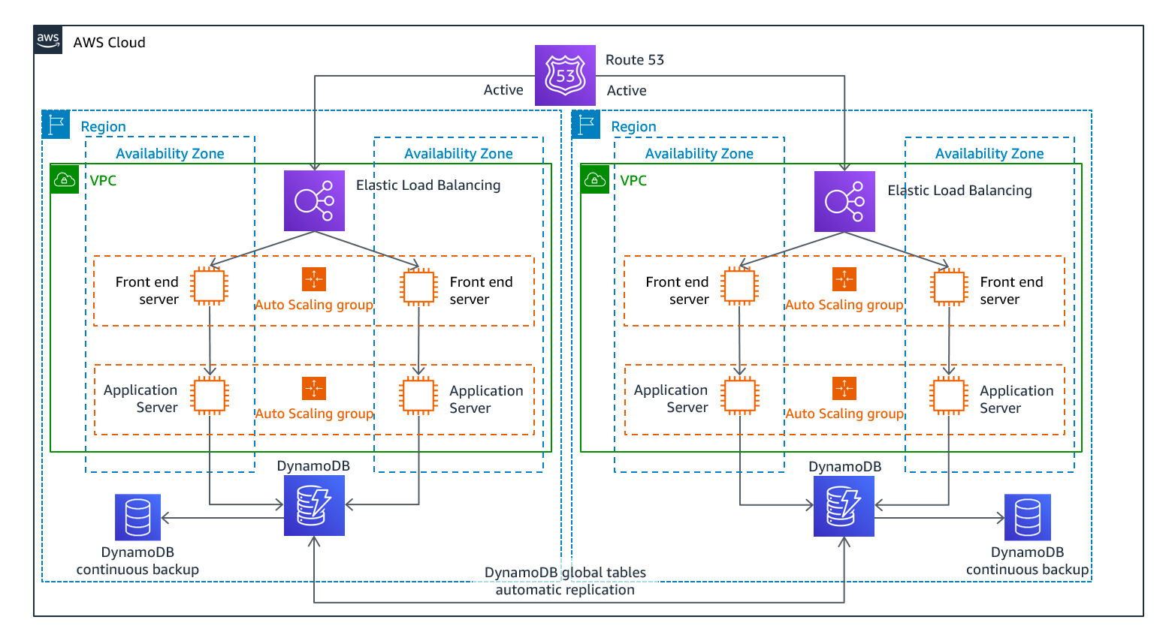

For more information about DR, see the [Disaster Recovery of Workloads on AWS: Recovery in the Cloud](https://docs.aws.amazon.com/whitepapers/latest/disaster-recovery-workloads-on-aws/disaster-recovery-workloads-on-aws.html) whitepaper.

#### AWS Direct Connect with AWS VPN for failover

Raf commented that to make the connection to AWS more resilient, the customer can consider using Amazon Site-to-Site VPN as a failover for AWS Direct Connect so that the connection is redundant. This setup would protect the customer if the AWS Direct Connect connection became unavailable. With this setup, the customer would be able to fail over to the virtual private network (VPN) connection and remain connected to their AWS resources.

For more information about how to set up Site-to-Site VPN as a failover for Direct Connect, see [How do I configure Direct Connect and VPN failover with Transit Gateway?](https://aws.amazon.com/premiumsupport/knowledge-center/dx-configure-dx-and-vpn-failover-tgw/)

#### Automatic scaling for containers

Morgan commented that this week’s customer needs to look into how they will scale their containers. When the customer uses Amazon Elastic Container Service (Amazon ECS), they will need to think about scaling both their underlying EC2 cluster and the containers themselves.

#### Scaling the cluster

Amazon ECS can manage the scaling of EC2 instances that are registered to your cluster. This capability is referred to as Amazon ECS cluster auto scaling, and is performed by an Amazon ECS Auto Scaling group capacity provider that has managed scaling turned on.

When you use an Auto Scaling group capacity provider with managed scaling, Amazon ECS creates two custom Amazon CloudWatch metrics, and a target tracking scaling policy that attaches to your Auto Scaling group. Amazon ECS then manages the scale-in and scale-out actions of the Auto Scaling group based on the load that your tasks put on your cluster.

#### Scaling the containers

Automatic scaling is the ability to increase or decrease the desired count of tasks in your Amazon ECS service automatically. Amazon ECS uses the Application Auto Scaling service to provide this functionality.

Your Amazon ECS service can be optionally configured automatically scale its desired count of tasks in your Amazon ECS service, either up or down, in response to CloudWatch alarms.Amazon ECS Service Auto Scaling supports the following types of scaling policies:

* Target tracking scaling policies (Recommended): Increase or decrease the number of tasks that your service runs, based on a target value for a specific metric. This scaling approach is similar to the way that your thermostat maintains the temperature of your home. You select the temperature, and the thermostat manages the temperature.
* Step scaling policies: Increase or decrease the number of tasks that your service runs, based on a set of scaling adjustments, which are also known as step adjustments. These adjustments vary based on the size of the alarm breach.

For more resources about automatic scaling and Amazon ECS, see the following:

* For more information about how to scale an ECS cluster, see [Amazon ECS cluster Auto Scaling](https://docs.aws.amazon.com/AmazonECS/latest/developerguide/cluster-auto-scaling.html).
* For a hands-on tutorial about how to scale an ECS cluster, see the [Amazon ECS Workshop: Deploy ECS Cluster Auto Scaling](https://ecsworkshop.com/capacity_providers/ec2/).
* For more information about service auto scaling, see [Service auto scaling](https://docs.aws.amazon.com/AmazonECS/latest/developerguide/service-auto-scaling.html) in the Amazon ECS Developer Guide.

#### Automatic scaling for Amazon RDS

Morgan commented that this week’s customer should look into RDS storage autoscaling.

When you enable storage autoscaling, Amazon RDS automatically scales up your storage when it detects that you are running out of free database space.

If your workload is unpredictable, you can enable storage autoscaling for an RDS DB instance. To do so, you can use the Amazon RDS console, the Amazon RDS API, or the AWS Command Line Interface (AWS CLI).

For more information about Amazon RDS storage autoscaling, see [Managing capacity automatically with Amazon RDS storage autoscaling.](https://docs.aws.amazon.com/AmazonRDS/latest/UserGuide/USER_PIOPS.StorageTypes.html#USER_PIOPS.Autoscaling)

#### Amazon S3 Intelligent-Tiering

Raf commented that this customer could also optimize for cost by using S3 Intelligent-Tiering on the S3 bucket where their data is being stored.

S3 Intelligent-Tiering is the only cloud storage class that delivers automatic storage cost savings when data access patterns change, thus reducing performance impact or operational overhead. The Amazon S3 Intelligent-Tiering storage class is designed to optimize storage costs by automatically moving data to the most cost-effective access tier when access patterns change. For a small monthly object monitoring and automation charge, S3 Intelligent-Tiering monitors access patterns and automatically moves objects that haven’t been accessed to lower-cost access tiers.

S3 Intelligent-Tiering is a good storage class for data with unknown, changing, or unpredictable access patterns—independent of object size or retention period. You can use S3 Intelligent-Tiering as the default storage class for virtually any workload, especially data lakes, data analytics, new applications, and user-generated content.

For more information about S3 Intelligent-Tiering, see [Amazon S3 Intelligent-Tiering storage class](https://aws.amazon.com/s3/storage-classes/intelligent-tiering/).

## Week4: Designing a solution following account governance and management best practices

### Multi-Account Strategies

This week’s customer is currently operating everything for all the clients that they support out of one AWS account. This situation isn’t ideal for a company that wants to organize and scale their usage of AWS as their usage grows.

The practice of using multiple accounts has many advantages. To summarize, you can group workloads based on business purposes and ownership, centralize logging, and constrain access to sensitive data. You can also limit the scope of impact from adverse events, manage costs better, and distribute AWS service quotas and API request rate limits.

Businesses that are starting to adopt AWS, expanding their footprint on AWS, or planning to enhance an established AWS environment need to ensure they have a [foundation on AWS](https://docs.aws.amazon.com/whitepapers/latest/establishing-your-cloud-foundation-on-aws/welcome.html) for their cloud environment. One important aspect of their foundation is to organize their AWS environment by following a multi-account strategy.

By using multiple AWS accounts to help isolate and manage your business applications and data, you can optimize across most of the [AWS Well-Architected Framework](http://aws.amazon.com/architecture/well-architected/) pillars—including operational excellence, security, reliability, and cost optimization.

#### Group workloads based on business purpose and ownership

You can group workloads with a common business purpose into distinct accounts. As a result, you can align the ownership and decision-making of those accounts. You can also avoid dependencies and conflicts with how workloads in other accounts are secured and managed.

Different business units or product teams might have different processes. Depending on your overall business model, you might choose to isolate distinct business units or subsidiaries in different accounts. By isolating business units, they can operate with greater decentralized control—while still retaining the ability to provide overarching guardrails. This approach might also ease divestment of those units over time.

Guardrails are governance rules for security, operations, and compliance that you can define and apply to align with your overall requirements.

If you acquire a business that already operates in AWS, you can move the associated accounts into your existing organization intact. This movement of accounts can be an initial step toward integrating acquired services into your standard account structure.

#### Apply distinct security controls by environment

Workloads often have distinct security profiles that require separate control policies and mechanisms to support them. For example, it’s common to apply different policies for security and operations to the non-production and production environments of a given workload. If you use separate accounts for the non-production and production environments, the resources and data that make up a workload environment are separated from other environments and workloads by default.

#### Constrain access to sensitive data

When you limit sensitive data stores to an account that is built to manage it, you can more easily constrain the number of people and processes that can access and manage the data store. This approach simplifies the process of achieving least-privilege access. Limiting access at the coarse-grained level of an account helps contain exposure to highly sensitive data.

For example, by designating a set of accounts to house publicly accessible Amazon Simple Storage Service (Amazon S3) buckets, you can implement policies that expressly forbid all other accounts from making S3 buckets publicly available.

#### Promote innovation and agility

At AWS, we refer to your technologists as [builders](http://aws.amazon.com/campaigns/build-on-aws/) because they’re responsible for building value by using AWS products and services. Your builders might represent diverse roles, such as application developers, data engineers, data scientists, data analysts, security engineers, and infrastructure engineers.

In the early stages of a workload’s lifecycle, you can help promote innovation by providing your builders with separate accounts in support of experimentation, development, and early testing. These environments often provide greater freedom than more tightly controlled production-like test and production environments. They do so by providing broader access to AWS services while also using guardrails that help prohibit access to (and the use of) sensitive and internal data.

* Sandboxaccounts: Typically disconnected from your enterprise services and don’t provide access to your internal data. However, they offer the greatest freedom for experimentation.
* Developmentaccounts: Typically provide limited access to your enterprise services and development data. However, they can more readily support day-to-day experimentation with your enterprise-approved AWS services, formal development, and early testing work.

In both cases, we recommend security guardrails and cost budgets so that you limit risks and proactively manage costs.

You can support later stages of the workload lifecycle by using distinct test and production accounts for workloads or groups of related workloads. By having an environment for each set of workloads, owning teams can move faster by reducing dependencies on other teams and workloads, and by also minimizing the impact of changes.

#### Limit scope of impact from adverse events

An AWS account applies boundaries for security, access, and billing boundaries to your AWS resources. These boundaries can help you achieve the independence and isolation of resources. By design, all resources that are provisioned within an account are logically isolated from resources that are provisioned in other accounts—even within your own AWS environment.

This isolation boundary provides a way to limit the risks of an application-related issue, misconfiguration, or malicious actions. If an issue occurs within one account, impacts to workloads contained in other accounts can be either reduced or eliminated.

#### Support multiple IT operating models

Organizations often have multiple IT operating models, or ways that they divide responsibilities among parts of the organization to deliver their application workloads and platform capabilities. The following diagram shows three example operating models:

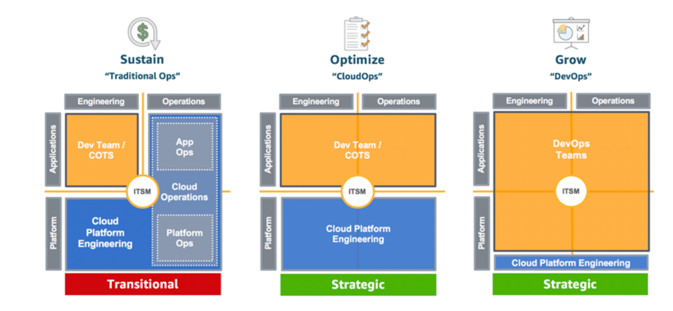

#### ****Example operating models****

In the Traditional Ops model, teams who own custom and commercial off-the-shelf (COTS) applications are responsible for engineering their applications, but not for their production operations. A cloud platform engineering team is responsible for engineering the underlying platform capabilities. A separate cloud operations team is responsible for the operations of both applications and platform.

In the CloudOps model, application teams are also responsible for production operations of their applications. In this model, a common cloud platform engineering team is responsible for both the engineering and operations of the underlying platform capabilities.

In the DevOps model, the application teams take on the additional responsibilities of engineering and operating platform capabilities that are specific to their applications. A cloud platform engineering team is responsible for the engineering and operations of shared platform capabilities that are used by multiple applications.

As a practice, IT Service Management (ITSM) is a common element across all of the models. Your overall goals and requirements for ITSM might not change across these models. However, the responsible individuals and solutions for meeting those goals and requirements can vary, depending on the model.

Given the implications of centralized operations versus more distributed operational responsibilities, you might benefit from establishing separate groups of accounts in support of different operating models. By using separate accounts, you can apply distinct governance and operational controls that are appropriate for each of your operating models.

#### Manage costs

An account is the default way that AWS costs are allocated. By using different accounts for different business units and groups of workloads, you can more easily report, control, forecast, and budget your cloud expenditures.

In addition to cost reporting at the account level, AWS has built-in support to consolidate and report costs across your entire set of accounts. When you require fine-grained cost allocation, you can apply cost allocation tags to individual resources in each of your accounts.

#### Distribute AWS service quotas and API request rate limits

AWS service quotas (also known as limits) are the maximum number of service resources or operations that apply to an account. For example, a service quota could be the number of S3 buckets that you can create for each account.

You can use the Service Quotas service to help protect you from unexpected or excessive provisioning of AWS resources, and from malicious actions that could dramatically impact your AWS costs.

AWS services can also throttle (or limit) the rate of requests that are made to their API operations.

Because service quotas and request rate limits are allocated for each account, use separate accounts for workloads to help distribute the potential impact of the quotas and limits.

For more information about multi-account strategies, see the following:

* For more information about building cloud foundations, see the [Establishing Your Cloud Foundation on AWS](https://docs.aws.amazon.com/whitepapers/latest/establishing-your-cloud-foundation-on-aws/welcome.html) whitepaper.
* For more information about organizing AWS accounts, see the [Organizing Your AWS Environment Using Multiple Accounts](https://docs.aws.amazon.com/whitepapers/latest/organizing-your-aws-environment/organizing-your-aws-environment.html) whitepaper.

### IAM Roles, Trust Relationships, and Permissions

This week, Raf suggested that the customer use AWS Identity and Access Management (IAM) roles to support the multi-account strategy. He suggested using IAM roles to facilitate cross-account access for the other accounts that are used in this solution. The roles provide cross-account access without needing to create static credentials for each account, such as IAM users.

#### IAM roles

An IAM role is an identity that you can create in your account, and it has specific permissions. An IAM role has some similarities to an IAM user. Roles and users are both AWS identities with permissions policies that determine what the identity can or can’t do in AWS. However, instead of being uniquely associated with one person, a role can be assumed by anyone who needs it. Also, a role doesn’t have standard long-term credentials (such as a password or access keys) associated with it. Instead, when you assume a role, it provides you with temporary security credentials for your role session.Roles can be used by the following entities:

* An IAM user in the same AWS account as the role
* An IAM user in a different AWS account than the role
* An AWS service, such as Amazon Elastic Compute Cloud (Amazon EC2)
* An external user who was authenticated by an external identity provider (IdP) service that’s compatible with Security Assertion Markup Language (SAML) 2.0, OpenID Connect (OIDC), or a custom-built identity broker.

When you work with AWS, you should also be familiar with the following terms, which are related to IAM roles.

#### ****AWS service role****

An AWS service role is a role that a service assumes to perform actions in your account on your behalf. When you set up some AWS service environments, you must define a role for the service to assume. This service role must include all the permissions that the service needs to access the AWS resources that it must work with. Service roles vary from service to service, but many allow you to choose your permissions if you meet the documented requirements for that service. You can create, modify, and delete a service role from within IAM.

#### ****AWS service-linked role****

An AWS service-linked role is a unique type of service role that’s linked directly to an AWS service. Service-linked roles are predefined by the service, and they include all permissions that the service needs to call other AWS services on your behalf. The linked service also defines how you create, modify, and delete a service-linked role. A service might automatically create or delete the role. It might allow you to create, modify, or delete the role as part of a wizard or process in the service. Or it might require you to use IAM to create or delete the role. Regardless of the method, service-linked roles make setting up a service easier because you don't need to manually add the necessary permissions.

#### ****Delegation****

Delegation is the granting of permissions to someone to allow access to resources that you control. Delegation involves setting up a trust between two accounts. The first account is the account that owns the resource (the trusting account). The second account is the account that contains the users that need to access the resource (the trusted account). The trusted and trusting accounts can be any of the following:

* The same account
* Separate accounts that are both under your organization's control
* Two accounts owned by different organizations

To delegate permissions to access a resource, you create an IAM role in the trusting account that has two [policies](https://docs.aws.amazon.com/IAM/latest/UserGuide/id_roles_terms-and-concepts.html#term_policy) attached. The permissions policy grants the user of the role the needed permissions to carry out the intended tasks on the resource. The trust policy specifies which trusted account members are allowed to assume the role.

When you create a trust policy, you can’t specify a wildcard (*) as a principal.

The trust policy is attached to the role in the trusting account, and comprises half of the permissions. The other half is a permissions policy that’s attached to the user in the trusted account. The permissions policy allows that user to switch to (or assume) the role. A user who assumes a role temporarily gives up his or her own permissions, and instead takes on the role’s permissions. When the user exits (or stops using) the role, their original user permissions are restored. An additional parameter that’s called external ID can help ensure the secure use of roles between accounts that are not controlled by the same organization.

#### ****Federation****

Federation is the creation of a trust relationship between an external IdP and AWS. Users can sign in to a web identity provider, such as Login with Amazon, Facebook, Google, or any IdP that is compatible with OIDC. Users can also sign in to an enterprise identity system that’s compatible with SAML 2.0, such as Microsoft Active Directory Federation Services. When you use OIDC and SAML 2.0 to configure a trust relationship between these external IdPs and AWS, the user is assigned to an IAM role. The user also receives temporary credentials that allow the user to access your AWS resources.

#### ****Federated user****

Instead of creating an IAM user, you can use existing identities from AWS Directory Service, your enterprise user directory, or a web identity provider. These identities are known as federated users. AWS assigns a role to a federated user when access is requested through an identity provider.

#### ****Trust policy****

A trust policy is a JSON policy document where you define the principals that you trust to assume the role. A role trust policy is a required, resource-based policy that’s attached to a role in IAM. The principals that you can specify in the trust policy include users, roles, accounts, and services.

#### ****Permissions boundary****

A permissions boundary is an advanced feature where you use policies to limit the maximum permissions that an identity-based policy can grant to a role. You can’t apply a permissions boundary to a service-linked role.

#### ****Principal****

A principal is an entity in AWS that can perform actions and access resources. A principal can be an AWS account root user, an IAM user, or a role.

For more information, see [Roles terms and concepts.](https://docs.aws.amazon.com/IAM/latest/UserGuide/id_roles_terms-and-concepts.html)

### AWS IAM Identity Center

Raf suggested that this week’s customer use AWS IAM Identity Center (successor to AWS Single Sign-On) to manage single sign-on (SSO) for their AWS accounts. By doing so, the customer can use one place for workforce user and group access, and one place to manage AWS account access. AWS IAM Identity Center helps you securely create or connect your workforce identities and manage their access centrally across AWS accounts and applications. IAM Identity Center is the recommended approach for workforce authentication and authorization on AWS for organizations of any size and type.

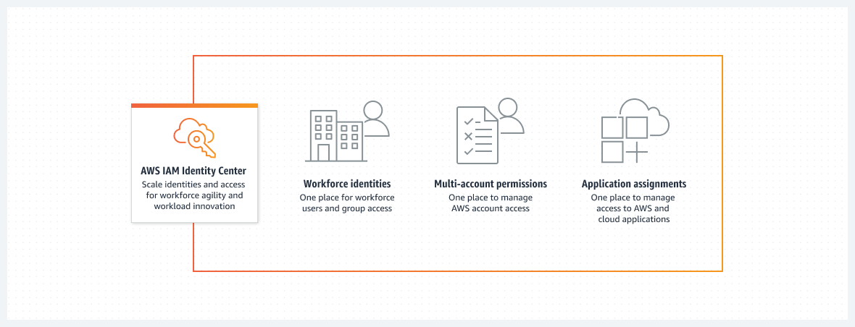

#### IAM Identity Center features

IAM Identity Center includes the following core features:

#### ****Workforce identities****

Human users who are members of your organization are also known as workforce identities or workforce users. You can create workforce users and groups in IAM Identity Center. You can also connect and synchronize to an existing set of users and groups in your own identity source for use across all your AWS accounts and applications. Supported identity sources include Microsoft Active Directory Domain Services, and external identity providers such as Okta Universal Directory or Microsoft Azure AD.

#### ****Application assignments for SAML applications****

With application assignments, you can grant your workforce users in IAM Identity Center SSO access to Security Assertion Markup Language (SAML) 2.0 applications, such as Salesforce and Microsoft 365. Your users can access these applications in a single place, without the need for you to set up federation separately.

#### ****Identity Center enabled applications****

AWS applications and services—such as Amazon Managed Grafana, Amazon Monitron, and Amazon SageMaker Studio Notebooks—discover and connect to IAM Identity Center automatically to receive sign-in and user directory services. This feature provides users with a consistent SSO experience for these applications, with no additional application configuration. Because the applications share a common view of users, groups, and group membership, users can also have a consistent experience when they share application resources with others.

#### ****Multi-account permissions****

With multi-account permissions, you can plan for and centrally implement IAM permissions across multiple AWS accounts at one time, without the need for you to configure each of your accounts manually. You can create fine-grained permissions based on common job functions, or define custom permissions that meet your security needs. You can then assign those permissions to workforce users to control their access over specific accounts.

#### ****AWS access portal****

The AWS access portal provides your workforce users with one-click access to all their assigned AWS accounts and cloud applications through a web portal. For more information, see [What is IAM Identity Center?](https://docs.aws.amazon.com/singlesignon/latest/userguide/what-is.html)

### Logging Services

Multiple AWS services do infrastructure logging, and you should be familiar with them: AWS CloudTrail, AWS Config, VPC Flow Logs, and Amazon GuardDuty. Raf recommended that the customer configure CloudTrail to concentrate data in the AWS Organizations management account, thus following best practices for account governance.

#### AWS CloudTrail

CloudTrail monitors and records account activity across your AWS infrastructure, which gives you control over actions for storage, analysis, and remediation. Events include actions that are performed in the AWS Management Console, the AWS Command Line Interface (AWS CLI), and the AWS SDKs and APIs. The actions recorded by CloudTrail don’t include API calls that are made to a backend application that’s hosted on Amazon Elastic Compute Cloud (Amazon EC2). They also don’t include internal API calls that are made within an application, and don’t involve AWS API calls. CloudTrail captures AWS API call events and logs them.

CloudTrail typically delivers logs within an average of about 15 minutes after an API call. (This time is not guaranteed.)

By using CloudTrail, a user in an Organizations management account can create an organization trail that logs all events for all AWS accounts in that organization. Organization trails are automatically applied to all member accounts in the organization. Member accounts can see the organization trail, but they can't modify or delete the organization trail. By default, member accounts don't have access to the log files for the organization trail in the Amazon Simple Storage Service (Amazon S3) bucket. This feature helps you uniformly apply and enforce your event-logging strategy across the accounts in your organization.

For more information about CloudTrail, see [How CloudTrail works](https://docs.aws.amazon.com/awscloudtrail/latest/userguide/how-cloudtrail-works.html).

#### AWS Config

It’s important to know the difference between AWS CloudTrail and AWS Config.

When you run your applications on AWS, you usually use AWS resources, which you must create and manage collectively. As the demand for your application grows, our need to keep track of your AWS resources also grows. AWS Config is designed to help you manage your application resources.

AWS Config provides a detailed view of how AWS resources are configured in your AWS account. This configuration includes how resources are related to one another, and how they were configured in the past—which means that you can see how the configurations and relationships change over time. You can use AWS Config to get an inventory of the resources that you have in your AWS account, and then you can apply rules for how those resources are configured.

An AWS resource is an entity that you can work with in AWS, such as an EC2 instance, an Amazon Elastic Block Store (EBS) volume, a security group, or a virtual private cloud (VPC).

#### Resource administration

To exercise better governance over your resource configurations—and to detect resource misconfigurations—you need fine-grained visibility into what resources exist, and how these resources are configured at any time. You can use AWS Config to notify you when resources are created, modified, or deleted without needing to monitor these changes by polling the calls made to each resource.

You can use AWS Config rules to evaluate the configuration settings of your AWS resources. When AWS Config detects that a resource violates the conditions in one of your rules, AWS Config flags the resource as noncompliant and sends a notification. AWS Config is designed to continuously evaluate your resources as they are created, changed, or deleted.

#### Auditing and compliance

You might work with data that requires frequent audits to ensure compliance with internal policies and best practices. To demonstrate compliance, you need access to the historical configurations of your resources. AWS Config can provide this information.

#### Managing and troubleshooting configuration changes

When you use multiple AWS resources that depend on one another, a change in the configuration of one resource might have unintended consequences on related resources. With AWS Config, you can view how the resource that you want to modify is related to other resources, and thus assess the potential impact of your change.

You can also use the historical configurations of your resources that are provided by AWS Config to troubleshoot issues and to access the last-known good configuration of a problem resource.

#### Security analysis

To analyze potential security weaknesses, you need detailed historical information about your AWS resource configurations. Examples include the AWS Identity and Access Management (IAM) permissions that are granted to your users, or the Amazon EC2 security group rules that control access to your resources.

You can use AWS Config to view the IAM policy that was assigned to an IAM user, group, or role at any time when AWS Config was recording. This information can help you determine the permissions that belonged to a user at a specific time: for example, you can view whether the user John Doe had the permissions to modify Amazon Virtual Private Cloud (Amazon VPC) settings on Jan 1, 2015.

You can also use AWS Config to view the configuration of your Amazon security groups, including the port rules that were open at a specific time. This information can help you determine whether a security group blocked incoming TCP traffic to a specific port.

For more information, see [What is AWS Config?](https://docs.aws.amazon.com/config/latest/developerguide/WhatIsConfig.html)

#### VPC Flow Logs

VPC Flow Logs is a feature that you can use to capture information about the IP traffic that goes to and from network interfaces in your VPC. Flow log data can be published to Amazon CloudWatch Logs or Amazon S3. After you create a flow log, you can retrieve and view its data in the chosen destination.Flow logs can help you with various tasks, such as the following:

* Diagnosing overly restrictive security group rules
* Monitoring the traffic that reaches your instance
* Determining the direction of the traffic to and from the network interfaces

Flow log data is collected outside the path of your network traffic. Therefore, it doesn’t affect network throughput or latency. You can create or delete flow logs with a minimal risk of impact to network performance.

For more information, see [Logging IP traffic using VPC Flow Logs](https://docs.aws.amazon.com/vpc/latest/userguide/flow-logs.html).

#### Amazon GuardDuty

Amazon GuardDuty is a near-continuous security monitoring service that analyzes and processes data sources, such as CloudTrail data events for Amazon S3 logs, CloudTrail management event logs, DNS logs, Amazon EBS volume data, Amazon Elastic Kubernetes Service (Amazon EKS) audit logs, and Amazon VPC flow logs.

It uses threat intelligence feeds (such as lists of malicious IP addresses and domains) and machine learning to identify unexpected, potentially unauthorized, and malicious activity within your AWS environment. This activity can include issues such as the escalation of privileges, use of exposed credentials, communication with malicious IP addresses or domains, or the presence of malware on your EC2 instances and container workloads.

For example, GuardDuty can detect compromised EC2 instances and container workloads that are serving malware or mining bitcoin. It also monitors AWS account access behavior for signs of compromise, such as unauthorized infrastructure deployments—for example, instances that are deployed in a Region that has never been used, or unusual API calls (such as a password policy change to reduce password strength).

For more information, see [What is Amazon GuardDuty?](https://docs.aws.amazon.com/guardduty/latest/ug/what-is-guardduty.html)

### Automatic Account Provisioning

This week, Raf suggested that the customer automate as much as possible when they provision new AWS accounts and configure them for use. By using the AWS service stack, they would have a solution that creates new accounts with AWS Organizations, applies security guardrails with service control policies (SCPs), authenticates users into accounts with AWS IAM Identity Center (successor to AWS Single Sign-On), and has centralized logging through AWS CloudTrail. To configure newly created accounts, Raf suggested that the customer use AWS Control Tower, and use AWS Service Catalog to determine which portfolio of solutions is available in each account when they are configured.

#### AWS CloudFormation

The services that we covered in this course—such as AWS Control Tower and AWS Service Catalog—use AWS CloudFormation templates. CloudFormation is an infrastructure as code (IaC) service. It helps you model and set up your AWS resources so that you can spend less time managing those resources, and more time focusing on your applications that run in AWS.

With CloudFormation, you create a template that describes all the AWS resources that you want—such as Amazon Elastic Compute Cloud (Amazon EC2) instances or Amazon Relational Database Service (Amazon RDS) DB instances—and CloudFormation provisions and configures those resources for you. You don't need to individually create and configure AWS resources and determine what resource is dependent on what. Instead, CloudFormation handles provisioning and configuration.

When you work with AWS, you should be very familiar with CloudFormation and its features. It’s a best practice to deploy infrastructure in an automated way, instead of doing everything manually in the console.

For more resources about CloudFormation, see the following:

* For more information, see [What is AWS CloudFormation?](https://docs.aws.amazon.com/AWSCloudFormation/latest/UserGuide/Welcome.html)
* For a tutorial about how to use CloudFormation, see [Deploy a Reliable Multi-tier Infrastructure Using CloudFormation](https://www.wellarchitectedlabs.com/reliability/100_labs/100_deploy_cloudformation/).

#### AWS Control Tower

AWS Control Tower offers a straightforward way to set up and govern an AWS multi-account environment that follows prescriptive best practices. AWS Control Tower orchestrates the capabilities of several other [AWS services](https://docs.aws.amazon.com/controltower/latest/userguide/integrated-services.html)—including AWS Organizations, AWS Service Catalog, and IAM Identity Center—to build a landing zone in typically less than an hour. Resources are set up and managed on your behalf.

AWS Control Tower orchestration extends the capabilities of Organizations. To help protect your organizations and accounts from being affected by drift (or divergence from best practices), AWS Control Tower applies preventive and detective controls (or guardrails). For example, you can use guardrails to help ensure that security logs and necessary cross-account access permissions are created, but not altered.

If you host more than a handful of accounts, it’s beneficial to have an orchestration layer that facilitates account deployment and account governance. You can adopt AWS Control Tower as your primary way to provision accounts and infrastructure. With AWS Control Tower, you can more easily adhere to corporate standards, meet regulatory requirements, and follow best practices.

AWS Control Tower uses CloudFormation StackSets to set up resources in your accounts. Each stack set has stack instances that correspond to accounts, and to AWS Regions per account. AWS Control Tower deploys one stack set instance per account and Region.

For more information, see [What is AWS Control Tower?](https://docs.aws.amazon.com/controltower/latest/userguide/what-is-control-tower.html)

#### AWS Service Catalog

By using AWS Service Catalog, organizations can create and manage catalogs of IT services that are approved for AWS. These IT services can include virtual machine images, servers, software, databases, and more—they can even include complete, multi-tier application architectures.

Organizations can use AWS Service Catalog to centrally manage commonly deployed IT services. AWS Service Catalog is designed to help organizations achieve consistent governance and meet compliance requirements. End users can quickly deploy only the approved IT services that they need, and these deployments will follow the constraints that your organization sets.

AWS Service Catalog provides the following benefits:

* Standardization: Administer and manage approved assets by restricting where the product can be launched, the type of instance that can be used, and many other configuration options. The result is a standardized landscape for product provisioning for your entire organization.
* Self-service discovery and launch: Users browse listings of products (that is, services or applications) that they can access, locate the product that they want to use, and launch it on their own as a provisioned product.
* Fine-grained access control: Administrators assemble portfolios of products from their catalog, and add constraints and resource tags that will be used when the products are provisioned. Administrators then grant access to the portfolio through AWS Identity and Access Management (IAM) users and groups.
* Extensibility and version control: Administrators can add a product to different portfolios and restrict it without creating another copy. When the product is updated to a new version, the update is propagated to the product in every portfolio that references it.

For more information, see [What is AWS Service Catalog?](https://docs.aws.amazon.com/servicecatalog/latest/adminguide/introduction.html)

### Multi-Account Best Practices

Implementing multi-account best practices is an ongoing effort. The following links and references provide resources so that you can learn more about the subject. Remember that the goal of this course is not to dive deep into each approach. Instead, the goal of this course is to maintain knowledge at a Solutions Architect - Associate level by highlighting the services that are used for the most common approaches.

#### Multi-account environments

The AWS for Industries Blog includes a blog post called [Best Practices for AWS Organizations Service Control Policies in a Multi-Account Environment](https://aws.amazon.com/blogs/industries/best-practices-for-aws-organizations-service-control-policies-in-a-multi-account-environment/). This blog post talks about core concepts of AWS Organizations and service control policies (SCPs). It also provides suggestions about using different organizational unit (OU) structures for different use cases (such as a corporate OU, a production public-facing OU, a production internal-facing OU, and a security OU). At the end, you might have a complex structure that looks like the following diagram:

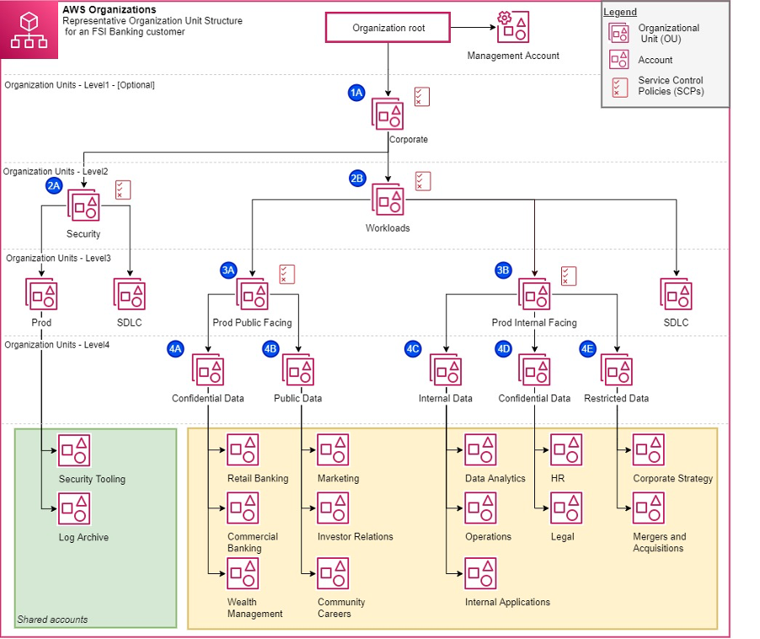

[Organizing Your AWS Environments Using Multiple Accounts](https://docs.aws.amazon.com/whitepapers/latest/organizing-your-aws-environment/organizing-your-aws-environment.html) is an AWS Whitepaper that was published on July 26, 2022. It talks about the AWS Well-Architected Framework and much of the content that you learned about in this course. It’s a good read! The AWS Organizations website also has another reference for further reading, called [Establishing your best practice AWS environment](https://aws.amazon.com/organizations/getting-started/best-practices/).

#### Tag policies and SCPs

With Organizations, you can set tag policies, in addition to defining SCPs. You can use tag policies to maintain standardized tags for AWS resources that are used with Organizations accounts. For example, the following example tag policy defines a tag with a key of Environment and a value of Production, and this tag is enforced for Amazon Elastic Compute Cloud (Amazon EC2) instances.

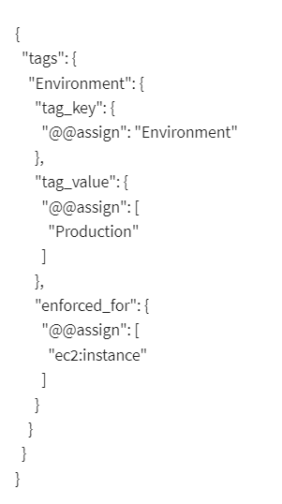{ "tags": { "Environment": { "tag_key": { "@@assign": "Environment" }, "tag_value": { "@@assign": [ "Production" ] }, "enforced_for": { "@@assign": [ "ec2:instance" ] } } } }

This tag policy prevents users from changing this tag on existing Amazon EC2 instances. However, it doesn't prevent a user from launching new instances with non-compliant tags, or no tags. This tag policy might be adequate if you use infrastructure as code (IaC) to provision environments. With IaC, environments will be created from a CloudFormation template, and you can thus embed the tags in the template. However, if you want to prevent the creation of new AWS resources that aren't tagged, you need to use SCPs. You could use the following example SCP to make sure that the AWS resources are created only if a certain tag is present. This SCP requires specific tags on specified created resources, and it uses explicit deny statements.

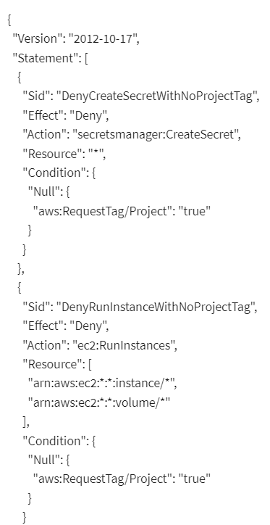

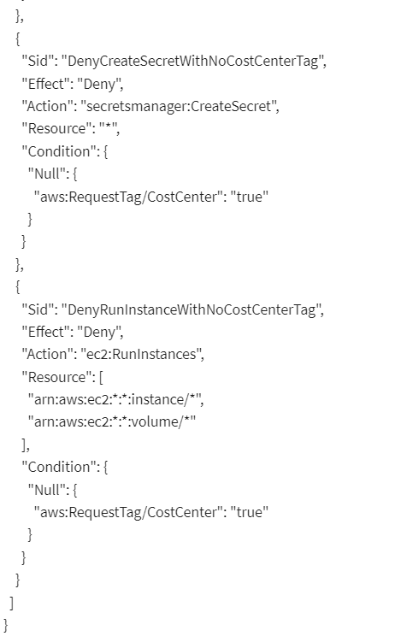

{ "Version": "2012-10-17", "Statement": [ { "Sid": "DenyCreateSecretWithNoProjectTag", "Effect": "Deny", "Action": "secretsmanager:CreateSecret", "Resource": "*", "Condition": { "Null": { "aws:RequestTag/Project": "true" } } }, { "Sid": "DenyRunInstanceWithNoProjectTag", "Effect": "Deny", "Action": "ec2:RunInstances", "Resource": [ "arn:aws:ec2:*:*:instance/*", "arn:aws:ec2:*:*:volume/*" ], "Condition": { "Null": { "aws:RequestTag/Project": "true" } } }, { "Sid": "DenyCreateSecretWithNoCostCenterTag", "Effect": "Deny", "Action": "secretsmanager:CreateSecret", "Resource": "*", "Condition": { "Null": { "aws:RequestTag/CostCenter": "true" } } }, { "Sid": "DenyRunInstanceWithNoCostCenterTag", "Effect": "Deny", "Action": "ec2:RunInstances", "Resource": [ "arn:aws:ec2:*:*:instance/*", "arn:aws:ec2:*:*:volume/*" ], "Condition": { "Null": { "aws:RequestTag/CostCenter": "true" } } } ] }

Do you see how SCPs and tag policies can—and should—be used together? For more information, see [Require a tag on specified created resources](https://docs.aws.amazon.com/organizations/latest/userguide/orgs_manage_policies_scps_examples_tagging.html#example-require-tag-on-create) in the AWS Organizations User Guide.

# Course 3: Introduction to Designing Data Lake on AWS

## Week 1

### Data Lake Characteristics and Components

#### ****What is a Data Lake?****

A data lake is a centralized repository that allows you to store all your structured and unstructured data at any scale. You can store your data as-is, without having to first structure the data, and run different types of analytics—from dashboards and visualizations to big data processing, real-time analytics, and machine learning to guide better decisions. The architecture of data lakes has four components: ingestion and storage mechanisms, data catalog and search options, a processing layer, and protection and security.

More info: <https://aws.amazon.com/big-data/datalakes-and-analytics/what-is-a-data-lake/>

#### ****Why do you need a data lake?****

Organizations that successfully generate business value from their data, will outperform their peers. An Aberdeen survey saw organizations who implemented a Data Lake outperforming similar companies by 9% in organic revenue growth. These leaders were able to do new types of analytics like machine learning over new sources like log files, data from click-streams, social media, and internet connected devices stored in the data lake. This helped them to identify, and act upon opportunities for business growth faster by attracting and retaining customers, boosting productivity, proactively maintaining devices, and making informed decisions.

#### ****Data Lakes and Analytics on AWS****

Customers leverage AWS Analytics as the fastest way to get answers from all of their data to all their users. The breadth and depth of analytics services on AWS makes it easy to spin up the right resources to run whatever analysis is most appropriate for a specific need. Deep integration between all the layers of the AWS analytics stack gives builders the tools to quickly analyze data using any approach.

More info: <https://aws.amazon.com/big-data/datalakes-and-analytics/>

#### ****Building Big Data Storage Solutions (Data Lakes) for Maximum Flexibility****

Organizations are collecting and analyzing increasing amounts of data making it difficult for traditional on-premises solutions for data storage, data management, and analytics to keep pace. Amazon S3 and S3 Glacier provide an ideal storage solution for data lakes. They provide options such as a breadth and depth of integration with traditional big data analytics tools as well as innovative query-in-place analytics tools that help you eliminate costly and complex extract, transform, and load processes. This guide explains each of these options and provides best practices for building your Amazon S3-based data lake.

More info: <https://docs.aws.amazon.com/whitepapers/latest/building-data-lakes/building-data-lake-aws.html>

#### ****AWS Analytics Newsletter****

Want to stay in the loop on product launches, upcoming events, and other innovations from [AWS Analytics](https://aws.amazon.com/big-data/datalakes-and-analytics/)? Subscribe to the monthly Analytics newsletter. Easily unsubscribe at any time if you want!

More info: <https://pages.awscloud.com/Subscribe-to-the-Analytics-Newsletter.html>

### Data Lakes and Data Warehouses

#### ****Data Lakes compared to Data Warehouses – Two Different Approaches****

Depending on the requirements, a typical organization will require both a data warehouse and a data lake as they serve different needs, and use cases.

A data warehouse is a database optimized to analyze relational data coming from transactional systems and line of business applications. The data structure, and schema are defined in advance to optimize for fast SQL queries, where the results are typically used for operational reporting and analysis. Data is cleaned, enriched, and transformed so it can act as the “single source of truth” that users can trust.

A data lake is different, because it stores relational data from line of business applications, and non-relational data from mobile apps, IoT devices, and social media. The structure of the data or schema is not defined when data is captured. This means you can store all of your data without careful design or the need to know what questions you might need answers for in the future. Different types of analytics on your data like SQL queries, big data analytics, full text search, real-time analytics, and machine learning can be used to uncover insights.

As organizations with data warehouses see the benefits of data lakes, they are evolving their warehouse to include data lakes, and enable diverse query capabilities, data science use-cases, and advanced capabilities for discovering new information models. Gartner names this evolution the “Data Management Solution for Analytics” or “DMSA.”

#### ****Data warehouse vs. Data lake****

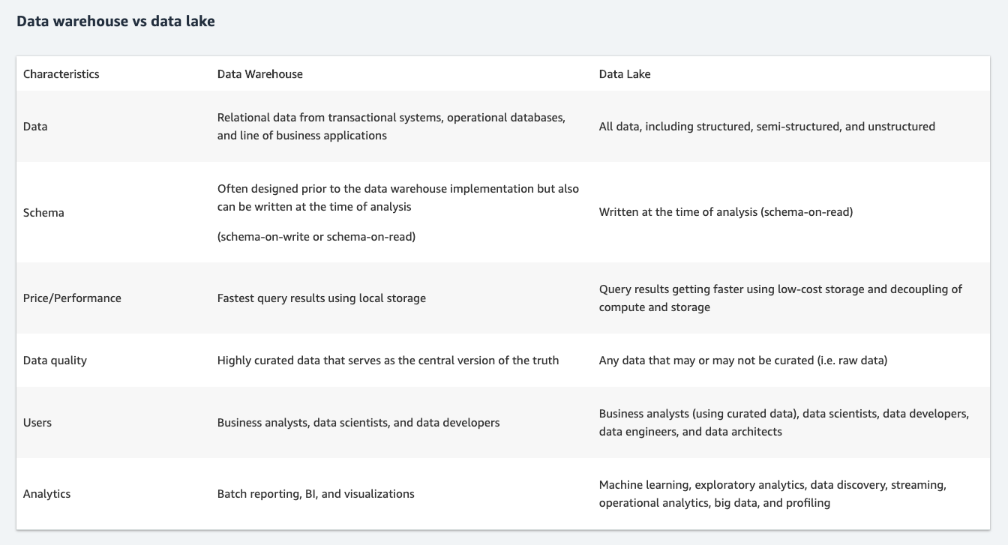

#### ****Data Warehouse vs. Database****

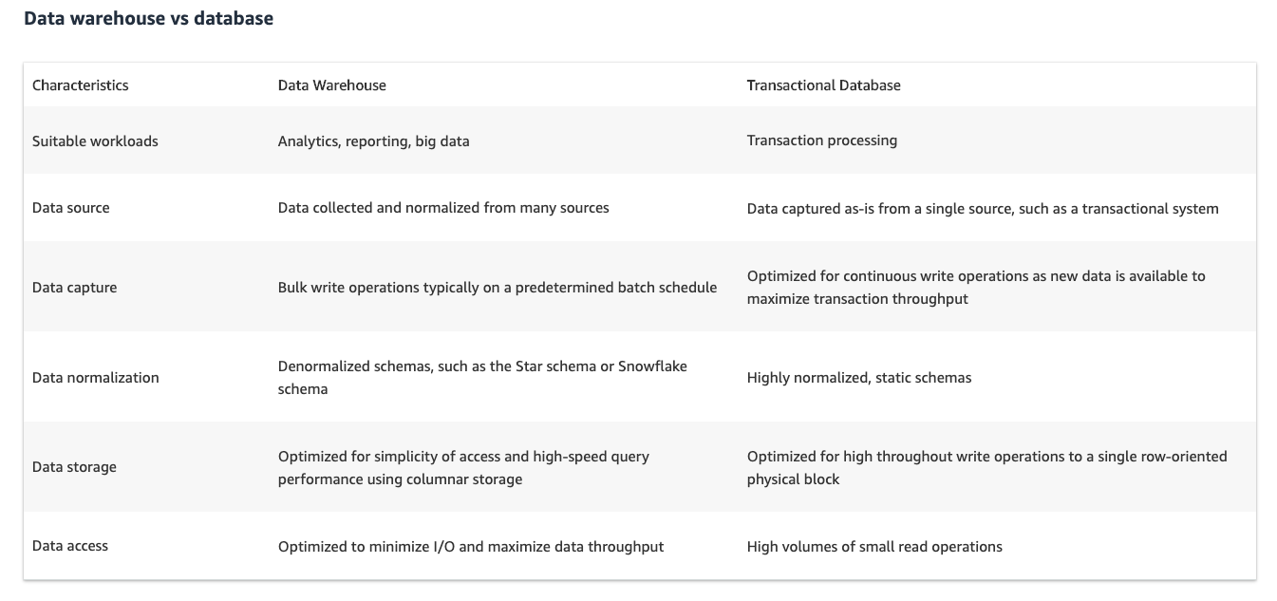

**More information on Data Lake and Data Warehouses can be found at:**

Data Lake vs. Data Warehouse - Snowflake - <https://www.snowflake.com/trending/data-lake-vs-data-warehouse>

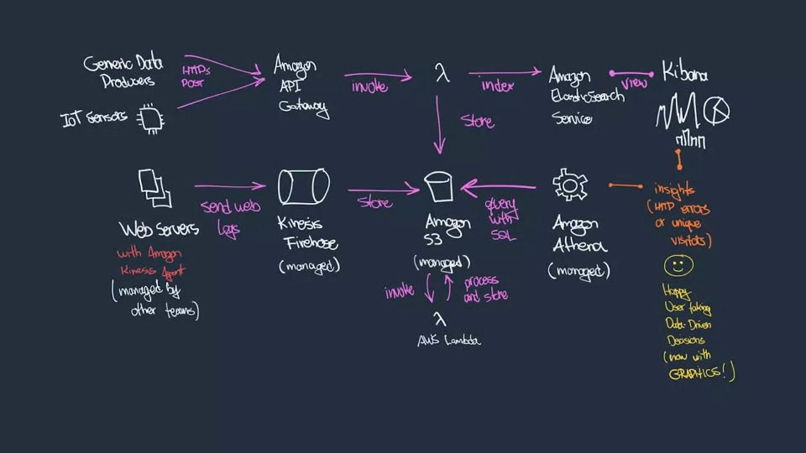

### Amazon S3 and Glue Data Catalog

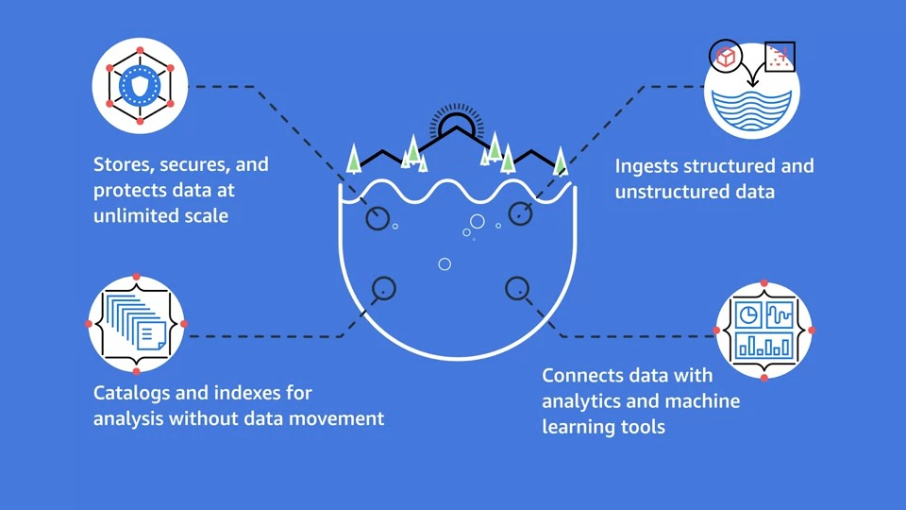

#### ****Amazon S3****

S3 and S3 Glacier are the preferred AWS services for the storage layer for your data lake. S3 is a service where the underlying infrastructure hosting the service is managed for you. if you upload an object to S3, the likelihood that that object would be corrupted or lost over time is incredibly low.

Amazon Simple Storage Service is storage for the Internet. It is designed to make web-scale computing easier for developers.

Amazon S3 has a simple web services interface that you can use to store and retrieve any amount of data, at any time, from anywhere on the web. It gives any developer access to the same highly scalable, reliable, fast, inexpensive data storage infrastructure that Amazon uses to run its own global network of web sites. The service aims to maximize benefits of scale and to pass those benefits on to developers.

Amazon S3 is the largest and most performant object storage service for structured and unstructured data and the storage service of choice to build a data lake. With Amazon S3, you can cost-effectively build and scale a data lake of any size in a secure environment where data is protected by 99.999999999% (11 9s) of durability.

Read more about Amazon S3 and data lakes here: <https://aws.amazon.com/products/storage/data-lake-storage/>

#### ****Amazon S3 Storage Classes****

For performance-sensitive use cases (those that require millisecond access time) and frequently accessed data, Amazon S3 provides the following storage classes: **S3 Standard**—The default storage class. If you don't specify the storage class when you upload an object, Amazon S3 assigns the S3 Standard storage class. **Reduced Redundancy**—The Reduced Redundancy Storage (RRS) storage class is designed for noncritical, reproducible data that can be stored with less redundancy than the S3 Standard storage class.

The **S3 Standard-IA** and **S3 One Zone-IA** storage classes are designed for long-lived and infrequently accessed data. (IA stands for infrequent access.) S3 Standard-IA and S3 One Zone-IA objects are available for millisecond access (same as the S3 Standard storage class). Amazon S3 charges a retrieval fee for these objects, so they are most suitable for infrequently accessed data.

The **S3 Glacier** and **S3 Glacier Deep Archive** storage classes are designed for low-cost data archiving. These storage classes offer the same durability and resiliency as the S3 Standard storage class.

The **S3 Intelligent-Tiering** storage class is designed to optimize storage costs by automatically moving data to the most cost-effective storage access tier, without performance impact or operational overhead. S3 Intelligent-Tiering delivers automatic cost savings by moving data on a granular object level between two access tiers, a frequent access tier and a lower-cost infrequent access tier, when access patterns change. The Intelligent-Tiering storage class is ideal if you want to optimize storage costs automatically for long-lived data when access patterns are unknown or unpredictable.

Read more about storage classes here: <https://docs.aws.amazon.com/AmazonS3/latest/dev/storage-class-intro.html>

### Data Movement

#### ****Data Movement****

Data Lakes allow you to import any amount of data that can come in real-time. Data is collected from multiple sources, and moved into the data lake in its original format. This process allows you to scale to data of any size, while saving time of defining data structures, schema, and transformations.

Read more about data lakes on AWS here: <https://aws.amazon.com/big-data/datalakes-and-analytics/><https://aws.amazon.com/big-data/datalakes-and-analytics/what-is-a-data-lake/>

#### ****Amazon Kinesis****

Amazon Kinesis makes it easy to collect, process, and analyze real-time, streaming data so you can get timely insights and react quickly to new information. Amazon Kinesis offers key capabilities to cost-effectively process streaming data at any scale, along with the flexibility to choose the tools that best suit the requirements of your application. With Amazon Kinesis, you can ingest real-time data such as video, audio, application logs, website clickstreams, and IoT telemetry data for machine learning, analytics, and other applications. Amazon Kinesis enables you to process and analyze data as it arrives and respond instantly instead of having to wait until all your data is collected before the processing can begin.

There are multiple services in the Amazon Kinesis family. For data ingestion, there is Amazon Kinesis Data Streams, Amazon Kinesis Video Streams, and Amazon Kinesis Data Firehose. Read more about Amazon Kinesis here: <https://aws.amazon.com/kinesis/>

To better understand each service please review the diagrams below.

#### ****Amazon Kinesis Video Streams:****

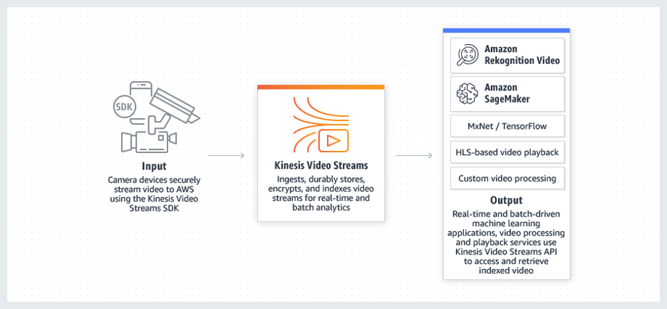

#### ****Amazon Kinesis Data Streams:****

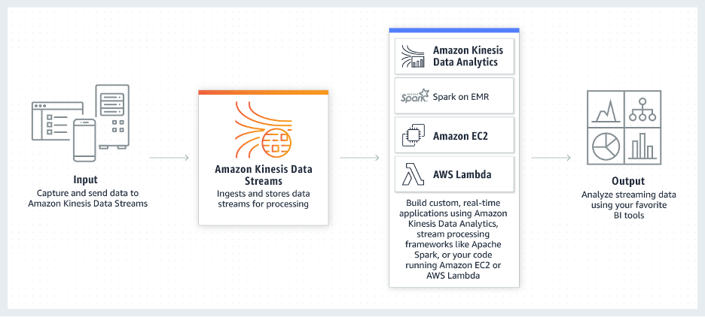

#### ****Amazon Kinesis Data Firehose:****

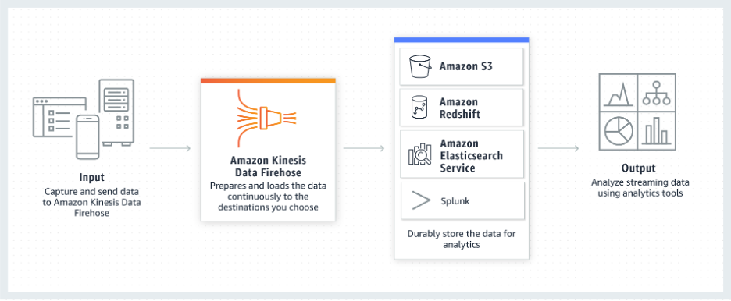

#### ****Amazon API Gateway****

Amazon API Gateway is a fully managed service that makes it easy to create, publish, and maintain secure APIs at scale. APIs are the front door to backend applications and services. API Gateway handles all the tasks involved in accepting and processing up to hundreds of thousands of concurrent API calls, including traffic management, CORS support, authorization and access control, throttling, monitoring, and API version management.

Read more about API Gateway here: <https://aws.amazon.com/api-gateway/>

### EMR, Glue Jobs, Lambda, Kinesis Analytics, RedShift

#### ****Apache Hadoop on AWS****

Apache Hadoop is an open source framework that is used to efficiently store and process large datasets ranging in size from gigabytes to petabytes of data. Instead of using one large computer to store and process the data, Hadoop allows clustering multiple computers to analyze massive datasets in parallel more quickly.

Read more about Hadoop here: <https://aws.amazon.com/emr/details/hadoop/what-is-hadoop/>

#### ****Amazon EMR****

Amazon EMR is a managed cluster platform that simplifies running big data frameworks, such as Apache Hadoop and Apache Spark, on AWS to process and analyze vast amounts of data. By using these frameworks and related open-source projects, such as Apache Hive and Apache Pig, you can process data for analytics purposes and business intelligence workloads. Additionally, you can use Amazon EMR to transform and move large amounts of data into and out of other AWS data stores and databases, such as Amazon Simple Storage Service (Amazon S3) and Amazon DynamoDB.

Read more about Amazon EMR here: <https://docs.aws.amazon.com/emr/latest/ManagementGuide/emr-what-is-emr.html>

#### ****Amazon EMR Serverless****

Amazon EMR Serverless is a serverless option in Amazon EMR that makes it easy for data analysts and engineers to run open-source big data analytics frameworks without configuring, managing, and scaling clusters or servers. You get all the features and benefits of Amazon EMR without the need for experts to plan and manage clusters.

Read more about Amazon EMR Serverless here: <https://aws.amazon.com/emr/serverless/>

#### ****AWS Glue DataBrew****

AWS Glue DataBrew is a new visual data preparation tool that makes it easy for data analysts and data scientists to clean and normalize data to prepare it for analytics and machine learning. You can choose from over 250 pre-built transformations to automate data preparation tasks, all without the need to write any code. You can automate filtering anomalies, converting data to standard formats, and correcting invalid values, and other tasks. After your data is ready, you can immediately use it for analytics and machine learning projects. You only pay for what you use - no upfront commitment. Read more about AWS Glue DataBrew here: <https://aws.amazon.com/glue/features/databrew/>

#### ****AWS Glue Jobs****

A job is the business logic that performs the extract, transform, and load (ETL) work in AWS Glue. When you start a job, AWS Glue runs a script that extracts data from sources, transforms the data, and loads it into targets. You can create jobs in the ETL section of the AWS Glue console.

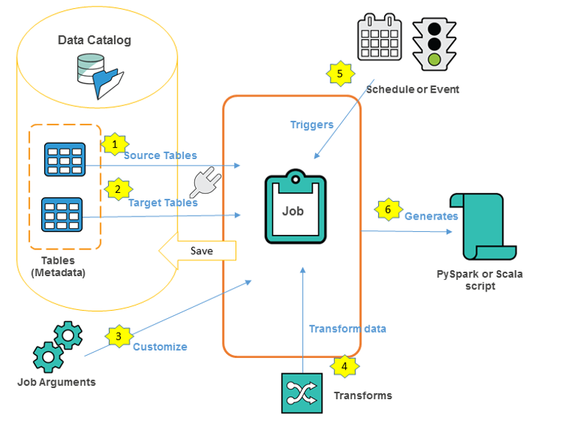

Read more about authoring AWS Glue jobs here: <https://docs.aws.amazon.com/glue/latest/dg/author-job.html>

#### ****AWS Lambda****

AWS Lambda is a compute service that lets you run code without provisioning or managing servers. AWS Lambda runs your code only when needed and scales automatically, from a few requests per day to thousands per second. You pay only for the compute time you consume - there is no charge when your code is not running. With AWS Lambda, you can run code for virtually any type of application or backend service - all with zero administration. AWS Lambda runs your code on a high-availability compute infrastructure and performs all of the administration of the compute resources, including server and operating system maintenance, capacity provisioning and automatic scaling, code monitoring and logging.

When using AWS Lambda, you are responsible only for your code. AWS Lambda manages the compute fleet that offers a balance of memory, CPU, network, and other resources. This can be helpful when processing incoming data for your data lake being hosted on AWS.

Read more about AWS Lambda here: <https://docs.aws.amazon.com/lambda/latest/dg/welcome.html>

#### ****Amazon Athena****

Amazon Athena is an interactive query service that makes it easy to analyze data directly in Amazon Simple Storage Service (Amazon S3) using standard SQL. With a few actions in the AWS Management Console, you can point Athena at your data stored in Amazon S3 and begin using standard SQL to run ad-hoc queries and get results in seconds.

Read more about Athena here: <https://docs.aws.amazon.com/athena/latest/ug/what-is.html>

#### ****Amazon RedShift****

Amazon Redshift makes it simple and cost effective to run high performance queries on petabytes of structured data so that you can build powerful reports and dashboards using your existing business intelligence tools.

Read more about Amazon RedShift here: <https://aws.amazon.com/redshift/?whats-new-cards.sort-by=item.additionalFields.postDateTime&whats-new-cards.sort-order=desc>

#### ****Amazon Kinesis Data Analytics****

With Amazon Kinesis Data Analytics for SQL Applications, you can process and analyze streaming data using standard SQL. The service enables you to quickly author and run powerful SQL code against streaming sources to perform time series analytics, feed real-time dashboards, and create real-time metrics.

To get started with Kinesis Data Analytics, you create a Kinesis data analytics application that continuously reads and processes streaming data. The service supports ingesting data from Amazon Kinesis Data Streams and Amazon Kinesis Data Firehose streaming sources. Then, you author your SQL code using the interactive editor and test it with live streaming data. You can also configure destinations where you want Kinesis Data Analytics to send the results. Kinesis Data Analytics supports Amazon Kinesis Data Firehose (Amazon S3, Amazon Redshift, Amazon Elasticsearch Service, and Splunk), AWS Lambda, and Amazon Kinesis Data Streams as destinations.

Read more about Amazon Kinesis Data Analytics here: <https://docs.aws.amazon.com/kinesisanalytics/latest/dev/what-is.html>

#### ****Amazon OpenSearch Service****

Please note that Amazon Elasticsearch Service (Amazon ES) has a successor called **Amazon OpenSearch Service.** If in the videos you hear the instructors referring to Amazon ElasticSearch Service, please know they are talking about the service Amazon OpenSearch Service.

Amazon OpenSearch Service is an open source, distributed search and analytics suite derived from Elasticsearch. Elasticsearch is a popular open-source search and analytics engine for use cases such as log analytics, real-time application monitoring, and clickstream analysis. With OpenSearch Service, you get access to the latest versions of OpenSearch Service, support for 19 versions of Elasticsearch (1.5 to 7.10 versions),

Read more about Amazon OpenSearch Service here: [https://docs.aws.amazon.com/elasticsearch-service/latest/developerguide/what-is-amazon-elasticsearch-service.https://docs.aws.amazon.com/opensearch-service/latest/developerguide/gsg.html](https://docs.aws.amazon.com/elasticsearch-service/latest/developerguide/what-is-amazon-elasticsearch-service.html)

### AWS Lake Formation

#### ****AWS Lake Formation****

AWS Lake Formation makes it easier for you to build, secure, and manage data lakes. Lake Formation helps you do the following, either directly or through other AWS services:

* Register the Amazon Simple Storage Service (Amazon S3) buckets and paths where your data lake will reside.
* Orchestrate data flows that ingest, cleanse, transform, and organize the raw data.
* Create and manage a Data Catalog containing metadata about data sources and data in the data lake.
* Define granular data access policies to the metadata and data through a grant/revoke permissions model.

The following diagram illustrates how data is loaded and secured in Lake Formation.

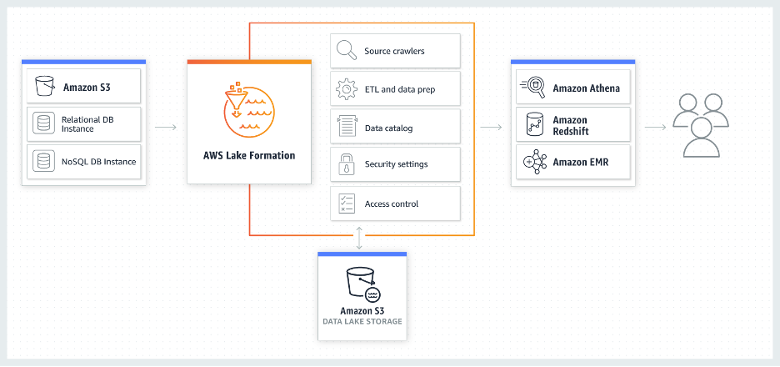

As the diagram shows, Lake Formation manages AWS Glue crawlers, AWS Glue ETL jobs, the Data Catalog, security settings, and access control. After the data is securely stored in the data lake, users can access the data through their choice of analytics services, including Amazon Athena, Amazon Redshift, and Amazon EMR.

Read more about Amazon Lake Formation here: <https://docs.aws.amazon.com/lake-formation/latest/dg/what-is-lake-formation.html>

### Diving Deep on Amazon Kinesis

#### ****AWS Kinesis Family****

Amazon Kinesis makes it easy to collect, process, and analyze real-time, streaming data so you can get timely insights and react quickly to new information. Amazon Kinesis offers key capabilities to cost-effectively process streaming data at any scale, along with the flexibility to choose the tools that best suit the requirements of your application. With Amazon Kinesis, you can ingest real-time data such as video, audio, application logs, website clickstreams, and IoT telemetry data for machine learning, analytics, and other applications. Amazon Kinesis enables you to process and analyze data as it arrives and respond instantly instead of having to wait until all your data is collected before the processing can begin.

More info: <https://aws.amazon.com/kinesis/>

#### ****Amazon Kinesis Data Streams****

Amazon Kinesis Data Streams (KDS) is a massively scalable and durable real-time data streaming service. KDS can continuously capture gigabytes of data per second from hundreds of thousands of sources such as website clickstreams, database event streams, financial transactions, social media feeds, IT logs, and location-tracking events. The data collected is available in milliseconds to enable real-time analytics use cases such as real-time dashboards, real-time anomaly detection, dynamic pricing, and more.

More info: <https://aws.amazon.com/kinesis/data-streams/>

#### ****Amazon Kinesis Firehose****

Amazon Kinesis Data Firehose is the easiest way to reliably load streaming data into data lakes, data stores, and analytics services. It can capture, transform, and deliver streaming data to Amazon S3, Amazon Redshift, Amazon Elasticsearch Service, generic HTTP endpoints, and service providers like Datadog, New Relic, MongoDB, and Splunk. It is a fully managed service that automatically scales to match the throughput of your data and requires no ongoing administration. It can also batch, compress, transform, and encrypt your data streams before loading, minimizing the amount of storage used and increasing security.

More info: <https://aws.amazon.com/kinesis/data-firehose/?kinesis-blogs.sort-by=item.additionalFields.createdDate&kinesis-blogs.sort-order=desc>

#### ****Amazon Kinesis Data Analytics****

Amazon Kinesis Data Analytics is the easiest way to transform and analyze streaming data in real time with Apache Flink. Apache Flink is an open source framework and engine for processing data streams. Amazon Kinesis Data Analytics reduces the complexity of building, managing, and integrating Apache Flink applications with other AWS services. Amazon Kinesis Data Analytics takes care of everything required to run streaming applications continuously, and scales automatically to match the volume and throughput of your incoming data. With Amazon Kinesis Data Analytics, there are no servers to manage, no minimum fee or setup cost, and you only pay for the resources your streaming applications consume.

More info: <https://aws.amazon.com/kinesis/data-analytics/>

#### ****Amazon Kinesis Analytics In-Application Streams and Pumps****

When you configure [application input](https://docs.aws.amazon.com/kinesisanalytics/latest/dev/how-it-works-input.html), you map a streaming source to an in-application stream that is created. Data continuously flows from the streaming source into the in-application stream. An in-application stream works like a table that you can query using SQL statements, but it's called a stream because it represents continuous data flow.

More info: <https://docs.aws.amazon.com/kinesisanalytics/latest/dev/streams-pumps.html>

### Batch Data Ingestion with AWS Services

#### ****Data Ingestion Methods****

One of the core capabilities of a data lake architecture is the ability to quickly and easily ingest multiple types of data, such as real-time streaming data and bulk data assets from on-premises storage platforms, as well as data generated and processed by legacy on-premises platforms, such as mainframes and data warehouses. AWS provides services and capabilities to cover all of these scenarios.

More info: <https://docs.aws.amazon.com/whitepapers/latest/building-data-lakes/data-ingestion-methods.html>

#### ****AWS Snow Family****

The AWS Snow Family helps customers that need to run operations in austere, non-data center environments, and in locations where there's lack of consistent network connectivity. The Snow Family, comprised of AWS Snowcone, AWS Snowball, and AWS Snowmobile, offers a number of physical devices and capacity points, most with built-in computing capabilities. These services help physically transport up to exabytes of data into and out of AWS. Snow Family devices are owned and managed by AWS and integrate with AWS security, monitoring, storage management, and computing capabilities.

#### ****AWS Snowcone Launch - A Small, Portable, Rugged, and Secure Edge Computing and Data Transfer Device****

Check the very funny and informative video at: <https://www.youtube.com/watch?v=9euPWOLtzuw>

AWS Snowcone is the smallest member of the AWS Snow Family of edge computing and data transfer devices. Snowcone is portable, rugged, and secure – small and light enough to fit in a backpack, and able to withstand harsh environments. Customers use Snowcone to deploy applications at the edge, and to collect data, process it locally, and move it to AWS either offline (by shipping the device to AWS) or online (by using AWS DataSync on Snowcone to send the data to AWS over the network).

#### ****AWS Snowcone****

AWS Snowcone is the smallest member of the AWS Snow Family of edge computing, edge storage, and data transfer devices, weighing in at 4.5 pounds (2.1 kg) with 8 terabytes of usable storage. Snowcone is ruggedized, secure, and purpose-built for use outside of a traditional data center. Its small form factor makes it a perfect fit for tight spaces or where portability is a necessity. You can use Snowcone in backpacks on first responders, or for IoT, vehicular, and even drone use cases. You can execute compute applications at the edge, and you can ship the device with data to AWS for offline data transfer, or you can transfer data online with AWS DataSync from edge locations.

More info: <https://aws.amazon.com/snowcone/?sc_channel=EL&sc_campaign=Anim_Explainer_2020_vid%20&sc_medium=YouTube&sc_content=video7023&sc_detail=MIGRATION&TRANSFER&sc_country=US>

#### ****Using AWS OpsHub for Snow Family to Manage Devices****

The Snow Family Devices now offer a user-friendly tool, AWS OpsHub for Snow Family, that you can use to manage your devices and local AWS services. You use AWS OpsHub on a client computer to perform tasks such as unlocking and configuring single or clustered devices, transferring files, and launching and managing instances running on Snow Family Devices. You can use AWS OpsHub to manage both the Storage Optimized and Compute Optimized device types and the Snow device. The AWS OpsHub application is available at no additional cost to you.

More info: <https://docs.aws.amazon.com/snowball/latest/developer-guide/aws-opshub.html>

#### ****Enable password authentication for AWS Transfer Family using AWS Secrets Manager (updated)****

More info: <https://aws.amazon.com/blogs/storage/enable-password-authentication-for-aws-transfer-family-using-aws-secrets-manager-updated/>

#### ****AWS Transfer for SFTP – Fully Managed SFTP Service for Amazon S3****

This blog post contain further information on how to configure AWS Transfer for SFTP.

More info: <https://aws.amazon.com/blogs/aws/new-aws-transfer-for-sftp-fully-managed-sftp-service-for-amazon-s3/>

# The Importance of Data Cataloging

### ****Data Cataloging****

More info: <https://docs.aws.amazon.com/whitepapers/latest/building-data-lakes/data-cataloging.html>

The earliest challenges that inhibited building a data lake were keeping track of all of the raw assets as they were loaded into the data lake, and then tracking all of the new data assets and versions that were created by data transformation, data processing, and analytics. Thus, an essential component of an Amazon S3-based data lake is the data catalog. The data catalog provides a query-able interface of all assets stored in the data lake’s S3 buckets. The data catalog is designed to provide a single source of truth about the contents of the data lake.

There are two general forms of a data catalog: a comprehensive data catalog that contains information about all assets that have been ingested into the S3 data lake, and a Hive Metastore Catalog (HCatalog) that contains information about data assets that have been transformed into formats and table definitions that are usable by analytics tools like Amazon Athena, Amazon Redshift, Amazon Redshift Spectrum, and Amazon EMR. The two catalogs are not mutually exclusive and both may exist. The comprehensive data catalog can be used to search for all assets in the data lake, and the HCatalog can be used to discover and query data assets in the data lake.

### ****Comprehensive Data Catalog****

The comprehensive data catalog can be created by using standard AWS services like AWS Lambda, Amazon DynamoDB, and Amazon Elasticsearch Service (Amazon ES). At a high level, Lambda triggers are used to populate DynamoDB tables with object names and metadata when those objects are put into Amazon S3 then Amazon ES is used to search for specific assets, related metadata, and data classifications. The following figure shows a high-level architectural overview of this solution.

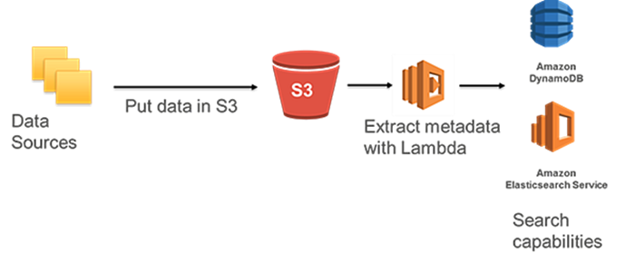

### ****HCatalog with AWS Glue****

AWS Glue can be used to create a Hive-compatible Metastore Catalog of data stored in an Amazon S3-based data lake. To use AWS Glue to build your data catalog, register your data sources with AWS Glue in the AWS Management Console. AWS Glue will then crawl your S3 buckets for data sources and construct a data catalog using pre-built classifiers for many popular source formats and data types, including JSON, CSV, Parquet, and more. You may also add your own classifiers or choose classifiers from the AWS Glue community to add to your crawls to recognize and catalog other data formats. The AWS Glue-generated catalog can be used by Amazon Athena, Amazon Redshift, Amazon Redshift Spectrum, and Amazon EMR, as well as third-party analytics tools that use a standard Hive Metastore Catalog.

More info: <https://docs.aws.amazon.com/whitepapers/latest/building-data-lakes/data-cataloging.html>

### ****Data Ingestion Methods****

One of the core capabilities of a data lake architecture is the ability to quickly and easily ingest multiple types of data, such as real-time streaming data and bulk data assets from on-premises storage platforms, as well as data generated and processed by legacy on-premises platforms, such as mainframes and data warehouses. AWS provides services and capabilities to cover all of these scenarios.

More info: <https://docs.aws.amazon.com/whitepapers/latest/building-data-lakes/data-ingestion-methods.html>

### ****Future Proofing the Data Lake****

A data lake built on AWS can immediately solve a broad range of business analytics challenges and quickly provide value to your business. However, business needs are constantly evolving, AWS and the analytics partner ecosystem are rapidly evolving and adding new services and capabilities, as businesses and their data lake users achieve more experience and analytics sophistication over time. Therefore, it’s important that the data lake can seamlessly and non-disruptively evolve as needed.

AWS futureproofs your data lake with a standardized storage solution that grows with your organization by ingesting and storing all of your business’s data assets on a platform with virtually unlimited scalability and well-defined APIs and integrates with a wide variety of data processing tools. This allows you to add new capabilities to your data lake as you need them without infrastructure limitations or barriers. Additionally, you can perform agile analytics experiments against data lake assets to quickly explore new processing methods and tools, and then scale the promising ones into production without the need to build new infrastructure, duplicate and/or migrate data, and have users migrate to a new platform. In closing, a data lake built on AWS allows you to evolve your business around your data assets, and to use these data assets to quickly and agilely drive more business value and competitive differentiation without limits.

# Course 4: Exam Prep: AWS Certified Solutions Architect – Associate

Domain 1: design secure architectures 30%

* 1. design secure access to AWS resources

what is cloud computing?

AWS Global Infrastructure

Shared responsibility model

AWS well-architected framework

Aws fundamentals

Public, private, hybrid, and multi-cloud

AWS accounts

IAM

* 1. design secure workloads and applications
  2. determine appropriate data security controls

Domain 2: design resilient architectures 26%

Domain 3: design high-performing architectures 24%

Domain 4: design cost-optimized architectures 20%